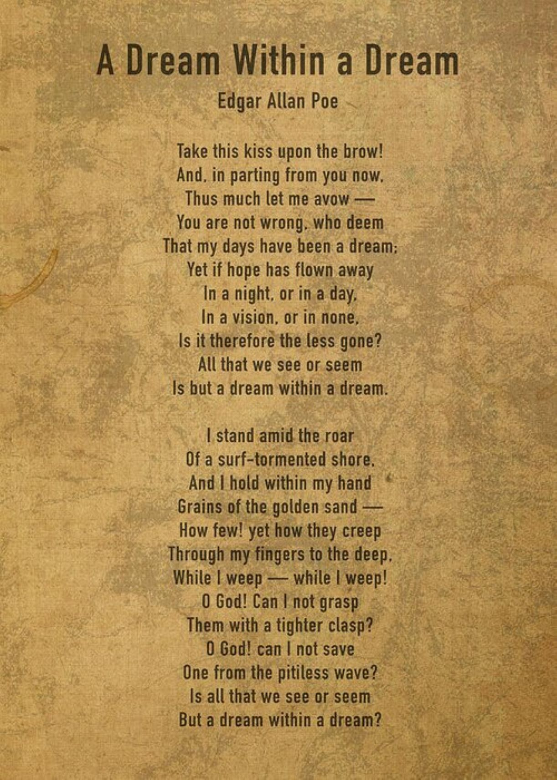

A Dream Within a Dream, Edgar Allen Poe

Take this kiss upon the brow!

And, in parting from you now,

Thus much let me avow —

You are not wrong, who deem

That my days have been a dream;

Yet if hope has flown away

In a night, or in a day,

In a vision, or in none,

Is it therefore the less gone?

All that we see or seem

Is but a dream within a dream.

I stand amid the roar

Of a surf-tormented shore,

And I hold within my hand

Grains of the golden sand —

How few! yet how they creep

Through my fingers to the deep,

While I weep — while I weep!

O God! Can I not grasp

Them with a tighter clasp?

O God! can I not save

One from the pitiless wave?

Is all that we see or seem

But a dream within a dream?