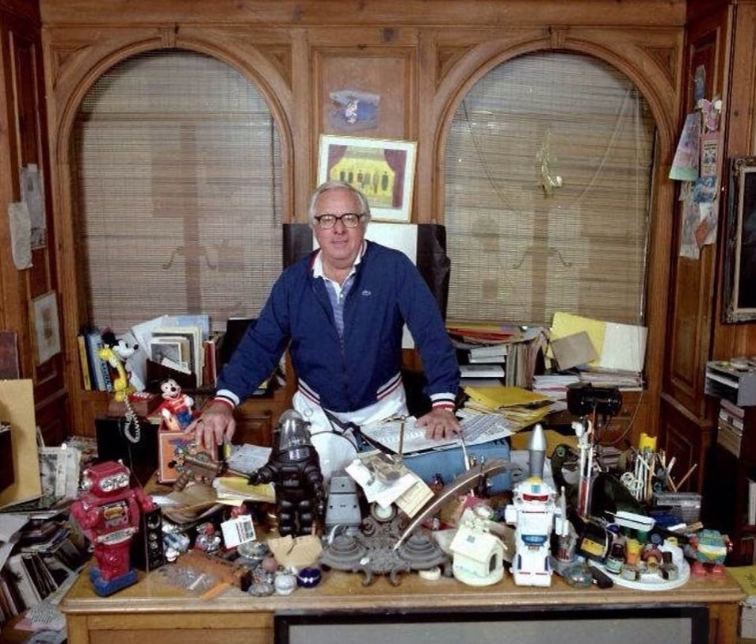

A Literary Encounter, Ray Bradbury

A Literary Encounter

It had been going on for a long time, but perhaps she first gave it notice this autumn evening when Charlie was walking the dog and met her on the way back from the grocer’s. They had been married a year, but it wasn’t often they happened on each other this way, like two strangers.

‘God, it’s good to see you, Marie!’ he cried, taking her arm fiercely. His dark eyes were shining and he was sniffing great lungfuls of the sharp air. ‘God, isn’t it a lost evening, though!’

‘It’s nice.’ She looked quietly at him as they walked toward their house.

‘October,’ he gasped. ‘Lord, I love to be out in it, eating it, breathing it, smelling its smell. Oh, it’s a wild, sad month, all right. Look at the way the trees are burning with it. The world’s on fire in October; and you think of all the dead you’ll never see again.’ He gripped her hand tightly.

‘Just a minute. The dog wants to stop.’

They waited in the cold darkness while the dog tapped a tree with his nose.

‘God, smell that incense!’ The husband stretched. ‘I feel tall tonight, like I could stride the earth, yank down stars, start volcanoes roaring!’

‘Is your headache gone from this morning?’ she asked softly.

‘Gone, Christ, it’llnevercome back! Who thinks of headaches on such a night! Listen to the leaves rustle! Listen to that wind in the high and empty trees! God, isn’t it a lonely, lost time, though, and where are we going, we lost and wandering souls on the brick pavements of the surging cities and little lonely towns where the trains pound through the night? I’d love to be traveling tonight, oh, traveling anywhere, to be out in it, drinking its wildness, its sad sweetness!’

‘Why don’t we ride the trolley out to Chessman Park tonight, it’s a nice ride,’ she said, nodding.

He flung up a hand, urging on the slow dog. ‘No, I meanreallytraveling! Over bridges and hills and by cold cemeteries and past hidden villages where lights are all out and nobody knows you’re passing in the night on ringing steel!’

‘Well, then, we might take the North Shore up to Chicago for the weekend,’ she suggested.

He looked at her pitiably in the dark and crushed her small cool hand in his mighty one. ‘No,’ he said with grand simplicity. ‘No.’ He turned. ‘Come on. Home to a huge dinner. Three steaks, I want, a glutton’s repast! Rare red wines, rich sauces, and a steaming tureen of creamed soup, with an after-dinner liqueur, and—’

‘We’ve pork chops and peas.’ She unlocked the front door.

On the way to the kitchen, she tossed her hat. It landed on an opened copy of Thomas Wolfe’sOf Time and the River, which lay under the hurricane lamp. Giving her husband a look, she ran to investigate the potatoes.

Three nights passed in which he stirred violently in bed when the wind blew. He stared with intent brightness at the window rattling in the autumn storm. Then, he relaxed.

The following evening, when she entered from snatching a few sheets off the line, she found him seated deep in his library chair, a cigarette hanging from his lower lip.

‘Drink?’ he said.

‘Yes,’ she said.

‘What?’

‘What do you mean, “what?”’ she asked.

A faint tinge of irritation moved in his impassive cold face.

‘Whatkind?’ he said.

‘Scotch,’ she said.

‘Soda?’ he said.

‘Right.’ She felt her face take on the same expressionless aspect as his.

He lunged over to the cabinet, took out a couple glasses big as vases, and perfunctorily filled them.

‘Okay?’ He gave her hers.

She looked at it. ‘Fine.’

‘Dinner?’ He eyed her coldly, over his drink.

‘Steak.’

‘Hash browns?’ His lips were a thin line.

‘Right.’

‘Good girl.’ He laughed a little, bleakly, tossing the drink into his hard mouth, eyes closed.

She lifted her drink. ‘Luck.’

‘You said it.’ He thought it over slyly, eyes moving about the room. ‘Another?’

‘Don’t mind,’ she said.

‘Atta girl,’ he said. ‘Atta baby.’

He shot soda into her glass. It sounded like a fire hose let loose in the silence. He walked back to lose himself like a little boy in the immense library chair. Just before sinking behind a copy of Dashiell Hammett’sThe Maltese Falcon, he drawled, ‘Call me.’

She turned her glass slowly in her hand that was like a white tarantula.

‘Check,’ she said.

She watched him for another week. She found herself frowning most of the time. Several times she felt like screaming.

As she watched, one evening, he seated himself at dinner and said:

‘Madame, you look absolutely exquisite tonight.’

‘Thank you.’ She passed the corn.

‘A most extraordinary circumstance occurred at the office today,’ he said. ‘A gentleman called to ascertain my health. “Sir,” I said politely. “I am in excellent equilibrium, and am in no need of your services.”

“Oh, but, sir,” he said, “I am representative of such-and-so’s insurance company, and I wish only to give into your hands this splendid and absolutely irreproachable policy.” Well, we conversed pleasantly enough, and, resultantly, this evening, I am the proud possessor of a new life insurance, double indemnity and all, which protects you under all circumstances, dear kind lady love of my life.’

‘How nice,’ she said.

‘Perhaps you will also be pleased to learn,’ he said, ‘that for the last few days, beginning on the night of Thursday last, I became acquainted and charmed with the intelligent and certain prose of one Samuel Johnson. I am now amidst hisLife of Alexander Pope.’

‘So much I assumed,’ she said, ‘from your demeanor.’

‘Eh?’ He held his knife and fork politely before him.

‘Charlie,’ she said wistfully. ‘Could you do me a big favor?’

‘Anything.’

‘Charlie, do you remember when we married a year ago?’

‘But yes; every sweet, singular instant of our courtship!’

‘Well, Charlie, do you remember what books you were reading during our courtship?’

‘Is it of importance, my darling?’

‘Very.’

He put himself to it with a scowl. ‘I cannot remember,’ he admitted finally. ‘But I shall attempt to recall during the evening.’

‘I wish you would,’ she urged. ‘Because, well, because I’d like you to start reading those books again, those books, whatever they were, which you read when first we met. You swept me from my feet with your demeanor then. But since, you’ve–changed.’

‘Changed?I?’ He drew back as from a cold draft.

‘I wish you’d start reading those same books again,’ she repeated.

‘But why do you desire this?’

‘Oh, because.’

‘Truly a woman’s reason.’ He slapped his knees. ‘But I shall try to please. As soon as I recall, I shall read those books once more.’

‘And, Charlie, one more thing, promise to read them every day for the rest of your life?’

‘Your wish, dear lady, my command. Please pass the salt.’

But he did not remember the names of the books. The long evening passed and she looked at her hands, biting her lips.

Promptly at eight o’clock, she jumped up, crying out, ‘I remember!’

In a matter of instants she was in their car, driving down the dark streets to town, into a bookstore where, laughing, she bought ten books.

‘Thank you!’ said the book dealer. ‘Good night!’

The door slammed with a tinkle of bells.

Charlie read late at night, sometimes fumbling to bed, blind with literature, at three in the morning.

Now, at ten o’clock, before retiring, Marie slipped into the library, laid the ten books quietly next to Charlie, and tiptoed out.

She watched through the library keyhole, her heart beating loudly in her. She was in a perfect fever.

After a time, Charlie glanced up at the desk. He blinked at the new books. Hesitantly, he closed his copy of Samuel Johnson, and sat there.

‘Go on,’ whispered Marie through the keyhole. ‘Go on!’ Her breath came and went in her mouth.

Charlie licked his lips thoughtfully and then, slowly, he put out his hand. Taking one of the new books, he opened it, settled down, and began reading.

Singing softly, Marie walked off to bed.

He bounded into the kitchen the next morning with a glad cry. ‘Hello, beautiful woman! Hello, lovely, wonderful, kind, understanding creature, living in this great wide sweet world!’

She looked at him happily. ‘Saroyan?’ she said.

‘Saroyan!’ he cried, and they had breakfast.

The End