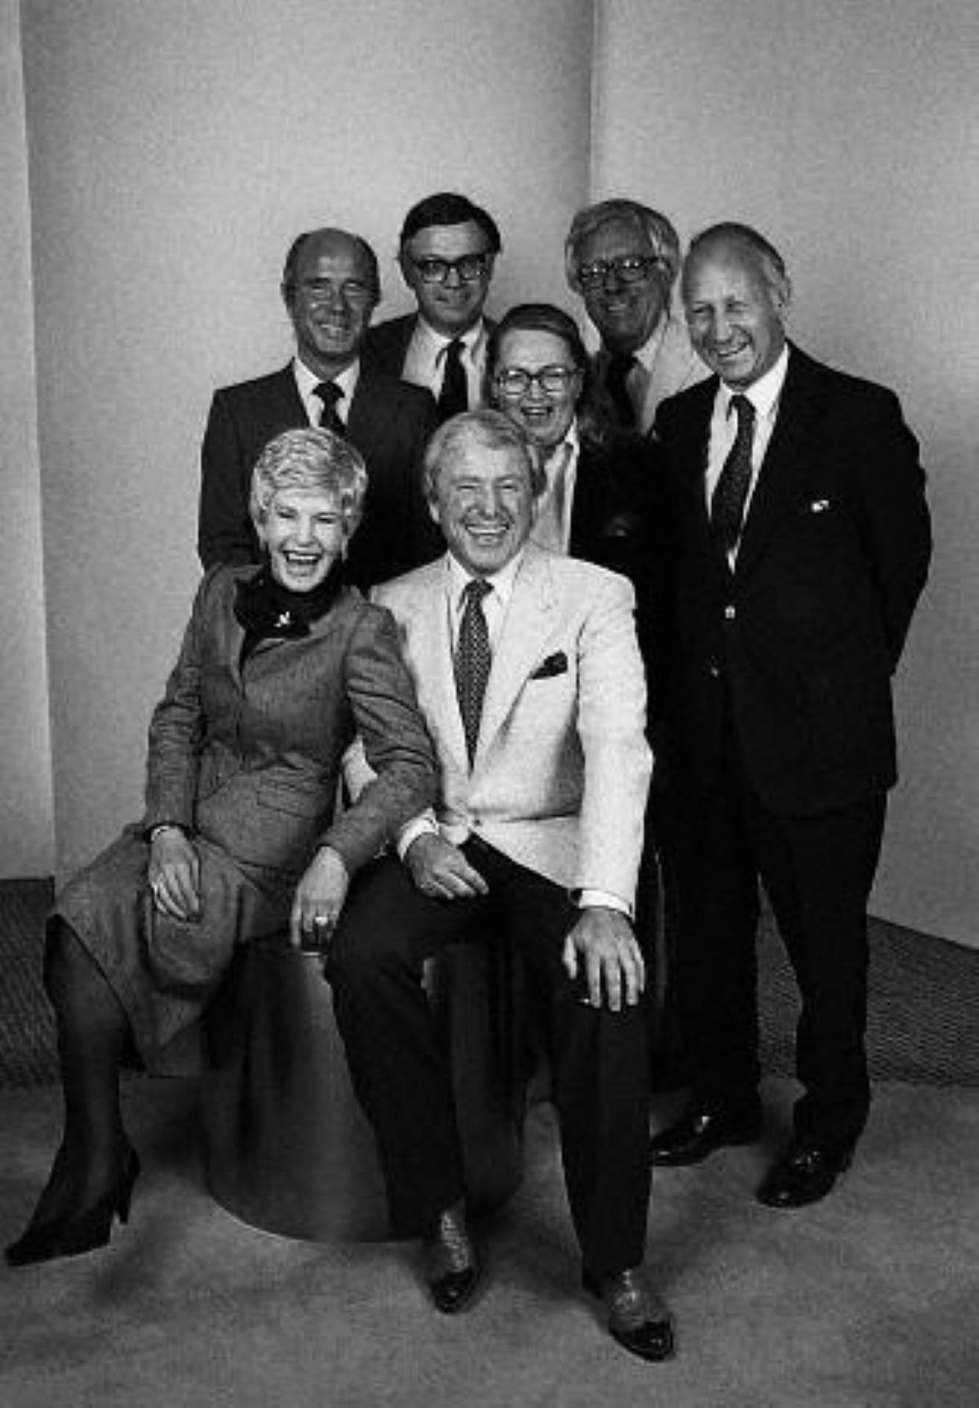

A Medicine for Melancholy, Ray Bradbury

A Medicine for Melancholy

“Send for some leeches; bleed her,” said Doctor Gimp.

“She has no blood left!” cried Mrs. Wilkes. “Oh, Doctor, what ails our Camillia?”

“She’s not right.”

“Yes, yes?”

“She’s poorly.” The good doctor scowled.

“Go on, go on!”

“She’s a fluttering candle flame, no doubt.”

“Ah, Doctor Gimp,” protested Mr. Wilkes. “You but tell us as you go out what we told you when you came in!”

“No, more! Give her these pills at dawn, high noon, and sunset. A sovereign remedy!”

“Damn, she’s stuffed with sovereign remedies now!”

“Tut-tut! That’s a shilling as I pass downstairs, sir.”

“Go down and send the Devil up!” Mr. Wilkes shoved a coin in the good doctor’s hand.

Whereupon the physician, wheezing, taking snuff, sneezing, stamped down into the swarming streets ofLondon on a sloppy morn in the spring of 1762.

Mr. and Mrs. Wilkes turned to the bed where their sweet Camillia lay pale, thin, yes, but far from unlovely, with large wet lilac eyes, her hair a creek of gold upon her pillow.

“Oh,” she almost wept. “What’s to become of me? Since the start of spring, three weeks, I’ve been a ghost in my mirror; I frighten me. To think I’ll die without seeing my twentieth birthday.”

“Child,” said the mother. “Where do you hurt?”

“My arms. My legs. My bosom. My head. How many doctors - six? - have turned me like a beef on a spit. No more. Please, let me pass away untouched.”

“What a ghastly, what a mysterious illness,” said the mother. “Oh, do something, Mr. Wilkes!”

“What?” asked Mr. Wilkes angrily. “She won’t have the physician, the apothecary, or the priest! - and Amen to that! - they’ve wrung me dry! Shall I run in the street then and bring the Dustman up?”

“Yes,” said a voice.

“What!” All three turned to stare.

They had quite forgotten her younger brother, Jamie, who stood picking his teeth at a far window, gazing serenely down into the drizzle and the loud rumbling of the town.

“Four hundred years ago,” he said serenely, “it was tried, it worked. Don’t bring the Dustman up, no, no. But let us hoist Camillia, cot and all, maneuver her downstairs, and set her up outside our door.”

“Why? What for?”

“In a single hour” - Jamie’s eyes jumped, counting - “a thousand folk rush by our gate. In one day, twenty thousand people run, hobble, or ride by. Each might eye my swooning sister, each count her teeth, pull her ear lobes, and all, all, mind you, would have a sovereign remedy to offer! One of them would just have to be right!”

“Ah,” said Mr. Wilkes, stunned.

“Father!” said Jamie breathlessly. “Have you ever known one single man who didn’t think he personally wrote Materia Medica? This green ointment for sour throat, that ox-salve for miasma or bloat? Right now, ten thousand self-appointed apothecaries sneak off down there, their wisdom lost to us!”

“Jamie boy, you’re incredible!”

“Cease!” said Mrs. Wilkes. “No daughter of mine will be put on display in this or any street-“

“Fie, woman!” said Mr. Wilkes. “Camillia melts like snow and you hesitate to move her from this hot room? Come, Jamie, lift the bed!”

“Camillia?” Mrs. Wilkes turned to her daughter.

“I may as well die in the open,” said Camlila, “where a cool breeze might stir my locks as I . . .”

“Bosh!” said the father. “You’ll not die. Jamie, heave! Ha! There! Out of the way, wife! Up, boy, higher!”

“Oh,” cried Camillia faindy. “I fly, I fly . . . !”

Quite suddenly a blue sky opened overLondon . The population, surprised by the weather, hurried out into the streets, panicking for something to see, to do, to buy. Blind men sang, dogs jigged, clowns shuffled and tumbled, children chalked games and threw balls as if it were carnival time.

Down into all this, tottering, their veins bursting from their brows, Jamie and Mr. Wilkes carried Camillia like a lady Pope sailing high in her sedan-chair cot, eyes clenched shut, praying.

“Careful!” screamed Mrs. Wilkes. “Ah, she’s dead! No. There. Put her down. Easy . . .”

And at last the bed was tilted against the house front so that theRiverofHumanity surging by could see Camillia, a large pale Bartolemy Doll put out like a prize in the sun.

“Fetch a quill, ink, paper, lad,” said the father. “I’ll make notes as to symptoms spoken of and remedies offered this day. Tonight we’ll average them out. Now-“

Bijt already a man in the passing crowd had fixed Camillia with a sharp eye.

“She’s sick!” he said.

“Ah,” said Mr. Wilkes, gleefully. “It begins. The quill, boy. There. Go on, sir!”

“She’s not well.” The man scowled. “She does poorly.”

“Does poorly-“ Mr. Wilkes wrote, then froze. “Sir?” He looked up suspiciously. “Are you a physician?”

“I am, sir.”

“I thought I knew the words! Jamie, take my cane, drive him off! Go, sir, be gone!”

But the man hastened off, cursing, mightily exasperated.

“She’s not well, she does poorly . . . pah!” mimicked Mr. Wilkes, but stopped. For now a woman, tall and gaunt as a specter fresh risen from the tomb, was pointing a finger at Camillia Wilkes.

“Vapors,” she intoned.

“Vapors,” wrote Mr. Wilkes, pleased.

“Lung-flux,” chanted the woman.

“Lung-flux!” Mr. Wilkes wrote, beaming. “Now, that’s more like it!”

“A medicine for melancholy is needed,” said the woman palely. “Be there mummy ground to medicine in your house? The best mummies are: Egyptian, Arabian, Hirasphatos, Libyan, all of great use in magnetic disorders. Ask for me, the Gypsy, at theFlodden Road . I sell stone parsley, male frankincense-“

“Flodden Road, stone parsey - slower, woman!”

“Opobalsam, pontic valerian-“

“Wait, woman! Opobalsam, yes! Jamie, stop her!”

But the woman, naming medicines, glided on.

A girl, no more than seventeen, walked up now and stared at Camillia Wilkes.

“She-“

“One moment!” Mr. Wilkes scribbled feverishly. “-magnetic disorders - pontic valerian - drat! Well, young girl, now. What do you see in my daughter’s face? You fix her with your gaze, you hardly breathe. So?”

“She-“ The strange girl searched deep into Camillia’s eyes, flushed, and stammered. “She suffers from . . . from . . .”

“Spit it out!”

“She . . . she . . . oh!”

And the girl, with a last look of deepest sympathy, darted off through the crowd.

“Silly girl!”

“No, Papa,” murmured Camillia, eyes wide. “Not silly. She saw. She knew. Oh, Jamie, run fetch her, make her tell!”

“No, she offered nothing! Whereas, the Gypsy, see her list!”

“I know it, Papa.” Camillia, paler, shut her eyes.

Someone cleared his throat.

A butcher, his apron a scarlet battleground, stood bristling his fierce mustaches there.

“I have seen cows with this look,” he said. “I have saved them with brandy and three new eggs. In winter I have saved myself with the same elixir-“

“My daughter is no cow, sir!” Mr. Wilkes threw down his quill. “Nor is she a butcher, nor is it January! Step back, sir, others wait!”

And indeed, now a vast crowd clamored, drawn by the others, aching to advise their favorite swig, recommend some country site where it rained less and shone more sun than in allEngland or your South of France. Old men and women, especial doctors as all the aged are, clashed by each other in bristles of canes, in phalanxes of crutches and hobble sticks.

“Back!” cried Mrs. Wilkes, alarmed. “They’ll crush my daughter like a spring berry!”

“Stand off!” Jamie seized canes and crutches and threw them over the mob, which turned on itself to go seek their missing members.

“Father, I fail, I fail,” gasped Camillia.

“Father!” cried Jamie. “There’s but one way to stop this riot! Charge them! Make them pay to give us their mind on this ailment!”

“Jamie, you are my son! Quick, boy, paint a sign! Listen, people! Tuppence! Queue up please, a line! Tuppence to speak your piece! Get your money out, yes! That’s it. You, sir. You, madame. And you, sir. Now, my quill! Begin!”

The mob boiled in like a dark sea.

Camlia opened one eye and swooned again.

Sundown, the streets almost empty, only a few strollers now. Camillia moth-fluttered her eyelids at a famiiar clinking jingle.

“Three hundred and ninety-nine, four hundred pennies!” Mr. Wilkes counted the last money into a bag held by his grinning son. “There!”

“It will buy me a fine black funeral coach,” said the pale girl.

“Hush! Did you imagine, family, so many people, two hundred, would pay to give us their opinion?”

“Yes,” said Mrs. Wilkes. “Wives, husbands, children, are deaf to each other. So people gladly pay to have someone listen. Poor things, each today thought he and he alone knew quinsy, dropsy, glanders, could tell the slaver from the hives. So tonight we are rich and two hundred people are happy, having unloaded their full medical kit at our door.”

“Gods, instead of quelling the riot, we had to drive them off snapping like pups.”

“Read us the list, Father,” said Jamie, “of two hundred remedies. Which one is true?”

“I care not,” whispered Carillia, sighing. “It grows dark. My stomach is queasy from listening to the names! May I be taken upstairs?”

“Yes, dear. Jamie, lift!”

“Please,” said a voice.

Half-bent, the men looked up.

There stood a Dustman of no particular size or shape, his face masked with soot from which shone water-blue eyes and a white slot of an ivory smile. Dust sifted from his sleeves and his pants as he moved, as he talked quietly, nodding.

“I couldn’t get through the mob earlier,” he said, holding his dirty cap in his hands. “Now, going home, here I am. Must I pay?”

“No, Dustman, you need not,” said Camillia gently.

“Hold on-“ protested Mr. Wilkes.

But Camillia gave him a soft look and he grew silent.

“Thank you, ma’am.” The Dustman’s smile flashed like warm sunlight in the growing dusk. “I have but one advice.”

He gazed at Camillia. She gazed at him.

“Be this Saint Bosco’s Eve, sir, ma ‘am?”

“Who knows? Not me, sir!” said Mr. Wilkes.

“I think it is Saint Bosco’s Eve, sir. Also, it is the night of the Full Moon. So,” said the Dustman humbly, unable to take his eyes from the lovely haunted girl, “you must leave your daughter out in the light of that rising moon.”

“Out under the moon!” said Mrs. Wilkes.

“Doesn’t that make the lunatic?” asked Jamie.

“Beg pardon, sir.” The Dustman bowed. “But the full moon soothes all sick animal, be they human or plain field beast. There is a serenity of color, a quietude of touch, a sweet sculpturing of mind and body in full moonlight.”

“It may rain-“ said the mother uneasily.

“I swear,” said the Dustman quickly. “My sister suffered this same swooning paleness. We set her like a potted lily out one spring night with the moon. She lives today inSussex , the soul of reconstituted health!”

“Reconstituted! Moonlight! And will cost us not one penny of the four hundred we collected this day, Mother, Jamie, Camillia.”

“No!” said Mrs. Wilkes. “I won’t have it!”

“Mother,” said Camillia.

She looked earnestly at the Dustman.

From his grimed face the Dustman gazed back, his smile like a little scimitar in the dark.

“Mother,” said Camillia. “I feel it. The moon will cure me, it will, it will . . .”

The mother sighed. “This is not my day, nor night. Let me kiss you for the last time, then. There.”

And the mother went upstairs.

Now the Dustman backed off, bowing courteously to all.

“All night, now, remember, beneath the moon, not the slightest disturbance until dawn. Sleep well, young lady. Dream, and dream the best. Good night.”

Soot was lost in soot; the man was gone.

Mr. Wilkes and Jamie kissed Camillia’s brow.

“Father, Jamie,” she said. “Don’t worry.”

And she was left alone to stare off where at a great distance she thought she saw a smile hung by itself in the dark blink off and on, then go round a corner, vanishing.

She waited for the rising of the moon.

Night inLondon , the voices growing drowsier in the inns, the slamming of doors, drunken farewells, clocks chiming. Camillia saw a cat like a woman stroll by in her furs, saw a woman like a cat stroll by, both wise, both Egyptian, both smelling of spice. Every quarter hour or so a voice drifted down from above:

“You all right, child?”

“Yes, Father.”

“Camillia?”

“Mother, Jamie, I’m fine.”

And at last. “Good night.”

“Good night.”

The last lights out.London asleep.

The moon rose.

And the higher the moon, the larger grew Camillia’s eyes as she watched the alleys, the courts, the streets, until at last, atmidnight , the moon moved over her to show her like a marble figure atop an ancient tomb.

A motion in darkness.

Camillia pricked her ears.

A faint melody sprang out on the air.

A man stood in the shadows of the court.

Camillia gasped.

The man stepped forth into moonlight, carrying a lute which he strummed softly. He was a man well-dressed, whose face was handsome and, now anyway, solemn.

“A troubadour,” said Camillia aloud.

The man, his finger on his lips, moved slowly forward and soon stood by her cot.

“What are you doing out so late?” asked the girl, unafraid but not knowing why.

“A friend sent me to make you well.” He touched the lute strings. They hummed sweetly. He was indeed handsome there in the silver light.

“That cannot be,” she said, “for it was told me, the moon is my cure.”

“And so it will be, maiden.”

“What songs do you sing?”

“Songs of spring nights, aches and ailments without name. Shall I name your fever, maiden?”

“If you know it, yes.”

“First, the symptoms: raging temperatures, sudden cold, heart fast then slow, storms of temper, then sweet calms, drunkenness from having sipped only well water, dizziness from being touched only thus-“

He touched her wrist, saw her melt toward delicious oblivion, drew back.

“Depressions, elations,” he went on. “Dreams-“

“Stop!” she cried, enthralled. “You know me to the letter. Now, name my ailment!”

“I will.” He pressed his lips to the palm of her hand so she quaked suddenly. “The name of the ailment is Camillia Wilkes.”

“How strange.” She shivered, her eyes glinting lilac fires. “Am I then my own affliction? How sick I make myself! Even now, feel my heart!”

“I feel it, so.”

“My limbs, they burn with summer heat!”

“Yes. They scorch my fingers.”

“But now, the night wind, see how I shudder, cold! I die, I swear it, I die!”

“I will not let you,” he said quietly.

“Are you a doctor, then?”

“No, just your plain, your ordinary physician, like another who guessed your trouble this day. The girl who would have named it but ran off in the crowd.”

“Yes, I saw in her eyes she knew what had seized me. But, now, my teeth chatter. And no extra blanket!”

“Give room, please. There. Let me see: two arms, two legs, head and body. I’m all here!”

“What, sir!”

“To warm you from the night, of course.”

“How like a hearth! Oh, sir, sir, do I know you? Your name?”

Swiftly above her, his head shadowed hers. From it his merry clear-water eyes glowed as did his white ivory slot of a smile.

“Why, Bosco, of course,” he said.

“Is there not a saint by that name?”

“Given an hour, you will call me so, yes.”

His head bent closer. Thus sooted in shadow, she cried with joyous recognition to welcome her Dustman back.

“The world spins! I pass away! The cure, sweet Doctor, or all is lost!”

“The cure,” he said. “And the cure is this . . .”

Somewhere, cats sang. A shoe, shot from a window, tipped them off a fence. Then all was silence and the moon . . .

“Shh . . .”

Dawn. Tiptoeing downstairs, Mr. and Mrs. Wilkes peered into their courtyard.

“Frozen stone dead from the terrible night, I know it!”

“No, wife, look! Alive! Roses in her cheeks! No, more! Peaches, persimmons! She glows all rosy-milky! Sweet Camillia, alive and well, made whole again!”

They bent by the slumbering girl.

“She smiles, she dreams; what’s that she says?”

“The sovereign,” sighed the girl, “remedy.”

“What, what?”

The girl smiled again, a white smile, in her sleep.

“A medicine,” she murmured, “for melancholy.”

She opened her eyes.

“Oh, Mother, Father!”

“Daughter! Child! Come upstairs!”

“No.” She took their hands, tenderly. “Mother? Father?”

“Yes?”

“No one will see. The sun but rises. Please. Dance with me.”

They did not want to dance.

But, celebrating they knew not what, they did.

The End