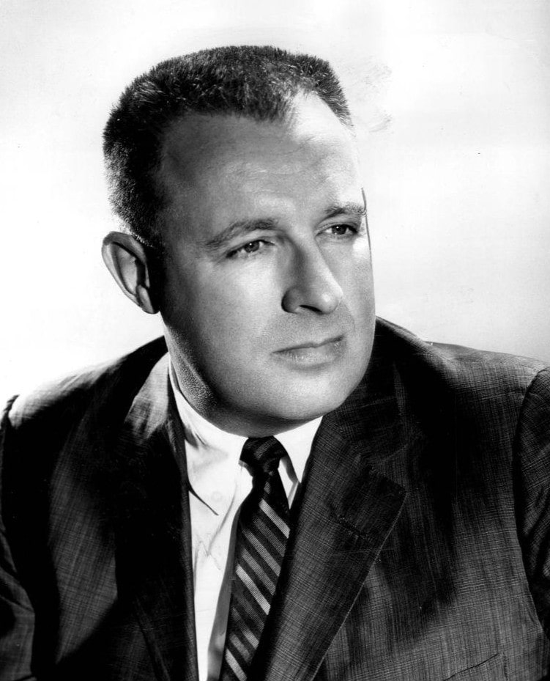

A Wild Night in Galway, Ray Bradbury

A Wild Night in Galway

We were far out at the tip of ireland, in Galway, where the weather strikes from its bleak quarters in the Atlantic with sheets of rain and gusts of cold and still more sheets of rain. You go to bed sad and wake in the middle of the night thinking you heard someone cry, thinking you yourself were weeping, and feel your face and find it dry. Then you look at the window and turn over, sadder still, and fumble about for your dripping sleep and try to get it back on.

We were out, as I said, in Galway, which is gray stone with green beards on it, a rock town, and the sea coming in and the rain falling down; and we had been there a month solid working with our film director on a script which was, with immense irony, to be shot in the warm yellow sun of Mexico sometime in January.

The pages of the script were full of fiery bulls and hot tropical flowers and burning eyes, and I typed it with chopped-off frozen fingers in my gray hotel room where the food was criminal’s gruel and the weather a beast at the window.

On the thirty-first night, a knock at the door, at seven. The door opened, my film director stepped nervously in.

“Let’s get the hell out and find some wild life in Ireland and forget this damn rain,” he said, all in a rush.

“What rain?” I said, sucking my fingers to get the ice out. “The concussion here under the roof is so steady I’m shellshocked and have quite forgot the stuff’s coming down!”

“Four weeks here and you’re talking Irish,” said the director.

“Hand me my clay pipe,” I said. And we ran from the room.

“Where?” said I.

“Heber Finn’s pub,” said he.

And we blew along the stony street in the dark that rocked gently as a boat on the black flood because of the tilty-dancing streetlights above which made the shadows tear and fly, uneasy.

Then, sweating rain, faces pearled, we struck through the pub doors, and it was warm as a sheepfold because there were the townsmen pressed in a great compost heap at the bar and Heber Finn yelling jokes and foaming up drinks.

“Heber Finn,” cried the director, “we’re here for a wild night!”

“A wild night we’ll make it,” said Heber Finn, and in a moment a slug of poteen was burning lace patterns in our stomachs, to let new light in.

I exhaled fire. “That’s a start,” I said.

We had another and listened to the rollicking jests and the jokes that were less than half clean, or so we guessed, for the brogue made it difficult, and the whiskey poured on the brogue and thus combined made it double-difficult.

But we knew when to laugh, because when a joke was finished the men hit their knees and then hit us. They’d give their limbs a great smack and then bang us on the arm or thump us in the chest.

As our breath exploded, we’d shape the explosion to hilarity and squeeze our eyes tight. Tears ran down our cheeks not from joy but from the exquisite torture of the drink scalding our throats. Thus pressed like shy flowers in a huge warm-moldy book, the director and I lingered on, waiting for some vast event.

At last my director’s patience thinned. “Heber Finn,” he called across the seethe, “it’s been wild so far, all right, but we want it wilder, I mean, the biggest night Ireland ever saw!”

Whereupon Heber Finn whipped off his apron, shrugged his meat-cleaver shoulders into a tweed coat, jumped up in the air, slid down inside his raincoat, slung on his beardy cap, and thrust us at the door.

“Nail everything down till I get back,” he advised his crew. “I’m taking these gents to the damnedest evening ever. Little do they know what waits for them out there.”

He opened the door and pointed. The wind threw half a ton of ice water on him. Taking this as no more than an additional spur to rhetoric, Heber Finn, not wiping his face, added in a roar, “Out with you! On! Here we go!”

“Do you think we should?” I said, doubtful now that things seemed really on the move.

“What do you mean?” cried the director. “What do you want to do? Go freeze in your room? Rewrite that scene you did so lousily today?”

“No, no,” I said, and slung on my own cap.

I was first outside thinking, I’ve a wife and three loud but lovely children, what am I doing here, eight thousand miles gone from them, on the dark side of God’s remembrance? Do I really want to do this?

Then, like Ahab, I thought on my bed, a damp box with its pale cool winding-sheets and the window dripping next to it like a conscience: all night through. I groaned. I opened the door of Heber Finn’s car, took my legs apart to get in, and we shot down the town like a ball in a bowling alley.

Heber Finn at the wheel talked fierce, half hilarity, half sobering King Lear.

“A wild night, is it? You’ll have the grandest night ever,” he said. “You’d never guess, would you, to walk through Ireland, so much could go on under the skin?”

“I knew there must be an outlet somewhere,” I yelled.

The speedometer was up to fifty miles an hour. Stone walls raced by on the right, stone walls raced by on the left. It was raining the entire dark sky down on the entire dark land.

“Outlet indeed!” said Heber Finn. “If the Church knew, but it don’t! Or then maybe it does, but figures—the poor craythurs—and lets us be!”

“Where, what—?”

“You’ll see!” said Heber Finn.

The speedometer read sixty. My stomach was stone like the stone walls rushing left and right. Does the car have brakes? I wondered. Death on an Irish road, I thought, a wreck, and before anyone found us strewn we’d melt away in the pounding rain and be part of the turf by morn. What’s death anyway? Better than hotel food.

“Can’t we go a bit faster?” I asked.

“It’s done,” said Heber Finn, and made it seventy.

“That will do it, nicely,” I said in a faint voice, wondering what lay ahead. Behind all the slate-stone weeping walls of Ireland, what happened? Beneath the rain-drenched sod, the flinty rock, at the numbed core of living, was there one small seed of fire which, fanned, might break volcanoes free and boil the rains to steam?

Was there then somewhere a Baghdad harem, nests awriggle and aslither with silk and tassel the absolutely perfect tint of women unadorned? Somewhere in this drizzling land were there hearth-fleshed peach-fuzz Renoir ladies bright as lamps you could hold your hands out to and warm your palms? We passed a church. No. We passed a convent. No. We passed a village slouched under its old men’s thatch. No. Stone walls to left. Stone walls to right. No. Yet . . .

I glanced over at Heber Finn. We could have switched off our lights and driven by the steady piercing beams of his forward-directed eyes snatching at the dark, flicking away the rain.

Wife, I thought to myself, children, forgive me for what I do this night, terrible as it might be, for this is Ireland in the rain of an ungodly time and way out in Galway where the dead must go to die.

The brakes were hit. We slid a good ninety feet, my nose mashed on the windscreen. Heber Finn was out of the car.

“We’re here.” He sounded like a man drowning deep in the rain.

I looked left. Stone walls. I looked right. Stone walls.

“Where is it?” I shouted.

“Where, indeed.” He pointed, mysteriously. “There.”

I saw a hole in the wall, a tiny gate flung wide.

The director and I followed at a plunge. We saw other cars in the dark now, and many bikes. But not a light anywhere. A secret, I thought, oh, it must be wild to be this secret. What am I doing here? I yanked my cap lower. Rain crawled down my neck.

Through the hole in the wall we stumbled, Heber Finn clenching our elbows. “Here,” he husked, “stand here. It’ll be a moment. Swig on this to keep your blood high.”

I felt a flask knock my fingers. I got the fire into my boilers and let the steam up the flues.

“It’s a lovely rain,” I said.

“The man’s mad,” said Heber Finn, and drank after the director, a shadow among shadows in the dark.

I squinted about. I had an impression of a midnight sea upon which men like little boats passed on the murmurous tides. Heads down, muttering, in twos and threes, a hundred men stirred out beyond.

It has an unholy air—Good God, what’s it all about? I asked myself, incredibly curious now.

“Heber Finn—?” said the director.

“Wait,” whispered Heber Finn. “This is it!”

What did I expect? Perhaps some scene like those old movies where innocent sailing ships suddenly flap down cabin walls and guns appear like magic to fire on the foe. Or a farmhouse falls apart like a cereal box, Long Tom rears up to blast a projectile five hundred miles to target Paris.

So here, maybe, I thought, the stones will spill away each from the others, the walls of that house will curtain back, rosy lights will flash forth, and from a monstrous cannon six, a dozen, ten dozen pink pearly women, not dwarf-Irish but willowy-French, will be shot out over the heads and down into the waving arms of the grateful multitude. Benison indeed! What’s more—manna!

The lights came on. I blinked.

For I saw the entire unholy thing. There it was, laid out for me under the drizzling rain.

The lights came on. The men quickened, turned, gathered, us with them.

A mechanical rabbit popped out of a little box at the far end of the stony yard and ran. Eight dogs, let free from gates, yelping, ran after in a great circle. There was not one shout or murmur from the crowd of men. Their heads turned slowly, watching.

The rain rained down on the illuminated scene. The rain fell upon tweed caps and thin cloth coats. The rain dripped off thick eyebrows and thin noses. The rain beat on hunched shoulders. I stared. The rabbit ran. The dogs ran. At the finish, the rabbit popped into its electric hatch. The dogs collided into each other, barking. The lights went out.

In the dark, I turned to stare at the director as I knew he must be turning to stare at me.

I was thankful for the dark, the rain, so Heber Finn could not see our faces.

“Come on, now,” he shouted, “place your bets!”

We were back in Galway, speeding, at ten o’clock. The rain was still raining, the wind was still blowing. The highway was a river working to erase the stone beneath as we drew up in a great tidal spray before my hotel.

“Well, now,” said Heber Finn, not looking at us, but at the windscreen wiper beating, palpitating there. “Well.”

The director and I had bet on five races and had lost between us two or three pounds. It worried Heber Finn.

“I won a great deal,” he said, “and some of it I put down in your names. That last race, I swear to God, I bet and won for all of us. Let me pay you.”

“No, Heber Finn, thanks,” I said, my numb lips moving.

He took my hand and pressed two shillings into it. I didn’t fight him. “That’s better,” he said.

Wringing out his cap in the hotel lobby my director looked at me and said, “It was a wild Irish night, wasn’t it?”

“A wild night,” I said. He left.

I hated to go up to my room. So I sat for another hour in the reading lounge of the damp hotel and took the traveler’s privilege, a glass and a bottle provided by the dazed hall porter.

I sat alone, listening to the rain and the rain on the cold hotel roof, thinking of Ahab’s coffin-bed waiting for me up there under the drumbeat weather.

I thought of the only warm thing in the hotel, in the town, in all the land of Eire this night, the script in my typewriter this moment, with its sun of Mexico, its hot winds blowing from the Pacific, its mellow papayas, its yellow lemons, its fiery sand, and its women with dark charcoal-burning eyes.

And I thought of the darkness beyond the town, the light flashing on, the electric rabbit running, the dogs running, and the rabbit gone, and the light going out, and the rain falling down on the dank shoulders and the soaked caps, and trickling off the noses and seeping through the tweeds.

Going upstairs I glanced through a streaming window. There, riding by under a streetlight, was a man on a bicycle. He was terribly drunk, for the bike weaved back and forth across the road. He kept pumping on unsteadily, blearily. I watched him ride off into the raining dark.

Then I went on up to die in my room.

The End