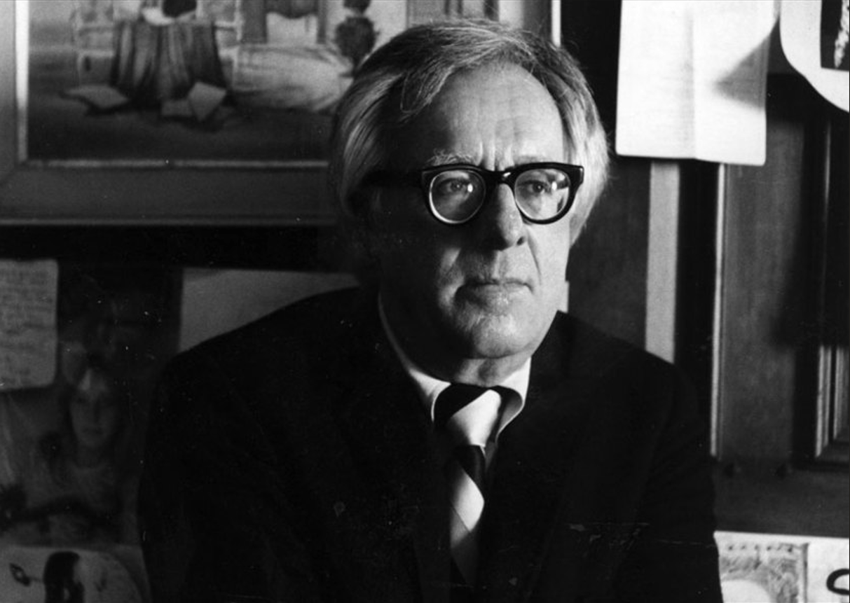

All on a Summer’s Night, Ray Bradbury

All on a Summer’s Night

“You’re getting too big for this!” Grandpa gave Doug a toss toward the blazing chandelier. The boarders sat laughing, with knives and forks at hand.

Then Doug, ten years old, was caught and popped in his chair and Grandma tapped his bowl with a steaming spoonful of soup.

The crackers crunched like snow when he bit them. The cracker salt glittered like tiny diamonds.

And there, at the far end of the table, with her gray eyes always down to watch her hand stir her coffee with a spoon or break her gingerbread and lay on the butter, was Miss Leonora Welkes, with whom men never sat on backyard swings or walked through the town ravine on summer nights.

There was Miss Leonora whose eyes watched out the window as summer couples drifted by on the darkening sidewalks night after night, and Douglas felt his heart squeeze tight.

“Evening, Miss Leonora,” he called.

“Evening, Douglas.” She looked up past the steaming mounds of food, and the boarders turned their heads a moment before bowing again to their rituals.

Oh, Miss Welkes, he thought, Miss Welkes! And he wanted to stab every man at the table with a silver fork for not blinking their eyes at Miss Welkes when she asked for the butter.

They always handed her things to their right, while still conversing with people on their left. The chandelier drew more attention than Miss Welkes. Isn’t it pretty? they said. Look at it sparkle! They cried.

But they did not know Miss Welkes as he knew her. There were as many facets to her as any chandelier, and if you went about it right she could be set laughing, and it was like stirring the Chinese hanging crystals in the wind on the summer night porch, all tinkling and melody.

No, Miss Welkes was cobweb and dust to them, and Douglas almost died in his chair, fastening his eyes upon her all through the soup and salad.

Now the three young ladies came laughing down the stairs, late, like a troupe of orioles. They always came last to the table, as if they were actresses making entrance through the frayed blue-velvet portieres.

They would hold each other by the shoulders, looking into each other’s faces, telling themselves if their cheeks were pink enough or their hair ringed up tight, or their eyelashes dyed with spit-and-color enough; then they would pause, straighten their hems, and enter to something like applause from the male boarders.

“Evening, Tom, Jim, Bill. Evening, John, Peter!”

The five would tongue their food over into their cheeks, leap up, and draw out chairs for the young belles, everyone laughed until the chandelier cried with pain.

“Look what I got!”

“Look what I got!”

“Look at mine!”

The three ladies held up gifts which they had saved to open at table. It was the Fourth of July, and on any day of the year that was in any way special they pulled the ribbons off gifts and cried, Oh, you shouldn’t have done it! They even got gifts on Memorial Day, that was how it was.

Lincoln’s Birthday, Washington’s, Jefferson’s, Columbus Day, Friday the Thirteenth. It was quite a joke. Once they got gifts on a day that wasn’t any kind of day at all, with notes printed on them saying: JUST BECAUSE IT’S MONDAY! They talked about that particular incident for six months after.

Now there was a crisp rattling as they cut the ribbons with their fingernails which flashed red, and far away at the end of the tunnel of people sat Miss Leonora Welkes, still inching at her food, but slowing down until at last her fork came to rest and she watched the gifts exposed to the crystalline light.

“Perfume! With Old Glory on the box!”

“Bath powder, in the shape of a pinwheel!”

“Candy, done up in ten-inch salutes!”

Everyone said how nice it was.

Miss Leonora Welkes said, “Oh, how nice that is.”

A moment later, Miss Welkes said, “I’m all done. It was a fine meal.”

“Don’t you want any dessert?” asked Grandma.

“I’m choke-full.” And Miss Welkes, smiling, glided from the room.

“Smell!” cried one young lady, waving the opened perfume under the men’s noses.

“Ah!” said everyone.

Douglas hit the screen door like a bullet to a target, and before it slammed he had taken sixty-eight steps across the cool green lawn in his bare feet. Money jingled in his pocket, the remains of his firecracker savings; and quite a remains, too.

Now he thudded his bare feet on the warm summer twilight cement, across the street to press his nose on Mrs. Singer’s store window, to see the devils laid in red round rows, the torpedoes in sawdust, the ten-inch salutes that could toss your head in the trees like a football, the nine inchers that could bang a can to the sun, and the fire balloons, so rare and beautiful, like withered red, white and blue butterflies, their delicate silk wings folded, ready to be lit and gassed with warm air later and sent up into the summer night among the stars.

There were so many things to pack your pockets with, and yet as he stood there, counting the money, ten, twenty, forty, a dollar and seventy cents, precariously saved during a long year of mowing lawns and clipping hedges, he turned and looked back at Grandma’s house, at the highest room of all, up in the little green cupola, where the window was shut in the hottest weather, and the shades half drawn. Miss Welkes’ room.

In half an hour the kids would come like a summer shower, their feet raining on the pavement, their hands full of explosions, little adhesive turbans on their burned thumbs, smelling of brimstone and punk, to run him off in fairy circles where they waved the magical sparklers, tracing their names and their destinies in luminous firefly paths on the sultry evening air, making great white symbols that lingered in phosphorous after-image even if you looked down from your night bed at three in the morning, remembering what a day and what an evening it had been.

In half an hour he would be fat with treasure, breast pockets bulging with torpedoes, his money gone. But—now. He looked back and forth between the high room in Grandma’s house, and this store window full of dynamite wonders.

How many nights in winter had he gone down to the stone public library and seen Miss Welkes there with the stamp pad at her elbow and the purple ink rubber stamper in her hand, and the great book sections behind her?

“Good evening, Douglas.”

“Evening, Miss Welkes.”

“Can I help you meet some new friends, tonight?”

“Yes’m.”

“I know a man named Longfellow,” she said. Or, “I know a man named Whittier.”

And that was it. It wasn’t so much Miss Welkes herself, it was the people she knew. On autumn nights when, for no reason, the library might be empty for hours on end, she would say, “Let me bring out Mr. Whittier.”

And she went back among the warm stacks of books, and returned to sit under the green glass shade, opening the book to meet the season, while Douglas sat on a stool looking up as her lips moved and, half of the time, she didn’t even glance at the words but could look away or close her eyes while she recited the poem about the pumpkin:

Oh—fruit loved of childhood—the old days recalling,

When wood grapes were purpling and brown nuts were falling!

When wild ugly faces we carved in its skin,

Glaring out through the dark with a candle within!

And Douglas would walk home, tall and enchanted.

Or on silver winter evenings when he and the wind blew wide the library door and dust stirred on the farthest counters and magazines turned their pages unaided in the vast empty rooms, then what more particularly apt than a good friend of Miss Welkes?

Mr. Robert Frost, what a name for winter! His poem about stopping by the woods on a winter evening to watch the woods fill up with snow.. . . .

And in the summer, only last night, Mr. Whittier again, on a hot night in July that kept the people at home lying on their porches, the library like a great bread oven; there, under the green grass lamp:

Blessings on thee, little man,

Barefoot boy with cheeks of tan . . .

Every morn shall lead thee through,

Fresh baptisms of the dew!

And Miss Welkes’ face there, an oval, with her cobweb graying hair and her plainness, would be enchanted, color risen to her cheeks, and wetness to her lips, and the light from the reflection on the book pages shining her eyes and coloring her hair to a brightness!

In winter, he trudged home through icelands of magic, in summer through bakery winds of sorcery; the seasons given substance by the readings of Miss Welkes who knew so many people and introduced them, in due time to Douglas. Mr. Poe and Mr. Sandburg and Miss Amy Lowell and Mr. Shakespeare.

The screen door opened under his hand.

“Mrs. Singer,” he said, “have you got any perfume?”

The gift lay at the top of the stairs, tilted against her door. Supper had been early, over at six o’clock. There was the warm lull now before the extravagant evening. Downstairs, you could hear the tinkling of plates lifted to their kitchen wall racks.

Douglas, at the furthest bend of the stairs, half hid in the attic door shadows, waited for Miss Welkes to twist her brass doorknob, waited to see the gift drop at her feet, unsigned, anonymous, sparkling with tape and gold stars.

At last, the door opened. The gift fell.

Miss Welkes looked down at it as if she was standing on the edge of a cliff she had never guessed was there before. She looked in all directions, slowly, and bent to pick it up. She didn’t open it, but stood in the doorway, holding the gift in her hands, for a long time. He heard her move inside and set the gift on a table. But there was no rattle of paper.

She was looking at the gift, the wrapping, the tape, the stars, and not touching it.

“Oh, Miss Welkes, Miss Welkes!” he wanted to cry.

Half an hour later, there she was, on the front porch, seated with her neat hands folded, and watching the door. It was the summer evening ritual, the people on the porches, in the swings, on the figured pillows, the women talking and sewing, the men smoking, the children in idle groupings on the steps.

But this was early, the town porches still simmering from the day, the echoes only temporarily allayed, the civil war of Independence Afternoon muffled for an hour in the sounds of poured lemonade and scraped dishes.

But here, the only person on the street porches, alone, was Miss Eleanora Welkes, her face pink instead of gray, flushed, her eyes watching the door, her body tensed forward. Douglas saw her from the tree where he hung in silent vigilance.

He did not say hello, she did not see him there, and the hour passed into deeper twilight. Within the house the sounds of preparation grew intense and furious.

Phones rang, feet ran up and down the avalanche of stairs, the three belles giggled, bath doors slammed, and then out and down the front steps went the three young ladies, one at a time, a man on her arm. Each time the door swung, Miss Welkes would lean forward, smiling wildly.

And each time she sank back as the girls appeared in floaty green dresses and blew away like thistle down the darkening avenues, laughing up at the men.

That left only Mr. Britz and Mr. Jerrick, who lived upstairs across from Miss Welkes. You could hear them whistling idly at their mirrors, and through the open windows you could see them finger their ties.

Miss Welkes leaned over the porch geraniums to peer up at their windows, her heart pumping in her face, it seemed, making it heart-shaped and colorful. She was looking for the man who had left the gift.

And then Douglas smelled the odor. He almost fell from the tree.

Miss Welkes had tapped her ears and neck with drops of perfume, many, many bright drops of Summer Night Odor, 97 cents a bottle! And she was sitting where the warm wind might blow this scent to whoever stepped out upon the porch. This would be her way of saying, I got your gift! Well?

“It was me, Miss Welkes!” screamed Douglas, silently, and hung in the tree, cold as ice.

“Good evening, Mr. Jerrick,” said Miss Welkes, half rising.

“Evening.” Mr. Jerrick sniffed in the doorway and looked at her. “Have a nice evening.” He went whistling down the steps.

That left only Mr. Britz, with his straw hat cocked over one eye, humming.

“Here I am,” said Miss Welkes, rising, certain that this must be the man, the last one in the house.

“There you are,” said Mr. Britz, blinking. “Hey, you smell good. I never knew you used scent.” He leered at her.

“Someone gave me a gift.”

“Well, that’s fine.” And Mr. Britz did a little dance going down the porch steps, his cane jauntily flung over his shoulder. “See you later, Miss W.” He marched off.

Miss Welkes sat, and Douglas hung in the cooling tree. The kitchen sounds were fading. In a moment, Grandma would come out, bringing her pillow and a bottle of mosquito oil.

Grandpa would cut the end off a long stogie and puff it to kill his own particular insects, and the aunts and uncles would arrive for the Independence Evening Event at the Spaulding House, the Festival of Fire, the shooting stars, the Roman Candles so diligently held by Grandpa, looking like Julius Caesar gone to flesh, standing with great dignity on the dark summer lawn, directing the setting off of fountains of red fire, and pinwheels of sizzle and smoke, while everyone, as if to the order of some celestial doctor, opened their mouths and said Ah! their faces burned into quick colors by blue, red, yellow, white flashes of sky bomb among the cloudy stars.

The house windows would jingle with concussion. And Miss Welkes would sit among the strange people, the scent of perfume evaporating during the evening hours, until it was gone, and only the sad, wet smell of punk and sulfur would remain.

The children screamed by on the dim street now, calling for Douglas, but, hidden, he did not answer. He felt in his pocket for the remaining dollar and fifty cents. The children ran away into the night.

Douglas swung and dropped. He stood by the porch steps.

“Miss Welkes?”

She glanced up. “Yes?”

Now that the time had come he was afraid. Suppose she refused, suppose she was embarrassed and ran up to lock her door and never came out again?

“Tonight,” he said, “there’s a swell show at the Elite Theater. Harold Lloyd in WELCOME, DANGER. The show starts at eight o’clock, and afterward we’ll have a chocolate sundae at the Midnight Drug Store, open until eleven forty-five. I’ll go change clothes.”

She looked down at him and didn’t speak. Then she opened the door and went up the stairs.

“Miss Welkes!” he cried.

“It’s all right,” she said. “Run and put your shoes on!”

It was seven thirty, the porch filling with people, when Douglas emerged, in his dark suit, with a blue tie, his hair wet with water, and his feet in the hot tight shoes.

“Why, Douglas!” the aunts and uncles and Grandma and Grandpa cried, “Aren’t you staying for the fireworks?”

“No.” And he looked at the fireworks laid out so beautifully crisp and smelling of powder, the pinwheels and sky bombs, and the Fire Balloons, three of them, folded like moths in their tissue wings, those balloons he loved most dearly of all, for they were like a summer night dream going up quietly, breathlessly on the still high air, away and away to far lands, glowing and breathing light as long as you could see them. Yes, the Fire Balloons, those especially would he miss, while seated in the Elite Theater tonight.

There was a whisper, the screen door stood wide, and there was Miss Welkes.

“Good evening, Mr. Spaulding,” she said to Douglas.

“Good evening, Miss Welkes,” he said.

She was dressed in a gray suit no one had seen ever before, neat and fresh, with her hair up under a summer straw hat, and standing there in the dim porch light she was like the carved goddess on the great marble library clock come to life.

“Shall we go, Mr. Spaulding?” and Douglas walked her down the steps.

“Have a good time!” said everyone.

“Douglas!” called Grandfather.

“Yes, sir?”

“Douglas,” said Grandfather, after a pause, holding his cigar in his hand. “I’m saving one of the Fire Balloons. I’ll be up when you come home. We’ll light her together and send her up. How’s that sound, eh?”

“Swell!” said Douglas.

“Good night, boy.” Grandpa waved him quietly on.

“Good night, sir.”

He took Miss Eleanora Welkes down the street, over the sidewalks of the summer evening, and they talked about Mr. Longfellow and Mr. Whittier and Mr. Poe all the way to the Elite Theater . . .

The End