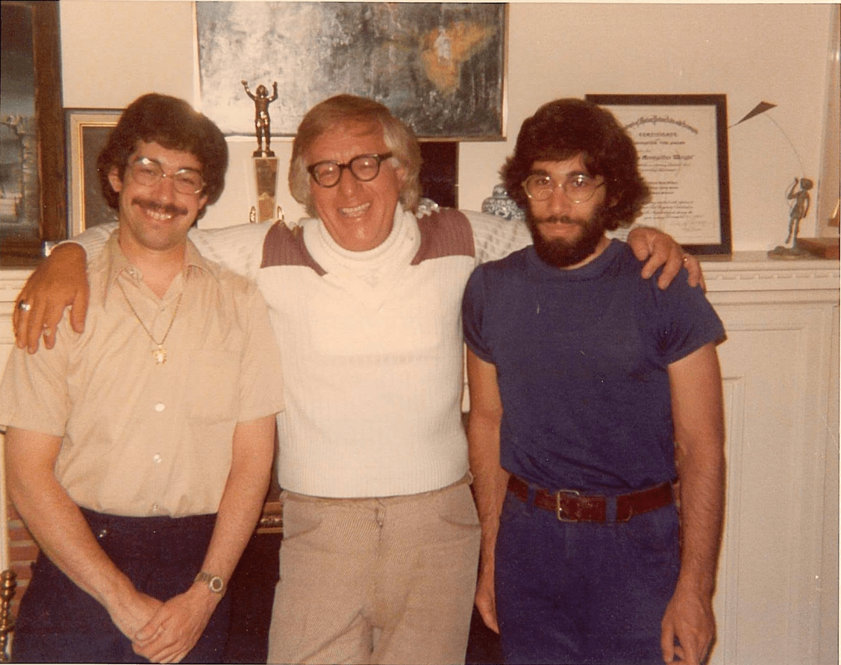

April 2026: The Long Years, Ray Bradbury

April 2026: The Long Years

Whenever the wind came through the sky, he and his small family would sit in the stone hut and warm their hands over a wood fire. The wind would stir the canal waters and almost blow the stars out of the sky, but Mr. Hathaway would sit contented and talk to his wife, and his wife would reply, and he would speak to his two daughters and his son about the old days on Earth, and they would all answer neatly.

It was the twentieth year after the Great War. Mars was a tomb planet. Whether or not Earth was the same was a matter for much silent debate for Hathaway and his family on the long Martian nights.

This night one of the violent Martian dust storms had come over the low Martian graveyards, blowing through ancient towns and tearing away the plastic walls of the newer, American-built city that was melting down into the sand, desolated.

The storm abated. Hathaway went out into the cleared weather to see Earth burning green on the windy sky. He put his hand up as one might reach to adjust a dimly burning globe in the ceiling of a dark room. He looked across the long-dead sea bottoms. Not another living thing on this entire planet, he thought. Just myself. And them. He looked back within the stone hut.

What was happening on Earth now? He had seen no visible sign of change in Earth’s aspect through his thirty-inch telescope. Well, he thought, I’m good for another twenty years if I’m careful. Someone might come. Either across the dead seas or out of space in a rocket on a little thread of red flame.

He called into the hut, “I’m going to take a walk.”

“All right,” his wife said.

He moved quietly down through a series of ruins. “Made in New York,” he read from a piece of metal as he passed. “And all these things from Earth will be gone long before the old Martian towns.” He looked toward the fifty-centuries-old village that lay among the blue mountains.

He came to a solitary Martian graveyard, a series of small hexagonal stones on a hill swept by the lonely wind.

He stood looking down at four graves with crude wooden crosses on them, and names. Tears did not come to his eyes. They had dried long ago.

“Do you forgive me for what I’ve done?” he asked of the crosses. “I was very much alone. You do understand, don’t you?”

He returned to the stone hut and once more, just before going in, shaded his eyes, searching the black sky.

“You keep waiting and waiting and looking,” he said, “and one night, perhaps—”

There was a tiny red flame on the sky.

He stepped away from the light of the hut.

“—and you look again,” he whispered.

The tiny red flame was still there.

“It wasn’t there last night,” he whispered.

He stumbled and fell, picked himself up, ran behind the hut, swiveled the telescope, and pointed it at the sky.

A minute later, after a long, wild staring, he appeared in the low door of the hut. The wife and the two daughters and the son turned their heads to him. Finally he was able to speak.

“I have good news,” he said. “I have looked at the sky. A rocket is coming to take us all home. It will be here in the early morning.”

He put his hands down and put his head into his hands and began to cry gently.

He burned what was left of New New York that morning at three.

He took a torch and moved into the plastic city and with the flame touched the walls here or there. The city bloomed up in great tosses of heat and light. It was a square mile of illumination, big enough to be seen out in space. It would beckon the rocket down to Mr. Hathaway and his family.

His heartbeating rapidly with pain, he returned to the hut. “See?” He held up a dusty bottle into the light. “Wine I saved, just for tonight. I knew that someday someone would find us! We’ll have a drink to celebrate!”

He poured five glasses full.

“It’s been a long time,” he said, gravely looking into his drink. “Remember the day the war broke? Twenty years and seven months ago. And all the rockets were called home from Mars. And you and I and the children were out in the mountains, doing archaeological work, research on the ancient surgical methods of the Martians.

We ran our horses, almost killing them, remember? But we got here to the city a week late. Everyone was gone. America had been destroyed; every rocket had left without waiting for stragglers, remember, remember?

And it turned out we were the only ones left? Lord, Lord, how the years pass. I couldn’t have stood it without you here, all of you. I’d have killed myself without you. But with you, it was worth waiting. Here’s to us, then.” He lifted his glass. “And to our long wait together.” He drank.

The wife and the two daughters and the son raised their glasses to their lips.

The wine ran down over the chins of all four of them.

By morning the city was blowing in great black soft flakes across the sea bottom. The fire was exhausted, but it had served its purpose; the red spot on the sky grew larger.

From the stone hut came the rich brown smell of baked gingerbread. His wife stood over the table, setting down the hot pans of new bread as Hathaway entered. The two daughters were gently sweeping the bare stone floor with stiff brooms, and the son was polishing the silverware.

“We’ll have a huge breakfast for them,” laughed Hathaway. “Put on your best clothes!”

He hurried across his land to the vast metal storage shed. Inside was the cold-storage unit and power plant he had repaired and restored with his efficient, small, nervous fingers over the years, just as he had repaired clocks, telephones, and spool recorders in his spare time. The shed was full of things he had built, some senseless mechanisms the functions of which were a mystery even to himself now as he looked upon them.

From the deep freeze he fetched rimed cartons of beans and strawberries, twenty years old. Lazarus come forth, he thought, and pulled out a cool chicken.

The air was full of cooking odors when the rocket landed.

Like a boy, Hathaway raced down the hill. He stopped once because of a sudden sick pain in his chest. He sat on a rock to regain his breath, then ran all the rest of the way.

He stood in the hot atmosphere generated by the fiery rocket. A port opened. A man looked down.

Hathaway shielded his eyes and at last said, “Captain Wilder!”

“Who is it?” asked Captain Wilder, and jumped down and stood there looking at the old man. He put his hand out. “Good lord, it’s Hathaway!”

“That’s right.” They looked into each other’s faces.

“Hathaway, from my old crew, from the Fourth Expedition.”

“It’s been a long time, Captain.”

“Too long. It’s good to see you.”

“I’m old,” said Hathaway simply.

“I’m not young myself anymore. I’ve been out to Jupiter and Saturn and Neptune for twenty years.”

“I heard they had kicked you upstairs so you wouldn’t interfere with colonial policy here on Mars.” The old man looked around. “You’ve been gone so long you don’t know what’s happened—”

Wilder said, “I can guess. We’ve circled Mars twice.

Found only one other man, name of Walter Gripp, about ten thousand miles from here. We offered to take him with us, but he said no. The last we saw of him he was sitting in the middle of the highway in a rocking chair, smoking a pipe, waving to us. Mars is pretty well dead, not even a Martian alive. What about Earth?”

“You know as much as I do. Once in a while I get the Earth radio, very faintly. But it’s always in some other language. I’m sorry to say I only know Latin. A few words come through. I take it most of Earth’s a shambles, but the war goes on. Are you going back, sir?”

“Yes. We’re curious, of course. We had no radio contact so far out in space. We’ll want to see Earth, no matter what.”

“You’ll take us with you?”

The captain started. “Of course, your wife, I remember her. Twenty-five years ago, wasn’t it? When they opened First Town and you quit the service and brought her up here. And there were children—”

“My son and two daughters.”

“Yes, I remember. They’re here?”

“Up at our hut. There’s a fine breakfast waiting all of you up the hill. Will you come?”

“We would be honored, Mr. Hathaway.” Captain Wilder called to the rocket, “Abandon ship!”

They walked up the hill, Hathaway and Captain Wilder, the twenty crew members following, taking deep breaths of the thin, cool morning air. The sun rose and it was a good day.

“Do you remember Spender, Captain?”

“I’ve never forgotten him.”

“About once a year I walk up past his tomb. It looks like he got his way at last. He didn’t want us to come here, and I suppose he’s happy now that we’ve all gone away.”

“What about—what was his name?—Parkhill, Sam Parkhill?”

“He opened a hot-dog stand.”

“It sounds just like him.”

“And went back to Earth the next week for the war.” Hathaway put his hand to his chest and sat down abruptly upon a boulder. “I’m sorry. The excitement. Seeing you again after all these years. Have to rest.” He felt his heart pound. He counted the beats. It was very bad.

“We’ve a doctor,” said Wilder. “Excuse me, Hathaway, I know you are one, but we’d better check you with our own—” The doctor was summoned.

“I’ll be all right,” insisted Hathaway. “The waiting, the excitement.” He could hardly breathe. His lips were blue. “You know,” he said as the doctor placed a stethoscope to him, “it’s as if I kept alive all these years just for this day, and now you’re here to take me back to Earth, I’m satisfied and I can just lie down and quit.”

“Here.” The doctor handed him a yellow pellet. “We’d better let you rest.”

“Nonsense. Just let me sit a moment. It’s good to see all of you. Good to hear new voices again.”

“Is the pellet working?”

“Fine. Here we go!”

They walked on up the hill.

“Alice, come see who’s here!”

Hathaway frowned and bent into the hut. “Alice, did you hear?”

His wife appeared. A moment later the two daughters, tall and gracious, came out, followed by an even taller son.

“Alice, you remember Captain Wilder?”

She hesitated and looked at Hathaway as if for instructions and then smiled. “Of course, Captain Wilder!”

“I remember, we had dinner together the night before I took off for Jupiter, Mrs. Hathaway.”

She shook his hand vigorously. “My daughters, Marguerite and Susan. My son, John. You remember the captain, surely?”

Hands were shaken amid laughter and much talk.

Captain Wilder sniffed the air. “Is that gingerbread?”

“Will you have some?”

Everyone moved. Folding tables were hurried out while hot foods were rushed forth and plates and fine damask napkins and good silverware were laid. Captain Wilder stood looking first at Mrs. Hathaway and then at her son and her two tall, quiet-moving daughters.

He looked into their faces as they darted past and he followed every move of their youthful hands and every expression of their wrinkleless faces. He sat upon a chair the son brought. “How old are you, John?”

The son replied, “Twenty-three.”

Wilder shifted his silverware clumsily. His face was suddenly pale. The man next to him whispered, “Captain Wilder, that can’t be right.”

The son moved away to bring more chairs.

“What’s that, Williamson?”

“I’m forty-three myself, Captain. I was in school the same time as young John Hathaway there, twenty years ago. He says he’s only twenty-three now; he only looks twenty-three. But that’s wrong. He should be forty-two, at least. What’s it mean, sir?”

“I don’t know.”

“You look kind of sick, sir.”

“I don’t feel well. The daughters, too, I saw them twenty years or so ago; they haven’t changed, not a wrinkle. Will you do me a favor? I want you to run an errand, Williamson. I’ll tell you where to go and what to check. Late in the breakfast, slip away. It should take you only ten minutes. The place isn’t far from here. I saw it from the rocket as we landed.”

“Here! What are you talking about so seriously?” Mrs. Hathaway ladled quick spoons of soup into their bowls. “Smile now; we’re all together, the trip’s over, and it’s like home!”

“Yes.” Captain Wilder laughed. “You certainly look very well and young, Mrs. Hathaway!”

“Isn’t that like a man!”

He watched her drift away, drift with her pink face warm, smooth as an apple, unwrinkled and colorful. She chimed her laugh at every joke, she tossed salads neatly, never once pausing for breath.

And the bony son and curved daughters were brilliantly witty, like their father, telling of the long years and their secret life, while their father nodded proudly to each.

Williamson slipped off down the hill.

“Where’s he going?” asked Hathaway.

“Checking the rocket,” said Wilder. “But, as I was saying, Hathaway, there’s nothing on Jupiter, nothing at all for men. That includes Saturn and Pluto.” Wilder talked mechanically, not hearing his words, thinking only of Williamson running down the hill and climbing back to tell what he had found.

“Thanks.” Marguerite Hathaway was filling his water glass. Impulsively he touched her arm. She did not even mind. Her flesh was warm and soft.

Hathaway, across the table, paused several times, touched his chest with his fingers, painfully, then went on listening to the murmuring talk and sudden loud chattering, glancing now and again with concern at Wilder, who did not seem to like chewing his gingerbread.

Williamson returned. He sat picking at his food until the captain whispered aside to him, “Well?”

“I found it, sir.”

“And?”

Williamson’s cheeks were white. He kept his eyes on the laughing people. The daughters were smiling gravely and the son was telling a joke. Williamson said, “I went into the graveyard.”

“The four crosses were there?”

“The four crosses were there, sir. The names were still on them. I wrote them down to be sure.” He read from a white paper: “Alice, Marguerite, Susan, and John Hathaway. Died of unknown virus. July 2007.”

“Thank you, Williamson.” Wilder closed his eyes.

“Nineteen years ago, sir.” Williamson’s hand trembled.

“Yes.”

“Then who are these!”

“I don’t know.”

“What are you going to do?”

“I don’t know that either.”

“Will we tell the other men?”

“Later. Go on with your food as if nothing happened.”

“I’m not very hungry now, sir.”

The meal ended with wine brought from the rocket. Hathaway arose. “A toast to all of you; it’s good to be with friends again. And to my wife and children, without whom I couldn’t have survived alone.

It is only through their kindness in caring for me that I’ve lived on, waiting for your arrival.” He moved his wineglass toward his family, who looked back self-consciously, lowering their eyes at last as everyone drank.

Hathaway drank down his wine. He did not cry out as he fell forward onto the table and slipped to the ground. Several men eased him to rest. The doctor bent to him and listened. Wilder touched the doctor’s shoulder. The doctor looked up and shook his head. Wilder knelt and took the old man’s hand. “Wilder?” Hathaway’s voice was barely audible. “I spoiled the breakfast.”

“Nonsense.”

“Say good-bye to Alice and the children for me.”

“Just a moment, I’ll call them.”

“No, no, don’t!” gasped Hathaway. “They wouldn’t understand. I wouldn’t want them to understand! Don’t!”

Wilder did not move.

Hathaway was dead.

Wilder waited for a long time. Then he arose and walked away from the stunned group around Hathaway. He went to Alice Hathaway, looked into her face, and said, “Do you know what has just happened?”

“Something about my husband?”

“He’s just passed away; his heart,” said Wilder, watching her.

“I’m sorry,” she said.

“How do you feel?” he asked.

“He didn’t want us to feel badly. He told us it would happen one day and he didn’t want us to cry. He didn’t teach us how, you know. He didn’t want us to know. He said it was the worst thing that could happen to a man to know how to be lonely and know how to be sad and then to cry. So we’re not to know what crying is, or being sad.”

Wilder glanced at her hands, the soft warm hands and the fine manicured nails and the tapered wrists. He saw her slender, smooth white neck and her intelligent eyes. Finally he said, “Mr. Hathaway did a fine job on you and your children.”

“He would have liked to hear you say that. He was so proud of us. After a while he even forgot that he had made us. At the end he loved and took us as his real wife and children. And, in a way, we are.”

“You gave him a good deal of comfort.”

“Yes, for years on end we sat and talked. He so much loved to talk. He liked the stone hut and the open fire. We could have lived in a regular house in the town, but he liked it up here, where he could be primitive if he liked, or modern if he liked. He told me all about his laboratory and the things he did in it. He wired the entire dead American town below with sound speakers.

When he pressed a button the town lit up and made noises as if ten thousand people lived in it. There were airplane noises and car noises and the sounds of people talking. He would sit and light a cigar and talk to us, and the sounds of the town would come up to us, and once in a while the phone would ring and a recorded voice would ask Mr. Hathaway scientific and surgical questions and he would answer them.

With the phone ringing and us here and the sounds of the town and his cigar, Mr. Hathaway was quite happy. There’s only one thing he couldn’t make us do,” she said. “And that was to grow old. He got older every day, but we stayed the same. I guess he didn’t mind. I guess he wanted us this way.”

“We’ll bury him down in the yard where the other four crosses are. I think he would like that.”

She put her hand on his wrist, lightly. “I’m sure he would.”

Orders were given. The family followed the little procession down the hill. Two men carried Hathaway on a covered stretcher. They passed the stone hut and the storage shed where Hathaway, many years before, had begun his work. Wilder paused within the workshop door.

How would it be, he wondered, to live on a planet with a wife and three children and have them die, leaving you alone with the wind and silence?

What would a person do? Bury them with crosses in the graveyard and then come back up to the workshop and, with all the power of mind and memory and accuracy of finger and genius, put together, bit by bit, all those things that were wife, son, daughters. With an entire American city below from which to draw needed supplies, a brilliant man might do anything.

The sound of their footsteps was muffled in the sand. At the graveyard, as they turned in, two men were already spading out the earth.

They returned to the rocket in the late afternoon.

Williamson nodded at the stone hut. “What are we going to do about them?”

“I don’t know,” said the captain.

“Are you going to turn them off?”

“Off?” The captain looked faintly surprised. “It never entered my mind.”

“You’re not taking them back with us?”

“No, it would be useless.”

“You mean you’re going to leave them here, like that, as they are!”

The captain handed Williamson a gun. “If you can do anything about this, you’re a better man than I.”

Five minutes later Williamson returned from the hut, sweating. “Here, take your gun. I understand what you mean now. I went in the hut with the gun. One of the daughters smiled at me. So did the others. The wife offered me a cup of tea. Lord, it’d be murder!”

Wilder nodded. “There’ll never be anything as fine as them again. They’re built to last; ten, fifty, two hundred years. Yes, they’ve as much right to—to life as you or I or any of us.” He knocked out his pipe. “Well, get aboard. We’re taking off. This city’s done for, we’ll not be using it.”

It was late in the day. A cold wind was rising. The men were aboard. The captain hesitated. Williamson said, “Don’t tell me you’re going back to say—good-bye—to them?”

The captain looked at Williamson coldly. “None of your business.”

Wilder strode up toward the hut through the darkening wind. The men in the rocket saw his shadow lingering in the stone-hut doorway. They saw a woman’s shadow. They saw the captain shake her hand.

Moments later he came running back to the rocket.

On nights when the wind comes over the dead sea bottoms and through the hexagonal graveyard, over four old crosses and one new one, there is a light burning in the low stone hut, and in that hut, as the wind roars by and the dust whirls and the cold stars burn, are four figures, a woman, two daughters, a son, tending a low fire for no reason and talking and laughing.

Night after night for every year and every year, for no reason at all, the woman comes out and looks at the sky, her hands up, for a long moment, looking at the green burning of Earth, not knowing why she looks, and then she goes back and throws a stick on the fire, and the wind comes up and the dead sea goes on being dead.

The End