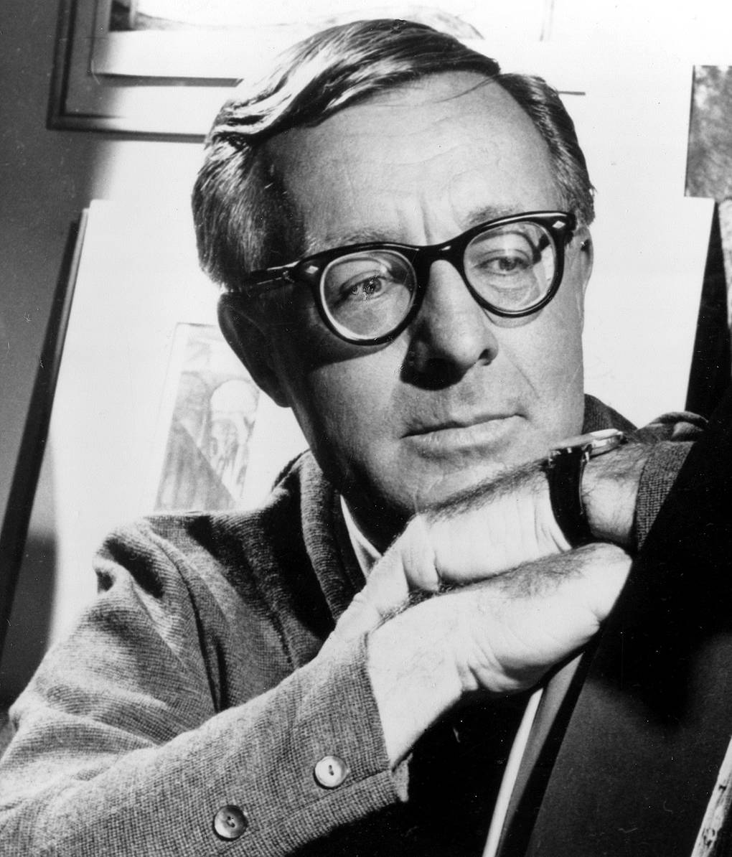

At Midnight, in the Month of June, Ray Bradbury

At Midnight, in the Month of June

He had been waiting a long, long time in the summer night, as the darkness pressed warmer to the earth and the stars turned slowly over the sky. He sat in total darkness, his hands lying easily on the arms of the Morris chair. He heard the town clock strike nine and ten and eleven, and then at last twelve.

The breeze from an open back window flowed through the midnight house in an unlit stream, that touched him like a dark rock where he sat silently watching the front door—silently watching.

At midnight, in the month of June. . . .

The cool night poem by Mr. Edgar Allan Poe slid over his mind like the waters of a shadowed creek.

The lady sleeps! Oh, may her sleep,

Which is enduring, so be deep!

He moved down the black shapeless halls of the house, stepped out of the back window, feeling the town locked away in bed, in dream, in night. He saw the shining snake of garden hose coiled resiliently in the grass.

He turned on the water. Standing alone, watering the flower bed, he imagined himself a conductor leading an orchestra that only night-strolling dogs might hear, passing on their way to nowhere with strange white smiles.

Very carefully he planted both feet and his tall weight into the mud beneath the window, making deep, well-outlined prints. He stepped inside again and walked, leaving mud, down the absolutely unseen hall, his hands seeing for him.

Through the front porch window he made out the faint outline of a lemonade glass, one-third full, sitting on the porch rail where she had left it. He trembled quietly.

Now, he could feel her coming home. He could feel her moving across town, far away, in the summer night. He shut his eyes and put his mind out to find her; and felt her moving along in the dark; he knew just where she stepped down from a curb and crossed a street, and up on a kerb and tack-tacking, tack-tacking along under the June elms and the last of the lilacs, with a friend.

Walking the empty desert of night, he was she. He felt a purse in his hands. He felt long hair prickle his neck, and his mouth turn greasy with lipstick. Sitting still, he was walking, walking, walking on home after midnight.

“Good night!”

He heard but did not hear the voices, and she was coming nearer, and now she was only a mile away and now only a matter of a thousand yards, and now she was sinking, like a beautiful white lantern on an invisible wire, down into the cricket- and frog- and water-sounding ravine. And he knew the texture of the wooden ravine stairs as if, a boy, he was rushing down them, feeling the rough grain and the dust and the leftover heat of the day. . . .

He put his hands out on the air, open. The thumbs of his hands touched, and then the fingers, so that his hands made a circle, enclosing emptiness, there before him. Then, very slowly, he squeezed his hands tighter and tighter together, his mouth open, his eyes shut.

He stopped squeezing and put his hands, trembling, back on the arms of the chair. He kept his eyes shut.

Long ago, he had climbed, one night, to the top of the courthouse tower fire escape, and looked out at the silver town, at the town of the moon, and the town of summer.

And he had seen all the dark houses with two things in them, people and sleep, the two elements joined in bed and all their tiredness and terror breathed upon the still air, siphoned back quietly, and breathed out again, until that element was purified, the problems and hatreds and horrors of the previous day exorcized long before morning and done away with forever.

He had been enchanted with the hour, and the town, and he had felt very powerful, like the magic man with the marionettes who strung destinies across a stage on spider threads.

On the very top of the courthouse tower he could see the least flicker of leaf turning in the moonlight five miles away; the last light, like a pink pumpkin eye, wink out. The town did not escape his eye—it could do nothing without his knowing its every tremble and gesture.

And so it was tonight. He felt himself a tower with the clock in it pounding slow and announcing hours in a great bronze tone, and gazing upon a town where a woman, hurried or slowed by fitful gusts and breezes now of terror and now of self-confidence, took the chalk white midnight sidewalks home, fording solid avenues of tar and stone, drifting among fresh cut lawns, and now running, running down the steps, through the ravine, up, up the hill, up the hill!

He heard her footsteps before he really heard them. He heard her gasping before there was a gasping. He fixed his gaze to the lemonade glass outside, on the banister. Then the real sound, the real running, the gasping, echoed wildly outside.

He sat up. The footsteps raced across the street, the pavement, in a panic. There was a babble, a clumsy stumble up the porch steps, a key ratcheting the door, a voice yelling in a whisper, praying to itself. “Oh, God, dear God!” Whisper! Whisper! And the woman crashing in the door, slamming it, bolting it, talking, whispering, talking to herself in the dark room.

He felt, rather than saw, her hand move toward the light switch.

He cleared his throat.

She stood against the door in the dark. If moonlight could have struck in upon her, she would have shimmered like a small pool of water on a windy night. He felt the fine sapphire jewels come out upon her face, and her face all glittering with brine.

“Lavinia,” he whispered.

Her arms were raised across the door like a crucifix. He heard her mouth open and her lungs push a warmness upon the air.

She was a beautiful dim white moth; with the sharp needle point of terror he had her pinned against the wooden door. He could walk all around the specimen, if he wished, and look at her, look at her.

“Lavinia,” he whispered.

He heard her heartbeating. She did not move.

“It’s me,” he whispered.

“Who?” she said, so faint it was a small pulse-beat in her throat.

“I won’t tell you,” he whispered. He stood perfectly straight in the center of the room. God, but he felt tall! Tall and dark and very beautiful to himself, and the way his hands were out before him was as if he might play a piano at any moment, a lovely melody, a waltzing tune.

The hands were wet, they felt as if he had dipped them into a bed of mint and cool menthol.

“If I told you who I am, you might not be afraid,” he whispered. “I want you to be afraid. Are you afraid?”

She said nothing. She breathed out and in, out and in, a small bellows which, pumped steadily, blew upon her fear and kept it going, kept it alight.

“Why did you go to the show tonight?” he whispered. “Why did you go to the show?”

No answer.

He took a step forward, heard her breath take itself, like a sword hissing in its sheath.

“Why did you come back through the ravine, alone?” he whispered. “You did come back alone, didn’t you? Did you think you’d meet me in the middle of the bridge? Why did you go to the show tonight? Why did you come back through the ravine, alone?”

“I—” she gasped.

“You,” he whispered.

“No—” she cried, in a whisper.

“Lavinia,” he said. He took another step.

“Please,” she said.

“Open the door. Get out. And run,” he whispered.

She did not move.

“Lavinia, open the door.”

She began to whimper in her throat.

“Run,” he said.

In moving he felt something touch his knee. He pushed, something tilted in space and fell over, a table, a basket, and a half-dozen unseen balls of yarn tumbled like cats in the dark, rolling softly.

In the one moonlit space on the floor beneath the window, like a metal sign pointing, lay the sewing shears. They were winter ice in his hand. He held them out to her suddenly, through the still air.

“Here,” he whispered.

He touched them to her hand. She snatched her hand back.

“Here,” he urged.

“Take this,” he said, after a pause.

He opened her fingers that were already dead and cold to the touch, and stiff and strange to manage, and he pressed the scissors into them. “Now,” he said.

He looked out at the moonlit sky for a long moment, and when he glanced back it was some time before he could see her in the dark.

“I waited,” he said. “But that’s the way it’s always been. I waited for the others, too. But they all came looking for me, finally. It was that easy. Five lovely ladies in the last two years.

I waited for them in the ravine, in the country, by the lake, everywhere I waited, and they came out to find me, and found me. It was always nice, the next day, reading the newspapers. And you went looking tonight, I know, or you wouldn’t have come back alone through the ravine.

Did you scare yourself there, and run? Did you think I was down there waiting for you? You should have heard yourself running up the walk! Through the door! And locking it! You thought you were safe inside, home at last, safe, safe, safe, didn’t you?”

She held the scissors in one dead hand, and she began to cry. He saw the merest gleam, like water upon the wall of a dim cave. He heard the sounds she made.

“No,” he whispered. “You have the scissors. Don’t cry.”

She cried. She did not move at all. She stood there, shivering, her head back against the door, beginning to slide down the length of the door toward the floor.

“Don’t cry,” he whispered.

“I don’t like to hear you cry,” he said. “I can’t stand to hear that.”

He held his hands out and moved them through the air until one of them touched her cheek. He felt the wetness of that cheek, he felt her warm breath touch his palm like a summer moth. Then he said only one more thing:

“Lavinia,” he said, gently. “Lavinia.”

How clearly he remembered the old nights in the old times, in the times when he was a boy and them all running and running, and hiding and hiding, and playing hide-and-seek.

In the first spring nights and in the warm summer nights and in the late summer evenings and in those first sharp autumn nights when doors were shutting early and porches were empty except for blowing leaves.

The game of hide-and-seek went on as long as there was sun to see by, or the rising snow-crusted moon.

Their feet upon the green lawns were like the scattered throwing of soft peaches and crab apples, and the counting of the Seeker with his arms cradling his buried head, chanting to the night: five, ten, fifteen, twenty, twenty-five, thirty, thirty-five, forty, forty-five, fifty. . . .

And the sound of thrown apples fading, the children all safely closeted in tree or bush shade, under the latticed porches with the clever dogs minding not to wag their tails and give their secret away. And the counting done: eighty-five, ninety, ninety-five, a hundred!

Ready or not, here I come!

And the Seeker running out through the town wilderness to find the Hiders, and the Hiders keeping their secret laughter in their mouths, like precious June strawberries, with the help of clasped hands.

And the Seeker seeking after the smallest heartbeat in the high elm tree or the glint of a dog’s eye in a bush, or a small water sound of laughter that could not help burst out as the Seeker ran right on by and did not see the shadow within the shadow. . . .

He moved into the bathroom of the quiet house, thinking all this, enjoying the clear rush, the tumultuous gushing of memories like a water-falling of the mind over a steep precipice, falling and falling toward the bottom of his head.

God, how secret and tall they had felt, hidden away. God, how the shadows mothered and kept them, sheathed in their own triumph. Glowing with perspiration how they crouched like idols and thought they might hide forever! While the silly Seeker went pelting by on his way to failure and inevitable frustration.

Sometimes the Seeker stopped right at your tree and peered up at you crouched there in your invisible warm wings, in your great colorless windowpane bat wings, and said, “I see you there!” But you said nothing. “You’re up there all right.” But you said nothing. “Come on down!” But not a word, only a victorious Cheshire smile.

And doubt coming over the Seeker below. “It is you, isn’t it?” The backing off and away. “Aw, I know you’re up there!” No answer. Only the tree sitting in the night and shaking quietly, leaf upon leaf. And the Seeker, afraid of the dark within darkness, loping away to seek easier game, something to be named and certain of. “All right for you!”

He washed his hands in the bathroom, and thought, Why am I washing my hands? And then the grains of time sucked back up the flue of the hourglass again and it was another year . . .

He remembered that sometimes when he played hide-and-seek they did not find him at all; he would not let them find him.

He said not a word, he stayed so long in the apple tree that he was a white-fleshed apple; he lingered so long in the chestnut tree that he had the hardness and the brown brightness of the autumn nut.

And God, how powerful to be undiscovered, how immense it made you, until your arms were branching, growing out in all directions, pulled by the stars and the tidal moon until your secretness enclosed the town and mothered it with your compassion and tolerance.

You could do anything in the shadows, anything. If you chose to do it, you could do it. How powerful to sit above the sidewalk and see people pass under, never aware you were there and watching, and might put out an arm to brush their noses with the five-legged spider of your hand and brush their thinking minds with terror.

He finished washing his hands and wiped them on a towel.

But there was always an end to the game. When the Seeker had found all the other Hiders and these Hiders in turn were Seekers and they were all spreading out, calling your name, looking for you, how much more powerful and important that made you.

“Hey, hey! Where are you! Come in, the game’s over!”

But you not moving or coming in. Even when they all collected under your tree and saw, or thought they saw you there at the very top, and called up at you. “Oh, come down! Stop fooling! Hey! We see you. We know you’re there!”

Not answering even then—not until the final, the fatal thing happened. Far off, a block away, a silver whistle screaming, and the voice of your mother calling your name, and the whistle again. “Nine o’clock!” her voice wailed. “Nine o’clock! Home!”

But you waited until all the children were gone. Then, very carefully unfolding yourself and your warmth and secretness, and keeping out of the lantern light at corners, you ran home alone, alone in darkness and shadow, hardly breathing, keeping the sound of your heart quiet and in yourself, so if people heard anything at all they might think it was only the wind blowing a dry leaf by in the night. And your mother standing there, with the screen door wide . . .

He finished wiping his hands on the towel. He stood a moment thinking of how it had been the last two years here in town. The old game going on, by himself, playing it alone, the children gone, grown into settled middle age, but now, as before, himself the final and last and only Hider, and the whole town seeking and seeing nothing and going on home to lock their doors.

But tonight, out of a time long past, and on many nights now, he had heard that old sound, the sound of the silver whistle, blowing and blowing. It was certainly not a night bird singing, for he knew each sound so well.

But the whistle kept calling and calling and a voice said, Home and Nine o’clock, even though it was now long after midnight. He listened. There was the silver whistle. Even though his mother had died many years ago, after having put his father in an early grave with her temper and her tongue.

“Do this, do that, do this, do that, do this, do that, do this, do that . . .” A phonograph record, broken, playing the same cracked turn again, again, again, her voice, her cadence, around, around, around, around, repeat, repeat, repeat.

And the clear silver whistle blowing and the game of hide-and-seek over. No more of walking in the town and standing behind trees and bushes and smiling a smile that burned through the thickest foliage. An automatic thing was happening. His feet were walking and his hands were doing and he knew everything that must be done now.

His hands did not belong to him.

He tore a button off his coat and let it drop into the deep dark well of the room. It never seemed to hit bottom. It floated down. He waited.

It seemed never to stop rolling. Finally, it stopped.

His hands did not belong to him.

He took his pipe and flung that into the depths of the room. Without waiting for it to strike emptiness, he walked quietly back through the kitchen and peered outside the open, blowing, white-curtained window at the footprints he had made there.

He was the Seeker, seeking now, instead of the Hider hiding. He was the quiet searcher finding and sifting and putting away clues, and those footprints were now as alien to him as something from a prehistoric age.

They had been made a million years ago by some other man on some other business; they were no part of him at all. He marveled at their precision and deepness and form in the moonlight. He put his hand down almost to touch them, like a great and beautiful archaeological discovery!

Then he was gone, back through the rooms, ripping a piece of material from his trousers turn-up and blowing it off his open palm like a moth.

His hands were not his hands anymore, or his body his body.

He opened the front door and went out and sat for a moment on the porch rail. He picked up the lemonade glass and drank what was left, made warm by an evening’s waiting, and pressed his fingers tight to the glass, tight, tight, very tight. Then he put the glass down on the railing.

The silver whistle!

Yes, he thought. Coming, coming.

The silver whistle!

Yes, he thought. Nine o’clock. Home, home. Nine o’clock. Studies and milk and graham crackers and white cool bed, home, home; nine o’clock and the silver whistle.

He was off the porch in an instant, running softly, lightly, with hardly a breath or a heartbeat, as one barefooted runs, as one all leaf and green June grass and night can run, all shadow, forever running, away from the silent house and across the street, and down into the ravine . . .

He pushed the door wide and stepped into the Owl Diner, this long railroad car that, removed from its track, had been put to a solitary unmoving destiny in the center of town. The place was empty.

At the far end of the counter, the counterman glanced up as the door shut and the customer walked along the line of empty swivel seats. The counterman took the toothpick from his mouth.

“Tom Dillon, you old so-and-so! What you doing up this time of night, Tom?”

Tom Dillon ordered without the menu. While the food was being prepared, he dropped a nickel in the wall phone, got his number, and spoke quietly for a time. He hung up, came back, and sat, listening. Sixty seconds later, both he and the counterman heard the police siren wail by at fifty miles an hour. “Well—hell!” said the counterman. “Go get ’em, boys!”

He set out a tall glass of milk and a plate of six fresh graham crackers.

Tom Dillon sat there for a long while, looking secretly down at his ripped trousers turn-up and muddied shoes. The light in the diner was raw and bright, and he felt as if he were on a stage.

He held the tall cool glass of milk in his hand, sipping it, eyes shut, chewing the good texture of the graham crackers, feeling it all through his mouth, coating his tongue.

“Would or would you not,” he asked, quietly, “call this a hearty meal?”

“I’d call that very hearty indeed,” said the counterman, smiling.

Tom Dillon chewed another graham cracker with great concentration, feeling all of it in his mouth. It’s just a matter of time, he thought, waiting.

“More milk?”

“Yes,” said Tom.

And he watched with steady interest, with the purest and most alert concentration in all of his life, as the white carton tilted and gleamed, and the snowy milk poured out, cool and quiet, like the sound of a running spring at night, and filled the glass up all the way, to the very brim, to the very brim, and over . . .

The End