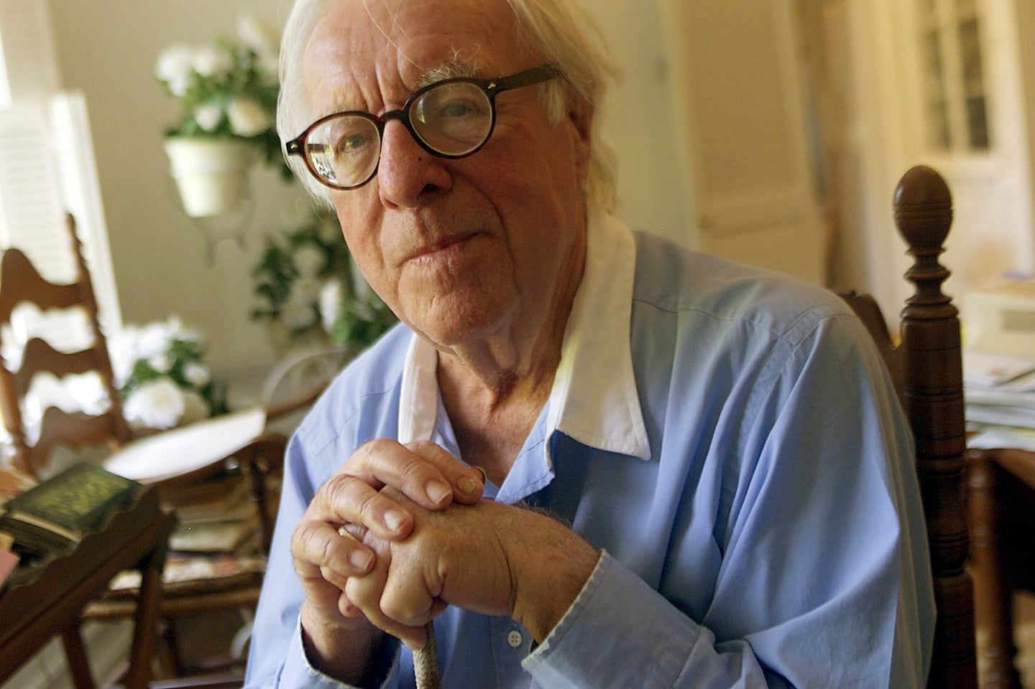

Bug, Ray Bradbury

Bug

Looking back now, i can’t remember a time when Bug wasn’t dancing. Bug is short for jitterbug and, of course, those were the days in the late thirties, our final days in high school and our first days out in the vast world looking for work that didn’t exist when jitterbugging was all the rage.

And I can remember Bug (his real name was Bert Bagley, which shortens to Bug nicely), during a jazz-band blast at our final aud-call for our high school senior class, suddenly leaping up to dance with an invisible partner in the middle of the front aisle of the auditorium.

That brought the house down. You never heard such a roar or such applause. The bandleader, stricken with Bug’s oblivious joy, gave an encore and Bug did the same and we all exploded. After that the band played “Thanks for the Memory” and we all sang it, with tears pouring down our cheeks.

Nobody in all the years after could forget: Bug dancing in the aisle, eyes shut, hands out to grasp his invisible girlfriend, his legs not connected to his body, just his heart, all over the place. When it was over, nobody, not even the band, wanted to leave. We just stood there in the world Bug had made, hating to go out into that other world that was waiting for us.

It was about a year later when Bug saw me on the street and stopped his roadster and said come on along to my place for a hot dog and a Coke, and I jumped in and we drove over with the top down and the wind really hitting us and Bug talking and talking at the top of his lungs, about life and the times and what he wanted to show me in his front parlor—front parlor, hell, dining room, kitchen, and bedroom.

What was it he wanted me to see?

Trophies. Big ones, little ones, solid gold and silver and brass trophies with his name on them. Dance trophies. I mean they were everywhere, on the floor by his bed, on the kitchen sink, in the bathroom, but in the parlor, especially, they had settled like a locust plague.

There were so many of them on the mantel, and in bookcases instead of books, and on the floor, you had to wade through, kicking some over as you went.

They totaled, he said, tilting his head back and counting inside his eyelids, to about three hundred and twenty prizes, which means grabbing onto a trophy almost every night in the past year.

“All this,” I gasped, “just since we left high school?”

“Ain’t I the cat’s pajamas?” Bug cried.

“You’re the whole darned department store! Who was your partner, all those nights?”

“Not partner, partners,” Bug corrected. “Three hundred, give or take a dozen, different women on three hundred different nights.”

“Where do you find three hundred women, all talented, all good enough, to win prizes?”

“They weren’t talented or all good,” said Bug, glancing around at his collection. “They were just ordinary, good, every-night dancers. I won the prizes. I made them good. And when we got out there dancing, we cleared the floor. Everyone else stopped, to watch us there out in the middle of nowhere, and we never stopped.”

He paused, blushed, and shook his head. “Sorry about that. Didn’t mean to brag.”

But he wasn’t bragging. I could see. He was just telling the truth.

“You want to know how this all started?” said Bug, handing over a hot dog and a Coke.

“Don’t tell me,” I said. “I know.”

“How could you?” said Bug, looking me over.

“The last aud-call at L.A. High, I think they played ‘Thanks for the Memory,’ but just before that—”

“‘Roll Out the Barrel’—”

“—‘the Barrel,’ yes, and there you were in front of God and everyone, jumping.”

“I never stopped,” said Bug, eyes shut, back in those years. “Never,” he said, “stopped.”

“You got your life all made,” I said.

“Unless,” said Bug, “something happens.”

What happened was, of course, the war.

Looking back, I remember that in that last year in school, sap that I was, I made up a list of my one hundred and sixty-five best friends. Can you imagine that? One hundred and sixty-five, count ’em, best friends! It’s a good thing I never showed that list to anyone. I would have been hooted out of school.

Anyway, the war came and went and took with it a couple dozen of those listed friends and the rest just disappeared into holes in the ground or went east or wound up in Malibu or Fort Lauderdale. Bug was on that list, but I didn’t figure out I didn’t really know him until half a lifetime later.

By that time I was down to half a dozen pals or women I might turn to if I needed, and it was then, walking down Hollywood Boulevard one Saturday afternoon, I heard someone call:

“How about a hot dog and a Coke?”

Bug, I thought without turning. And that’s who it was, standing on the Walk of Stars with his feet planted on Mary Pickford and Ricardo Cortez just behind and Jimmy Stewart just ahead. Bug had taken off some hair and put on some weight, but it was Bug and I was overjoyed, perhaps too much, and showed it, for he seemed embarrassed at my enthusiasm.

I saw then that his suit was not half new enough and his shirt frayed, but his tie was neatly tied and he shook my hand off and we popped into a place where we stood and had that hot dog and that Coke.

“Still going to be the world’s greatest writer?” said Bug.

“Working at it,” I said.

“You’ll get there,” said Bug and smiled, meaning it. “You were always good.”

“So were you,” I said.

That seemed to pain him slightly, for he stopped chewing for a moment and took a swig of Coke. “Yes, sir,” he said. “I surely was.”

“God,” I said, “I can still remember the day I saw all those trophies for the first time. What a family! Whatever—?”

Before I could finish asking, he gave the answer.

“Put ’em in storage, some. Some wound up with my first wife. Goodwill got the rest.”

“I’m sorry,” I said, and truly was.

Bug looked at me steadily. “How come you’re sorry?”

“Hell, I dunno,” I said. “It’s just, they seemed such a part of you. I haven’t thought of you often the last few years or so, to be honest, but when I do, there you are knee-deep in all those cups and mugs in your front room, out in the kitchen, hell, in your garage!”

“I’ll be damned,” said Bug. “What a memory you got.”

We finished our Cokes and it was almost time to go. I couldn’t help myself, even seeing that Bug had fleshed himself out over the years.

“When—” I started to say, and stopped.

“When what?” said Bug.

“When,” I said with difficulty, “when was the last time you danced?”

“Years,” said Bug.

“But how long ago?”

“Ten years. Fifteen. Maybe twenty. Yeah, twenty. I don’t dance anymore.”

“I don’t believe that. Bug not dance? Nuts.”

“Truth. Gave my fancy night-out shoes to the Goodwill, too. Can’t dance in your socks.”

“Can, and barefoot, too!”

Bug had to laugh at that. “You’re really something. Well, it’s been nice.” He started edging toward the door. “Take care, genius—”

“Not so fast.” I walked him out into the light and he was looking both ways as if there were heavy traffic. “You know one thing I never saw and wanted to see? You bragged about it, said you took three hundred ordinary girls out on the dance floor and turned them into Ginger Rogers inside three minutes. But I only saw you once at that aud-call in ’38, so I don’t believe you.”

“What?” said Bug. “You saw the trophies!”

“You could have had those made up,” I pursued, looking at his wrinkled suit and frayed shirt cuffs. “Anyone can go in a trophy shop and buy a cup and have his name put on it!”

“You think I did that?” cried Bug.

“I think that, yes!”

Bug glanced out in the street and back at me and back in the street and back to me, trying to decide which way to run or push or shout.

“What’s got into you?” said Bug. “Why’re you talking like that?”

“God, I don’t know,” I admitted. “It’s just, we might not meet again and I’ll never have the chance, or you to prove it. I’d like, after all this time, to see what you talked about. I’d love to see you dance again, Bug.”

“Naw,” said Bug. “I’ve forgotten how.”

“Don’t hand me that. You may have forgotten, but the rest of you knows how. Bet you could go down to the Ambassador Hotel this afternoon, they still have tea dances there, and clear the floor, just like you said. After you’re out there nobody else dances, they all stop and look at you and her just like thirty years ago.”

“No,” said Bug, backing away but coming back. “No, no.”

“Pick a stranger, any girl, any woman, out of the crowd, lead her out, hold her in your arms and just skim her around as if you were on ice and dream her to Paradise.”

“If you write like that, you’ll never sell,” said Bug.

“Bet you, Bug.”

“I don’t bet.”

“All right, then. Bet you you can’t. Bet you, By God, that you’ve lost your stuff!”

“Now, hold on,” said Bug.

“I mean it. Lost your stuff forever, for good. Bet you. Wanna bet?”

Bug’s eyes took on a peculiar shine and his face was flushed. “How much?”

“Fifty bucks!”

“I don’t have—”

“Thirty bucks, then. Twenty! You can afford to lose that, can’t you?”

“Who says I’d lose, dammit?”

“I say. Twenty. Is it a deal?”

“You’re throwing your money away.”

“No, I’m a sure winner, because you can’t dance worth shoats and shinola!”

“Where’s your money?” cried Bug, incensed now.

“Here!”

“Where’s your car!?”

“I don’t own a car. Never learned to drive. Where’s yours?”

“Sold it! Jesus, no cars. How do we get to the tea dance!?”

We got. We grabbed a cab and I paid and, before Bug could relent, dragged him through the hotel lobby and into the ballroom. It was a nice summer afternoon, so nice that the room was filled with mostly middle-aged men and their wives, a few younger ones with their girlfriends, and some kids out of college who looked out of place, embarrassed by the mostly old-folks music out of another time. We got the last table and when Bug opened his mouth for one last protest, I put a straw in it and helped him nurse a margarita.

“Why are you doing this?” he protested again.

“Because you were just one of one hundred sixty-five close friends!” I said.

“We were never friends,” said Bug.

“Well, today, anyway. There’s ‘Moonlight Serenade.’ Always liked that, never danced myself, clumsy fool. On your feet, Bug!”

He was on his feet, swaying.

“Who do you pick?” I said. “You cut in on a couple? Or there’s a few wallflowers over there, a tableful of women. I dare you to pick the least likely and give her lessons, yes?”

That did it. Casting me a glance of the purest scorn, he charged off half into the pretty teatime dresses and immaculate men, searching around until his eyes lit on a table where a woman of indeterminate age sat, hands folded, face thin and sickly pale, half hidden under a wide-brimmed hat, looking as if she were waiting for someone who never came.

That one, I thought.

Bug glanced from her to me. I nodded. And in a moment he was bowing at her table and a conversation ensued. It seemed she didn’t dance, didn’t know how to dance, didn’t want to dance. Ah, yes, he seemed to be saying.

Ah, no, she seemed to reply. Bug turned, holding her hand, and gave me a long stare and a wink. Then, without looking at her, he raised her by her hand and arm and out, with a seamless glide, onto the floor.

What can I say, how can I tell? Bug, long ago, had never bragged, but only told the truth. Once he got hold of a girl, she was weightless.

By the time he had whisked and whirled and glided her once around the floor, she almost took off, it seemed he had to hold her down, she was pure gossamer, the closest thing to a hummingbird held in the hand so you cannot feel its weight but only sense its heartbeat sounding to your touch, and there she went out and around and back, with Bug guiding and moving, enticing and retreating, and not fifty anymore, no, but eighteen, his body remembering what his mind thought it had long forgotten, for his body was free of the earth now, too.

He carried himself, as he carried her, with that careless insouciance of a lover who knows what will happen in the next hour and the night soon following.

And it happened, just like he said. Within a minute, a minute and a half at most, the dance floor cleared. As Bug and his stranger lady whirled by with a glance, every couple on the floor stood still. The bandleader almost forgot to keep time with his baton, and the members of the orchestra, in a similar trance, leaned forward over their instruments to see Bug and his new love whirl and turn without touching the floor.

When the “Serenade” ended, there was a moment of stillness and then an explosion of applause. Bug pretended it was all for the lady, and helped her curtsy and took her to her table, where she sat, eyes shut, not believing what had happened. By that time Bug was on the floor again, with one of the wives he borrowed from the nearest table. This time, no one even went out on the floor. Bug and the borrowed wife filled it around and around, and this time even Bug’s eyes were shut.

I got up and put twenty dollars on the table where he might find it. After all, he had won the bet, hadn’t he?

Why had I done it? Well, I couldn’t very well have left him out in the middle of the high school auditorium aisle dancing alone, could I?

On my way out I looked back. Bug saw me and waved, his eyes as brimmed full as mine. Someone passing whispered, “Hey, come on, lookit this guy!”

God, I thought, he’ll be dancing all night.

Me, I could only walk.

And I went out and walked until I was fifty again and the sun was going down and the low June fog was coming in early over old Los Angeles.

That night, just before going to sleep, I wished that in the morning when Bug woke up he would find the floor around his bed covered with trophies.

Or at the very least he would turn and find a quiet and understanding trophy with her head on his pillow, near enough to touch.

The End