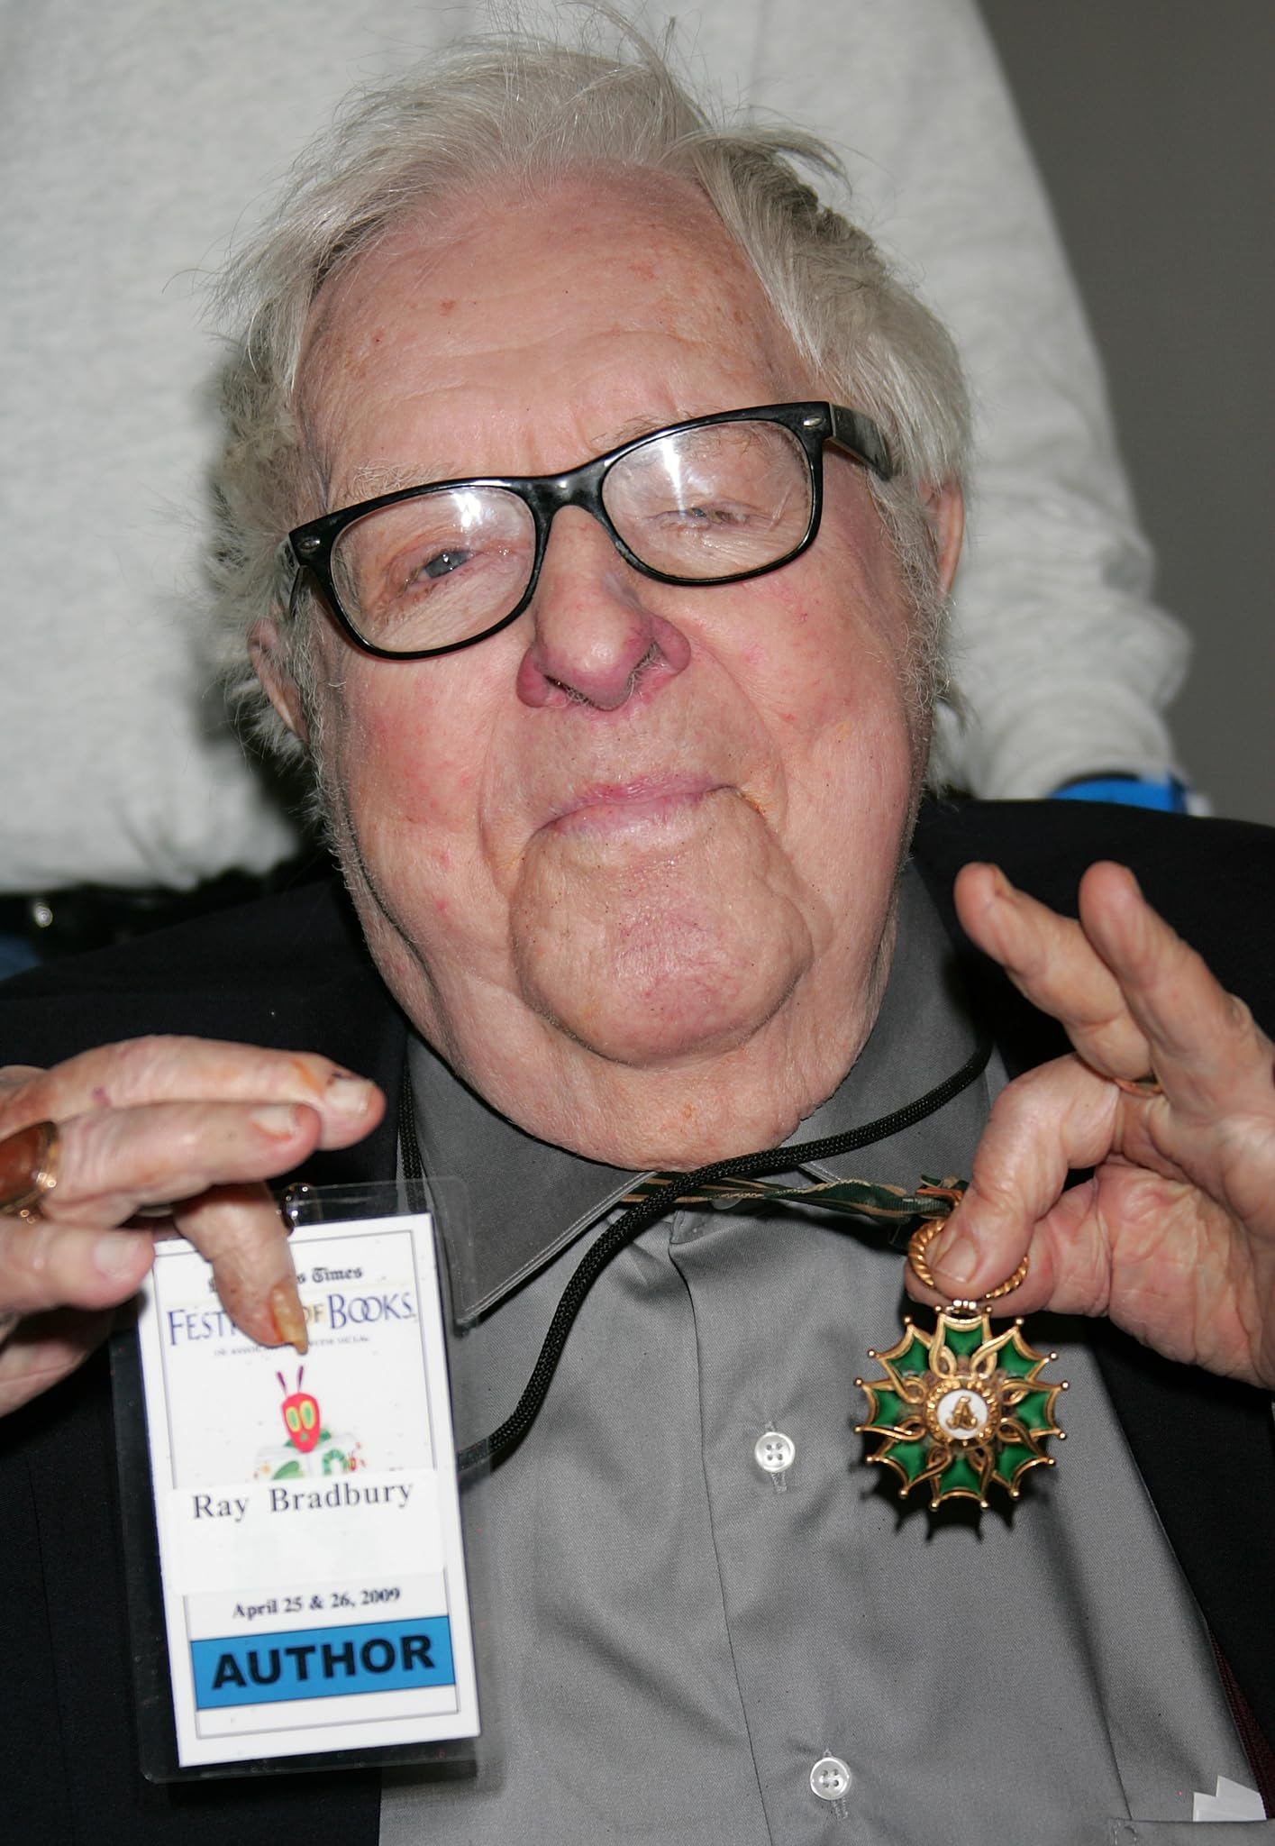

By the Numbers! Ray Bradbury

By the Numbers!

“Company, tenshun!”

Snap.

“Company, forward—Harch!”

Tromp, tromp.

“Company halt!”

Tromp, rattle, clump.

“Eyes right.”

Whisper.

“Eyes left.”

Rustle.

“About face!”

Tromp, scrape, tromp.

In the sunlight, a long time ago, the man shouted and the company obeyed. By a hotel pool under a Los Angeles sky in the summer of ’52, there was the drill sergeant and there stood his team.

“Eyes front! Head up! Chin in! Chest out! Stomach sucked! Shoulders back, dammit, back!

Rustle, whisper, murmur, scratch, silence.

And the drill sergeant walking forward, dressed in bathing trunks by the edge of that pool to fix his cold bluewater gaze on his company, his squad, his team, his—

Son.

A boy of nine or ten, standing stiffly upright, staring arrow-straight ahead at military nothings, shoulders starched, as his father paced, circling him, barking commands, leaning in at him, mouth crisply enunciating the words. Both father and son were dressed in bathing togs and, a moment before, had been cleaning the pool area, arranging towels, sweeping with brooms.

But now, just before noon:

“Company! By the numbers! One, two!”

“Three, four!” cried the boy.

“One, two!” shouted the father.

“Three, four!”

“Company halt, shoulder arms, present arms, tuck that chin, square those toes, hup!”

The memory came and went like a badly projected film in an old rerun cinema. Where had it come from, and why?

I was on a train heading north from Los Angeles to San Francisco. I was in the bar-car, alone, late at night, save for the barman and a young-old stranger who sat directly across from me, drinking his second martini.

The old memory had come from him.

Nine feet away, his hair, his face, his startled blue and wounded eyes had suddenly cut the time stream and sent me back.

In and out of focus, I was on the train, then beside that pool, watching the hurt bright gaze of this man across the aisle, hearing his father thirty years lost, and watching the son, five thousand afternoons ago, wheeling and pivoting, turning and freezing, presenting imaginary arms, shouldering imaginary rifles.

“Tenshun!!” barked the father.

“Shun!” echoed the son.

“My God,” whispered Sid, my best friend, lying beside me in the hot noon light, staring.

“My God, indeed,” I muttered.

“How long has this been going on?”

“Years, maybe. Looks that way. Years.”

“Hut, two!”

“Three, four!”

A church clock nearby struck noon; time to open the pool liquor bar.

“Company . . . harch!”

A parade of two, the man and boy strode across the tiles toward the half-locked gates on the open-air bar.

“Company, halt. Ready! Free locks! Hut!”

The boy snapped the locks wide.

“Hut!”

The boy flung the gate aside, jumped back, stiffened, waiting.

“Bout face, forward, harch!”

When the boy had almost reached the rim of the pool and was about to fall in, the father, with the wryest of smiles, called, quietly: “. . . halt.”

The son teetered on the edge of the pool.

“God damn,” whispered Sid.

The father left his son standing there skeleton stiff and flagpole erect, and went away.

Sid jumped up suddenly, staring at this.

“Sit down,” I said.

“Christ, is he going to leave the kid just waiting there?!”

“Sit down, Sid.”

“Well, for God’s sake, that’s inhuman!”

“He’s not your son, Sid,” I said, quietly. “You want to start a real fight?”

“Yeah!” said Sid. “Dammit!”

“It wouldn’t do any good.”

“Yes, it would. I’d like to beat hell—”

“Look at the boy’s face, Sid.”

Sid looked and began to slump.

The son, standing there in the burning glare of sun and water, was proud. The way he held his head, the way his eyes took fire, the way his naked shoulders carried the burden of goad or instruction, was all pride.

It was the logic of that pride which finally caved Sid in. Weighted with some small despair, he sank back down to his knees.

“Are we going to have to sit here all afternoon, and watch this dumb game of—” Sid’s voice rose in spite of himself “—Simon Says?!”

The father heard. In the midst of stacking towels on the far side of the pool, he froze. The muscles on his back played like a pinball machine, making sums. Then he turned smartly, veered past his son who still stood balanced a half inch from the pool’s rim, gave him a glance, nodded with intense, scowling approval, and came to cast his iron shadow over Sid and myself.

“I will thank you, sir,” he said, quietly, “to keep your voice down, to not confuse my son—”

“I’ll say any damn thing I want!” Sid started to get up.

“No, sir, you will not.” The man pointed his nose at Sid; it might just as well have been a gun. “This is my pool, my turf, I have an agreement with the hotel, their territory stops out there by the gate.

If I’m to run a clean, tucked-in shop, it is to be with total authority. Any dissidents—out. Bodily. On the gymnasium wall inside you’ll find my ju-jitsu black belt, boxing, and rifle-marksman certificates. If you try to shake my hand, I will break your wrist. If you sneeze, I will crack your nose. One word and your dental surgeon will need two years to reshape your smile. Company, tenshun!”

The words all flowed together.

His son stiffened at the rim of the pool.

“Forty laps! Hut!”

“Hut!” cried the boy, and leaped.

His body striking the water and his beginning to swim furiously stopped Sid from any further outrage. Sid shut his eyes.

The father smiled at Sid, and turned to watch the boy churning the summer waters to a foam.

“There’s everything I never was,” he said. “Gentlemen.”

He gave us a curt nod and stalked away.

Sid could only run and jump in the pool. He did twenty laps himself. Most of the time, the boy beat him. When Sid came out, the blaze was gone from his face and he threw himself down.

“Christ,” he muttered, his face buried in his towel, “someday that boy must haul off and murder that son of a bitch!”

“As a Hemingway character once said,” I replied, watching the son finish his thirty-fifth lap, “wouldn’t it be nice to think so?”

The final time, the last day I ever saw them, the father was still marching about briskly, emptying ashtrays (no one could empty them the way he could), straightening tables, aligning chairs and loungers in military rows, and arranging fresh white towels on benches in crisp mathematical stacks.

Even the way he swabbed the deck was geometrical. In all his marching and going, fixing and realigning, only on occasion did he snap his head up, flick a gaze to make sure his squad, his platoon, his company still stood frozen by the hour, a boy like a ramrod guidon, his hair blowing in the summer wind, eyes straight on the late afternoon horizon, mouth clamped, chin tucked, shoulders back.

I could not help myself. Sid was long gone. I waited on the balcony of the hotel overlooking the pool, having a final drink, not able to take my gaze off the marching father and the statue son. At dusk, the father double-timed it to the outer gate and almost as an afterthought called over his shoulder:

“Tenshun! Squad right. One, two—”

“Three, four!” cried the boy.

The boy strode through the gate, feet clubbing the cement as if he wore boots. He marched off toward the parking lot as his father snap-locked the gate with a robot’s ease, took a fast scan around, raised his stare, saw me, and hesitated. His eyes burned over my face. I felt my shoulders go back, my chin drop, my shoulders flinch. To stop it, I lifted my drink, waved it carelessly at him, and drank.

What will happen, I thought, in the years ahead? Will the son grow up to kill his old man, or beat him up, or just run away to know a ruined life, always marching to some unheard shout of “Hut” or “harch!” but never “at ease!”?

Or, I thought, drinking, would the boy raise sons himself and just yell at them on hot noons by far pools in endless years? Would he one day stick a pistol in his mouth and kill his father the only way he knew how? Or would he marry and have no sons and thus bury all shouts, all drills, all sergeants? Questions, half-answers, more questions.

My glass was empty. The sun had gone, and the father and his son with it.

But now, in the flesh, straight across from me on this late night train, heading north for unlit destinations, one of them had returned. There he was, the kid himself, the raw recruit, the child of the father who shouted at noon and told the sun to rise or set.

Merely alive? half alive? all alive?

I wasn’t sure.

But there he sat, thirty years later, a young-old or old-young man, sipping on his third martini.

By now, I realized that my glances were becoming much too constant and embarrassing. I studied his bright blue, wounded eyes, for that is what they were: wounded, and at last took courage and spoke:

“Pardon me,” I said. “This may seem silly, but—thirty years back, I swam weekends at the Ambassador Hotel where a military man tended the pool with his son. He—well. Are you that son?”

The young-old man across from me thought for a moment, looked me over with his shifting eyes and at last smiled, quietly.

“I,” he said, “am that son. Come on over.”

We shook hands. I sat and ordered a final round for us, as if we were celebrating something, or holding a wake, nobody seemed to know which. After the barman delivered the drinks, I said, “To nineteen fifty-two, a toast. A good year? Bad year? Here’s to it, anyway!”

We drank and the young-old man said, almost immediately, “You’re wondering what ever happened to my father.”

“My God,” I sighed.

“No, no,” he assured me, “it’s all right. A lot of people have wondered, have asked, over the years.”

The boy inside the older man nursed his martini and remembered the past.

“Do you tell people when they ask?” I said.

“I do.”

I took a deep breath. “All right, then. What did happen to your father?”

“He died.”

There was a long pause.

“Is that all?”

“Not quite.” The young-old man arranged his glass on the table in front of him, and placed a napkin at a precise angle to it, and fitted an olive to the very center of the napkin, reading the past there. “You remember what he was like?”

“Vividly.”

“Oh, what a world of meaning you put into that ‘vividly’!” The young-old man snorted faintly. “You remember his marches up, down, around the pool, left face, right, tenshun, don’t move, chin-stomach in, chest out, harch two, hut?”

“I remember.”

“Well, one day in nineteen fifty-three, long after the old crowd was gone from the pool, and you with them, my dad was drilling me outdoors one late afternoon. He had me standing in the hot sun for an hour or so and he yelled in my face, I can remember the saliva spray on my chin, my nose, my eyelids when he yelled: don’t move a muscle! don’t blink! don’t twitch! don’t breathe till I tell you! You hear, soldier? Hear? You hear? Hear?!

“‘Sir!’ I gritted between my teeth.

“As my father turned, he slipped on the tiles and fell in the water.”

The young-old man paused and gave a strange small bark of a laugh.

“Did you know? Of course you didn’t. I didn’t either . . . that in all those years of working at various pools, cleaning out the showers, replacing the towels, repairing the diving boards, fixing the plumbing, he had never, my God, never learned to swim! Never! Jesus. It’s unbelievable. Never.

“He had never told me. Somehow, I had never guessed! And since he had just yelled at me, instructed me, ordered me: eyes right! don’t twitch! don’t move! I just stood there staring straight ahead at the late afternoon sun. I didn’t let my eyes drop to see, even once. Just straight ahead, by the numbers, as told.

“I heard him thrashing around in the water, yelling. But I couldn’t understand what he said. I heard him suck and gasp and gargle and suck again, going down, shrieking, but I stood straight, chin up, stomach tight, eyes level, sweat on my brow, mouth firm, buttocks clenched, ramrod spine, and him yelling, gagging, taking water. I kept waiting for him to yell, ‘At ease!’ ‘At ease!’ he should have yelled, but he never did.

So what could I do? I just stood there, like a statue, until the shrieking stopped and the water lapped the pool rim and everything got quiet. I stood there for ten minutes, maybe twenty, half an hour, until someone came out and found me there, and they looked down in the pool and saw something deep under and said Jesus Christ and finally turned and came up to me, because they knew me and my father, and at last said, At Ease.

“And then I cried.”

The young-old man finished his drink.

“You see, the thing is, I couldn’t be sure he wasn’t faking. He’d done tricks like that before, to get me off guard, make me relax. He’d go around a corner, wait, duck back, to see if I was ramrod tall. Or he’d pretend to go into the men’s room, and jump back to find me wrong.

Then he’d punish me. So, standing there by the pool that day, I thought, it’s a trick, to make me fall out. So I had to wait, didn’t I, to be sure? . . . to be sure.”

Finished, he put his empty martini glass down on the tray and sat back in his own silence, eyes gazing over my shoulder at nothing in particular. I tried to see if his eyes were wet, or if his mouth gave some special sign now that the tale was told, but I saw nothing.

“Now,” I said, “I know about your father. But . . . what ever happened to you?”

“As you see,” he said, “I’m here.”

He stood up and reached over and shook my hand.

“Good night,” he said.

I looked straight up in his face and saw the young boy there waiting for orders five thousand afternoons back. Then I looked at his left hand; no wedding ring there. Which meant what? No sons, no future? But I couldn’t ask.

“I’m glad we met again,” I heard myself say.

“Yes.” He nodded, and gave my hand a final shake. “It’s good to see you made it through.”

Me, I thought. My God! Me?!

But he had turned and was walking off down the aisle, beautifully balanced, not swaying with the train’s motion, this way or that. He moved in a clean, lithe, well-cared-for body, which the train’s swerving could do nothing to as he went away.

As he reached the door, he hesitated, his back to me, and he seemed to be waiting for some final word, some order, some shout from someone.

Forward, I wanted to say, by the numbers! March!

But I said nothing.

Not knowing if it would kill him, or release him, I simply bit my tongue, and watched him open the door, slip silently through, and stride down the corridor of the next sleeping car toward a past I just might have imagined, toward a future I could not guess.

The End