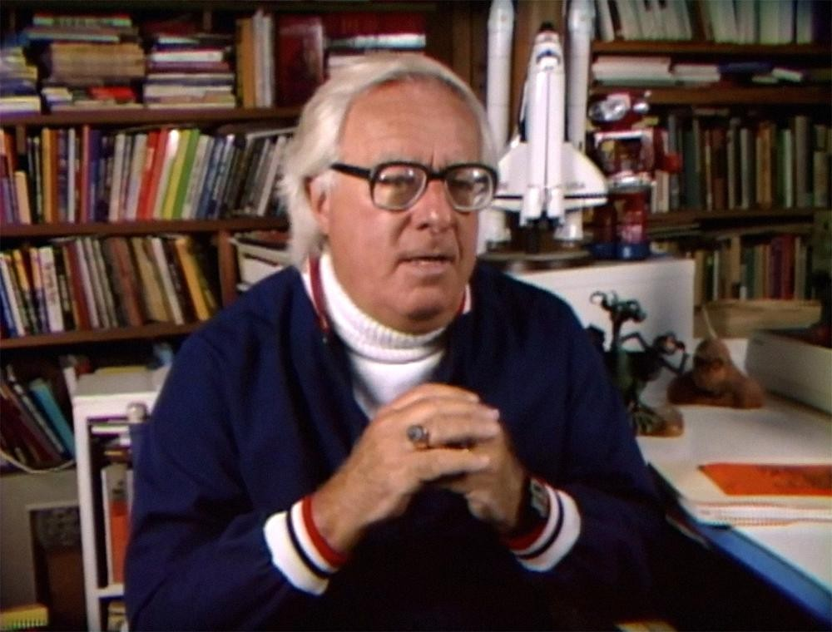

Changeling, Ray Bradbury

Changeling

By eight o’clock she had placed the long cigarettes and the wine crystals and the silver bucket of thin shaved ice packed around the green bottle. She stood looking at the room, each picture neat, ashtrays conveniently disposed.

She plumped a lounge pillow and stepped back, her eyes squinting. Then she hurried into the bathroom and returned with the strychnine bottle, which she laid under a magazine on an end table. She had already hidden a hammer and an ice pick.

She was ready.

Seeming to know this, the phone rang. When she answered, a voice said:

“I’m coming up.”

He was in the elevator now, floating silently up the iron throat of the house, fingering his accurate little mustache, adjusting his white summer evening coat and black tie.

He would be smoothing his gray-blond hair, that handsome man of fifty still able to visit handsome women of thirty-three, fresh, convivial, ready for the wine and the rest of it.

“You’re a faker!” she whispered to the closed door a moment before he rapped.

“Good evening, Martha,” he said. “Are you just going to stand there, looking?” She kissed him quietly. “Was that a kiss?” he wondered, his blue eyes warmly amused. “Here.” He gave her a better one.

Her eyes closed, she thought, is this different from last week, last month, last year? What makes me suspicious? Some little thing. Something she couldn’t even tell, it was so minor. He had changed subtly and drastically.

So drastically in fact, so completely that she had begun to stay awake nights two months ago. She had taken to riding the helicopters at three in the morning out to the beach and back to see all-night films projected on the clouds near The Point, films that had been made way back in 1955, huge memories in the ocean mist over the dark waters, with the voices drifting in like gods’ voices with the tide. She was constantly tired.

“Not much response.” He held her away and surveyed her critically. “Is anything wrong, Martha?”

“Nothing,” she said. Everything she thought. You, she thought. Where are you tonight, Leonard? Who are you dancing with far away, or drinking with in an apartment on the other side of town, who are you being lovably polite with? For you most certainly are not here in this room, and I intend to prove it.

“What’s this?” he said, looking down. “A hammer? Have you been hanging pictures, Martha?”

“No, I’m going to hit you with it,” she said, and laughed.

“Of course,” he said, smiling. “Well, perhaps this will make you change your mind.” He drew forth a plush case, inside which was a pearl necklace.

“Oh, Leonard!” She put it on with trembling fingers and turned to him, excited. “You are good to me.”

“It’s nothing at all,” he said.

At these times, she almost forgot her suspicions. She had everything with him, didn’t she? There was no sign of his losing interest, was there? Certainly not. He was just as kind and gentle and generous. He never came without something for her wrist or her finger.

Why did she feel so lonely with him then? Why didn’t she feel with him? Perhaps it had started with that picture in the paper two months ago. A picture of him and Alice Summers in The Club on the night of April 17th. She hadn’t seen the picture until a month later and then she had spoken of it to him:

“Leonard, you didn’t tell me you took Alice Summers to The Club on the night of April seventeenth.”

“Didn’t I, Martha? Well, I did.”

“But wasn’t that one of the nights you were here with me?”

“I don’t see how it could have been. We have supper and play symphonies and drink wine until early morning.”

“I’m sure you were here with me April seventeenth, Leonard.”

“You’re a little drunk, my dear. Do you keep a diary?”

“I’m not a child.”

“There you are then. No diary, no record. I was here the night before or the night after. Come on now, Martha, drink up.”

But that hadn’t settled it. She had not gone to sleep that night with thinking and being positive he had been with her on April 17th. It was impossible, of course. He couldn’t be in two places.

They both stood looking down at the hammer on the floor. She picked it up and put it on a table. “Kiss me,” she said, quite suddenly, for she wanted now, more than ever, to be certain of this thing. He evaded her and said, “First, the wine.” “No,” she insisted, and kissed him.

There it was. The difference. The little change. There was no way to tell anyone, or even describe it. It would be like trying to describe a rainbow to a blind man. But there was a subtle chemical difference to his kiss. It was no longer the kiss of Mr. Leonard Hill.

It approximated the kiss of Leonard Hill but was sufficiently different to set a subconscious wheel rolling in her. What would an analysis of the faint moisture on his lips reveal? Some bacterial lack? And as for the lips themselves, were or were they not harder, or softer, than before? Some small difference.

“All right, now the wine,” she said, and opened it. She poured his glass full. “Oh, will you get some mats from the kitchen to set them on?” While he was gone she poured the strychnine in his glass. He returned with the mats to set the glasses on and picked up his drink.

“To us,” he said.

Good Lord, she thought, what if I’m wrong? What if this is really him? What if I’m just some wild paranoid sort of creature, really insane and not aware of it?

“To us.” She raised her glass.

He drained his at a gulp, as always. “My God,” he said, wincing. “That’s horrible stuff. Where did you get it?”

“At Modesti’s.”

“Well, don’t get any more. Here, I’d better ring for more.”

“Never mind, I have more in the refrigerator.”

When she brought the new bottle in, he was sitting there, clever and alive and fresh. “You look wonderful,” she said.

“Feel fine. You’re beautiful. I think I love you more tonight than ever.”

She waited for him to fall sidewise and stare the stare of the dead. “Here we go,” he said, opening the second bottle.

When the second bottle was empty, an hour had passed. He was telling witty little stories and holding her hand and kissing her gently now and again. At last he turned to her and said, “You seem quiet tonight, Martha? Anything wrong?”

“No,” she said.

She had seen the news item last week, the item that had finally set her worrying and planning, that had explained her loneliness in his presence. About the Marionettes. Marionettes, Incorporated. Not that they really existed, surely not. But there was a rumor. Police were investigating.

Life-size marionettes, mechanical, stringless, secretive, duplicates of real people. One might buy them for ten thousand dollars on some distant black market. One could be measured for a replica of one’s self. If one grew weary of social functions, one could send the replica out to wine, to dine, to shake hands, to trade gossip with Mrs. Rinehart on your left, Mr. Simmons on your right, Miss Glenner across the table.

Think of the political tirades one might miss! Think of the bad shows one need never see. Think of the dull people one could snub without actually snubbing. And, last of all, think of the jeweled loved ones you could ignore, yet not ignore.

What would a good slogan be? She Need Never Know? Don’t Tell Your Best Friends? It Walks, It Talks, It Sneezes, It Says “Mama”?

When she thought of this she became almost hysterical. Of course it had not been proven that such things as Marionettes existed. Just a sly rumor, with enough to it to make a sensitive person crawl with horror.

“Abstracted again,” he said, interrupting her quietness. “There you go, wandering off. What’s in that pretty head of yours?”

She looked at him. It was foolish; at any moment he might convulse and die. Then she would be sorry for her jealousy.

Without thinking, she said, “Your mouth; it tastes funny.”

“Dear me,” he said. “I shall have to see to that, eh?”

“It’s tasted funny for some time.”

For the first time he seemed concerned. “Has it? I’m sorry. I’ll see my doctor.”

“It’s not that important.” She felt her heart beating quickly and she was cold. It was his mouth. After all, no matter how perfect chemists were, could they analyze and reproduce the exact taste?

Hardly. Taste was individual. Taste was one thing to her, something else to another. There was where they had fallen down. She would not put up with it another minute. She walked over to the other couch, reached down and drew out the gun.

“What’s that?” he said, looking at it. “Oh my God,” he laughed. “A gun. How dramatic.”

“I’ve caught on to you,” she said.

“Is there anything to catch on to?” he wanted to know, calmly, his mouth straight, his eyes twinkling.

“You’ve been lying to me. You haven’t been here in eight weeks or more,” she said.

“Is that true? Where have I been then?”

“With Alice Summers, I wouldn’t doubt. I’ll bet you’re with her right now.”

“Is that possible?” he asked.

“I don’t know Alice Summers, I’ve never met her, but I think I’ll call her apartment right now.”

“Do that,” he said, looking straight at her.

“I will,” she said, moving to the phone. Her hand shook so that she could hardly dial information. While waiting for the number to come through she watched Leonard and he watched her with the eye of a psychiatrist witnessing a not-unusual phenomenon.

“You are badly off,” he said. “My dear Martha—”

“Sit down!”

“My dear Martha,” he moved back in the couch, chuckling softly. “What have you been reading?”

“About the Marionettes is all.”

“That poppycock? Good God, Martha, I’m ashamed of you. It’s not true. I looked into it!”

“What!”

“Of course!” he cried, in delight. “I have so many social obligations, and then my first wife came back from India as you know and demanded my time and I thought how fine it would be if I had a replica of myself made, as bait you might say, to turn my wife off my trail, to keep her busy, how nice, eh? But it was all false. Just me. I thought I needed a change.

So I went on to Alice and tired of her. And went on to Helen Kingsley, you remember her, don’t you? And tired of her. And on to Ann Montgomery. And that didn’t last. Oh, Martha, there are at least six duplicates of me, mechanical hypocrites, ticking away tonight, in all parts of the town, keeping six people happy. And do you know what I am doing, the real I?

“I’m home in bed early for the first time in thirty years, reading my little book of Montaigne’s essays and enjoying it and drinking a hot glass of chocolate milk and turning out the lights at ten o’clock. I’ve been asleep for an hour now, and I shall sleep the sleep of the innocent until morning and arise refreshed and free.”

“Stop!” she shrieked.

“I’ve got to tell you,” he said. “You’ve cut several of my ligaments with your bullets. I can’t get up. The doctors, if they came, would find me out anyway, I’m not that perfect. Perfect enough, but not that good. Oh, Martha, I didn’t want to hurt you. Believe me.

I wanted only your happiness. That’s why I was so careful with my planned withdrawal. I spent fifteen thousand dollars for this replica, perfect in every detail. There are variables. The saliva for one. A regrettable error. It set you off. But you must know that I loved you.”

She would fall at any moment, writhing into insanity, she thought. He had to be stopped from talking.

“And when I saw how the others loved me,” he whispered to the ceiling, eyes wide, “I had to provide replicas for them, poor dears. They love me so. You won’t tell them, will you, Martha? Promise me you won’t give the show away. I’m a very tired old man, and I want only peace, a book, some milk and a lot of sleep. You won’t call them up and give it away?”

“All this year, this whole year, I’ve been alone, alone every night,” she said, the coldness filling her. “Talking to a mechanical horror! In love with nothingness! Alone all that time, when I could have been out with someone real!”

“I can still love you, Martha.”

“Oh God!” she cried, and seized up the hammer.

“Don’t, Martha!”

She smashed his head in and beat at his chest and his thrashing arms and wild legs. She beat at the soft head until steel shone through, and sudden explosions of wire and brass coggery showered about the room with metal tinkles.

“I love you,” said the man’s mouth. She struck it with the hammer and the tongue fell out. The glass eyes rolled on the carpet. She pounded at the thing until it was strewn like the remains of a child’s electric train on the floor. She laughed while she was doing it.

In the kitchen she found several cardboard boxes. She loaded the cogs and wires and metal into these and sealed the tops. Ten minutes later she had summoned the houseboy from below.

“Deliver these packages to Mr. Leonard Hill, 17 Elm Drive,” she said, and tipped the boy. “Right now, tonight. Wake him up, tell him it’s a surprise package from Martha.”

“A surprise package from Martha,” said the boy.

After the door closed, she sat on the couch with the gun in her hand, turning it over and over, listening. The last thing she heard in her life was the sound of the packages being carried down the hall, the metal jingling softly, cog against cog, wire against wire, fading.

The End