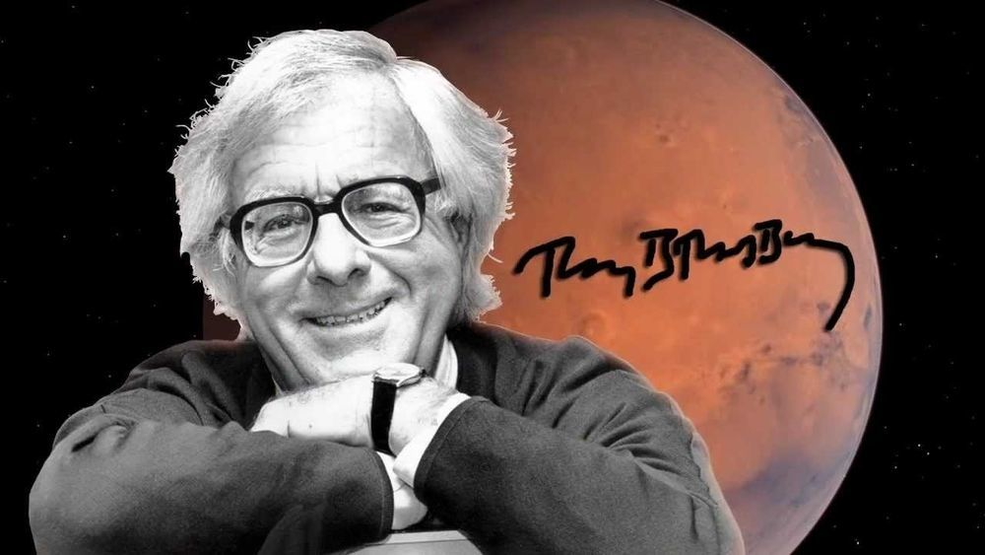

Come Away with Me, Ray Bradbury

Come Away with Me

Why Joseph Kirk did what he did, on impulse, he could not immediately say. He could only recall, instantaneously, similar incidents that had caused him to erupt years ago.

At a small private dinner, when an obnoxious film producer had bragged about ‘selling out,’ implying thateveryonedid, Joseph Kirk had put down his knife and fork and ordered the producer away from the table. The producer obeyed.

On another occasion, when a film actress verbally whiplashed her husband for half an hour in front of guests, Kirk had jumped up, told her how awful she was, and walked off to the next room to read a book. On the way out, later, she apologized and he looked the other way.

Now, tonight, it had happened again. He heard himself saying an incredible thing. It was as if someone had handed him a grenade and, thoughtless, he had yanked the ring and gripped the damned thing, staring, as it went off.

He was browsing at a newsstand in the early evening, leafing through a few magazines, when he heard angry voices approaching. One high, shrill, and derogatory; the other smothered, half mute, already defeated. The newsstand was south of Hollywood Boulevard, and the voices came from that direction.

Joseph Kirk glanced from the corners of his eyes. What he saw was one handsome young man striding along, hurling insults as if they were favors over his shrugged shoulder. He seemed to be wearing an invisible cape.

He seemed to be wearing a mask. But that wasn’t true, either; it was just the way he held his face, in a frozen grimace of hauteur as he manufactured his diatribes.

Behind him, smaller, meeker, and most certainly not louder, came his friend with an equally handsome face, but no invisible cape, no mask, just a face like someone out in the rain and bewildered by the storm.

‘My God,’ cried the first young man, glaring at the street ahead, ‘you never doanythingright!’

‘What did I do now?’

‘Last night, this morning, just now. You behave like a cow. Can’t you be polite? Can’t you act properly? At that party, my God! Can’t you smile, or laugh, or make small talk? Stood around like a damned wooden Indian!’

‘I—’

‘And today at lunch, with Teddy trying to amuse us, hilarious, and you just sat there. Jesus! You—’

The parade of two went by, the first part pompous, tall, and glorious in its feline display, the second part defeated, dragging, and lost. The hackles on the back of Kirk’s neck rose and rippled down his back. He found himself grinding his teeth and shutting his eyes.

‘Then this afternoon. Do you know what youdidthis afternoon?’

‘What did I do, what did Ido?’

‘You—’

‘Oh, shut up!’ cried Kirk.

The world froze. The parade stopped. Its pompous half whirled as if shot through the heart. His defeated friend stood motionless, slowly lifting his head with a look of dismay mixed with curious relief.

‘What?’ cried the man with the invisible mask.

Kirk felt his mouth move and, still disbelieving his own outburst, continued. ‘I said shut up.’

‘And who the hell are you?’ cried the first young man.

‘Nobody at all, but damn it all to hell!’

Where am I going with this? Kirk wondered. And then he looked at the second young man’s face and saw an answer. There was a burgeoning of hope there, a wonder, and a need to escape.

‘Look,’ said Kirk. ‘You’re coming withme.’

‘What?’ said the second young man.

‘You don’t really want to be with this monster, do you?’ said Kirk. ‘No. No, come along. I’ll make you happier than he can. I’ll start by leaving you alone. We’ll go on from there, yes? Well? Him or me?’

The second young man stood riven, blinking from his friend to Kirk, and then at the ground, unable to choose.

‘Look here,’ said the first young man, his mask beginning to melt. ‘You—’

‘No.’ Kirk put his hand out to touch the second young man’s elbow. ‘Freedom at last. Isn’t it glorious? Get out of the way,you! Come along,you.’

He stepped between them quickly, and spun the second man about and walked him off.

‘You can’tdothat!’ cried the other, stunned.

‘Watch my dust!’ shouted Kirk.

And he kept walking with his captive to and around the corner, swiftly, with the cries of the cormorant or the shrike or whatever it was, echoing behind.

‘Keep walking,’ said Kirk.

‘I am.’

‘Don’t look back.’

‘I’m not.’

‘Faster.’

‘I’m running.’

‘Good.’

They made it to the next corner and stopped for a moment, staring at each other.

‘Who are you?’ the second young man asked.

‘Your savior, I guess.’

‘Why did you do that?’

‘I don’t know. I had to. It was awful.’

‘What’s your name?’

‘Kirk. Joseph Kirk.’

‘I’m Willy-Bob.’

‘Jesus Christ. Youlooklike a Willy-Bob.’

‘I know. Will he come after us?’

‘He’s probably in shock right now. Let’s keep moving. My car’s down here.’

They made it to the car, and while Kirk was unlocking the passenger-side door, Willy-Bob said: ‘Lord, you’re not even one of us! You’re not even…youknow.’

There was a long silence while they got into the car. Before Kirk started the engine, he heard Willy-Bob say, ‘Areyou?’

Kirk turned to look at him, laughing quietly. ‘No.’

‘Then, why,why?’

‘Letting you go on down the street with that son of a bitch drove me wild. I couldn’t let it happen.’

‘I love him, you know.’

‘Yeah, and more’s the pity. But, you’re withmenow.’

‘What are you going to do with me?’

‘I’m a man without a nose. You’re a box of Kleenex. I’ll think of something.’

Kirk began to laugh. Willy-Bob joined him.

‘Oh, this is incredible. This is rich!’

Tears ran down both their faces.

‘Isn’t it?’ said Kirk, and drove away with his captive.

They found a drive-in and finished their laughing there. They ordered two hamburgers, french fries, and two beers and sat waiting to let the laughter die.

‘My God, his face! Christ, I feel good,’ cried Willy-Bob.

‘That’s what I intended,’ said Kirk.

‘It’s the first time, the first time I ever spoke up in my life!’

But you didn’t, thought Kirk, but let it go.

‘I can just imagine him, right now, stomping up and down the boulevard, trying to find me, furious…’

Willy-Bob’s voice began to fade. ‘Jesus, when hedoesfind me! All my stuff is back at his place.’

‘It’s notyourplace, too?’

‘We share an apartment over on Fountain.’

‘How much junk you got there?’

‘A lot. Change of clothes. A toilet kit. Beat-up old typewriter. I guess there’s nothing there.’

‘Not much,’ said Kirk.

The hamburgers arrived in time to interrupt a growing silence. They ate quietly. Half through his sandwich, Willy-Bob swallowed hard and said, ‘Well, again, what are you going to do with me?’

‘Nothing.’

‘You can, you know. I owe you.’

‘You don’t owe me anything. You owe yourself something. To get the hell out, to get the hell away.’

‘You’re right. Still, I don’t understand, why did you do it, why am I here with you?’

Kirk took another bite and ruminated, his eyes on the windshield, where bugs had struck and died. He tried to read their dried juices.

‘Two dogs get joined, middle of the street, can’t get free, I run out, hose them down. Barn owl in a field, fallen from a tree, took it home, gave it warm milk. Hell.’

‘Am I a barn owl out of a tree?’

‘There’s a remarkable resemblance.’

‘I still can’t fly.’

‘That’s why I spoke up.’

‘But you didn’t know anythingaboutme.’

‘Yes, I did, seeing you go by.Listeningto you.’

‘You didn’t know anything abouthim.’

‘I did, seeinghimwalk by, hearing his whole life, and yours.’

‘You’re awfully good at seeing and hearing.’

‘It’s no virtue. Makes trouble. Look at us here, me and you. What next?’

They finished their sandwiches and worked on their beers, and Willy-Bob said, ‘Maybe we could have a life together…’

‘No way,’ said Kirk abruptly, and stopped. ‘I mean, I’m just a down-at-the-heels analyst, a damn-fool ham-fisted do-gooder, in this up to my chin and as uncomfortable as you are. We have no true use for one another. The only thing holding us together is my pity and your fear.’

‘That’ll have to do,’ said Willy-Bob. ‘Do I go home with you tonight? That is,ifI go home with you.’

‘You’re sounding more doubtful every second.’

‘I’m scared as hell. Feel as if I had thrown up in church.’

‘God willneverforgive you, will He?’

‘He never has.’

Kirk drank his beer. ‘Your guy isn’t God, he’s Lucifer. And his apartment is hell on Earth. You might as well blow your brains out as go back.’

‘I know.’ Willy-Bob nodded, eyes shut.

‘Yet you’re thinking about it, right now?’

‘I am.’

‘Let’s find you a room for the night. Being somewhere different may give you more—’

‘Courage?’

‘Hell, I don’t want to preach.’

‘God, Ineedpreaching. A hotel, yes. But I’ve no money—’

‘I think I can afford it,’ said Kirk.

Kirk started the car and Willy-Bob said, ‘On the way, if it isn’t far, could we drive by your place, so I could see—’

‘What?’

‘From outside, the house you live in, youaremarried, aren’t you? It would be nice to see some place permanent. I mean, just drive by, okay?’

‘Well,’ said Kirk.

‘Okay?’ said Willy-Bob.

They drove, circling, through Hollywood. Along the way, Kirk said, ‘You have a job? No. I’ll bring you the want ads tomorrow, so you can live alone awhile and find out who the hell you really are. How long you been living, if you can call it that, with that son of a bitch?’

‘A year. The greatest year in my life. A year. The most horrible year in my life.’

‘Half and half. I know the feeling.’

They arrived at and moved slowly past the front of Kirk’s small white bungalow. An apricot-colored lamp shone in the front window. It looked warm, even to Kirk, as they almost stopped.

‘Is that it, your window?’ asked Willy-Bob. ‘It looks great.’

‘It’s all right.’

‘God, you’re a nice man. What’s wrong with me I can’t relax and be saved? What’s wrong?!’ Willy-Bob wailed, and burst into tears.

Kirk handed over a Kleenex and then impulsively leaned across and kissed Willy-Bob on the forehead. Willy-Bob’s face, tear-streaked, came up swiftly, surprised.

Kirk pulled back. ‘No offense. No offense!’

They both laughed and circled back through Hollywood to find a small hotel.

Kirk got out of the car.

‘You better get back in,’ said Willy-Bob.

‘You’re not staying here now?’

‘You know I can’t.’

Kirk stood waiting. At last Willy-Bob said: ‘Did you have a lot of girlfriends?’

‘A few.’

‘I should think so. You’re nice-looking. And you behave nicely. Is your marriage happy? Does niceness help that?’

‘I’m all right,’ said Kirk. ‘I miss the way it once was, when we started out.’

‘Oh, I wish I could misshimsometime and get it over with. I’m sick to my stomach now.’

‘It’ll pass, if you give it a chance.’

‘No.’ Willy-Bob shook his head. ‘It will never pass.’

That did it.

Kirk climbed back in and sat for a moment watching the young, fragile man dry his tears.

‘Where do you want me to take you?’

‘I’ll show you the place.’

Kirk put the keys in the ignition and waited. ‘The hotel is here. Last chance for life. Going, going, gone. Nine-eight-seven…’

Kirk looked at the beer Willy-Bob was holding. Willy-Bob laughed quietly.

‘The condemned man drank a hearty meal.’ He crumpled the can, threw it out. ‘Now it’s just junk, like me. Well?’

Kirk swallowed a curse and started the car.

‘There he is!’

They had driven along Santa Monica Boulevard and approached a place called the Blue Parrot. Out front, half in, half out the door, stood the man with the invisible mask and the unseen cape. Right now his mask hung half off his face, his eyes damaged, his mouth wounded, but there he stood, anyway, arms crossed over his chest, foot tapping impatiently.

When he saw Kirk’s car slow and saw who was in the passenger seat, his whole body toppled forward eagerly. But then his mask sank back in place, his spine straightened, his arms crushed his chest firmly as his chin came up and his eyes blazed in silence.

Kirk stopped the car. ‘You sure you want to be here?’

‘Yes,’ said Willy-Bob, eyes down, hands tucked between his legs.

‘You know what’s going to happen, don’t you? It’ll be hell for the next week, or, if I read him right, the next month.’

‘I know.’ Willy-Bob’s head nodded quietly.

‘And yet you want to go to him?’

‘It’s the only thing I can do.’

‘No, you can stay at the hotel and I’ll buy you a compass.’

‘What kind of future is that?’ said Willy-Bob. ‘You don’t love me.’

‘No, I don’t. Now, jump out and run like hell,alone!’

‘Christ, don’t you think I’dliketo do that?’

‘Do it, then. For me. For you. Run. Find someone else.’

‘Thereisno one else, in the whole world. He loves me, you know. If I left him, it’d kill him.’

‘And if you go back, he’ll killyou.’ Kirk took a deep breath and let it out in a sigh. ‘God, I feel like someone’s drowning and I’m throwing him an anvil.’

Willy-Bob’s fingers toyed with the door handle. The door sprang open. The man standing in the Blue Parrot doorway saw this. Again, the toppled move of his body, again the return of balance, as a grim line formed around his death-rictus mouth.

Willy-Bob slid out of the car, the bones in his body dissolving as he went. By the time he stood full on the pavement, he seemed a foot shorter than he had been ten minutes ago. He leaned down and peered anxiously in through the car window as if talking to a judge in a traffic court.

‘You don’t understand.’

‘I do,’ said Kirk. ‘And that’s the sad part.’

He reached out and patted Willy-Bob’s cheek. ‘Try to have a good life, Willy-Bob.’

‘You’vealready had one. I’ll always remember you,’ said Willy-Bob. ‘Thanks for trying.’

‘Used to be a lifeguard. Maybe I’ll head down to the beach tonight, climb up on the station, be on the lookout for more drowning bodies.’

‘Do that,’ said Willy-Bob. ‘Save someone worth saving. Good night.’

Willy-Bob turned and headed for the Blue Parrot.

His friend, the man with the now-restored mask and flamboyant cape, had gone inside, secure, certain, without waiting. Willy-Bob blinked at the flapping hinged doors until they stood still. Then, head down in the rain that no one else saw, he walked across the sidewalk.

Kirk didn’t wait. He gunned the motor and drove away.

He reached the ocean in twenty minutes, stared at the empty lifeguard station in the moonlight, listened to the surf, and thought, Hell, there’s no one out there to be saved, and drove home.

He climbed into bed with the last of the beer and drank it slowly, staring at the ceiling until his wife, head turned toward the wall, at last said, ‘Well, what have you been up to,thistime?’

He finished the beer, lay back, and shut his eyes.

‘Even if I told you,’ he said, ‘you wouldn’t believe it.’

The End