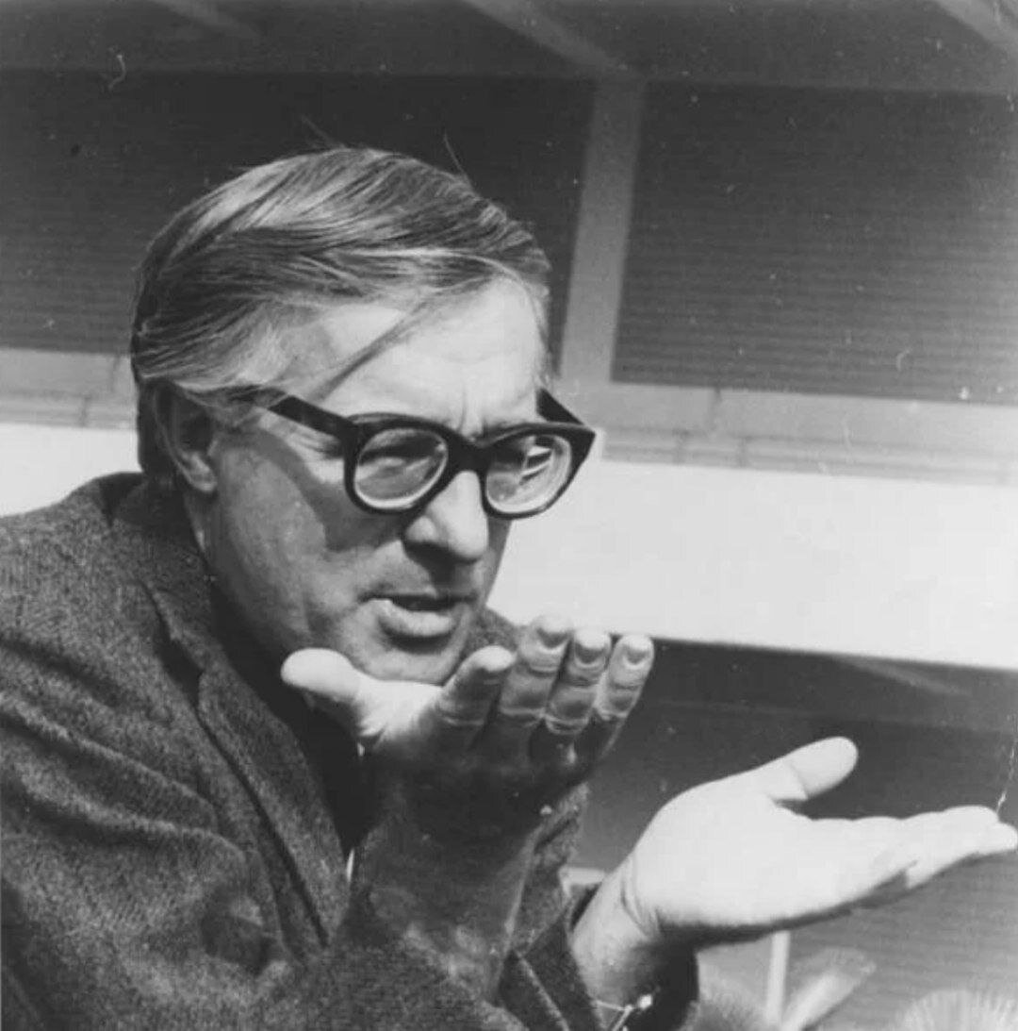

Fly Away Home, Ray Bradbury

Fly Away Home

‘Take good care. That’s it, that’s it.’

The cargo was most especially precious. It had been assembled and disassembled with the tenderest care here at the rocket port and given over to the workmen in immense packing cases, boxes as large as rooms, wrapped, double-wrapped, cottoned and serpentined and velveted over to prevent breakage. For all the tenderness and concern with the cartons and bales and parceled property, everyone rushed.

‘On the double! Quick now!’

This was the Second Rocket. This was the Relief Rocket. The First Rocket had leaped up toward Mars the previous day. It was out booming now in the great black grasslands of space, lost from sight.

And this Second Rocket must follow, as a bloodhound through a haunted moor, seeking a faint smell of iron and burned atom and phosphor. This Second Rocket, of a fat, overpacked size and shape, and with an odd and ridiculous series of people aboard, must not delay.

The Second Rocket was stuffed full. It trembled, shuddered, gathered itself like the hound of heaven, and bounded with a full and graceful leap, into the sky. It shook down avalanches of fire in its track. It rained coals and flame like furnaces suddenly heaven-borne. When the cinders died on the tarmac-concrete, the rocket was gone.

‘Hope it gets there safely,’ said a psychologist’s aide, watching the sky.

The First Rocket arrived from a night sky and landed on the planet Mars. There was a great gasping sound as its machines drank of the cool air. After sniffing it through mechanical nostrils and lungs, the rocket pronounced the air of the finest vintage, ten million years old, intoxicating, but pure.

The rocket men stepped out.

They were alone.

Thirty men and a captain in a land where the wind blew forever across dust seas and around dead cities that had been dead when Earth was opening out like a jungle flower three times twenty million miles away.

The sky was immensely clear, like a vat of crystal alcohol in which the stars blazed without a twinkle. The air knifed the throat and the lungs. You jerked it in with a gasp. It was thin, a ghost, gone when sought after.

The men felt giddy and doubly alone. Sand moaned over their rocket. In time, said the night wind, if you stand quietly, I could bury you, as I did the stone cities and the mummified people hidden there, bury you like a needle and a few bright bits of thread, before you have a chance to make a pattern here.

‘All right!’ cried the captain, snapping it up.

The wind blew his voice away, end over end, a scrap of ghostly paper.

‘Let’s make a line there!’ he cried against the loneliness.

The men moved in a numbed series of motions. They collided and milled and at last found their positions.

The captain faced them. The planet was under and all about them. They were at the bottom of a dry sea. A tide of years and centuries poured over and crushed them. They were the only living things here. Mars was dead and so far away from everything that a trembling began, imperceptibly, among them.

‘Well,’ cried the captain heartily. ‘Here we are!’

‘Here we are,’ said a ghostly voice.

The men jerked about. Behind them, the walls of a half-buried town, a town dreamed full of dust and sand and old moss, a town that had drowned in time up to its highest turrets, tossed back an echo. The black walls quivered as running water does with sand.

‘You all have your work to do!’ cried the captain.

‘To do,’ said the city walls. ‘To do.’

The captain showed his irritation. The men did not turn again, but the backs of their necks were cool and each hair felt separate and stirring.

‘Sixty million miles,’ whispered Anthony Smith, a corporal at the end of the line.

‘No talking there!’ cried the captain.

‘Sixty million miles,’ said Anthony Smith again, to himself, turning. In the cold dark sky, high above, Earth shone, a star, no more than a star, remote, beautiful, but only a star. There was nothing in the shape or the light to suggest a sea, a continent, a state, a city.

‘Let’s have it quiet!’ shouted the captain angrily, surprised at his anger.

The men glanced down the line at Smith.

He was looking at the heavens. They looked where he looked and they saw Earth, infinitely removed over a distance of six months of time, and millions fired upon millions of miles in distance.

Their thoughts whirled. Long years ago, men went to the arctic regions of Earth in boats, ships, balloons, and airplanes, took with them the bravest men, handpicked, psychologically clean, alert, the noncrackables, the well adjusted. But pick as they would, some men cracked, some went off into the arctic whiteness, into the long nights or the insanity of monthlong days.

It was so alone. It was so alone. And herd-man, cut off from life, from women, from homes and towns, felt his mind melt away. Everything was bad and lonely.

‘Sixty million miles!’ said Anthony Smith, louder.

Then take thirty men. Shape, size, box, and parcel them. Antitoxin them, mind and body, purify and psychoanalyze, clap these hardies in a pistol, fire it at a target! At the end, in the final accounting, what do you have?

You have thirty men in a line, one man beginning to talk under his breath, then louder, thirty men gazing up at the sky, seeing at a distant star, knowing that Illinois, Iowa, Ohio, and California are gone. Gone the cities, women, children, everything good, comfortable, and dear.

Here you are, by God, on some terrible world where the wind never stops, where all is dead, where the captain is trying to be hearty. Suddenly, as if you had never considered it before, you say to yourself:

‘Good Lord, I’m on Mars!’

Anthony Smith said it.

‘I’m not home, I’m not on Earth, I’m on Mars! Where’s Earth? There it is! See that damn small pinpoint of light? That’s it! Isn’t it silly? What’re we doing here?’

The men stiffened. The captain jerked his head at Walton, the psychiatrist. They went down the line quickly, trying to be casual.

‘All right, Smith, what seems to be the trouble?’

‘I don’t want to be here.’ Smith’s face was white. ‘Good God, why did I come? This isn’t Earth.’

‘You took all the exams, you knew what you’d be up against.’

‘No, I didn’t. I blocked it off.’

The captain turned to the psychiatrist with a look of irritation and hatred, as if the doctor had failed. The doctor shrugged. ‘Everyone makes mistakes,’ he would have said, but stopped himself.

The young corporal was beginning to cry.

The psychiatrist turned instantly. ‘Get to your jobs! Build a fire! Set up your tents! On the double!’

The men broke, mumbling. They walked off stiffly, looking back. ‘Afraid of this,’ said the psychiatrist. ‘I was afraid. Space travel’s so new, damn it. Sodamnnew. No telling how many sixty million miles’ll affect a person.’ He took hold of the young corporal. ‘Here we are. Everything’s all right. You’d better get to your job, Corporal. Get busy. Get on the ball.’

The corporal had his hands to his face. ‘It’s a Christ-awful feeling. To know we’re so far away from everything. And this whole damn planet is dead. Nothing else here but us.’

They started him unloading packets of frozen food.

The psychiatrist and the captain stood on a sand dune nearby for a moment, watching the men move.

‘He’s right, of course,’ said the psychiatrist. ‘I don’t like it, either. It really hits you. It hits hard. It’s lonely here. It’s awfully dead and far away. And that wind. And the empty cities. I feel lousy.’

‘I don’t feel so well myself,’ said the captain. ‘What do you think? About Smith? Will he stay on this side of the cliff or will he fall over?’

‘I’ll stick with him. He needs friends now. If he falls over, I’m afraid he’ll take some others with him. We’re all tied together by ropes, even if you can’t see them. I hope to hell the second rocket comes through. See you later.’

The psychiatrist went away and the rocket stood on the sea bottom in the night in the center of the planet Mars, as the two white moons rose suddenly, like terrors and memories, and flung themselves in a race over the sky. The captain stood looking up at the sky and Earth burning there.

During the night, Smith went mad. He fell over into darkness, but took no one with him. He pulled hard at the ropes, caused terrible secret panics all night, with screams, shouts, warning of terror and death.

But the others stood firm positioned in the dark, working, perspiring. None was blown with him to his secret place at the bottom of a long cliff. He fell all night. He hit in the morning. Under sedatives, eyes shut, coiled upon himself, he was bunked in the ship, where his cries whispered away.

There was silence, with only the wind and the men working. The psychiatrist passed extra rations of food, chocolate, cigarettes, brandy. He watched. The captain watched with him.

‘I don’t know. I’m beginning to think—’

‘What?’

‘Men were never meant to go so far alone. Space travel asks too much. Isolation, completely unnatural, a form of realistic insanity, space itself, if you ask me,’ said the captain. ‘Watch out, I’m going balmy myself.’

‘Keep talking,’ said the doctor.

‘What do you think? Can we stick it out here?’

‘We’ll hold on. The men look bad, I admit. If they don’t improve in twenty-four hours, and if our relief ship doesn’t show up, we’d best get back into space. Just knowing they’re heading home will snap them out of it.’

‘God, what a waste. What a shame. A billion dollars spent to send us. What do we tell the senators at home, that we were cowards?’

‘At times, cowardice is the only thing left. A man can take only so much, then it’s time for him to run, unless he can find someone to do his running for him. We’ll see.’

The sun rose. The double moons were gone. But Mars was no more comfortable by day than by night. One of the men fired off a gun at some animal he saw behind him. Another stopped work with a blinding headache, and retired to the ship. Though they slept most of the day, it was a fitful sleeping, with many calls on the doctor for sedatives and brandy rations. At nightfall, the doctor and the captain conferred.

‘We’d better pull out,’ said Walton. ‘This man Sorenson is another. I give him twenty-four hours. Ditto Bernard. A damn shame. Good men, both of them. Fine men. But there was no way to duplicate Mars in our Earth offices. No test can duplicate the unknown. Isolation-shock, loneliness-shock,severe. Well, it was a good try. Better to be happy cowards than raving lunatics. Myself? I hate it here. As the man said, I want to go home.’

‘Shall I give the order, then?’ asked the captain.

The psychiatrist nodded.

‘Jesus, God, I hate to give up without a fight.’

‘Nothing to fight but wind and dust. We could give it a decent fight with the relief ship, but that doesn’t seem to be—’

‘Captain, sir!’ someone shouted.

‘Eh?’ The captain and psychiatrist turned.

‘Look there, sir! In the sky! The relief rocket!’

This was no more than the truth. The men ran out of the ship and the tents. The sun was set and the wind was cold, but they stood there, straining their eyes up, watched the fire grow large, larger, larger.

The Second Rocket beat a drum and let out a long plume of red color. It landed. It cooled. The men of the First Rocket ran across the sea bottom toward it, yelling.

‘Well?’ asked the captain, standing back. ‘What does this mean? Do we go or stay?’

‘I think,’ said the psychiatrist, ‘that we’ll stay.’

‘For twenty-four hours?’

‘For a little longer than that,’ Walton replied.

They hoisted immense crates out of the Second Rocket.

‘Careful! Careful there!’

They held up blueprints and wielded hammers and pries and levers. The psychiatrist supervised. ‘This way! Crate 75? Here. Box 067?Here!That’s it. Open ’er up. Tab A into Slot B. Tab B into Slot C. Right, fine,good!’

They put it all up before dawn. In eight hours they assembled the miracles out of boxes and crates. They took away the serpentines, wax papers, cardboards, brushed and dusted every part and portion of the whole. When the time came, the men of the First Rocket stood on the outer rim of the miracle, gazed in at it, incredulous and awed.

‘Ready, Captain?’

‘I’ll be damned! Yes!’

‘Throw the switch.’

The captain threw the switch.

The little town lit up.

‘Good Lord!’ said the captain.

He walked into the single main street of the town.

It was a street of no more than six buildings on a side, false fronts, strung with bright red, yellow, green lights. Music played from a half-dozen hidden jukeboxes, somewhere. Doors slammed.

A man in a white smock emerged from a barbershop, blue shears and a black comb in hand. A peppermint-stick pole rotated slowly behind him. Next was a drugstore, a magazine rack out front, newspapers fluttering in the wind, a fan turning in the ceiling, the snakelike hiss of soda water sounding inside. As they passed the door they looked in. A girl smiled there, a crisp green starched cap on her head.

A pool hall, with green tables, like jungle glades, soft, inviting. Billiard balls, multicolored, triangled, waiting. Across the street, a church, with candied-root-beer, strawberry, lemon-glass windows. A man there, too, in dark suit, white collar. Next to that, a library. Next to that, a hotel. SOFT BEDS. FIRST NIGHT FREE. AIR-CONDITIONING.

A clerk behind a desk with his hand on a silver bell. But the place they were going to, that drew them like the smell of water draws cattle across a dusty prairie, was the building at the head of the street.

THE MILLED BUCK SALOON.

A man with greased, curled hair, his shirtsleeves gartered with red elastic above his hairy elbows, leaned against a post there. He vanished behind swinging doors. When they hit the swinging doors, he was polishing the bar and tipping rye into thirty glasses all lined up glittering on the beautiful long bar. A crystal chandelier blazed warmly overhead. There was a stairway leading up and a number of doors above, on a balcony, and the faintest smell of perfume.

They all went to the bar. They were quiet. They took up the rye and drank it straight down, not wiping their mouths. Their eyes stung.

The captain said, in a whisper, to the psychiatrist, standing by the door, ‘Good God! The expense!’

‘Film sets, knockdowns, collapsibles. A real minister next door in the church of course. Three real barbers. A piano player.’

The man at the yellow-toothed piano began to play ‘St. Louis Woman with Your Diamond Rings.’

‘A druggist, two fountain girls, a pool-hall proprietor, shoeshine boy, rack boy, two librarians, odds and ends, workmen, electricians, et cetera. Totals up another two million dollars. The hotel isallreal. Every room with bath. Comfort. Good beds. Other buildings are three-quarters false front. All of it so beautifully constructed, with slots and tabs, a child could put up the whole toy-works in an hour.’

‘But will it work?’

‘Look at their faces, beginning to relax already.’

‘Why didn’t you tell me?!’

‘Because, if it’d got out, spending money this silly, ridiculous way, the papers would’ve jumped me–senators, Congress, God would have gotten in the act. It’s silly, damn silly, but itworks. It’sEarth.

That’s all I care about. It’sEarth. It’s a piece of Earth the men can hold in their hand and say, “This is Illinois, this is a town Iknew.These arebuildingsI knew. This is a little piece of Earth that’s here for me to hold on to until we bringmoreof it up and make the loneliness run away forever.”’

‘Ingenious, devilish, clever.’

The men ordered a second rye all around, smiling.

‘The men on our ship, Captain, are from fourteen small towns. Picked them that way. One of each of these buildings in this little street here is from one of those towns. The bartender, ministers, grocery-store owner, all thirty of the people on the Second Rocket, are from those towns.’

‘Thirty?Besidesthe relief crew?’

The psychiatrist glanced happily at the steps leading up to the balcony and the series of shut doors. One of the doors opened a trifle and a beautiful blue eye gazed out for a moment.

‘We’ll rush in more lights and more towns every month, more people, more Earth. Priority on familiarity. Familiarity breeds sanity. We’ve won the first round. We’ll keep winning if we keep moving.’

Now the men were beginning to laugh and talk and slap one another on the shoulders. Some of them walked out and across the street for a haircut, some went to play pool, some to buy groceries, some into the quiet church, you could hear organ music for a moment just before the piano player here in the crystal-chandeliered saloon began ‘Frankie and Johnny.’ Two men walked laughingly up the stairs to the doors along the balcony.

‘I’m no drinking man, Captain. How about a pineapple malt at the drugstore over the way?’

‘What? Oh. I was thinking…Smith.’ The captain turned. ‘Back in the ship. Do you think–I mean–could we get Smith, bring him here, with us, would it do any good, would helikeit, mightn’t it make himhappy?’

‘We could certainly try,’ said the doctor.

The pianist was playing, very loud, ‘That Old Gang of Mine.’ Everybody singing, some of them starting to dance, and the city like a jewel blazing in the wilderness, darkness all around.

Mars lonely, the sky black and full of stars, the wind rushing, the moons rising, the seas and old cities dead. But the barber pole whirled brightly, and the church windows were the color of Coca-Cola and lemonade and boysenberry phosphate.

The piano was tinkling ‘Skip to My Lou’ half an hour later when the captain, the psychiatrist, and a third man walked into the drugstore and sat.

‘Three pineapple malts,’ said the captain.

And they sat, reading magazines, turning slowly on the stools, until the girl behind the fountain set three beautiful pineapple malts at their elbows.

They all reached for the straws.

The End