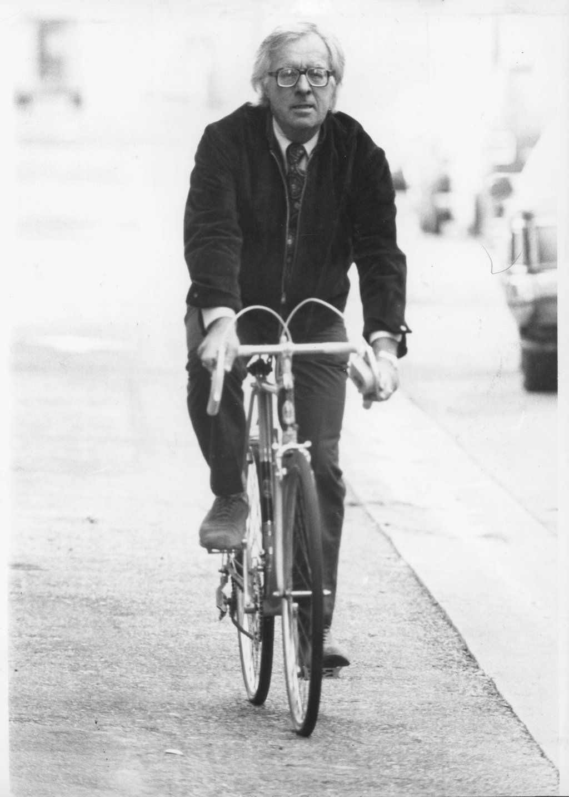

Frost and Fire, Ray Bradbury

Frost and Fire

During the night, Sim was born. He lay wailing upon the cold cave stones. His blood beat through him a thousand pulses each minute. He grew, steadily.

Into his mouth his mother with feverish hands put the food. The nightmare of living was begun. Almost instantly at birth his eyes grew alert, and then, without half understanding why, filled with bright, insistent tenor. He gagged upon the food, choked and wailed. He looked about, blindly.

There was a thick fog. It cleared. The outlines of the cave appeared. And a man loomed up, insane and wild and terrible. A man with a dying face. Old, withered by winds, baked like adobe in the heat. The man was crouched in a far corner of the cave, his eyes whitening to one side of his face, listening to the far wind trumpeting up above on the frozen night planet.

Sim's mother, trembling now and again, staring at the man, fed Sim pebble-fruits, valley-grasses and ice-nipples broken from the cavern entrances, and eating, eliminating, eating again, he grew larger, larger.

The man in the corner of the cave was his father! The man's eyes were all that was alive in his face. He held a crude stone dagger in his withered hands and his jaw hung loose and senseless.

Then, with a widening focus, Sim saw the old people sitting in the tunnel beyond this living quarter. And as he watched, they began to die.

Their agonies filled the cave. They melted like waxen images, their faces collapsed inward on their sharp bones, their teeth protruded. One minute their faces were mature, fairly smooth, alive, electric. The next minute a dessication and burning away of their flesh occurred.

Sim thrashed in his mother's grasp. She held him. "No, no," she soothed him, quietly, earnestly, looking to see if this, too, would cause her husband to rise again.

With a soft swift padding of naked feet, Sim's father ran across the cave. Sim's mother screamed. Sim felt himself torn loose from her grasp. He fell upon the stones, rolling, shrieking with his new, moist lungs!

The webbed face of his father jerked over him, the knife was poised. It was like one of those prenatal nightmares he'd had again and again while still in his mother's flesh. In the next few blazing, impossible instants questions flicked through his brain.

The knife was high, suspended, ready to destroy him. But the whole question of life in this cave, the dying people, the withering and the insanity, surged through Sim's new, small head. How was it that he understood? A newborn child?

Can a newborn child think, see, understand, interpret? No. It was wrong! It was impossible. Yet it was happening! To him. He had been alive an hour now. And in the next instant perhaps dead!

His mother flung herself upon the back of his father, and beat down the weapon. Sim caught the terrific backwash of emotion from both their conflicting minds. "Let me kill him!" shouted the father, breathing harshly, sobbingly. "What has he to live for?"

"No, no!" insisted the mother, and her body, frail and old as it was, stretched across the huge body of the father, tearing at his weapon. "He must live! There may be a future for him! He may live longer than us, and be young!"

The father fell back against a stone crib. Lying there, staring, eyes glittering, Sim saw another figure inside that stone crib. A girl-child, quietly feeding itself, moving its delicate hands to procure food. His sister.

The mother wrenched the dagger from her husband's grasp, stood up, weeping and pushing back her cloud of stiffening gray hair. Her mouth trembled and jerked. "I'll kill you!" she said, glaring down at her husband. "Leave my children alone."

The old man spat tiredly, bitterly, and looked vacantly into the stone crib, at the little girl. "One-eighth ofherlife's over, already," he gasped. "And she doesn't know it. What's the use?"

As Sim watched, his own mother seemed to shift and take a tortured, smokelike form. The thin bony face broke out into a maze of wrinkles. She was shaken with pain and had to sit by him, shuddering and cuddling the knife to her shriveled breasts. She, like the old people in the tunnel, was aging, dying.

Sim cried steadily. Everywhere he looked was horror. A mind came to meet his own. Instinctively he glanced toward the stone crib. Dark, his sister, returned his glance. Their minds brushed like straying fingers. He relaxed somewhat. He began to learn.

The father sighed, shut his lids down over his green eyes. "Feed the child," he said, exhaustedly. "Hurry. It is almost dawn and it is our last day of living, woman. Feed him. Make him grow."

Sim quieted, and images, out of the terror, floated to him.

This was a planet next to the sun. The nights burned with cold, the days were like torches of fire. It was a violent, impossible world. The people lived in the cliffs to escape the incredible ice and the day of flame.

Only at dawn and sunset was the air breath-sweet, flower-strong, and then the cave peoples brought their children out into a stony, barren valley. At dawn the ice thawed into creeks and rivers, at sunset the day fire died and cooled. In the intervals of even, livable temperature the people lived, ran, played, loved, free of the caverns; all life on the planet jumped, burst into life.

Plants grew instantly, birds were flung like pellets across the sky. Smaller, legged animal life rushed frantically through the rocks; everything tried to get its living down in the brief hour of respite.

It was an unbearable planet. Sim understood this, a matter of hours after birth. Racial memory bloomed in him. He would live his entire life in the caves, with two hours a day outside. Here, in stone channels of air he would talk, talk incessantly with his people, sleep never, think, think and lie upon his back, dreaming; but never sleeping.

And he would live exactly eight days.

Theviolenceof this thought! Eight days. Eight short days. It was wrong, impossible, but a fact. Even while in his mother's flesh some racial knowledge or some strange far wild voice had told him he was being formed rapidly, shaped and propelled out swiftly.

Birth was quick as a knife. Childhood was over in a flash. Adolescence was a sheet of lightning. Manhood was a dream, maturity a myth, old age an inescapably quick reality, death a swift certainty.

Eight days from now he'd stand half-blind, withering, dying, as his father now stood, staring uselesly at his own wife and child.

This day was an eighth part of his total life! He must enjoy every second of it. He must search his parents thoughts for knowledge.

Because in a few hours they'd be dead.

This was so impossibly unfair. Was this all of life? In his prenatal state hadn't he dreamed oflonglives, valleys not of blasted stone but green foliage and temperate clime? Yes! And if he'd dreamed then there must be truth in the visions.

How could he seek and find the long life? Where? And how could he accomplish a life mission that huge and depressing in eight short, vanishing days?

How had his people gotten into such a condition?

As if at a button pressed, he saw an image. Metal seeds, blown across space from a distant green world, fighting with long flames, crashing on this bleak planet. From their shattered hulls tumbled men and women.

When? Long ago. Ten thousand days. The crash victims hid in the cliffs from the sun. Fire, ice and floods washed away the wreckage of the huge metal seeds. The victims were shaped and beaten like iron upon a forge.

Solar radiations drenched them. Their pulses quickened, two hundred, five hundred, a thousand beats a minute. Their skins thickened, their blood changed. Old age came rushing. Children were born in the caves. Swifter, swifter, swifter the process. Like all this world's wild life, the men and women from the crash lived and died in a week, leaving children to do likewise.

So this is life, thought Sim. It was not spoken in his mind, for he knew no words, he knew only images, old memory, an awareness, a telepathy that could penetrate flesh, rock, metal.

Somewhere along the line, theyhaddeveloped telepathy, plus racial memory, the only good gifts, the only hope in all this terror. So thought Sim, I'm the five-thousandth in a long line of futile sons? What can I do to save myself from dying eight days from now? Is there escape?

His eyes widened, another image came to focus.

Beyond this valley of cliffs, on a low mountain lay a perfect, unscaned metal seed. A metal ship, not rusted or touched by the avalanches. The ship was deserted, whole, intact. It was the only ship of all these that had crashed that was still a unit, still usable. But it was so far away. There was no one in it to help. This ship, then, on the far mountain, was the destiny toward which he would grow. There was his only hope of escape.

His mind flexed.

In this cliff, deep down in a confinement of solitude, worked a handful of scientists. To these men, when he was old enough and wise enough, he must go. They, too, dreamed of escape, of long life, of green valleys and temperate weathers. They, too, stared longingly at that distant ship upon its high mountain, its metal so perfect it did not rust or age.

The cliff groaned.

Sim's father lifted his eroded, lifeless face.

"Dawn's coming," he said.

The End