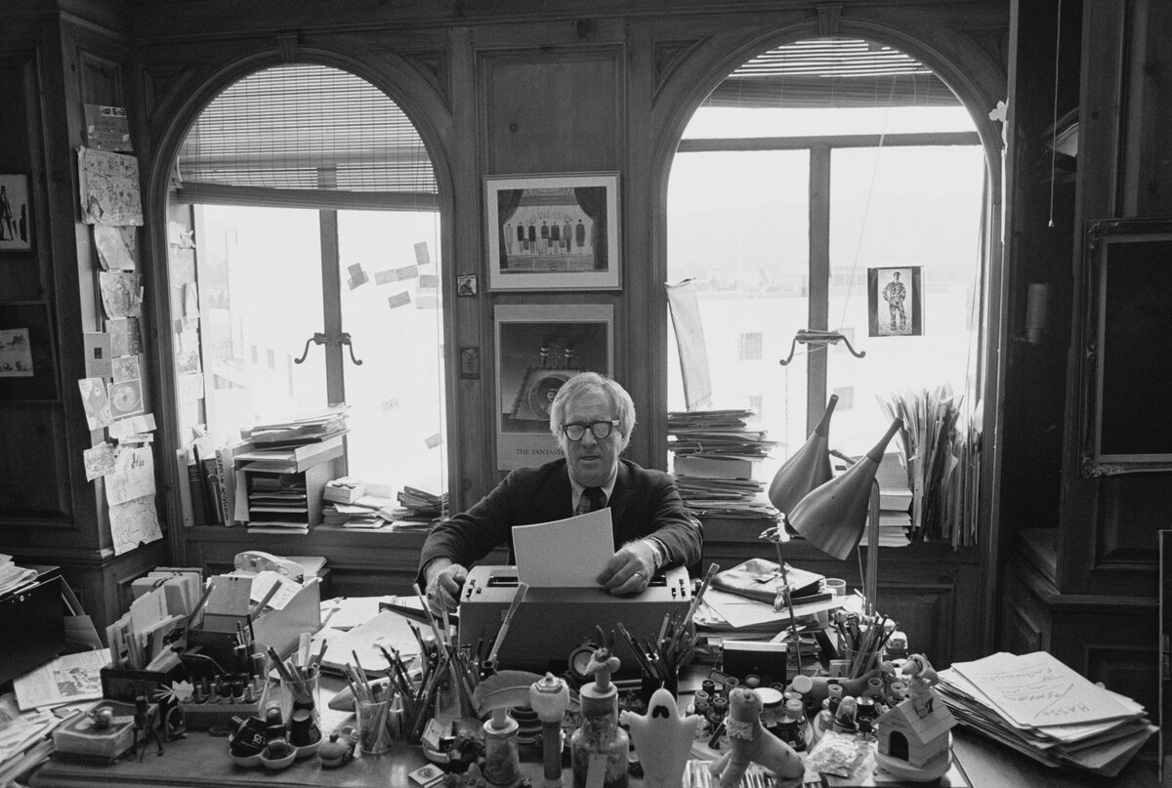

Grand Theft, Ray Bradbury

Grand Theft

Emily Wilkes had her eyes pried open by a peculiar sound at three o'clock in the deep morning, with no moon, and only the stars as witness.

"Rose?" she said.

Her sister, in a separate bed not three feet away, already had her eyes wide, so was not surprised.

"Youhearit?" she said, spoiling everything.

"I was going to tellyou," said Emily. "Since you already seem to know, there's no use—"

She stopped and sat up in bed, as did Rose, both pulled by invisible wires. They sat there, two ancient sisters, one eighty, the other eighty-one, both bone-thin and bundles of nerves because they were staring at the ceiling.

Emily Wilkes nodded her head up. "Thatwhat you heard?"

"Mice in the attic?"

"Sounds bigger'n that. Rats."

"Yes, but it sounds like they're wearing boots and carrying bags."

That did it. Out of bed, they grabbed their wrappers and went downstairs as fast as arthritis would allow. No one wanted to stay underneath whoever wore those boots.

Below they grabbed the banister and stared up, whispering.

"What would anyone do in our atticthistime of night?"

"Burgling all our old junk?"

"You don't think they'll come down andattackus?"

"What, two old fools, with skinny backsides?"

"Thank God, the trapdoor only works one way, and is locked beneath."

They began to edge step by step back up toward the hidden sounds.

"Iknow!" said Rose, suddenly. "In the Chicago papers last week: they're stealingantique furniture!"

"Pshaw! We're the only antiques here!"

"Still, there's some up there. A Morris chair, that's old. Some dining room chairs, older, and a cut crystal chandelier."

"From the dime store, 1914. So ugly we couldn't put it out with the trash. Listen."

It was quieter above. On the top floor, they gazed at the ceiling trapdoor and cocked their ears.

"Someone's opening my trunk." Emily clapped her hands to her mouth. "Hear that? The hinges need oiling."

"Why would they open your trunk? Nothing is there."

"Maybesomething … "

Above, in the dark, the trunk lid fell.

"Fool!" whispered Emily.

Someone tiptoed across the attic floor, careful after being clumsy.

"There's a window up there, they're climbing out!"

The two sisters ran to their own bedroom window.

"Unlock the screen, poke your head out!" cried Rose.

"And let themseeme? No, ma'am!"

They waited and heard a scraping noise and a clatter as something fell on the driveway below.

Gasping, they shoved the screen out to peer down and see a long ladder being toted along the driveway by two shadows. One of the shadows grasped a small white packet in his free hand.

"They stole something!" hissed Emily. "Come!"

Downstairs, they threw the front door wide to see two sets of footprints on the lawn in the dew. A truck, at the curb, pulled away.

Running out, both ladies shaded their eyes to read the vanishing license plate.

"Damnation!" cried Emily. "Did yousee?"

"A seven and nine, is all. Do we call the police?"

"Not till we know what'sgone.Shake a leg."

By flashlight on the attic stairs they unlocked the trapdoor and climbed up into darkness.

Emily swept the attic room with the flash as they stumbled through old suitcases, a child's bike, and that truly ugly chandelier.

"Nothing's gone," said Rose. "Odd-peculiar."

"Maybe. Here's the trunk. Grab on."

As they lifted, the lid sprang back with an exhalation of dust and ancient scent.

"My God, rememberthat? Ben Hur perfume, 1925, came out with the movie!"

"Hush," said Emily. "Oh, hush!"

She poked the flashlight into an empty place in the middle of an old party dress: a sort of crushed pocket, two inches deep, four inches wide, and eight inches long.

"Dear God in heaven!" cried Emily. "They're gone!"

"Gone?"

"My love letters! From 1919 and 1920 and 1921! Wrapped in a pink ribbon, thirty of them. Gone!"

Emily stared down at the coffin-shaped emptiness in the middle of the old party dress. "Why would anyone steal love letters written so far back by someone probably dead to someone, me, good as dead?"

"Emily Bernice!" exclaimed Rose. "Where you been lately? You ever see those TV matinees make you want your mouth washed out with soap? How about the gossip columns in the town gazette? You ever look at the crazy ladies' magazines at the beauty parlor?"

"I trynotto."

"Next time, look! All those folks got up on the dark side of the bed. Our phone'll ring tomorrow. Whoever stole your letters'll want cash to hand them back, or edit them for some crazed women's book club, or for advice in a lovelorn column. Blackmail. What else? Publicity! Come on!"

"Don't call the police! Oh, Rose, I won't wash my underwear for them or anyone! Is there any grape wine left in the pantry? Rose, move! It's the end of the world!"

Going down, they almost fell.

The next day every time a special-delivery mail truck ran by, Emily would part the parlor curtains and wait for it to stop. It never did.

The day after, when a TV repair van slowed to seek an address, Emily stepped out to fend off any ill-mannered reporters who might nose in. They never nosed.

On the third day, when intuition said there had been time enough for theGreen Town Gazetteto save up its spit and let fly, the spit was not saved or flown.

But ...

On the fourth day a single letter fell in her mailbox with no mailman in sight. Emily's name on the letter seemed written in lemon juice and scorched to raise the calligraphy.

"Look," Emily whispered, "Emily BerniceWatriss! And the two-cent stamp is canceled: June fourth, 1921." She held the letter up to X-ray its mystery. "Whoever stole this four nights ago," she gasped, "is sending itbackto me! Why?"

"Open it," said Rose. "The outside is sixty-two years old. What'sinside?"

Emily took a deep breath and slid out the brittle paper with brownish handwriting inafine flourished Palmer penmanship.

"June fourth, 1921," she read. "And the letter says: My dearest dear Emily—"

Emily let a tear drop from one eye.

"Well, goon!" said Rose.

"It's my love letter!"

"I know, I know, but we're two old battle-axes now. Nothing can offend us! Gimme that!"

Rose grabbed and turned the letter toward the light. Her voice faded as her eyes squinted along the fine calligraphy from another year:

"My dearest dear Emily: I know not how to pour out all that is in my heart. I have admired you for so many years and yet, when we have danced or shared picnics at the lake, I have been unable to speak.

At home I stare at myself in the mirror and hate my cowardice. But now at last I must speak my tenderest thoughts or go mad beyond salvation. I fear to offend, and this small letter will take many hours to rewrite.

Dear, dear Emily, know my affection and willingness to share some part of my life near or with you. If you could look upon me with the smallest kindness, I would be overcome with happiness. I have had to stop myself from touching your hand.

And the thought of anything more, the merest kiss, shakes me that I even dare to say these words. My intentions are honorable. If you would permit, I would like to speak to your parents. Until that hour and day, I send you my affections and kindest thoughts for your future life and existence."

Rose's voice sounded clearly with these last words ...

"Signed William Ross Fielding."

Rose glanced at Emily. "William Ross Fielding? Who washe,writing to you and madly in love?"

"Oh, God," Emily Bernice Watriss cried, her eyes blind with tears. "I'll be damned ifIknow!"

Day after day the letters arrived, not by mail, but slipped in the box at midnight or dawn to be read aloud by Rose or Emily who took turns wiping their eyes. Day after day the writer from a far year begged Emily's pardon, worried on her future, and signed himself with a flourish and an almost audible sigh, William Ross Fielding.

And each day Emily, eyes shut, said, "Read it again. Ialmostgot a face to match the words!"

By week's end, with six ancient letters stacked and crumbling fast, Emily fell into exhaustion and exclaimed, "Stop! Devil take that sinful blackmailer who won't show his face! Burn it!"

"Not yet," said Rose, arriving with no ancient yellowed note, but a spanking bright new envelope, nameless outside, nameless in.

Emily, back from the dead, snatched it and read:

"I am ashamed for assisting all this trouble which now must stop. You can find your mail at 11 South St. James. Forgive."

And no signature.

"I don't understand," Emily said.

"Easy as pie," said Rose. "Whoever's sending your letters back is making affectionate approaches with someone else's notes from when Coolidge was president!"

"My God, Rose, feel my face: red-hot. Why would someone climb a ladder, rob an attic, and run? Why not stand on our lawn and yell?"

"Because," said Rose, quietly, turning the new letter over, "maybe whoever wrote this is just as shy now as William Ross Fielding was way back where you can't remember. Now what?"

"I wonder … " Emily stared out the window. " … who lives at 11 South St. James."

"Here it is."

They stood in front of it late in the day.

11 South St. James.

"Who's there looking out at us this very minute?" said Emily.

"Not the gent who sent you the confession," said Rose. "He just helped carry the ladder but can't carry the guilt. In there now is the mad fool who's been sending your notes. And if we don't move the whole street'll be a beehive. Shake a leg."

They crossed the porch and rang the bell. The front door drifted wide. An old man, well into his late seventies, stood there, astonished.

"Why, Emily Bernice Watriss," he exclaimed. "Hello!"

"What," said Emily Bernice Watriss, "in hell's name are youupto?"

"Right now?" he said. "Tea's ready. Yes?"

They sidled in, perched themselves, ready to run, and watched him pour teakettle water over some orange pekoe leaves.

"Cream or lemon?" he asked.

"Don't cream and lemon me!" Emily said.

"Please."

They took their cups but said nothing and drank none, as he sipped his own and said:

"My friend called to admit he had revealed my address. This whole week has made me incredibly sad."

"How do you thinkIfeel?" Emily exclaimed. "Youarethe one, then, who stole my mail and sent it back?"

"I am that one, yes."

"Well then, make your demands!"

"Demands? No, no! Did you fear blackmail? How stupid of me not to guess you might think so. No, no. Are those the letters there?"

"They are!"

"The letter on the top, the first one, dated June fourth, 1921. Would you mind opening it? Just hold it where I can't read it, and let me speak, yes?"

Emily fumbled the letter out on her lap.

"Well?" she said.

"Just this," he said, and shut his eyes and began to recite in a voice they could hardly hear:

"My dearest dear Emily—"

Emily sucked in her breath.

The old man waited, eyes shut, and then repeated the words signed across the inside of his eyelids:

"My dearest dear Emily. I know not how to address you or pour out all that is in my heart—"

Emily let her breath out.

The old man whispered:

"—I have admired you for so many months and years, and yet when I have seen you, when we have danced or shared picnics with your friends at the lake, I had found myself unable to speak—but now at last I must speak my tenderest thoughts or find myself mad beyond salvation—"

Rose took out her handkerchief and applied it to her nose. Emily took out hers and applied it to her eyes.

His voice was soft and then loud and then soft again:

"—and the thought of anything more than that, the merest kiss, shakes me that I dare to put it in words—"

He finished, whispering:

"—until that hour and day, I send you my affections and kindest thoughts for your future life and existence. Signed William Ross Fielding. Now. Second letter."

Emily opened the second letter and held it where he could not see it.

"Dearest dear one," he said. "You have not answered my first letter which means one or several things: you did not receive it, it was kept from you, or you received, destroyed it, or hid it away. If I have offended you, forgive—Everywhere I go, your name is spoken. Young men speak of you. Young women tell rumors that soon you may travel away by ocean liner … "

"They did that, in those days," said Emily, almost to herself. "Young women, sometimes young men, sent off for a year to forget."

"Even if there was nothingtoforget?" said the old man, reading his own palms spread out on his knees.

"Even that. I have another letter here. Can you tell me what it says?"

She opened it and her eyes grew wet as she read the lines and heard him, head down, speak them quietly, from remembrance.

"Dearest dear, do I dare say it, love of my life? You are leaving tomorrow and will not return until long after Christmas. Your engagement has been announced to someone already in Paris, waiting.

I wish you a grand life and a happy one and many children. Forget my name. Forget it? Why, dear girl, you never knew it. Willie or Will? I think you called me that. But there was no last name, really, so nothing to forget. Remember instead my love. Signed W.R.F."

Finished, he sat back and opened his eyes as she folded the letter and placed it with the others in her lap, tears running down her cheeks.

"Why," she asked at last, "did you steal the letters? And use them this way, sixty years later? Who told you where the letters might be? I buried them in that coffin, that trunk, when I sailed to France. I don't think I have looked at them more than once in the past thirty years. Did William Ross Fielding tell you about them?"

"Why, dear girl, haven't you guessed?" said the old man. "My Lord, IamWilliam Ross Fielding."

There was an incredibly long silence.

"Let me look at you." Emily leaned forward as he raised his head into the light.

"No," she said. "I wish I could say. Nothing."

"It's an old man's face now," he said. "No matter. When you sailed around the world one way, I went another. I have lived in many countries and done many things, a bachelor traveling.

When I heard that you had no children and that your husband died, many years ago, I drifted back to this, my grandparents' house. It has taken all these years to nerve myself to find and send this best part of my life to you."

The two sisters were very still. You could almost hear their hearts beating. The old man said:

"What now?"

"Why," said Emily Bernice Watriss Wilkes slowly, "every day for the next two weeks, send the rest of the letters. One by one."

He looked at her, steadily.

"And then?" he said.

"Oh, God!" she said. "I don't know. Let's see."

"Yes, yes. Indeed. Let's say good-bye."

Opening the front door he almost touched her hand.

"My dear dearest Emily," he said.

"Yes?" She waited.

"What—" he said.

"Yes?" she said.

"What … " he said, and swallowed. "What … are you … "

She waited.

"Doing tonight?" he finished, quickly.

The end