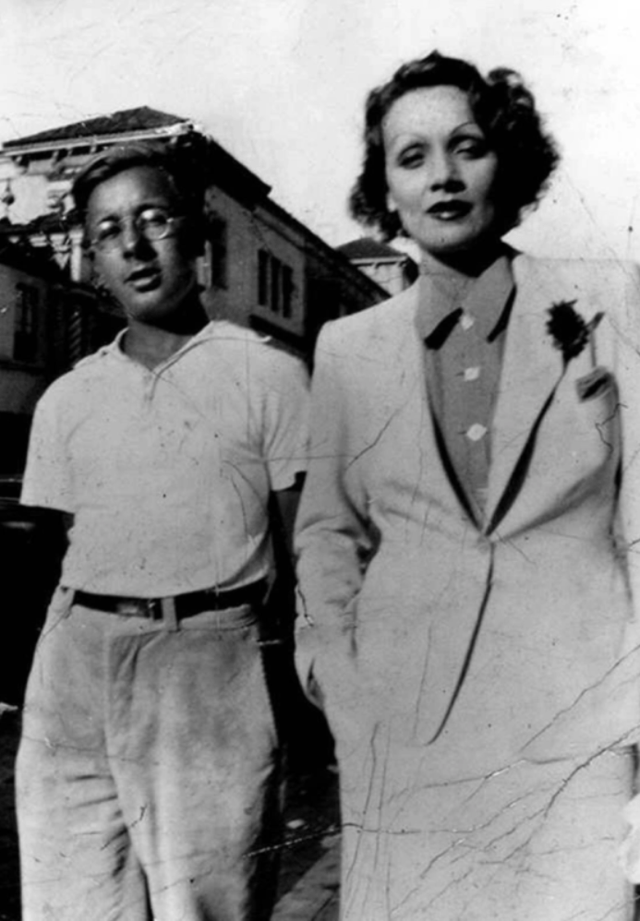

Heavy-Set, Ray Bradbury

Heavy-Set

The woman stepped to the kitchen window and looked out.

There in the twilight yard a man stood surrounded by barbells and dumbbells and dark iron weights of all kinds and slung jump ropes and elastic and coiled-spring exercisors. He wore a sweat suit and tennis shoes and said nothing to no one as he simply stood in the darkening world and did not know she watched.

This was her son, and everyone called him Heavy-Set.

Heavy-Set squeezed the little bunched, coiled springs in his big fists. They were lost in his fingers, like magic tricks; then they reappeared. He crushed them. They vanished. He let them go. They came back.

He did this for ten minutes, otherwise motionless.

Then he bent down and hoisted up the one-hundred-pound barbells, noiselessly, not breathing. He motioned it a number of times over his head, then abandoned it and went into the open garage among the various surfboards he had cut out and glued together and sanded and painted and waxed, and there he punched a punching bag easily, swiftly, steadily, until his curly golden hair got moist.

Then he stopped and filled his lungs until his chest measured fifty inches and stood eyes closed, seeing himself in an invisible mirror poised and tremendous, two hundred and twenty muscled pounds, tanned by the sun, salted by the sea wind and his own sweat.

He exhaled. He opened his eyes.

He walked into the house, into the kitchen and did not look at his mother, this woman, and opened the refrigerator and let the arctic cold steam him while he drank a quart of milk straight out of the carton, never putting it down, just gulping and swallowing. Then he sat down at the kitchen table to fondle and examine the Hallowe’en pumpkins.

He had gone out earlier in the day and bought the pumpkins and carved most of them and did a fine job: they were beauties and he was proud of them. Now, looking childlike in the kitchen, he started carving the last of them.

You would never suspect he was thirty years old, he still moved so swiftly, so quietly, for a large action like hitting a wave with an uptilted and outthrust board, or here with the small action of a knife, giving sight to a Hallowe’en eye. The electric light bulb filled the summer wildness of his hair, but revealed no emotion, except this one intent purpose of carving, on his face. There was all muscle in him, and no fat, and that muscle waited behind every move of the knife.

His mother came and went on personal errands around the house and then came to stand and look at him and the pumpkins and smile. She was used to him. She heard him every night drubbing the punching bag outside, or squeezing the little metal springs in his hands or grunting as he lifted his world of weights and held it in balance on his strangely quiet shoulders.

She was used to all these sounds even as she knew the ocean coming in on the shore beyond the cottage and laying itself out flat and shining on the sand. Even as she was used, by now, to hearing Heavy-Set each night on the phone saying he was tired to girls and said no, no he had to wax the car tonight or do his exercises to the eighteen-year-old boys who called.

She cleared her throat. “Was the dinner good tonight?”

“Sure,” he said.

“I had to get special steak. I bought the asparagus fresh.”

“It was good,” he said.

“I’m glad you liked it, I always like to have you like it.”

“Sure,” he said, working.

“What time is the party?”

“Seven thirty.” He finished the last of the smile on the pumpkin and sat back. “If they all show up, they might not show up, I bought two jugs of cider.”

He got up and moved into his bedroom, quietly massive, his shoulders filling the door and beyond. In the room, in the half-dark, he made the strange pantomime of a man seriously and silently wrestling an invisible opponent as he got into his costume. He came to the door of the living room a minute later licking a gigantic peppermint-striped lollipop. He wore a pair of short black pants, a little boy’s shirt with ruff collar, and a Buster Brown hat.

He licked the lollipop and said, “I’m the mean little kid!” and the woman who had been watching him laughed. He walked with an exaggerated little child’s walk, licking the huge lollipop, all around the room while she laughed at him and he said things and pretended to be leading a big dog on a rope. “You’ll be the life of the party!” the woman cried, pink-faced and exhausted. He was laughing now, also.

The phone rang.

He toddled out to answer it in the bedroom. He talked for a long time and his mother heard him say Oh for gosh sakes several times and finally he came slowly and massively into the living room looking stubborn. “What’s wrong?” she wanted to know. “Aw,” he said, “half the guys aren’t showing up at the party. They got other dates. That was Tommy calling. He’s got a date with a girl from somewhere. Good grief.” “There’ll be enough,” said his mother.

“I don’t know,” he said. “There’ll be enough for a party,” she said. “You go on.” “I ought to throw the pumpkins in the garbage,” he said, scowling. “Well you just go on and have a good time,” she said. “You haven’t been out in weeks.”

Silence.

He stood there twisting the huge lollipop as big as his head, turning it in his large muscular fingers. He looked as if at any moment now he would do what he did other nights. Some nights he pressed himself up and down on the ground with his arms and some nights he played a game of basketball with himself and scored himself, team against team, black against white, in the backyard.

Some nights he stood around like this and then suddenly vanished and you saw him way out in the ocean swimming long and strong and quiet as a seal under the full moon or you could not see him those nights the moon was gone and only the stars lay over the water but you heard him there, on occasion, a faint splash as he went under and stayed under a long time and came up, or he went out some times with his surfboard as smooth as a girl’s cheeks, sandpapered to a softness, and came riding in, huge and alone on a white and ghastly wave that creamed along the shore and touched the sands with the surfboard as he stepped off like a visitor from another world and stood for a long while holding the soft smooth surfboard in the moonlight, a quiet man and a vast tombstone-shaped thing held there with no writing on it.

In all the nights like that in the past years, he had taken a girl out three times one week and she ate a lot and every time he saw her she said Let’s eat and so one night he drove her up to a restaurant and opened the car door and helped her out and got back in and said There’s the restaurant. So long. And drove off. And went back to swimming way out, alone. Much later, another time, a girl was half an hour late getting ready and he never spoke to her again.

Thinking all this, remembering all this, his mother looked at him now.

“Don’t stand there,” she said. “You make me nervous.”

“Well,” he said, resentfully.

“Go on!” she cried. But she didn’t cry it strong enough. Even to herself her voice sounded faint. And she did not know if her voice was just naturally faint or if she made it that way.

She might as well have been talking about winter coming; everything she said had a lonely sound. And she heard the words again from her own mouth, with no force: “Go on!”

He went into the kitchen. “I guess there’ll be enough guys there,” he said. “Sure, there will,” she said, smiling again. She always smiled again. Sometimes when she talked to him, night after night, she looked as if she were lifting weights, too. When he walked through the rooms she looked like she was doing the walking for him.

And when he sat brooding, as he often did, she looked around for something to do which might be burn the toast or overfire the steak. She made a short barking faint and stifled laugh now, “Get out, have a good time.” But the echoes of it moved around in the house as if it were already empty and cold and he should come back in the door. Her lips moved: “Fly away.”

He snatched up the cider and the pumpkins and hurried them out to his car. It was a new car and had been new and unused for almost a year. He polished it and jiggered with the motor or lay underneath it for hours messing with all the junk underneath or just sat in the front seat glancing over the strength and health magazines, but rarely drove it.

He put the cider and the cut pumpkins proudly in on the front seat, and by this time he was thinking of the possible good time tonight so he did a little child’s stagger as if he might drop everything, and his mother laughed. He licked his lollipop again, jumped into the car, backed it out of the gravel drive, swerved it around down by the ocean, not looking out at this woman, and drove off along the shore road. She stood in the yard watching the car go away. Leonard, my son, she thought.

It was seven fifteen and very dark now; already the children were fluttering along the sidewalks in white ghost sheets and zinc-oxide masks, ringing bells, screaming, lumpy paper sacks banging their knees as they ran.

Leonard, she thought.

They didn’t call him Leonard, they called him Heavy-Set and Sammy, which was short for Samson. They called him Butch and they called him Atlas and Hercules. At the beach you always saw the high-school boys around him feeling his biceps as if he was a new sports car, testing him, admiring him.

He walked golden among them. Each year it was that way. And then the eighteen-year-old ones got to be nineteen and didn’t come around so often, and then twenty and very rarely, and then twenty-one and never again, just gone, and suddenly there were new eighteen year olds to replace them, yes, always the new ones to stand where the others had stood in the sun, while the older ones went on somewhere to something and somebody.

Leonard, my good boy, she thought. We go to shows on Saturday nights. He works on the high power lines all day, up in the sky, alone, and sleeps alone in his room at night, and never reads a book or a paper or listens to a radio or plays a record, and this year he’ll be thirty-one. And just where, in all the years, did the thing happen that put him up on that pole alone and working out alone every night?

Certainly there had been enough women, here and there, now and then, through his life. Little scrubby ones, of course, fools, yes, by the look of them, but women, or girls, rather, and none worth glancing at a second time. Still, when a boy gets past thirty . . .?

She sighed. Why even as recent as last night the phone had rung. Heavy-Set had answered it, and she could fill in the unheard half of the conversation because she had heard thousands like it in a dozen years:

“Sammy, this is Christine.” A woman’s voice. “What you doing?”

His little golden eyelashes flickered and his brow furrowed, alert and wary. “Why?”

“Tom, Lu, and I are going to a show, want to come along?”

“It better be good!” he cried, indignantly.

She named it.

“That!” He snorted.

“It’s a good film,” she said.

“Not that one,” he said. “Besides, I haven’t shaved yet today.”

“You can shave in five minutes.”

“I need a bath, and it’d take a long time.”

A long time, thought his mother, he was in the bathroom two hours today. He combs his hair two dozen times, musses it, combs it again, talking to himself.

“Okay for you.” The woman’s voice on the phone. “You going to the beach this week?”

“Saturday,” he said, before he thought.

“See you there, then,” she said.

“I meant Sunday,” he said, quickly.

“I could change it to Sunday,” she replied.

“If I can make it,” he said, even more quickly. “Things go wrong with my car.”

“Sure,” she said. “Samson. So long.”

And he had stood there for a long time, turning the silent phone in his hand.

Well, his mother thought, he’s having a good time now. A good Hallowe’en party, with all the apples he took along, tied on strings, and the apples, untied, to bob for in a tub of water, and the boxes of candy, the sweet corn kernels that really taste like autumn. He’s running around looking like the bad little boy, she thought, licking his lollipop, everyone shouting, blowing horns, laughing, dancing.

At eight, and again at eight thirty and nine she went to the screen door and looked out and could almost hear the party a long way off at the dark beach, the sounds of it blowing on the wind crisp and furious and wild, and wished she could be there at the little shack out over the waves on the pier, everyone whirling about in costumes, and all the pumpkins cut each a different way and a contest for the best homemade mask or makeup job, and too much popcorn to eat and—

She held to the screen door knob, her face pink and excited and suddenly realized the children had stopped coming to beg at the door. Hallowe’en, for the neighborhood kids anyway, was over.

She went to look out into the backyard.

The house and yard were too quiet. It was strange not hearing the basketball volley on the gravel or the steady bumble of the punching bag taking a beating. Or the little tweezing sound of the hand-squeezers.

What if, she thought, he found someone tonight, found someone down there, and just never came back, never came home. No telephone call. No letter, that was the way it could be. No word. Just go off away and never come back again. What if? What if?

No! she thought, there’s no one, no one there, no one anywhere. There’s just this place. This is the only place.

But her heart was beating fast and she had to sit down.

The wind blew softly from the shore.

She turned on the radio but could not hear it.

Now, she thought, they’re not doing anything except playing blind man’s buff, yes, that’s it, blind tag, and after that they’ll just be—

She gasped and jumped.

The windows had exploded with raw light.

The gravel spurted in a machine-gun spray as the car jolted in, braked, and stopped, motor gunning. The lights went off in the yard. But the motor still gunned up, idled, gunned up, idled.

She could see the dark figure in the front seat of the car, not moving, staring straight ahead.

“You—” she started to say, and opened the back screen door. She found a smile on her mouth. She stopped it. Her heart was slowing now. She made herself frown.

He shut off the motor. She waited. He climbed out of the car and threw the pumpkins in the garbage can and slammed the lid.

“What happened?” she asked. “Why are you home so early—?”

“Nothing.” He brushed by her with the two gallons of cider intact. He set them on the kitchen sink.

“But it’s not ten yet—”

“That’s right.” He went into the bedroom and sat down in the dark.

She waited five minutes. She always waited five minutes. He wanted her to come ask, he’d be mad if she didn’t, so finally she went and looked into the dark bedroom.

“Tell me,” she said.

“Oh, they all stood around,” he said. “They just stood around like a bunch of fools and didn’t do anything.”

“What a shame.”

“They just stood around like dumb fools.”

“Oh, that’s a shame.”

“I tried to get them to do something, but they just stood around. Only eight of them showed up, eight out of twenty, eight, and me the only one in costume. I tell you. The only one. What a bunch of fools.”

“After all your trouble, too.”

“They had their girls and they just stood around with them and wouldn’t do anything, no games, nothing. Some of them went off with the girls,” he said, in the dark, seated, not looking at her. “They went off up the beach and didn’t come back.

Honest to gosh.” He stood now, huge, and leaned against the wall, looking all disproportioned in the short trousers. He had forgotten the child’s hat was on his head. He suddenly remembered it and took it off and threw it on the floor. “I tried to kid them. I played with a toy dog and did some other stuff but nobody did anything.

I felt like a fool the only one there dressed like this, and them all different, and only eight out of twenty there, and most of them gone in half an hour. Vi was there. She tried to get me to walk up the beach, too. I was mad by then. I was really mad. I said no thanks. And here I am. You can have the lollipop. Where did I put it? Pour the cider down the sink, drink it, I don’t care.”

She had not moved so much as an inch in all the time he talked. She opened her mouth.

The telephone rang.

“If that’s them, I’m not home.”

“You’d better answer it,” she said.

He grabbed the phone and whipped off the receiver.

“Sammy?” said a loud high clear voice. He was holding the receiver out on the air, glaring at it in the dark. “That you?” He grunted. “This is Bob.” The eighteen-year-old voice rushed on. “Glad you’re home. In a big rush, but—what about that game tomorrow?”

“What game?”

“What game? For cri-yi, you’re kidding. Notre Dame and S.C.!”

“Oh, football.”

“Don’t say oh football like that, you talked it, you played it up, you said—”

“That’s no game,” he said, not looking at the telephone, the receiver, the woman, the wall, nothing.

“You mean you’re not going? Heavy-Set, it won’t be a game without you!”

“I got to water the lawn, polish the car—”

“You can do that Sunday!”

“Besides, I think my uncle’s coming over to see me. So long.”

He hung up and walked out past his mother into the yard. She heard the sounds of him out there as she got ready for bed.

He must have drubbed the punching bag until three in the morning. Three, she thought, wide awake, listening to the concussions. He’s always stopped at twelve, before.

At three thirty he came into the house.

She heard him just standing outside her door.

He did nothing else except stand there in the dark, breathing.

She had a feeling he still had the little boy suit on. But she didn’t want to know if this were true.

After a long while the door swung slowly open.

He came into her dark room and lay down on the bed, next to her, not touching her. She pretended to be asleep.

He lay face up and rigid.

She could not see him. But she felt the bed shake as if he were laughing. She could hear no sound coming from him, so she could not be sure.

And then she heard the squeaking sounds of the little steel springs being crushed and uncrushed, crushed and uncrushed in his fists.

She wanted to sit up and scream for him to throw those awful noisy things away. She wanted to slap them out of his fingers.

But then, she thought, what would he do with his hands? What could he put in them? What would he, yes, what would he do with his hands?

So she did the only thing she could do, she held her breath, shut her eyes, listened, and prayed, O God, let it go on, let him keep squeezing those things, let him keep squeezing those things, let him, let him, oh let, let him, let him keep squeezing . . . let . . . let . . .

It was like lying in bed with a great dark cricket.

And a long time before dawn.

The End