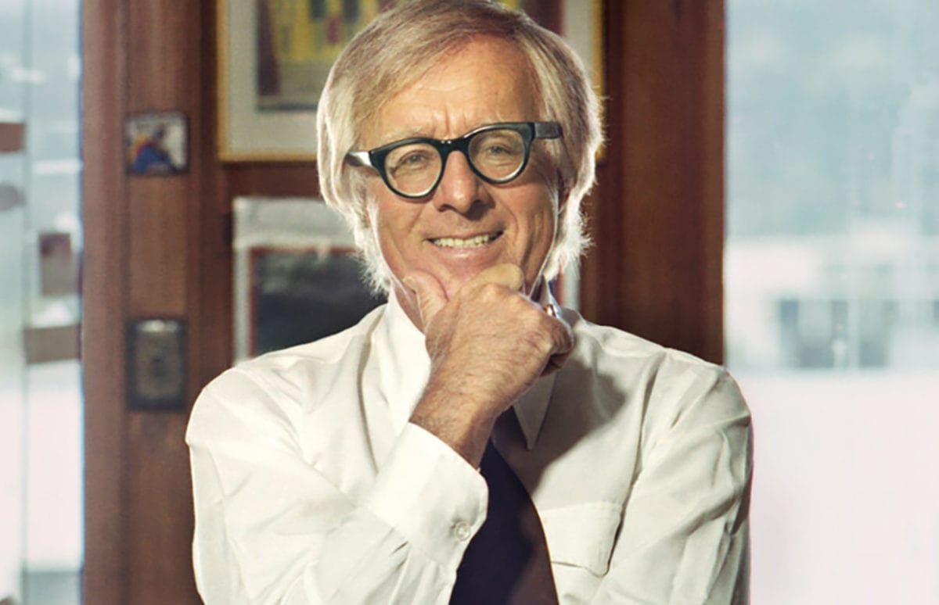

Henry the Ninth, Ray Bradbury

Henry the Ninth

“There he is!”

The two men leaned. The helicopter tilted with their lean. The coastline whipped by below.

“No. Just a bit of rock and some moss—”

The pilot lifted his head, which signaled the lift of the helicopter to swivel and rush away. The white cliffs of Dover vanished. They broke over green meadows and so wove back and forth, a giant dragonfly excursioning the stuffs of winter that sleeted their blades.

“Wait! There! Drop!”

The machine fell down; the grass came up. The second man, grunting, pushed the bubble-eye aside and, as if he needed oiling, carefully let himself to the earth. He ran. Losing his breath instantly he slowed to cry bleakly against the wind:

“Harry!”

His yell caused a ragged shape on the rise ahead to stumble up and run.

“I’ve done nothing!”

“It’s not the law, Harry! It’s me! Sam Welles!”

The old man who fled before him slowed, then stopped, rigid, on the edge of the cliff above the sea, holding to his long beard with two gloved hands.

Samuel Welles, gasping, trudged up behind, but did not touch, for fear of putting him to flight.

“Harry, you damn fool. It’s been weeks. I was afraid I might not find you.”

“And I was afraid you would.”

Harry, whose eyes had been tight shut, now opened them to look tremblingly down at his beard, his gloves, and over at his friend Samuel. Here they were, two old men, very gray, very cold, on a rise of raw stone on a December day.

They had known each other so long, so many years, they had passed each other’s expressions back and forth between their faces. Their mouths and eyes, therefore, were similar. They might have been ancient brothers. The only difference showed in the man who had unhinged himself from the helicopter. Under his dark clothes you could spy an incongruous Hawaiian-colored sport shirt. Harry tried not to stare at it.

Right now, anyway, both their eyes were wet.

“Harry, I came to warn you.”

“No need. Why do you think I’ve been hiding. This is the final day?”

“The final, yes.”

They stood and thought on it.

Christmas tomorrow. And now this Christmas Eve afternoon the last boats leaving. And England, a stone in a sea of mist and water, would be a marble monument to herself left written on by rain and buried in fog.

After today, only the gulls would own the island. And a billion monarch butterflies in June rising up like celebrations tossed on parades to the sea.

Harry, his eyes fixed to the tidal shore, spoke:

“By sunset, will every damn stupid idiot fool clear off the Isle?”

“That’s about the shape of it.”

“And a dread shape it is. And you, Samuel, have you come to kidnap me?”

“Persuade is more like it.”

“Persuade? Great God, Sam, don’t you know me after fifty years? Couldn’t you guess I would want to be the last man in all Britain, no, that hasn’t the proper sound, Great Britain?”

Last man in Great Britain, thought Harry, Lord, listen. It tolls. It is the great bell of London heard through all the mizzles down through time to this strange day and hour when the last, the very last save one, leave this racial mound, this burial touch of green set in a sea of cold light. The last. The last.

“Samuel, listen. My grave is dug. I’d hate to leave it behind.”

“Who’ll put you in it?”

“Me, when the time’s right.”

“And who’s to cover over?”

“Why, there’s dust to cover dust, Sam. The wind will see to it. Ah, God!” Not wishing it, the words exploded from his mouth. He was amazed to see tears flung out on the air from his blinking eyes. “What are we doing here? Why all the good-byes?

Why are the last boats in the Channel and the last jets gone? Where did people go, Sam? What happened, what happened!”

“Why,” said Samuel Welles quietly, “it’s simple, Harry. The weather here is bad. Always has been. No one dared speak of it, for nothing could be done. But now, England is finished. The future belongs—”

Their eyes moved jointly south.

“To the damn Canary Islands?”

“Samoa.”

“To the Brazilian shores?”

“Don’t forget California, Harry.”

Both laughed, gently.

“California. All the jokes. That funny place. And yet, aren’t there a million English from Sacramento to Los Angeles this noon?”

“And another million in Florida.”

“Two million Down Under, the past four years alone.”

They nodded at the sums.

“Well, Samuel, man says one thing. The sun says another. So man goes by what his skin tells his blood. And the blood at last says: South. It has been saying it for two thousand years. But we pretended not to hear.

A man with his first sunburn is a man in the midst of a new love affair, know it or not. Finally, he lies out under some great foreign sky and says to the blinding light: Teach me, oh God, gently, teach.”

Samuel Welles shook his head with awe. “Keep talking like that and I won’t have to kidnap you!”

“No, the sun may have taught you, Samuel, but cannot quite teach me. I wish it could. The truth is, ’twill be no fun here alone. Can’t I argue you, Sam, to stay on, the old team, you and me, like when we were boys, eh?” He buffed the other’s elbow roughly, dearly.

“God, you make me feel I’m deserting King and Country.”

“Don’t. You desert nothing, for no one’s here. Who would have dreamed, when we were kids in 1980, the day would come when a promise of always summer would leak John Bull to the four corners of beyond?”

“I’ve been cold all my life, Harry. Too many years putting on too many sweaters and not enough coal in the scuttle. Too many years when the sky did not show so much as a crack of blue on the first day of June nor a smell of hay in July nor a dry day and winter begun August 1st, year on year. I can’t take it anymore, Harry, I can’t.”

“Nor need you. Our race has suffered itself well. You have earned, all of you, you deserve, this long retirement in Jamaica, Port-au-Prince, and Pasadena. Give me that hand. Shake hard again! It’s a great moment in history. You and me, we’re living it!”

“So we are, by God.”

“Now look here, Sam, when you’ve gone and settled in Sicily, Sidney, or Navel Orange, California, tell this ‘moment’ to the news. They might write you in a column. And history books? Well, shouldn’t there be half a page for you and me, the last gone and the last stayed behind? Sam, Sam, you’re breaking the bones, but shake away, hold tight, this is our last tussle.”

They stood off, panting, wet-eyed.

“Harry, now, will you walk me as far as the copter?”

“No. I fear the damn contraption. The thought of the sun on his dark day might leap me in and fly me off with you.”

“And what harm in that?”

“Harm! Why, Samuel, I must guard our coast from invasion. The Normans, the Vikings, the Saxons. In the coming years I’ll walk the entire isle, stand guard from Dover north on round the reefs and back through Folkestone, here again.”

“Will Hitler invade, chum?”

“He and his iron ghosts just might.”

“And how will you fight him, Harry?”

“Do you think I walk alone? No. Along the way, I may find Caesar on the shore. He loved it so he left a road or two. Those roads I’ll take, and borrow just those ghosts of choice invaders to repel less choice. It’s up to me, yes, to commit or uncommit ghosts, choose or not choose out of the whole damn history of the land?”

“It is. It is.”

The last man wheeled to the north and then to the west and then to the south.

“And when I’ve seen all’s well from castle here to lighthouse there, and listened to battles of gunfires in the plunge off Firth, and bagpiped round Scotland with a sour mean pipe, in each New Year’s week, Sam, I’ll scull back down-Thames and there each December 31st to the end of my life, the night watchman of London, meaning me, yes, me, will make his clock rounds and say out the bells of the old rhymed churches. Oranges and lemons say the bells of St. Clemens. Bow bells. St. Marguerite’s. Paul’s. I shall dance rope-ends for you, Sam, and hope the cold wind blown south to the warm wind wherever you are stirs some small gray hairs in your sunburned ears.”

“I’ll be listening, Harry.”

“Listen more! I’ll sit in the houses of Lords and Commons and debate, losing one hour but to win the next. And say that never before in history did so many owe so much to so few and hear the sirens again from old remembered records and things broadcast before we both were born.

“And a few seconds before January 1st I shall climb and lodge with mice in Big Ben as it strikes the changing of the year.

“And somewhere along the line, no doubt, I shall sit on the Stone of Scone.”

“You wouldn’t!”

“Wouldn’t I? Or the place where it was, anyway, before they mailed it south to Summer’s Bay. And hand me some sort of sceptre, a frozen snake perhaps stunned by snow from some December garden. And fit a kind of paste-up crown upon my head. And name me friend to Richard, Henry, outcast kin of Elizabeths I and II.

Alone in Westminster’s desert with Kipling mum and history underfoot, very old, perhaps mad, mightn’t I, ruler and ruled, elect myself king of the misty isles?”

“You might, and who would blame you?”

Samuel Welles bearhugged him again, then broke and half ran for his waiting machine. Halfway he turned to call back:

“Good God. I just thought. Your name is Harry. What a fine name for a king!”

“Not bad.”

“Forgive me for leaving?!”

“The sun forgives all, Samuel. Go where it wants you.”

“But will England forgive?”

“England is where her people are. I stay with old bones. You go with her sweet flesh, Sam, her fair sunburned skin and blooded body, get!”

“Good-bye.”

“God be with you, too, oh you and that bright yellow sport shirt!”

And the wind snatched between and though both yelled more neither heard, waved, and Samuel hauled himself into that machine which swarmed the air and floated off like a vast white summer flower.

And the last man left behind in great gasps and sobs cried out to himself:

Harry! Do you hate change? Against progress? You do see, don’t you, the reasons for all this? That ships and jets and planes and a promise of weather piped all the folk away? I see, he said, I see. How could they resist when at long last forever August lay just across the sill?

Yes, yes! He wept and ground his teeth and leaned up from the cliff rim to shake his fists at the vanishing craft in the sky.

“Traitors! Come back!”

You can’t leave old England, can’t leave Pip and Humbug, Iron Duke and Trafalgar, the Horse Guard in the rain, London burning, buzz bombs and sirens, the new babe held high on the palace balcony, Churchill’s funeral cortege still in the street, man, still in the street! and Caesar not gone to his Senate, and strange happenings this night at Stonehenge! Leave all this, this, this!?

Upon his knees, at the cliff’s edge, the last and final king of England, Harry Smith wept alone.

The helicopter was gone now, called toward august isles where summer sang its sweetness in the birds.

The old man turned to see the countryside and thought, why this is how it was one hundred thousand years ago. A great silence and a great wilderness and now, quite late, the empty shell towns and King Henry, Old Harry, the Ninth.

He rummaged half blindly about in the grass and found his lost book bag and chocolate bits in a sack and hoisted his Bible, and Shakespeare and much-thumbed Johnson and much-tongued Dickens and Dryden and Pope, and stood out on the road that led all round England.

Tomorrow: Christmas. He wished the world well. Its people had gifted themselves already with sun, all over the globe. Sweden lay empty. Norway had flown. None lived any longer in God’s cold climes.

All basked upon the continental hearths of His best lands in fair winds under mild skies. No more fights just to survive. Men, reborn like Christ on such as tomorrow, in southern places, were truly returned to an eternal and fresh-grown manger.

Tonight, in some church, he would ask forgiveness for calling them traitors.

“One last thing, Harry. Blue.”

“Blue?” he asked himself.

“Somewhere down the road find some blue chalk. Didn’t English men once color themselves with such?”

“Blue men, yes, from head to foot!”

“Our ends are in our beginnings, eh?”

He pulled his cap tight. The wind was cold. He tasted the first snowflakes that fell to brush his lips.

“O remarkable boy!” he said, leaning from an imaginary window on a golden Christmas morn, an old man reborn and gasping for joy, “Delightful boy, there, is the great bird, the turkey, still hung in the poulterer’s window down the way?”

“It’s hanging there now,” said the boy.

“Go buy it! Come back with the man and I’ll give you a shilling. Come back in less than five minutes and I’ll give you a crown!”

And the boy went to fetch.

And buttoning his coat, carrying his books, Old Harry Ebenezer Scrooge Julius Caesar Pickwick Pip and half a thousand others marched off along the road in winter weather. The road was long and beautiful. The waves were gunfire on the coast. The wind was bagpipes in the north.

Ten minutes later, when he had gone singing beyond a hill, by the look of it, all the lands of England seemed ready for a people who someday soon in history might arrive . . .

The End