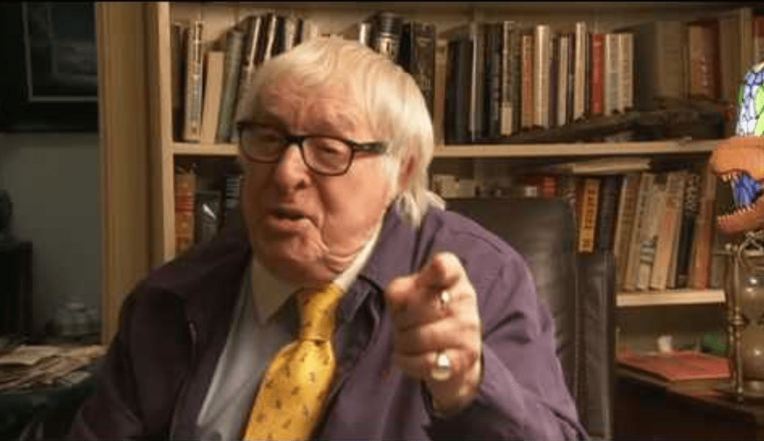

If Paths Must Cross Again, Ray Bradbury

If Paths Must Cross Again

It was almost unbelievable when they found out. Dave Lacey couldn’t believe it, and Theda didn’t dare. It shocked them gently, stunned them, then turned them a bit cold, and they were sad and wondrous all at once.

‘No, it can’t be,’ insisted Theda, clenching his hand. ‘It just can’t. I went to Central School, the eighth grade, and that was in 1933, and you—’

‘Sure,’ said Dave, delightedly out of breath. ‘I came to town in 1933, right there to Brentwood, Illinois, I swear it, and I roomed in the YMCA right across the street from Central School for six months. My parents had divorce troubles in Chicago and packed me off up there from April to September!’

‘Oh, Lord.’ She sighed. ‘What floor did you live on?’

‘The fifth,’ said he. He lit a cigarette, gave it to her, lit another, and leaned back against the leather wall of the La Bomba cocktail lounge. Soft music played somewhere in dimness; both paid it no heed. He snapped his fingers. ‘I used to eat at Mick’s, half a block down the street from the Y.’

‘Mick’s!’ cried Theda. ‘I ate there, too. Mother said it was a horrid greasy sort of place, so I ate there on the sly. Oh, Lordy, David, all those years ago, and we didn’t even know it!’

His eyes were distant, thinking back quietly. He nodded gently. ‘Why, I ate at Mick’s every noon. Sat down at the end where I could watch girls from school walk by in bright dresses.’

‘And here we are in Los Angeles, two thousand miles away and ten years removed from it, and I’m twenty-four,’ said Theda, ‘and you’re twenty-nine, and it took us all these years to meet!’

He shook his head uncomprehendingly. ‘Why didn’t I find you then?’

‘Maybe we weren’t supposed to meet then.’

‘Maybe,’ he said, ‘I was scared. That’s probably it. I was a frightened sort. Girls had to waylay me. I wore horn-rims and carried thick books under my arm instead of muscles. Lord, Lord, Theda, darling, I ate more hamburgers at Mike’s.’

‘With big hunks of onion,’ said Theda. ‘And hotcakes with syrup. Remember?’ She began to think and it was hard, looking at him. ‘I don’t remember you, Dave. I send my mind back, searching frantically, back a decade, and I never saw you then. At least not the way you are now.’

‘Perhaps you snubbed me.’

‘I did if you flirted.’

‘No. I only remember looking at a blond girl.’

‘A blond girl in Brentwood in the year 1933,’ said Theda. ‘In Mike’s at twelve o’clock on a spring day.’ Theda thought back. ‘How was she dressed?’

‘All I remember is a blue ribbon in her hair, tied in a large bow, and I have an impression of a blue polka-dot dress and young breasts just beginning to rise. Oh, she was pretty.’

‘Do you remember her face, Dave?’

‘Only that she was beautiful. You don’t remember single faces out of a crowd after so much time’s passed. Think of all the people you meet on the street every day, Theda.’

She closed her eyes. ‘If I’d only known then that I’d meet you later in life, I would have looked for you.’

He laughed ironically. ‘But you never know those things. You see too many people every week, every year, and most of them are destined for obscurity. All you can do, later, is look back at the dim movements of the years and see where your life briefly touched, flickered against another’s.

The same town, the same restaurant, the same food, the same air, but two different paths and ways of living, oblivious one of the other.’ He kissed her fingers. ‘I should have kept my eyes open for you, too. But the only girl I noticed was that blond girl with the ribbon hair.’

It irritated her. ‘We rubbed elbows, we actually passed on the street. Why, on summer nights, I bet you were down at the carnival at the lake.’

‘Yes, I went down. I looked at the colored lights reflected in the water and heard the merry-go-round music jangling at the stars!’

‘I remember, I remember,’ she said eagerly. ‘And maybe some nights you went to the Academy Theatre?’

‘I saw Harold Lloyd’s pictureWelcome Dangerthere that summer.’

‘Yes, yes. I was there. I remember. And they had a short feature with Ruth Etting singing “Shine On, Harvest Moon.” Follow the bouncing ball.’

‘You’ve got a memory,’ he said.

‘Darling, so near and yet so far. Do you realize we practically knocked each other down going by for six months. It’s murderous! Those brief months together and then ten years until this year. It happens all the time. We live a block from people in New York, never see them, go to Milwaukee and meet them at a party. And tomorrow night—’

She stopped talking. Her face paled and she held his strong tanned fingers. Dim lights played off his lieutenant’s bars, winking them strangely, hypnotically.

He had to finish it for her, slowly. ‘Tomorrow night I go away again. Overseas. So damn soon, oh, so damn soon.’ He made a fist and beat the table slowly, with no noise. After a while he looked at his wristwatch and exhaled. ‘We’d better go, darling. It’s late.’

‘No,’ she said. ‘Please, Dave, just a moment more.’ She looked at him. ‘I’ve got the awfulest feeling. I’m scared stiff. I’m sorry.’

He closed his eyes, opened them, looked around, and saw the faces. Theda did likewise. Perhaps they both thought the same strange thoughts.

‘Look around, Theda,’ he said. ‘Remember all these faces. Maybe, if I don’t come back, you may meet someone else again and you’ll go with them six months and suddenly discover that your paths crossed before–on a July night 1944 at a cocktail place called La Bomba on the Sunset Strip.

And, oh yeah, you were with a young lieutenant named David Lacey that night, whatever happened to him? Oh, he went to war and didn’t come back–and well, by gosh, you’ll discover that one of these faces in the room right now was here seeing this, seeing me talk to you now, noting your beauty and hearing me say “I love you, I love you.” Remember these faces, Theda, and maybe they’ll remember us, and—’

Her fingers went upon his lips, sealing in any other words. She was crying and afraid and her eyes blinked a wet film through which she saw the many faces of people looking her way, and she thought of all the paths and patterns, and it was awful, the future, David—She looked at him again, holding him so tightly, and she said that she loved him over and over.

And all the rest of the evening he was a boy in horn-rims with books under his arm, and she was a golden-haired girl with a very blue ribbon tied in her long bright hair…

The End