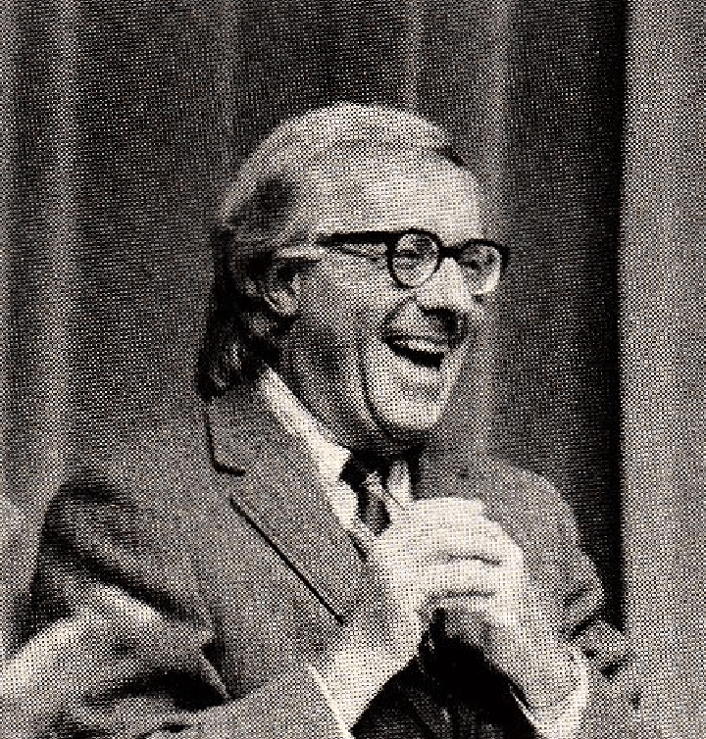

Junior, Ray Bradbury

Junior

It was on the morning of october 1 that Albert Beam, aged eighty-two, woke to find an incredible thing had happened, if not in the night, miraculously at dawn.

He witnessed a warm and peculiar rise two-thirds of the way down the bed, under the covers. At first he thought he had drawn up one knee to ease a cramp, but then, blinking, he realized—

It was his old friend, Albert, Junior.

Or just Junior, as some frolicsome girl had dubbed it, how long, oh God . . . some sixty years ago!

And Junior was alive, well, and freshly alert.

Hallo, thought Albert Beam, Senior, to the scene, that’s the first time he’s waked before me since July 1970.

July 1970!

He stared. And the more he stared and mused, the more Junior blushed unseen; all resolute, a true beauty.

Well, thought Albert Beam, I’ll just wait for him to go away.

He shut his eyes and waited, but nothing happened. Or rather, it continued to happen. Junior did not go away. He lingered, hopeful for some new life.

Hold on! thought Albert Beam. It can’t be.

He sat bolt upright, his eyes popped wide, his breath like a fever in his mouth.

“Are you going to stay?” he cried down at his old and now bravely obedient friend.

Yes! he thought he heard a small voice say.

For as a young man, he and his trampoline companions had often enjoyed Charlie McCarthy talks with Junior, who was garrulous and piped up with outrageously witty things. Ventriloquism, amidst Phys. Ed. II, was one of Albert Beam’s most engaging talents.

Which meant that Junior was talented, too.

Yes! the small voice seemed to whisper. Yes!

Albert Beam bolted from bed. He was halfway through his personal phonebook when he realized all the old numbers still drifted behind his left ear. He dialed three of them, furiously, voice cracking.

“Hello.”

“Hello!”

“Hello!”

From this island of old age now he called across a cold sea toward a summer shore. There, three women answered. Still reasonably young, trapped between fifty and sixty, they gasped, crowed and hooted when Albert Beam stunned them with the news:

“Emily, you won’t believe—”

“Cora, a miracle!”

“Elizabeth, Junior’s back.”

“Lazarus has returned!”

“Drop everything!”

“Hurry over!”

“Good-bye, good-bye, good-bye!”

He dropped the phone, suddenly fearful that after all the alarums and excursions, this Most Precious Member of the Hot-Dog Midnight Dancing-Under-the-Table Club might dismantle. He shuddered to think that Cape Canaveral’s rockets would fall apart before the admiring crowd could arrive to gape in awe.

Such was not the case.

Junior, steadfast, stayed on, frightful in demeanor, a wonder to behold.

Albert Beam, ninety-five percent mummy, five percent jaunty peacock lad, raced about his mansion in his starkers, drinking coffee to give Junior courage and shock himself awake, and when he heard the various cars careen up the drive, threw on a hasty robe.

With hair in wild disarray he rushed to let in three girls who were not girls, nor maids, and almost ladies.

But before he could throw the door wide, they were storming it with jackhammers, or so it seemed, their enthusiasm was so manic.

They burst through, almost heaving him to the floor, and waltzed him backward into the parlor.

One had once been a redhead, the next a blond, the third a brunette. Now, with various rinses and tints obscuring past colors false and real, each a bit more out of breath than the next, they laughed and giggled as they carried Albert Beam along through his house.

And whether they were flushed with merriment or blushed at the thought of the antique miracle they were about to witness, who could say? They were scarcely dressed, themselves, having hurled themselves into dressing-gowns in order to race here and confront Lazarus triumphant in the tomb!

“Albert, is it true?”

“No joke?”

“You once pinched our legs, now are you pulling them?!”

“Chums!”

Albert Beam shook his head and smiled a great warm smile, sensing a similar smile on the hidden countenance of his Pet, his Pal, his Buddy, his Friend. Lazarus, impatient, jogged in place.

“No jokes. No lies. Ladies, sit!”

The women rushed to collapse in chairs and turn their rosy faces and July Fourth eyes full on the old moon rocket expert, waiting for countdown.

Albert Beam took hold of the edges of his now purposely elusive bathrobe, while his eyes moved tenderly from face to face.

“Emily, Cora, Elizabeth,” he said, gently, “how special you were, are, and will always be.”

“Albert, dear Albert, we’re dying with curiosity!”

“A moment, please,” he murmured. “I need to—remember.”

And in the quiet moment, each gazed at the other, and suddenly saw the obvious; something never spoken of in their early afternoon lives, but which now loomed with the passing years.

The simple fact was that none of them had ever grown up.

They had used each other to stay in kindergarten, or at the most, fourth grade, forever.

Which meant endless champagne noon lunches, and prolonged late night foxtrot/waltzes that sank down in nibblings of ears and founderings in grass.

None had ever married, none had ever conceived of the notion of children, much less conceived them, so none had raised any family save the one gathered here, and they had not so much raised each other as prolonged an infancy and lingered an adolescence. They had responded only to the jolly or wild weathers of their souls and their genetic dispositions.

“Listen, dear, dear, ladies,” whispered Albert Beam.

They continued to stare at each other’s masks with a sort of fevered benevolence. For it had suddenly struck them that while they had been busy making each other happy they had made no one else unhappy!

It was something to sense that by some miracle they’d given each other only minor wounds and those long since healed, for here they were, forty years on, still friends in remembrance of three loves.

“Friends,” thought Albert Beam aloud. “That’s what we are. Friends!”

Because, many years ago, as each beauty departed his life on good terms, another had arrived on better. It was the exquisite precision with which he had clocked them through his existence that made them aware of their specialness as women unafraid and so never jealous.

They beamed at one another.

What a thoughtful and ingenious man, to have made them absolutely and completely happy before he sailed on to founder in old age.

“Come, Albert, my dear,” said Cora.

“The matinée crowd’s here,” said Emily.

“Where’s Hamlet?”

“Ready?” said Albert Beam. “Get set?”

He hesitated in the final moment, since it was to be his last annunciation or manifestation or whatever before he vanished into the halls of history.

With trembling fingers that tried to remember the difference between zippers and buttons, he took hold of the bathrobe curtains on the theater, as ’twere.

At which instant a most peculiar loud hum bumbled beneath his pressed lips.

The ladies popped their eyes and smartened up, leaning forward.

For it was that grand moment when the Warner Brothers logo vanished from the screen and the names and titles flashed forth in a fountain of brass and strings by Steiner or Korngold.

Was it a symphonic surge from Dark Victory or The Adventures of Robin Hood that trembled the old man’s lips?

Was it the score from Elizabeth and Essex, Now, Voyager or The Petrified Forest?

Petrified forest!? Albert Beam’s lips cracked with the joke of it. How fitting for him, for Junior!

The music rose high, higher, highest, and exploded from his mouth.

“Ta-tah!” sang Albert Beam.

He flung wide the curtain.

The ladies cried out in sweet alarms.

For there, starring in the last act of Revelations, was Albert Beam the Second.

Or perhaps, justifiably proud, Junior!

Unseen in years, he was an orchard of beauty and sweet Eden’s Garden, all to himself.

Was he both Apple and Snake?

He was!

Scenes from Krakatoa, the Explosion that Rocked the World teemed through the ladies’ sugar-plum minds. Lines like “Only God Can Make a Tree” leaped forth from old poems. Cora seemed to recall the score from Last Days of Pompeii, Elizabeth the music from Rise and Fall of the Roman Empire. Emily, suddenly shocked back into 1927, babbled the inane words to “Lucky Lindy . . . Spirit of St. Louis, high, stay aloft . . . we’re with you . . .!”

The musical trio quieted into a sort of twilight-in-mid-morning-holy-hour, a time for veneration and loving regard. It almost seemed that a wondrous illumination sprang forth from the Source, the Shrine at which they gathered as motionless worshippers, praying that the moment would be prolonged by their silent alleluias.

And it was prolonged.

Albert Beam and Junior stood as one before the throng, a large smile on the old man’s face, a smaller one on Junior’s.

Time-travel shadowed the ladies’ faces.

Each remembered Monte Carlo or Paris or Rome or splash-dancing the Plaza Hotel fount that night centuries ago with Scott and Zelda. Suns and moons rose and set in their eyes and there was no jealousy, only lives long lost but brought back and encircled in this moment.

“Well,” everyone whispered, at last.

One by one, each of the three pal-friends stepped forward to kiss Albert Beam lightly on the cheek and smile up at him and then down at the Royal Son, that most Precious Member who deserved to be patted, but was not, in this moment, touched.

The three Grecian maids, the retired Furies, the ancient vest porch goddesses, stepped back a way to line up for a final view-halloo.

And the weeping began.

First Emily, then Cora, then Elizabeth, as all summoned back some midnight collision of young fools who somehow survived the crash.

Albert Beam stood amidst the rising salt sea, until the tears also ran free from his eyes.

And whether they were tears of somber remembrance for a past that was not a golden pavane, or celebratory wails for a present most salubrious and enchanting, none could say. They wept and stood about, not knowing what to do with their hands.

Until at last, like small children peering in mirrors to catch the strangeness and mystery of weeping, they ducked under to look at each other’s sobs.

They saw each other’s eyeglasses spattered with wet salt stars from the tips of their eyelashes.

“Oh, hah!”

And the whole damned popcorn machine exploded into wild laughter.

“Oh, heee!”

They turned in circles with the bends. They stomped their feet to get the barks and hoots of hilarity out. They became weak as children at four o’clock tea, that silly hour when anything said is the funniest crack in all the world and the bones collapse and you wander in dazed circles to fall and writhe in ecstasies of mirth on the floor.

Which is what now happened. The ladies let gravity yank them down to flag their hair on the parquetry, their last tears flung like bright comets from their eyes as they rolled and gasped, stranded on a morning beach.

“Gods! Oh! Ah!” The old man could not stand it. Their earthquake shook and broke him. He saw, in this final moment, that his pal, his dear and precious Junior, had at last in all the shouts and snorts and happy cries melted away like a snow memory and was now a ghost.

And Albert Beam grabbed his knees, sneezed out a great laugh of recognition at the general shape, size and ridiculousness of birthday-suit humans on an indecipherable earth, and fell.

He squirmed amidst the ladies, chuckling, flailing for air. They dared not look at each other for fear of merciless heart attacks from the seal barks and elephant trumpetings that echoed from their lips.

Waiting for their mirth to let go, they at last sat up to rearrange their hair, their smiles, their breathing and their glances.

“Dear me, oh, dear, dear,” moaned the old man, with a last gasp of relief. “Wasn’t that the best ever, the finest, the loveliest time we have ever had anytime, anywhere, in all the great years?”

All nodded “yes.”

“But,” said practical Emily, straightening her face, “drama’s done. Tea’s cold. Time to go.”

And they gathered to lift the old tentbones of the ancient warrior, and he stood among his dear ones in a glorious warm silence as they clothed him in his robe and guided him to the front door.

“Why?” wondered the old man. “Why? Why did Junior return on this day?”

“Silly!” cried Emily. “It’s your birthday!”

“Well, happy me! Yes, yes.” He mused. “Well, do you imagine, maybe, next year, and the next, will I be gifted the same?”

“Well,” said Cora.

“We—”

“Not in this lifetime,” said Emily, tenderly.

“Good-bye, dear Albert, fine Junior,” said each.

“Thanks for all of my life,” said the old man.

He waved and they were gone, down the drive and off into the fine fair morning.

He waited for a long while and then addressed himself to his old pal, his good friend, his now sleeping forever companion.

“Come on, Fido, here, boy, time for our pre-lunch nap. And, who knows, with luck we may dream wild dreams until tea!”

And, my God, he thought he heard the small voice cry, then won’t we be famished!?

“We will!”

And the old man, half-asleep on his feet, and Junior already dreaming, fell flat forward into a bed with three warm and laughing ghosts. . . .

And so slept.

The End