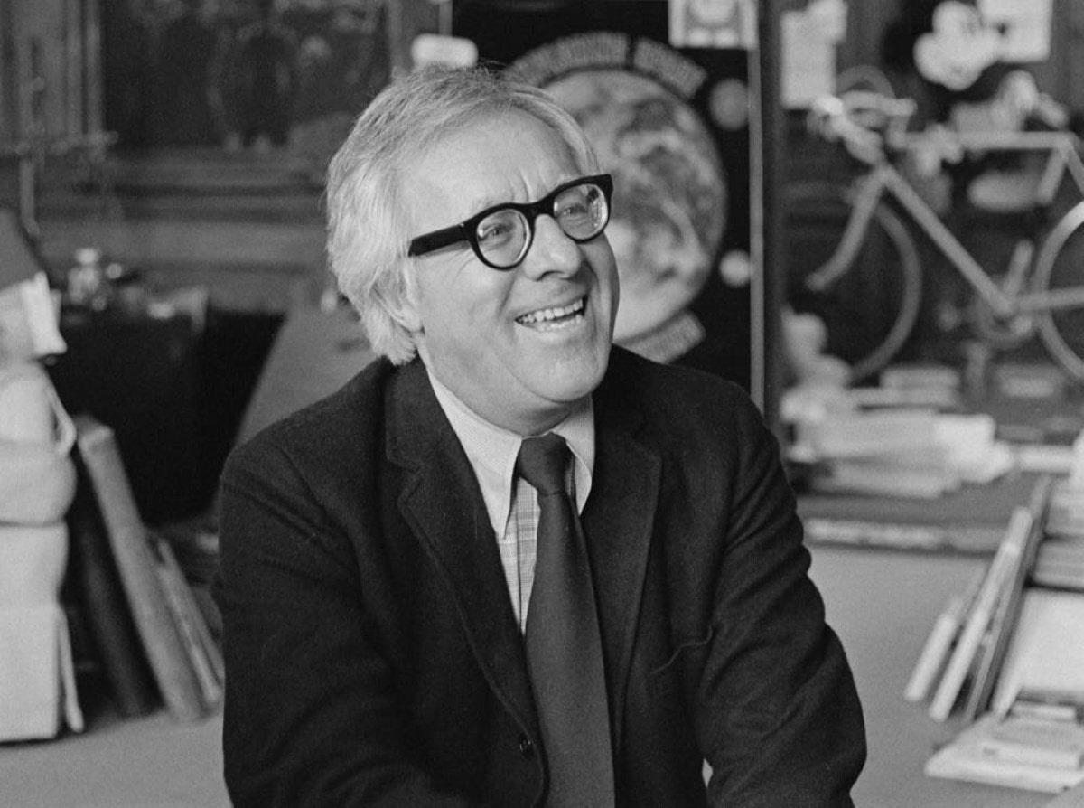

Lafayette, Farewell, Ray Bradbury

Lafayette, Farewell

There was a tap on the door, the bell was not rung, so I knew who it was. The tapping used to happen once a week, but in the past few weeks it came every other day. I shut my eyes, said a prayer, and opened the door.

Bill Westerleigh was there, looking at me, tears streaming down his cheeks.

“Is this my house or yours?” he said.

It was an old joke now. Several times a year he wandered off, an eighty-nine-year-old man, to get lost within a few blocks. He had quit driving years ago because he had wound up thirty miles out of Los Angeles instead of at the center where we were.

His best journey nowadays was from next door, where he lived with his wondrously warm and understanding wife, to here, where he tapped, entered, and wept. “Is this your house or mine?” he said, reversing the order.

“Mi casa es su casa.” I quoted the old Spanish saying.

“And thank God for that!”

I led the way to the sherry bottle and glasses in the parlor and poured two glasses while Bill settled in an easy chair across from me. He wiped his eyes and blew his nose on a handkerchief which he then folded neatly and put back in his breast pocket.

“Here’s to you, buster.” He waved his sherry glass. “The sky is full of ’em. I hope you come back. If not, we’ll drop a black wreath where we think your crate fell.”

I drank and was warmed by the drink and then looked a long while at Bill.

“The Escadrille been buzzing you again?” I asked.

“Every night, right after midnight. Every morning now. And, the last week, noons. I try not to come over. I tried for three days.”

“I know. I missed you.”

“Kind of you to say, son. You have a good heart. But I know I’m a pest, when I have my clear moments. Right now I’m clear and I drink your hospitable health.”

He emptied his glass and I refilled it.

“You want to talk about it?”

“You sound just like a psychiatrist friend of mine. Not that I ever went to one, he was just a friend. Great thing about coming over here is it’s free, and sherry to boot.” He eyed his drink pensively. “It’s a terrible thing to be haunted by ghosts.”

“We all have them. That’s where Shakespeare was so bright. He taught himself, taught us, taught psychiatrists. Don’t do bad, he said, or your ghosts will get you. The old remembrance, the conscience which doth make cowards and scare midnight men, will rise up and cry, Hamlet, remember me, Macbeth, you’re marked, Lady Macbeth, you, too! Richard the Third, beware, we walk the dawn camp at your shoulder and our shrouds are stiff with blood.”

“God, you talk purty.” Bill shook his head. “Nice living next door to a writer. When I need a dose of poetry, here you are.”

“I tend to lecture. It bores my friends.”

“Not me, dear buster, not me. But you’re right. I mean, what we were talking about. Ghosts.”

He put his sherry down and then held to the arms of his easy chair, as if it were the edges of a cockpit.

“I fly all the time now. It’s nineteen eighteen more than it’s nineteen eighty-seven. It’s France more than it’s the US of A. I’m up there with the old Lafayette. I’m on the ground near Paris with Rickenbacker. And there, just as the sun goes down, is the Red Baron. I’ve had quite a life, haven’t I, Sam?”

It was his affectionate mode to call me by six or seven assorted names. I loved them all. I nodded.

“I’m going to do your story someday,” I said. “It’s not every writer whose neighbor was part of the Escadrille and flew and fought against von Richthofen.”

“You couldn’t write it, dear Ralph, you wouldn’t know what to say.”

“I might surprise you.”

“You might, by God, you might. Did I ever show you the picture of myself and the whole Lafayette Escadrille team lined up by our junky biplane the summer of ’eighteen?”

“No,” I lied, “let me see.”

He pulled a small photo from his wallet and tossed it across to me. I had seen it a hundred times but it was a wonder and a delight.

“That’s me, in the middle left, the short guy with the dumb smile next to Rickenbacker.” Bill reached to point.

I looked at all the dead men, for most were long dead now, and there was Bill, twenty years old and lark-happy, and all the other young, young, oh, dear God, young men lined up, arms around each other, or one arm down holding helmet and goggles, and behind them a French 7-1 biplane, and beyond, the flat airfield somewhere near the Western Front. Sounds of flying came out of the damned picture. They always did, when I held it.

And sounds of wind and birds. It was like a miniature TV screen. At any moment I expected the Lafayette Escadrille to burst into action, spin, run, and take off into that absolutely clear and endless sky. At that very moment in time, in the photo, the Red Baron still lived in the clouds; he would be there forever now and never land, which was right and good, for we wanted him to stay there always, that’s how boys and men feel.

“God, I love showing you things.” Bill broke the spell. “You’re so damned appreciative. I wish I had had you around when I was making films at MGM.”

That was the other part of William (Bill) Westerleigh. From fighting and photographing the Western Front half a mile up, he had moved on, when he got back to the States. From the Eastman labs in New York, he had drifted to some flimsy film studios in Chicago, where Gloria Swanson had once starred, to Hollywood and MGM. From MGM he had shipped to Africa to camera-shoot lions and the Watusi for King Solomon’s Mines. Around the world’s studios, there was no one he didn’t know or who didn’t know him. He had been principal cameraman on some two hundred films, and there were two bright gold Academy Oscars on his mantel next door.

“I’m sorry I grew up so long after you,” I said. “Where’s that photo of you and Rickenbacker alone? And the one signed by von Richthofen.”

“You don’t want to see them, buster.”

“Like hell I don’t!”

He unfolded his wallet and gently held out the picture of the two of them, himself and Captain Eddie, and the single snap of von Richthofen in full uniform, and signed in ink below.

“All gone,” said Bill. “Most of ’em. Just one or two, and me left. And it won’t be long”—he paused—“before there’s not even me.”

And suddenly again, the tears began to come out of his eyes and roll down and off his nose.

I refilled his glass.

He drank it and said:

“The thing is, I’m not afraid of dying. I’m just afraid of dying and going to hell!”

“You’re not going there, Bill,” I said.

“Yes, I am!” he cried out, almost indignantly, eyes blazing, tears streaming around his gulping mouth. “For what I did, what I can never be forgiven for!”

I waited a moment. “What was that, Bill?” I asked quietly.

“All those young boys I killed, all those young men I destroyed, all those beautiful people I murdered.”

“You never did that, Bill,” I said.

“Yes! I did! In the sky, dammit, in the air over France, over Germany, so long ago, but Jesus, there they are every night now, alive again, flying, waving, yelling, laughing like boys, until I fire my guns between the propellers and their wings catch fire and spin down. Sometimes they wave to me, okay! as they fall. Sometimes they curse. But, Jesus, every night, every morning now, the last month, they never leave. Oh, those beautiful boys, those lovely young men, those fine faces, the great shining and loving eyes, and down they go. And I did it. And I’ll burn in hell for it!”

“You will not, I repeat not, burn in hell,” I said.

“Give me another drink and shut up,” said Bill. “What do you know about who burns and who doesn’t? Are you Catholic? No. Are you Baptist? Baptists burn more slowly. There. Thanks.”

I had filled his glass. He gave it a sip, the drink for his mouth meeting the stuff from his eyes.

“William.” I sat back and filled my own glass. “No one burns in hell for war. War’s that way.”

“We’ll all burn,” said Bill.

“Bill, at this very moment, in Germany, there’s a man your age, bothered with the same dreams, crying in his beer, remembering too much.”

“As well they should! They’ll burn, he’ll burn too, remembering my friends, the lovely boys who got themselves screwed into the ground when their propellers chewed the way. Don’t you see? They didn’t know. I didn’t know. No one told them, no one told us!”

“What?”

“What war was. Christ, we didn’t know it would come after us, find us, so late in time. We thought it was all over; that we had a way to forget, put it off, bury it. Our officers didn’t say. Maybe they just didn’t know. None of us did. No one guessed that one day, in old age, the graves would bust wide, and all those lovely faces come up, and the whole war with ’em! How could we guess that?

How could we know? But now the time’s here, and the skies are full, and the ships just won’t come down, unless they burn. And the young men won’t stop waving at me at three in the morning unless I kill them all over again. Jesus Christ. It’s so terrible. It’s so sad. How do I save them?

What do I do to go back and say, Christ, I’m sorry, it should never have happened, someone should have warned us when we were happy: war’s not just dying, it’s remembering and remembering late as well as soon. I wish them well. How do I say that, what’s the next move?”

“There is no move,” I said quietly. “Just sit here with a friend and have another drink. I can’t think of anything to do. I wish I could. . . .”

Bill fiddled with his glass, turning it round and round.

“Let me tell you, then,” he whispered. “Tonight, maybe tomorrow night’s the last time you’ll ever see me. Hear me out.”

He leaned forward, gazing up at the high ceiling and then out the window where storm clouds were being gathered by wind.

“They’ve been landing in our backyards, the last few nights. You wouldn’t have heard. Parachutes make sounds like kites, soft kind of whispers. The parachutes come down on our back lawns. Other nights, the bodies, without parachutes. The good nights are the quiet ones when you just hear the silk and the threads on the clouds.

The bad ones are when you hear a hundred and eighty pounds of aviator hit the grass. Then you can’t sleep. Last night, a dozen things hit the bushes near my bedroom window. I looked up in the clouds tonight and they were full of planes and smoke. Can you make them stop? Do you believe me?”

“That’s the one thing; I do believe.”

He sighed, a deep sigh that released his soul.

“Thank God! But what do I do next?”

“Have you,” I asked, “tried talking to them? I mean,” I said, “have you asked for their forgiveness?”

“Would they listen? Would they forgive? My God,” he said. “Of course! Why not? Will you come with me? Your backyard. No trees for them to get strung up in. Christ, or on your porch. . . .”

“The porch, I think.”

I opened the living room French doors and stepped out. It was a calm evening with only touches of wind motioning the trees and changing the clouds.

Bill was behind me, a bit unsteady on his feet, a hopeful grin, part panic, on his face.

I looked at the sky and the rising moon.

“Nothing out here,” I said.

“Oh, Christ, yes, there is. Look,” he said. “No, wait. Listen.”

I stood turning white cold, wondering why I waited, and listened.

“Do we stand out in the middle of your garden, where they can see us? You don’t have to if you don’t want.”

“Hell,” I lied. “I’m not afraid.” I lifted my glass. “To the Lafayette Escadrille?” I said.

“No, no!” cried Bill, alarmed. “Not tonight. They mustn’t hear that. To them, Doug. Them.” He motioned his glass at the sky where the clouds flew over in squadrons and the moon was a round, white, tombstone world.

“To von Richthofen, and the beautiful sad young men.”

I repeated his words in a whisper.

And then we drank, lifting our empty glasses so the clouds and the moon and the silent sky could see.

“I’m ready,” said Bill, “if they want to come get me now. Better to die out here than go in and hear them landing every night and every night in their parachutes and no sleep until dawn when the last silk folds in on itself and the bottle’s empty. Stand right over there, son. That’s it. Just half in the shadow. Now.”

I moved back and we waited.

“What’ll I say to them?” he asked.

“God, Bill,” I said, “I don’t know. They’re not my friends.”

“They weren’t mine, either. More’s the pity. I thought they were the enemy. Christ, isn’t that a dumb stupid halfass word. The enemy! As if such a thing ever really happened in the world. Sure, maybe the bully that chased and beat you up in the schoolyard, or the guy who took your girl and laughed at you. But them, those beauties, up in the clouds on summer days or autumn afternoons? No, no!”

He moved farther out on the porch.

“All right,” he whispered. “Here I am.”

And he leaned way out, and opened his arms as if to embrace the night air.

“Come on! What you waiting for!”

He shut his eyes.

“Your turn,” he cried. “My God, you got to hear, you got to come. You beautiful bastards, here!”

And he tilted his head back as if to welcome a dark rain.

“Are they coming?” he whispered aside, eyes clenched.

“No.”

Bill lifted his old face into the air and stared upward, willing the clouds to shift and change and become something more than clouds.

“Damn it!” he cried, at last. “I killed you all. Forgive me or come kill me!” And a final angry burst. “Forgive me. I’m sorry!”

The force of his voice was enough to push me completely back into shadows. Maybe that did it. Maybe Bill, standing like a small statue in the middle of my garden, made the clouds shift and the wind blow south instead of north. We both heard, a long way off, an immense whisper.

“Yes!” cried Bill, and to me, aside, eyes shut, teeth clenched, “You hear!?”

We heard another sound, closer now, like great flowers or blossoms lifted off spring trees and run along the sky.

“There,” whispered Bill.

The clouds seemed to form a lid and make a vast silken shape which dropped in serene silence upon the land. It made a shadow that crossed the town and hid the houses and at last reached our garden and shadowed the grass and put out the light of the moon and then hid Bill from my sight.

“Yes! They’re coming,” cried Bill. “Feel them? One, two, a dozen! Oh, God, yes.”

And all around, in the dark, I thought I heard apples and plums and peaches falling from unseen trees, the sound of boots hitting my lawn, and the sound of pillows striking the grass like bodies, and the swarming of tapestries of white silk or smoke flung across the disturbed air.

“Bill!”

“No!” he yelled. “I’m okay! They’re all around. Get back! Yes!”

There was a tumult in the garden. The hedges shivered with propeller wind. The grass lay down its nap. A tin watering can blew across the yard. Birds were flung from trees. Dogs all around the block yelped. A siren, from another war, sounded ten miles away. A storm had arrived, and was that thunder or field artillery?

And one last time, I heard Bill say, almost quietly, “I didn’t know, oh, God, I didn’t know what I was doing.” And a final fading sound of “Please.”

And the rain fell briefly to mix with the tears on his face.

And the rain stopped and the wind was still.

“Well.” He wiped his eyes, and blew his nose on his big hankie, and looked at the hankie as if it were the map of France. “It’s time to go. Do you think I’ll get lost again?”

“If you do, come here.”

“Sure.” He moved across the lawn, his eyes clear. “How much do I owe you, Sigmund?”

“Only this,” I said.

I gave him a hug. He walked out to the street. I followed to watch.

When he got to the corner, he seemed to be confused. He turned to his right, then his left. I waited and then called gently:

“To your left, Bill.”

“God bless you, buster!” he said, and waved.

He turned and went into his house.

They found him a month later, wandering two miles from home. A month after that he was in the hospital, in France all the time now, and Rickenbacker in the bed to his right and von Richthofen in the cot to his left.

The day after his funeral the Oscar arrived, carried by his wife, to place on my mantel, with a single red rose beside it, and the picture of von Richthofen, and the other picture of the gang lined up in the summer of ’18 and the wind blowing out of the picture and the buzz of planes. And the sound of young men laughing as if they might go on forever.

Sometimes I come down at three in the morning when I can’t sleep and I stand looking at Bill and his friends. And sentimental sap that I am, I wave a glass of sherry at them.

“Farewell, Lafayette,” I say. “Lafayette, farewell.”

And they all laugh as if it were the grandest joke that they ever heard.

The End