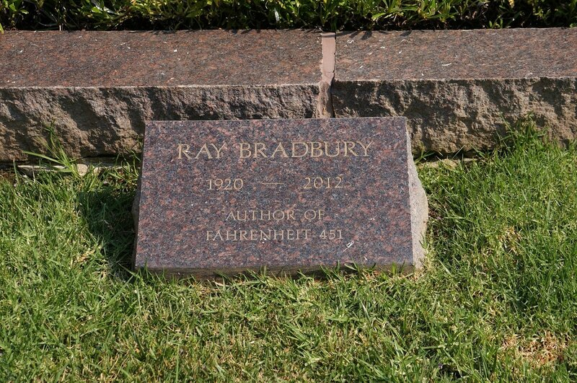

Last Laughs, Ray Bradbury

Last Laughs

His name was Andrew Rudolph Gerald Vesalius and he was a genius of the world, dialectician, statistician, creator of Italian operas, lyricist, poet of German lieder, Vedanta Temple lecturer, intellectual Santa Barbara brainstormer, and a grand pal.

This last seems unbelievable, for when we first met I was running on empty, a drab writer of pulp science fiction, earning two cents a word.

But Gerald, if I dare use his familiar name, discovered me and warned people that I had the future’s eye and should be watched.

He coached me and let me travel as lapdog when he addressed relatives of Einstein, Jung, and Freud.

For years I transcribed his lectures, sat for tea with Aldous Huxley, and trod speechless through art-gallery shows with Christopher Isherwood.

Now, suddenly, Vesalius was gone.

Well, almost. There were rumors that he was scribbling a book on those flying saucers that had hovered over the Palomar hot-dog stand and vanished.

I found that he no longer lectured at the Vedanta Temple, but survived in Paris or Rome; a promised novel was long overdue.

I telephoned his Malibu home ten dozen times.

Finally his secretary, William Hopkins Blair, admitted that Gerald was stricken with some mysterious disease.

I asked permission to visit my saintly friend. Blair disconnected.

I called again and Blair cried, in staccato phrases, that Vesalius had canceled our friendship.

Stunned, I tried to imagine how to apologize for sins which I knew I had not committed.

Then one evening at midnight the phone rang. A voice gasped one word: ‘Help!’

‘What?’ I said.

The cry was repeated: ‘Help!’

‘Vesalius?’ I cried.

A long silence.

‘That sounds like you. Gerald?’

Silence, voices muttering, and thenbuzzzz.

I clenched the phone and felt a rush of tears come to my eyes; thatwasVesalius’s voice. After weeks of silent absence, he had cried out to me, implying some danger beyond my understanding.

The next evening, on impulse, I wandered around the Italian-named streets of upper Malibu and finally stopped at Vesalius’s house.

I rang the bell.

No answer.

I rang again.

The house was silent.

I had spent twenty minutes ringing the bell and knocking when suddenly the door opened. That curious person, Gerald’s keeper Blair, stood there staring at me.

‘Yes?’

‘After half an hour,’ I said, ‘all you have to say isyes?’

‘Are you that pulp-writer friend of Gerald’s?’ he said.

‘You know it,’ I said. ‘And I’m not just a pulp writer. I’ve come to see Gerald.’

Blair answered quickly. ‘He’s not here, he’s in Rapallo.’

‘I know he’s here,’ I lied. ‘He called last night.’

‘Impossible! He’s in Italy!’

‘No,’ I lied again. ‘He asked me to find a new doctor.’

Blair turned very pale.

‘He’s here,’ I said. ‘I know his voice.’

I stared down the hall, beyond Blair.

Suddenly he stood aside.

‘Make it quick,’ he said.

I ran along the hall to the bedroom and entered.

There, stretched out like a thin white marble carving on a sarcophagus lid, lay my old friend Vesalius.

‘Gerald!’ I cried.

The pale figure, looking ancient and stricken, remained silent, but the eyeballs revolved frantically in the thin face.

Blair, behind me, said, ‘You see, he does poorly. Speak your piece and leave.’

I moved forward.

‘What’s wrong, Gerald?’ I said. ‘How can I help?’

There was a staccato pulse around Gerald’s thin lips, but no answer, only a gray moth-flick of the eyeballs, glancing from me to Blair, and back again to me, frantically.

I panicked and thought to seize Gerald and flee, but there was no way.

I leaned over my friend and whispered in his ear. ‘I’ll be back,’ I said. ‘I promise, Gerald. I’ll be back.’

I turned and hurried out of the room. At the front door Blair, staring beyond me, said: ‘No, no more visitors. Vesalius prefers it.’

And the door shut.

I stood a long while wanting to ring and knock, knock and ring, but finally turned away.

I waited in the street for an hour; I could not bear to leave.

At one in the morning, all the house’s lights went dark.

I crept around the side of the house toward the back and found the French doors leading into Gerald’s room open to the fresh night air.

Gerald Vesalius was as I had left him, eyes shut.

I cried softly, ‘Gerald,’ and his eyes flew wide open.

He was winter pale as before and stiff rigid, but his eyes jerked frantically.

I crept into the room and bent over the bed and whispered, ‘Gerald, what’s wrong?’

He could find no strength to answer, but at last he gasped and I thought I heard him say, ‘Soli,’ and then, ‘tary,’ and then ‘confine,’ and, gasp, ‘ment!’

I put the syllables together, shocked.

‘But why, Gerald?’ I cried, as quietly as possible. ‘Why?’

He could only jerk his chin toward the foot of his bed.

I pulled back the covers and stared.

His feet had been tied with adhesive tape to the end of the bed.

‘So,’ he gasped, ‘couldn’t,’ he said, ‘telephone!’

There was a phone to his right, just out of reach.

I unwound the adhesive and then bent back to question him.

‘Can you hear me?’

His head jerked. He cried softly. ‘Yes. Blair,’ gasped, ‘wants to,’ he said, ‘marry,’ he gasped again, ‘the…ancient…priest.’ Then, in an ardent burst of words: ‘Philosopher of all philosophers!’

‘How’s that again?’

‘Marry,’ the old man exploded, ‘me!’

‘Wait!’ I was stunned. ‘Marry?’

A frantic nod then, suddenly, a wild shriek of laughter.

‘Me,’ whispered Gerald Vesalius. ‘Him.’

‘Jesus! Blair and you? Wedding?’

‘That’s it.’ Gerald’s voice was clearer, stronger. ‘That’s it.’

‘Impossible!’

‘It is, it is!’

I felt a terrible urge toward laughter, but stopped.

‘You mean—’ I cried.

‘Softly,’ said Gerald, his voice fluid now. ‘He’ll hear, he’ll throw,’ he gasped, ‘you out!’

‘Gerald, that’s not legal,’ I cried softly.

‘Legal,’ he whispered, swallowed hard. ‘Make legal, headlines, news!’

‘My God!’

‘Yes, God!’

‘But why?’

‘Doesn’t,’ said Gerald, ‘care. Fame! Figures the more he wants to marry me, more fame and the more I will give him.’

‘But again, why, Gerald?’

‘He wants to own me, completely. Just,’ said Gerald, ‘in,’ he said, ‘his,’ he gasped, ‘nature.’

‘Lord!’ I said. ‘I know marriages where a man owns the woman, or the woman completely owns the man.’

‘Yes,’ said Gerald. ‘He wants that! He loves, but this is madness.’

Gerald stiffened, eyes shut, and then in a frail voice which rose and faded: ‘Wants to own my mind.’

‘He can’t!’

‘Will try, will try. Wants to be world’s greatest philosopher.’

‘Lunatic!’

‘Yes! Wants to write, travel, lecture, wants to be me. If owns me, thinks he can take my place.’

A noise. We both sucked breath.

‘Madness,’ I whispered. ‘Christ!’

‘Christ,’ Gerald snorted, ‘has nothing…to do with it.’ Vesalius blew a surprise of mirth.

‘Butstill!’

‘Shhh,’ Gerald Vesalius cautioned.

‘Was he like this when he first started to work for you?’

‘I suppose. Not this bad.’

‘It was okay then?’

‘o’—a pause—‘kay.’

‘But—’

‘As years passed he was more gree–gree–greedy.’

‘For your cash?’

‘No.’ A derisive smile. ‘My mind.’

‘He’d stealthat?’

Gerald sucked in, blew out. ‘Imagine!’

‘You’re one of a kind!’

‘Tell–tell–tellhimthat.’

‘Son of a bitch!’

‘No, jealous, envious, covetous, admiring, part monster, now monster full-time.’ Gerald cried this in a few clear instants.

‘Jesus,’ I said. ‘Why are we talking?’

‘What else?’ whispered Vesalius. ‘Help.’ He smiled.

‘How will I get you out of here?’

Vesalius laughed. ‘Let me count the ways.’

‘No time for jokes, damn it!’

Gerald Vesalius swallowed. ‘Have strange…sense’–he paused–‘humor. List!’

We both froze. A door creaked. Footsteps.

‘Should I call the cops?’

‘No.’ A pause. Gerald’s face writhed. ‘Action, drama, wins!’

‘Action?’

‘Do as I say or all’s lost.’

I bent close, he whispered frantically.

Whisper, whisper, whisper.

‘Got that? Try?’

‘Try!’ I said. ‘Oh, damn, damn, damn!’

Footsteps in the hall. I thought I heard someone yell.

I grabbed the phone. I dialed.

I ran out the French doors, around the house, to the front walk.

A siren screamed, then a second and a third.

Three trucks of paramedic firemen booted up the walk with nothing else to do so late at night. Nine different paramedic firemen ran, eager not to be bored.

‘Blair,’ I yelled. ‘That’s me! Damn, I’ve locked myself out! Around the side! Man dying. Follow me.’

I ran. The black-suited paramedics blundered after.

We flung wide the French doors. I pointed at Vesalius.

‘Out!’ I cried. ‘Brotman Hospital. Fast!’

They laid Gerald on a gurney and plunged out the French doors.

Behind us I heard Blair yelling hysterically.

Gerald Vesalius heard and waved gaily, calling out ‘Tata, toodle-o, farewell, solong, good-bye!’ as we rushed toward the waiting ambulance.

Gerald whooped with laughter.

‘Young man?’

‘Gerald?’

‘Do you love me?’

‘Yes, Gerald.’

‘But don’t want to own me?’

‘No, Gerald.’

‘Not my mind?’

‘No.’

‘Not my body?’

‘No, Gerald.’

‘Till death do us part?’

‘Till death do us part.’

‘Good.’

Run, run, hustle, hustle, across the lawn, down the walk, toward the waiting ambulance.

‘Young man.’

‘Yes?’

‘Vedanta Temple?’

‘Yes.’

‘Last year?’

‘Yes.’

‘Lecture on Great All Accepting Laughter?’

‘I was there.’

‘Well,now’sthe time!’

‘Oh, yes, yes.’

‘To hoot and holler?’

‘Hoot and holler.’

‘Zest and gusto, eh?’

‘Gusto, zest, oh my God!’

Here a bomb burst in Gerald’s chest and erupted from his throat. I’d never heard such jovial explosions in my life, and snort-laughed as I ran alongside Gerald as his gurney was hustled and hurried.

We howled, we shrieked, we yelled, we gasped, we insucked-outblew firecracker bomb-blasts of hilarity like boys on a forgotten summer day, collapsed on the sidewalk, writhing with comic seizures of wild upchuck heart attacks, throats choked, eyes clenched with brays of ha-hee and hee-ha and God, stop, I can’t breathe, Gerald, hee-ha, ha-hee, and God, ha and hee, and once more ha-hee and whistle-rustle whisper haw.

‘Young man?’

‘What?’

‘King Tut’s mummy.’

‘Yes?’

‘Found in tomb.’ ‘Yes.’

‘His mouth smiling.’ ‘Why?’

‘In his front teeth—’ ‘Yes?’

‘A single black hair.’ ‘What?’

‘Dying man ate a hearty meal. Ha-ho!’ Hee-ha, oh my God, ha-hee, rush run, run rush. ‘And now, one last thing.’ ‘What?’

‘Will you run away with me?’ ‘Where?’

‘Run off and be pirates!’ ‘What?’

‘Run away with me to be pirates.’ We were at the ambulance, the doors were flung wide, Gerald was shoved in. ‘Pirates!’ he cried again. ‘Oh God, yes, Gerald, I’ll run off with you!’ Door slam, siren sound, motor gunned. ‘Pirates!’ I cried.

The End