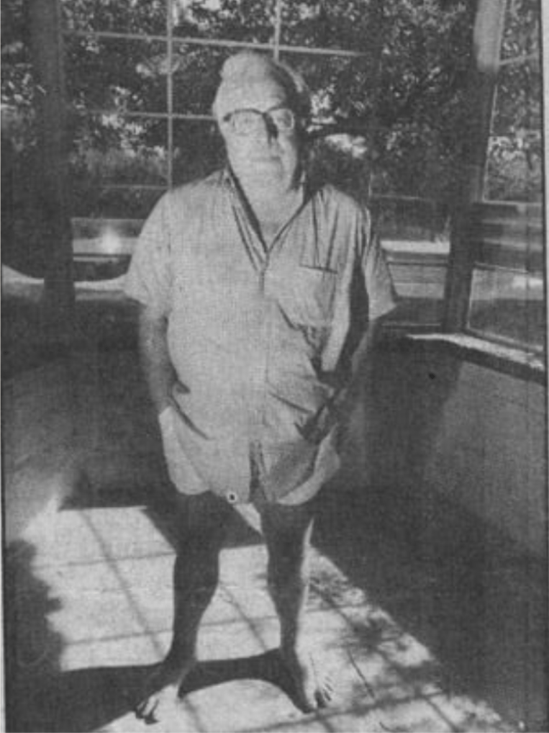

Make Haste to Live, Ray Bradbury

Make Haste To Live

Mademoiselle Angelina Marguerite was perhaps strange, to some grotesque, to many a nightmare, but most certainly a puzzle of inverted life.

Timothy did not know that she even existed until many months after that grand, happily remembered Homecoming.

For she lived, or existed, or in the final analysis hid in the shadowed acreage behind the great tree where stood markers with names and dates peculiar to the Family. Dates from when the Spanish Armada broke on the Irish coast and its women, to birth boys with dark, and girls with darker, hair.

The names recalled the glad times of the Inquisition or the Crusades children who rode happily into Muslim graves. Some stones, larger than others, celebrated the suffering of witches in a Massachusetts town. All of the markers had sunk in place as the House took boarders from other centuries. What lay beneath the stones was known only to a small rodent and a smaller arachnid.

But it was the name Angelina Marguerite that took Timothy's breath. It spelled softly on the tongue. It was a relish of beauty.

"How long ago did she die?" Timothy asked.

"Ask rather," said Father, "how soon will she be born."

"But she was born a long time ago," said Timothy. "I can't make out the date. Surely "

"Surely," said the tall, gaunt, pale man at the head of the dinner table, who got taller and gaunter and paler by the hour, "surely if I can trust my ears and ganglion, she will be truly born in a fortnight."

"How much is a fortnight?" asked Timothy.

Father sighed. "Look it up. She will not stay beneath her stone."

"You mean ?"

"Stand watch. When the grave marker trembles and the ground stirs, you will at last see Angelina Marguerite."

"Will she be as beautiful as her name?"

"Gods, yes. I would hate to wait while an old crone got younger and younger, taking years to melt her back to beauty. If we are fortunate, she'll be a Castilian rose. Angelina Marguerite waits. Go see if she's awake. Now!"

Timothy ran, one tiny friend on his cheek, another in his blouse, a third following.

"Oh, Arach, Mouse, Anuba," he said, hurrying through the old dark House, "what does Father mean?"

"Quiet." The eight legs rustled in his ear.

"Listen," said an echo from his blouse.

"Stand aside," said the cat. "Let me lead!"

And arriving at the grave with the pale stone, as smooth as a maiden's cheek, Timothy knelt and put that ear with its invisible weaver against the cool marble, so both might hear.

Timothy shut his eyes.

At first: stone silence.

And again, nothing.

He was about to leap up in confusion when the tickling in his ear said: Wait.

And deep under he heard what he thought was the single beat of a buried heart.

The soil under his knees pulsed three times swiftly.

Timothy fell back.

"Father told the truth!"

"Yes," said the whisper in his ear. "Yes," echoed the fur-ball thing in his blouse.

Anuba purred.

Yes!

He did not return to the pale gravestone, for it was so terrible and mysterious that he cried, not knowing why.

"Oh, that poor lady."

"Not poor, my dear," said his mother.

"But she's dead!"

"But not for long. Patience."

Still he could not visit, but sent his messengers to listen and come back.

The heartbeats increased. The ground shook with nervous tremors. A tapestry wove itself in his ear. His blouse pocket squirmed. Anuba ran in circles.

The time is near.

And then half through a long night with a storm freshly departed, a lightning bolt stabbed the graveyard to invigorate a celebration

And Angelina Marguerite was born.

At three in the morning, the soul's midnight, Timothy looked out his window to see a procession of candles lighting the path to the tree and that one special stone.

Glancing up, candelabra in hand, Father gestured. Panicked or not, Timothy must attend.

He arrived to find the Family around the grave, their candles burning.

Father handed Timothy a small implement.

"Some spades bury, some reveal. Be the first to shovel earth."

Timothy dropped the spade.

"Pick it up," said Father. "Move!"

Timothy stuck the spade into the mound. A trip-hammering of heartbeat sounded. The gravestone cracked.

"Good!" And Father dug. The others followed until at last the most beautiful golden case he had ever seen, with a Royal Castilian insignia on its lid, came into sight, to be laid out under the tree to much laughter.

"How can they laugh?" cried Timothy.

"Dear child," said his mother. "It is a triumph over death. Everything turned upside down. She is not buried, but unburied, a grand reason for joy. Fetch wine!"

He brought two bottles to be poured in a dozen glasses that were lifted as a dozen voices murmured, "Oh, come forth, Angelina Marguerite, as a maiden, girl, baby, and thence to the womb and the eternity before Time!"

Then the box was opened.

And beneath the bright lid was a layer of

"Onions?!" Timothy exclaimed.

And indeed, like a freshet of grass from the Nile banks, the onions were there, spring-green and lush and savory on the air.

And beneath the onions

"Bread!" said Timothy.

Sixteen small loaves baked within the hour, with golden crusts like the lip of the box, and a smell of yeast and the warm oven that was the box.

"Bread and onions," said the oldest near-uncle in his Egyptian cerements, leaning to point into the garden box. "I planted these onions and bread. For the long journey not down the Nile to oblivion but up the Nile to the source, the Family, and then the time of the seed, the pomegranate with a thousand buds, one ripe each month, surrounded by encirclements of life, millions crying to be born. And so … ?"

"Bread and onions." Timothy joined the smiles. "Onions and bread!"

The onions had been put aside with the bread sheaved near them to reveal a gossamer veil laid over the face in the box.

Mother gestured. "Timothy?"

Timothy fell back.

"No!"

"She's not afraid to be seen. You must not be afraid to see. Now."

He took hold and pulled.

The veil plumed on the air like a puff of white smoke and blew away.

And Angelina Marguerite lay there with her face upturned to the candlelight, her eyes shut, her mouth enclosing the faintest smile.

And she was a joy and a delight and a lovely toy crated and shipped from another time.

The candlelight trembled at the sight. The Family knew an earthquake of response. Their exclamations flooded the dark air. Not knowing what to do, they applauded the golden hair, the fine high cheekbones, the arched eyebrows, the small and perfect ears, the satisfied but not self-satisfied mouth, fresh from a thousand years' sleep, her bosom a slender hillock, her hands like ivory pendants, the feet tiny and asking to be kissed, there seemed no need for shoes. Good Lord, they would carry her anywhere!

Anywhere! thought Timothy.

"I don't understand," he said. "How can this be?"

"This is," someone whispered.

And the whisper had come from the breathing mouth of this creature come alive.

"But " said Timothy.

"Death is mysterious." Mother brushed Timothy's cheek. "Life even more so. Choose. And whether you blow away in dust at life's end or arrive at youngness and go back to birth and within birth, that is stranger than strange, yes?"

"Yes, but "

"Accept." Father lifted his wineglass. "Celebrate this miracle."

And Timothy indeed saw the miracle, this daughter of time, with a face of youngness which became younger, yes, and even younger as he stared. It was as if she lay beneath a smoothly flowing, slowly passing stream of clear water which washed her cheeks with shadows and light and trembled her eyelids and purified her flesh.

Angelina Marguerite at this moment opened her eyes. They were the soft blue of the delicate veins in her temples.

"Well," she whispered. "Is this birth, or rebirth?"

Quiet laughter from all.

"One or the other. Other or none." Timothy's mother reached out. "Welcome. Stay. Soon enough you will leave for your sublime destiny."

"But," Timothy protested yet again.

"Never doubt. Simply be."

An hour younger than a minute ago, Angelina Marguerite took Mother's hand.

"Is there a cake with candles? Is this my first birthday or my nine hundred and ninety-ninth?"

Seeking the answer, more wine was poured.

Sunsets are loved because they vanish.

Flowers are loved because they go.

The dogs of the field and the cats of the kitchen are loved because soon they must depart.

These are not the sole reasons, but at the heart of morning welcomes and afternoon laughters is the promise of farewell. In the gray muzzle of an old dog we see goodbye. In the tired face of an old friend we read long journeys beyond returns.

So it was with Angelina Marguerite and the Family, but most of all with Timothy.

Make haste to live was the motto embroidered on a great hall carpet over which they walked or ran each minute of each hour of the day that the lovely maid occupied their lives. For she was diminishing from nineteen to eighteen-and-one-half to eighteen-and-one-quarter, even as they stared and put out their hands to quell this endless yet beautiful retrogression.

"Wait for me!" Timothy cried one day, seeing her face and body melt from beauty to beauty, like a candle lit and never ceasing.

"Catch me if you can!" And Angelina Marguerite ran down across a meadow with Timothy weeping in pursuit.

Exhausted, with a great laugh, she fell and waited for him to drop near.

"Caught," he cried. "Trapped!"

"No," she said, gently, and took his hand. "Never, dear cousin. Listen."

Then she explained:

"I shall be this, eighteen, for a little while, and then seventeen and sixteen a small while, and oh, Timothy, while I am this and then that age, I must find me a quick love, a swift romance, in the town below, and not let them know I come down from this hill or this House, and release myself to joy for a little while before I am fifteen and fourteen and thirteen and then the innocence of twelve before the pulses start and the blood manifests, and then eleven and ignorant but happy, and ten even happier. And then again, Timothy, if only somewhere along the way backward, you and I could conjoin, clasp hands in friendship, clasp bodies in joy, how fine, yes?"

"I don't know what you're talking about!"

"How old are you, Timothy?"

"Ten, I guess."

"Ah, yes. So you don't know what I say."

She leaned forward suddenly and gave him such a kiss on his mouth that his eardrums fractured and the soft spot on his skull ached.

"Does that give you a small idea of what you'll miss by not loving me?" she said.

Timothy blushed all over. His soul leaped out from his body and rushed back in in a storm.

"Almost," he whispered.

"Eventually," she said, "I must leave."

"That's terrible," he cried. "Why?"

"I must, dear cousin, for if I stay too long in any one place they will notice, as the months pass, that in October I was eighteen, and in November seventeen and then sixteen, and by Christmas ten, and with spring two, and then one, and then search and seek to find some flesh to mother me as I hide back in her womb to visit that Forever from whence we all came to visit Time and vanish in Eternity. So Shakespeare said."

"Did he?"

"Life is a visit, bounded by sleeps. I, being different, came from the sleep of Death. I run to hide in the sleep of Life. Next spring I will be a seed stored in the honeycomb of some maiden/wife, eager for collisions, ripe for life."

"You are strange," said Timothy.

"Very."

"Have there been many like you since the world began?"

"Few that we know. But aren't I fortunate, to be born from the grave, then buried in some child bride's pomegranate maze?"

"No wonder they were celebrating. All that laughter!" said Timothy, "and the wine!"

"No wonder," said Angelina Marguerite, and leaned for another kiss.

"Wait!"

Too late. Her mouth touched his. A furious blush fired his ears, burnt his neck, broke and rebuilt his legs, banged his heart and rose to crimson his entire face. A vast motor started in his loins and died nameless.

"Oh, Timothy," she said, "what a shame that we could not truly meet, you moving on to your grave, and I to a sweet oblivion of flesh and procreation."

"Yes," said Timothy, "a shame."

"Do you know what goodbye means? It means God be with you. Goodbye, Timothy."

"What?!"

"Goodbye!"

And before he could stagger to his feet she had fled up in the House to vanish forever.

Some said that she was seen later in the village, almost seventeen, and the week after that in a town across country, reaching and then leaving sixteen, then in Boston. The sum? Fifteen! And later on a ship bound for France, a girl of twelve.

From there her history fell into mist. Soon a letter arrived that described a child of five who stayed some few days in Provence. A traveler from Marseilles said a two-year-old, passing in a woman's arms, crowed and laughed some inarticulate message about some country, some town, a tree, and a House. But that, others said, was bumbershoot and poppycock.

The sum that set the seal on Angelina Marguerite was an Italian count passing through Illinois who, savoring the victuals and vintages at a mid-state hostel, told of a remarkable encounter with a Roman countess, pregnant and full ripe with child, whose eye had the eye of Angelina and the mouth of Marguerite and the shining of the soul of both. But, again, nonsense!

Ashes to ashes, dust to dust?

Timothy, at dinner one night surrounded by his Family, and napkinning his tears, said:

"Angelina means like an angel, yes? And Marguerite is a flower?"

"Yes," someone said.

"Well then," murmured Timothy. "Flowers and angels. Not ashes to ashes. Dust to dust. Angels and flowers."

"Let's drink to that," said all.

And they did.

The End