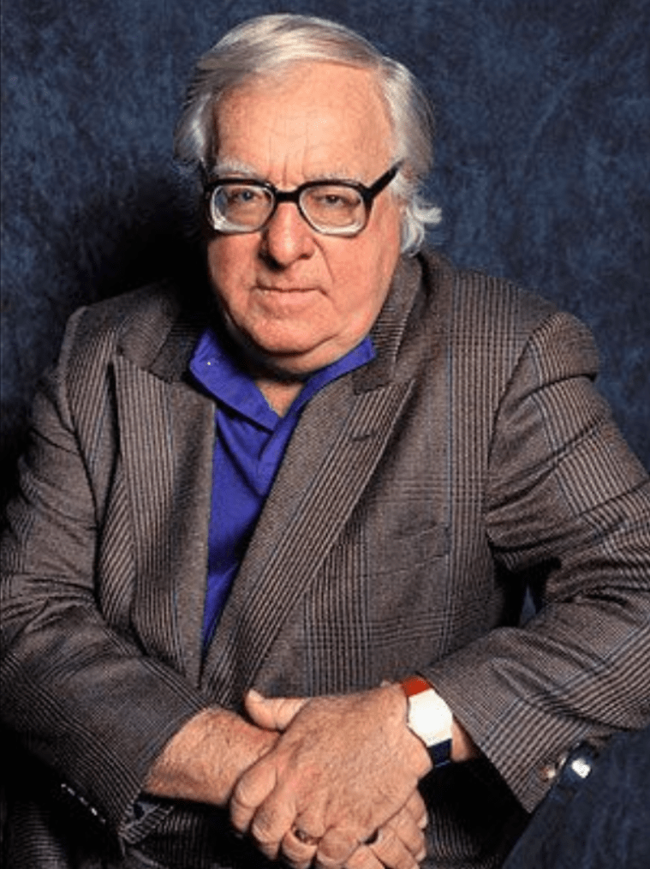

Massinello Pietro, Ray Bradbury

Massinello Pietro

He fed the canaries and the geese and the dogs and the cats. Then he cranked up the rusty phonograph and sang to the hissing ‘Tales from the Vienna Woods’:

Life goes up, life goes down,

But please smile, do not sigh, do not frown!

Dancing, he heard the car stop before his little shop. He saw the man in the gray hat glance up and down the storefront and knew the man was reading the sign which in large, uneven blue letters declared THE MANGER. EVERYTHING FREE! LOVE AND CHARITY FOR ALL!

The man stepped halfway through the open door and stopped. ‘Mr Massinello Pietro?’

Pietro nodded vigorously, smiling. ‘Come in. Do you want to arrest me? Do you want to throw me in jail?’

The man read from his notes. ‘Better known as Alfred Flonn?’ He eyed the silver bells on Pietro’s shirtsleeves.

‘That’s me!’ Pietro’s eye flashed.

The man was uncomfortable. He looked around a room crammed full of rustling birdcages and packing crates. Geese rushed in through the back door, stared at him angrily, and rushed back out. Four parrots blinked lazily on their high perches. Two Indian lovebirds cooed softly. Three dachshunds capered around Pietro’s feet, waiting for him to put down just one hand to pet them. On one shoulder he carried a banana-beaked mynah bird, on the other a zebra finch.

‘Sit down!’ sang Pietro. ‘I was just having a little music; that’s the way to start the day!’ He cranked the portable phonograph swiftly and reset the needle.

‘I know, I know.’ The man laughed, trying to be tolerant. ‘My name’s Tiffany, from the D.A.’s office. We got a lot of complaints.’ He waved around the cluttered shop. ‘Public health. All these ducks, raccoons, white mice. Wrong zone, wrong neighborhood. You’ll have to clean it up.’

‘Sixpeople have told me that.’ Pietro counted them proudly on his fingers. ‘Two judges, three policemen, and the district attorney himself!’

‘You were warned a month ago you had thirty days to stop this nuisance or go to jail,’ said Tiffany, over the music. ‘We’ve been patient.’

‘I,’ said Pietro, ‘have been the patient one. I have waited for the world to stop being silly. I have waited for it to stop wars. I have waited for politicians to be honest. I have waited–la la la–for real estate men to be good citizens. But while I wait, I dance!’ He demonstrated.

‘Butlookat this place!’ protested Tiffany.

‘Isn’t it wonderful? Do you see my shrine for the Virgin Mary?’ Pietro pointed. ‘And here, on the wall, a framed letter from the archbishop’s secretary himself, saying what good I’ve done for the poor! Once, I was rich, I had property, a hotel. A man took it all away, my wife with it, oh, twenty years ago. Do you know what I did? I invested what little I had left in dogs, geese, mice, parrots, who do not change their minds, who are always friends forever and forever. I bought my phonograph, which never is sad, which never stops singing!’

‘That’s another thing,’ said Tiffany, wincing. ‘The neighborhood says at four in the morning, um, you and the phonograph…’

‘Music is better than soap and water!’

Tiffany shut his eyes and recited the speech he knew so well. ‘If you don’t have these rabbits, the monkey, the parakeets, everything, out by sundown, it’s the Black Maria for you.’

Mr Pietro nodded with each word, smiling, alert.

‘What have I done? Have I murdered a man? Have I kicked a child? Have I stolen a watch? Have I foreclosed a mortgage? Have I bombed a city? Have I fired a gun? Have I told a lie? Have I cheated a customer? Have I turned from the Good Lord? Have I taken a bribe? Have I peddled dope? Do I sell innocent women?’

‘No, of course not.’

‘Tell me, then, what have I done? Point to it, lay a hand on it. My dogs, these are evil, eh? These birds, their song is dreadful, eh? My phonograph–I suppose that’s bad, too, eh? All right, put me in jail, throw away the key. You will not separate us.’

The music rose to a great crescendo. He sang along with it:

Tiffa-nee! Hear my plea!

Can’t you smile; sit awhile, be my friend?

The dogs leaped about, barking.

Mr Tiffany drove away in his car.

Pietro felt a pain in his chest. Still grinning, he stopped dancing. The geese rushed in and pecked gently at his shoes as he stood, bent down, holding his chest.

At lunchtime, Pietro opened a quart of homemade Hungarian goulash and refreshed himself. He paused and touched his chest, but the familiar pain had vanished. Finishing his meal, he went to gaze over the high wooden fence in the backyard.

There she was! There was Mrs Gutierrez, very fat, and as loud as a jukebox, talking to her neighbors on the other side of the lot.

‘Lovely lady!’ called Mr Massinello Pietro. ‘Tonight I go to jail! Your war is fought and won. I give you my saber, my heart, my soul!’

Mrs Gutierrez came ponderously across the dirt yard. ‘What?’ she said, as if she couldn’t see or hear him.

‘You told the police, the police toldme, and I laughed!’ His hand flirted on the air, two fingers wiggling. ‘I hope you will be happy!’

‘I didn’t call no police!’ she said indignantly.

‘Ah, Mrs Gutierrez, I will write a song for you!’

‘All of them other people must’ve called in,’ she insisted.

‘And when I leave today for jail, I’ll have a present for you.’ He bowed.

‘I tell you it wasn’t me!’ she cried. ‘You and your mealy mouth!’

‘I compliment you,’ he said sincerely. ‘You are a civic-minded citizen. All filth, all noise, all odd things must go.’

‘You, you!’ she shouted. ‘Oh,you!’ She had no more words.

‘I dance for you!’ he sang, and waltzed into the house.

In the late afternoon he put on his red silk bandanna and the huge gold earrings and the red sash and the blue vest with the golden piping. He put on his buckle shoes and tight knee breeches. ‘Come along! One last walk, eh?’ he told his dogs, and out of the shop they went, Pietro carrying the portable phonograph under his arm, wincing with the weight of it, for his stomach and body had been sick for some time and there was something wrong; he couldn’t lift things very easily.

The dogs padded on either side of him, the parakeets shrieked wildly on his shoulder. The sun was low, the air cool and settled. He looked at everything as if it was new. He said good evening to everyone, he waved, he saluted.

In a hamburger stand he set the phonograph whirling and scratching out the song on top of a stool. People turned to watch as he dived into the song and came up shining with laughter. He snapped his fingers, dipped his legs, whistled sweetly, eyes closed, as the symphony orchestra soared through Strauss. He made the dogs stand in a row while he danced. He made the parakeets tumble on the floor. He caught the spinning, flashing dimes from the startled but responsive audience.

‘Get the hell out!’ said the hamburger man. ‘What in hell you think this is, the opera?’

‘Thank you, good friends!’ Dogs, music, parakeets, Pietro ran into the night, bells chiming softly.

On a street corner he sang to the sky, to the new stars, and the October moon. A night wind arose. Faces watched smiling from the shadows. Again Pietro winked, smiled, whistled, whirled.

For charity, the poor!

Ah sweet, ah demure!

And he saw all the faces, the looking faces. And he saw the silent houses, with their silent people. And, in his singing, he wondered why he was the last one singing in the world. Why did no one else dance, open mouths, wink, strut, flourish?

Why was the world a silent world, silent housed, silent faced? Why were all the people watching people instead of dancing people? Why were they all spectators and only he the performer? What had they forgotten that he always and always remembered? Their houses, small and locked and silent, soundless. His house, his Manger, his shop, different! Filled with squeaks and stirs and mutters of bird sound, filled with feather whisper and murmurings of pad and fur and the sound that animal eyelids make blinking in the dark.

His house, ablaze with votive candles and pictures of rising–flying–saints, the glint of medallions. His phonograph circling at midnight, two, three, four in the morning, himself singing, mouth wide, heart open, eyes tight, world shut out; nothing but sound. And here he was now among the houses that locked at nine, slept at ten, wakened only from long silenced hours of slumber in the morn. People in houses, lacking only black wreaths on door fronts.

Sometimes, when he ran by, people remembered for a moment. Sometimes they squeaked a note or two, or tapped their feet, self-consciously, but most of the time the only motion they made to the music was to reach in their pockets for a dime.

Once, thought Pietro, once I had many dimes, many dollars, much land, many houses. And it all went away, and I wept myself into a statue. For a long time I couldn’t move. They killed me dead, taking away and taking away. And I thought, I won’t ever let anyone kill me again. But how? What do I have that I can let people take away without hurting? What can I give that I still keep?

And the answer was, of course, his talent.

My talent! thought Pietro. The more you give away, the better it is, the more you have. Those with talent must mind the world.

He glanced around. The world was full of statues much like he had been once. So many could move no longer, knew no way to even begin to move again in any direction, back, forth, up, down, for life had stung and bit and stunned and beat them to marble silence. So then, if they could not move, someone must move for them.

You, Pietro, he thought, must move. And besides, in moving, you don’t look back at what you were or what happened to you or the statue you became. So keep running and keep so busy you can make up for all those with good feet who have forgotten how to run. Run among the self-monuments with bread and flowers. Maybe they will move enough to stoop, touch the flowers, put bread in their dry mouths.

And if you shout and sing, they may even talk again someday, and someday fill out the rest of the song with you. Hey! you cry and La! you sing, and dance, and in dancing perhaps their toes may crack and knuckle and bunch and then tap and tremble and someday a long time after, alone in their rooms, because you danced they will dance by themselves in the mirror of their own souls. For remember, once you were chipped out of ice and stone like them, fit for display in a fish-grotto window.

But then you shouted and sang at your insides and one of your eyes blinked! Then the other! Then you sighed in a breath and exhaled a great cry of Life! and trembled a finger and shuffled a foot and bounded back into the explosion of life!

Since then, have you ever stopped running?

Never.

Now he ran into a tenement and left white bottles of milk by strange doors. Outside, by a blind beggar on the hurrying street, he carefully placed a folded dollar bill into the lifted cup so quietly that not even the antennae fingers of the old man sensed the tribute. Pietro ran on, thinking, Wine in the cup and he doesn’tknow…ha!…but, later, he will drink!

And running with his dogs and birds flickering, fluttering his shoulders, bells chiming on his shirt, he put flowers by old Widow Villanazul’s door, and in the street again paused by the warm bakery window.

The woman who owned the bakery saw him, waved, and stepped out the door with a hot doughnut in her hand.

‘Friend,’ she said, ‘I wish I had your pep.’

‘Madam,’ he confessed, biting into the doughnut, nodding his thanks, ‘only mind over matter allows me to sing!’ He kissed her hand. ‘Farewell.’ He cocked his alpine hat, did one more dance, and suddenly fell down.

‘You should spend a day or two in the hospital.’

‘No, I’m conscious; and you can’t put me in the hospital unless I say so,’ said Pietro. ‘I have to get home. People are waiting for me.’

‘Okay,’ said the intern.

Pietro took his newspaper clippings from his pocket. ‘Look at these. Pictures of me in court, with my pets. Are my dogs here?’ he cried in sudden concern, looking wildly about.

‘Yes.’

The dogs rustled and whined under the cot. The parakeets pecked at the intern every time his hand wandered over Pietro’s chest.

The intern read the news clippings. ‘Hey, that’s all right.’

‘I sang for thejudge, they couldn’t stop me!’ said Pietro, eyes closed, enjoying the ride, the hum, the rush. His head joggled softly. The sweat ran on his face, erasing the makeup, making the lampblack run in wriggles from his eyebrows and temples, showing the white hair underneath. His bright cheeks drained in rivulets away, leaving paleness. The intern swabbed pink color off with cotton.

‘Herewe are!’ called the driver.

‘What time is it?’ As the ambulance stopped and the back doors flipped wide, Pietro took the intern’s wrist to peer at the gold watch. ‘Five-thirty! I haven’t much time; they’ll be here!’

‘Take it easy, you all right?’ The intern balanced him on the oily street in front of the Manger.

‘Fine, fine,’ said Pietro, winking. He pinched the intern’s arm. ‘Thank you.’

With the ambulance gone, he unlocked the Manger and the warm animal smells mingled around him. Other dogs, all wool, bounded to lick him. The geese waddled in, pecked bitterly at his ankles until he did a dance of pain, waddled out, honking like pressed horn-bulbs.

He glanced at the empty street. Any minute, yes, any minute. He took the lovebirds from their perches. Outside, in the darkened yard, he called over the fence, ‘Mrs Gutierrez!’ When she loomed in the moonlight, he placed the lovebirds in her fat hands. ‘For you, Mrs Gutierrez!’

‘What?’ She squinted at the things in her hands, turning them. ‘What?’

‘Take good care of them!’ he said. ‘Feed them and they will sing for you!’

‘What can I do with these?’ she wondered, looking at the sky, at him, at the birds. ‘Oh, please.’ She was helpless.

He patted her arm. ‘I know you will be good to them.’

The back door to the Manger slammed.

In the following hour he gave one of the geese to Mr Gomez, one to Felipe Diaz, a third to Mrs Florianna. A parrot he gave to Mr Brown, the grocer up the street. And the dogs, separately, and in sorrow, he put into the hands of passing children.

At seven-thirty a car cruised around the block twice before stopping. Mr Tiffany finally came to the door and looked in. ‘Well,’ he said. ‘I see you’re getting rid of them. Half of them gone, eh? I’ll give you another hour, since you’re cooperating. That’s the boy.’

‘No,’ said Mr Pietro, standing there, looking at the empty crates. ‘I will give no more away.’

‘Oh, but look here,’ said Tiffany. ‘You don’t want to go to jail for these few remaining. Let my boys take these out for you—’

‘Lock me up!’ said Pietro. ‘I am ready!’

He reached down and took the portable phonograph and put it under his arm. He checked his face in a cracked mirror. The lampblack was reapplied, his white hair gone. The mirror floated in space, hot, misshapen. He was beginning to drift, his feet hardly touched the floor. He was feverish, his tongue thick. He heard himself saying, ‘Let us go.’

Tiffany stood with his open hands out, as if to prevent Pietro from going anywhere. Pietro stooped down, swaying. The last slick brown dachshund coiled into his arm, like a little soft tire, pink tongue licking.

‘You can’t take that dog,’ said Tiffany, incredulous.

‘Just to the station, just for the ride?’ asked Pietro. He was tired now; tiredness was in each finger, each limb, in his body, in his head.

‘All right,’ said Tiffany. ‘God, you make things tough.’

Pietro moved out of the shop, dog and phonograph under either arm. Tiffany took the key from Pietro. ‘We’ll clean out the animals later,’ he said.

‘Thanks,’ said Pietro, ‘for not doing it while I’m here.’

‘Ah, for God’s sake,’ said Tiffany.

Everyone was on the street, watching. Pietro shook his dog at them, like a man who has just won a battle and is holding up clenched hands in victory.

‘Good-bye, good-bye! I don’t know where I’m going but I’m on my way! This is a very sick man. But I’ll be back! Here I go!’ He laughed, and waved.

They climbed into the police car. He held the dog to one side, the phonograph on his lap. He cranked it and started it. The phonograph was playing ‘Tales from the Vienna Woods’ as the car drove away.

On either side of the Manger that night it was quiet at one A.M. and it was quiet at two A.M. and it was quiet at three A.M. and it was such aloudquietness at four A.M. that everyone blinked, sat up in bed, andlistened

The End