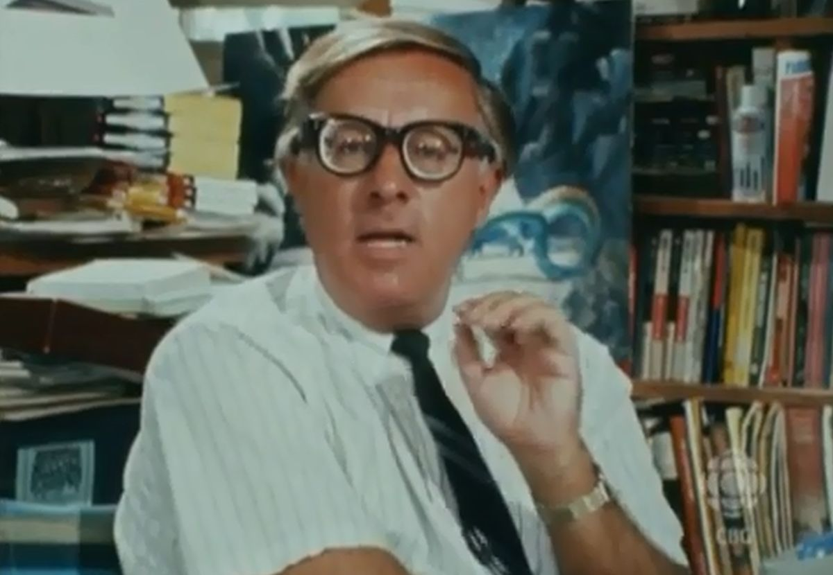

Night Call, Collect, Ray Bradbury

Night Call, Collect

What made the old poem run in his mind he could not guess, but run it did:

Suppose and then suppose and then suppose

That wires on the far-slung telephone black poles

Sopped up the billion-flooded words they heard

Each night all night and saved the sense

And meaning of it all.

He stopped. What next? Ah, yes …

Then, jigsaw in the night, Put all together and

In philosophic phase

Tried words like moron child.

Again he paused. How did the thing end? Wait—

Thus mindless beast

All treasuring of vowels and consonants

Saves up a miracle of bad advice

And lets it filter whisper, heartbeat out

One lisping murmur at a time.

So one night soon someone sits up

Hears sharp bell ring, lifts phone And hears a

Voice like Holy Ghost Gone far in nebulae

That Beast upon the wire,

Which with sibilance and savoring!

Down continental madnesses of time

Says Hell and O And then Hell-o.

He took a breath and finished:

To such Creation

Such dumb brute lost Electric Beast,

What is your wise reply?

He sat silently.

He sat, a man eighty years old. He sat in an empty room in an empty house on an empty street in an empty town on the empty planet Mars.

He sat as he had sat now for fifty years, waiting.

On the table in front of him lay a telephone that had not rung for a long, long time.

It trembled now with some secret preparation. Perhaps that trembling had summoned forth the poem

His nostrils twitched. His eyes flared wide. The phone shivered ever so softly. He leaned forward, staring at it. The phone … rang.

He leapt up and back, the chair fell to the floor. He cried out: cried out:

"No!"

The phone rang again.

"No!"

He wanted to reach out, he did reach out and knock the thing off the table. It fell out of the cradle at the exact moment of its third ring.

"No … oh, no, no," he said softly, hands covering his chest, head wagging, the telephone at his feet. "It can't be … can't be … "

For after all, he was alone in a room in an empty house in an empty town on the planet Mars where no one was alive, only he lived, he was King of the Barren Hill …

And yet …

" … Barton … "

Someone called his name.

No. Some thing buzzed and made a noise of crickets and cicadas in far desertlands.

Barton? he thought. Why … why that'sme!

He hadn't heard anyone say his name in so long he had quite forgot. He was not one for ambling about calling himself by name. He had never—

"Barton," said the phone. "Barton. Barton. Barton."

"Shut up!! "he cried.

And kicked the receiver and bent sweating, panting, to put the phone back on its cradle.

No sooner did he do this than the damned thing rang again.

This time he made a fist around it, squeezed it, as if to throttle the sound, but at last, seeing his knuckles burn color away to whiteness, let go and picked up the receiver.

"Barton," said a far voice, a billion miles away.

He waited until his heart had beat another three times and then said:

"Barton here," he said.

"Well, well," said the voice, only a million miles away now. "Do you know who this is?"

"Christ," said the old man. "The first call I've had in half a lifetime, and we play games."

"Sorry. How stupid of me. Of course you wouldn't recognize your own voice on the telephone. No one ever does. We are accustomed, all of us, to hearing our voice conducted through the bones of our head. Barton, this is Barton."

"What?"

"Who did you think it was?" said the voice. "A rocket captain? Did you think someone had come to rescue you?"

"No."

"What's the date?"

"July 20, 2097."

"Good Lord. Fifty years! Have you been sitting therethatlong waiting for a rocket to come from Earth?"

The old man nodded.

"Now, old man, do you know who I am?"

"Yes." He trembled. "I remember. We are one. I am Emil Barton and you are Emil Barton."

"With one difference. You're eighty, I'm only twenty. All of life before me!"

The old man began to laugh and then to cry. He sat holding the phone like a lost and silly child in his fingers. The conversation was impossible, and should not be continued, yet he went on with it. When he got hold of himself he held the phone close and said, "You there! Listen, oh God, if I could warn you! How can I? You're only a voice. If I could show you how lonely the years are. End it, kill yourself! Don't wait! If you knew what it is to change from the thing you are to the thing that is me, today, here, now, atthisend."

"Impossible!" The voice of the young Barton laughed, far away. "I've no way to tell if you ever get this call. This is all mechanical. You're talking to a transcription, no more. This is 2037. Sixty years in your past. Today, the atom war started on Earth. All colonials were called home from Mars, by rocket. I got left behind!"

"I remember," whispered the old man.

"Alone on Mars," laughed the young voice. "A month, a year, who cares? There are foods and books. In my spare time I've made transcription libraries of ten thousand words, responses, my voice, connected to phone relays. In later months I'll call, have someone to talk with."

"Yes."

"Sixty years from now my own tapes will ring me up. I don't really think I'll be here on Mars that long, it's just a beautiful ironic idea of mine, something to pass the time. Is that really you, Barton? Is that reallyme?"

Tears fell from the old man's eyes. "Yes."

"I've made a thousand Bartons, tapes, sensitive to all questions, in one thousand Martian towns. An army of Bartons over Mars, while I wait for the rockets to return."

"Fool." The old man shook his head, wearily. "You waited sixty years. You grew old waiting, always alone. And now you've become me and you're still alone in the empty cities."

"Don't expect my sympathy. You're like a stranger, off in another country. I can't be sad. I'm alive when I make these tapes. And you're alive when you hear them. Both of us, to the other, incomprehensible. Neither can warn the other, even though both respond, one to the other, one automatically, the other warmly and humanly. I'm human now. You're human later. It's insane. I can't cry, because not knowing the future I can only be optimistic. These hidden tapes can only react to a certain number of stimuli from you. Can you ask a dead man to weep?"

"Stop it!" cried the old man. He felt the familiar seizures of pain. Nausea moved through him, and blackness. "Oh God, but you were heartless. Go away!"

"Were, old man? Iam.As long as the tapes glide on, as long as spindles and hidden electronic eyes read and select and convert words to send to you, I'll be young and cruel. I'll go on being young and cruel long after you're dead. Good-bye."

"Wait!" cried the old man.

Click.

Barton sat holding the silent phone a long time. His heart gave him intense pain.

What insanity it had been. In his youth how silly, how inspired, those first secluded years, fixing the telephonic brains, the tapes, the circuits, scheduling calls on time relays:

The phone bell.

"Morning, Barton. This is Barton. Seven o'clock. Rise and shine!"

Again!

"Barton? Barton calling. You're to go to Mars Town at noon. Install a telephonic brain. Thought I'd remind you."

"Thanks."

The bell!

"Barton? Barton. Have lunch with me? The Rocket Inn?"

"Right."

"See you. So long!"

Brrrriinnnnng!

"That you, B.? Thought I'd cheer you. Firm chin, and all that. The rescue rocket might come tomorrow, to save us."

"Yes, tomorrow, tomorrow, tomorrow, tomorrow."

Click.

But the years had burned into smoke. Barton had muted the insidious phones and their clever, clever repartee. They were to call him only after he was eighty, if he still lived. And now today, the phone ringing, the past breathing in his ear, whispering, remembering.

The phone!

He let it ring.

I don't have to answer it, he thought.

The bell!

There's no one there at all, he thought.

The ringing!

It's like talking to yourself, he thought. But different. Oh God, how different.

He felt his hands lift the phone.

"Hello, old Barton, this is young Barton. I'm twenty-one today! In the last year I've put voice-brains in two hundred more towns. I've populated Mars with Bartons!"

"Yes." The old man remembered those nights six decades ago, rushing over blue hills and into iron valleys, with a truckful of machinery, whistling, happy. Another telephone, another relay. Something to do. Something clever and wonderful and sad. Hidden voices. Hidden, hidden. In those young days when death was not death, time was not time, old age a faint echo from the long cavern of years ahead. That young idiot, that sadistic fool, never thinking someday he might reap this harvest.

"Last night," said Barton, aged twenty-one, "I sat alone in a movie theater in an empty town. I played an old Laurel and Hardy. God, how I laughed."

"Yes."

"I got an idea. I recorded my voice one thousand times on one tape. Broadcast from the town, it sounds like a thousand people. A comforting noise, the noise of a crowd. I fixed it so doors slam in town, children sing, music boxes play, all by clockworks. If I don't look out the window, if I just listen, it's all right. But if I look, it spoils the illusion. I guess I'm getting lonely."

The old man said, "That was your first sign."

"What?"

"The first time you admitted you were lonely."

"I've experimented with smells. As I walk the empty streets, the smell of bacon, eggs, ham, fillets, come from the houses. All done with hidden machines."

"Madness."

"Self-protection!"

"I'm tired." Abruptly, the old man hung up. It was too much. The past drowning him …

Swaying, he moved down the tower stairs to the streets of the town.

The town was dark. No longer did red neons burn, music play, or cooking smells linger. Long ago he had abandoned the fantasy of the mechanical lie. Listen! Are those footsteps? Smell! Isn't that strawberry pic! He had stopped it all.

He moved to the canal where the stars shone in the quivering waters.

Underwater, in row after fishlike row, rusting, were the robot population of Mars he had constructed over the years, and, in a wild realization of his own insane inadequacy, had commanded to march, one two three four! into the canal deeps, plunging, bubbling like sunken bottles. He had killed them and shown no remorse.

Faintly a phone rang in a lightless cottage.

He walked on. The phone ceased.

Another cottage ahead rang its bell as if it knew of his passing. He began to run. The ringing stayed behind. Only to be taken up by a ringing from now this house—now that, now here, there! He darted on. Another phone!

"All right!" he shrieked, exhausted. "I'm coming!"

"Hello, Barton."

"What do you want!"

"I'm lonely. I only live when I speak. So I must speak. You can't shut me up forever."

"Leave me alone!" said the old man, in horror. "Oh, my heart!"

"This is Barton, age twenty-four. Another couple of years gone. Waiting. A tittle lonelier. I've readWar and Peace,drunk sherry, run restaurants with myself as waiter, cook, entertainer. Tonight, I star in a film at the Tivoli—Emil Barton inLove's Labor Lost,playing all the parts, some with wigs!"

"Stop calling me—or I'll kill you!"

"You can't kill me. You'll have to find me, first!"

"I'll find you!"

"You've forgotten where you hid me. I'm everywhere, in boxes, houses, cables, towers, underground! Go ahead, try! What'll you call it? Telecide? Suicide? Jealous, are you? Jealous of me here, only twenty-four, bright-eyed, strong, young. All right, old man, it's war! Between us. Between me! A whole regiment of us, all ages from against you, the real one. Go ahead, declare war!"

"I'll kill you!"

Click. Silence.

He threw the phone out the window.

In the midnight cold, the automobile moved in deep valleys. Under Barton's feet on the floorboard were revolvers, rifles, dynamite. The roar of the car was in his thin, tired bones.

I'll find them, he thought, and destroy all of them. Oh, God, how can he do this to me?

He stopped the car. A strange town lay under the late moons. There was no wind.

He held the rifle in his cold hands. He peered at the poles, the towers, the boxes. Where was this town's voice hidden? That tower? Or that one there! So many years ago. He turned his head now this way, now that, wildly.

He raised the rifle.

The tower fell with the first bullet.

All of them, he thought. All of the towers in this town will have to be cut apart. I've forgotten. Too long.

The car moved along the silent street.

A phone rang.

He looked at the deserted drugstore.

A phone.

Pistol in hand, he shot the lock off the door, and entered.

Click.

"Hello, Barton? Just a warning. Don't try to rip down all the towers, blow things up. Cut your own throat that way. Think it over … "

Click.

He stepped out of the phone booth slowly and moved into the street and listened to the telephone towers humming high in the air, still alive, still untouched. He looked at them and then he understood.

He could not destroy the towers. Suppose a rocket came from Earth, impossible idea, but suppose it came tonight, tomorrow, next week? And landed on the other side of the planet, and used the phones to try to call Barton, only to find the circuits dead?

Barton dropped his gun.

"A rocket won't come," he argued, softly with himself, "I'm old. It's too late."

But suppose it came, and you never knew, he thought. No, you've got to keep the lines open.

Again, a phone ringing.

He mrned dully. He shuffled back into the drugstore and fumbled with the receiver.

"Hello?" A strange voice.

"Please," said the old man, "don't bother me."

"Who's this, who's there? Who is it? Where are you?" cried the voice, surprised.

"Wait a minute." The old man staggered. "This is Emil Barton, who's that?"

"This is Captain Rockwell, Apollo Rocket 48. Just arrived from Earth."

"No, no, no."

"Are you there, Mr. Barton?"

"No, no, it can't be."

"Where are you?"

"You're lying!" The old man had to lean against the booth. His eyes were cold blind. "It's you, Barton, making fun of me, lying again!"

"This is Captain Rockwell. Just landed. In New Chicago. Where are you?"

"In Green Villa," he gasped. "That's six hundred miles from you."

"Look, Barton, can you come here?"

"What?"

"We've repairs on our rocket. Exhausted from the flight. Can you come help?"

"Yes, yes."

"We're at the field outside town. Can you come by tomorrow?"

"Yes, but—"

"Well?"

The old man petted the phone. "How's Earth? How's New York? Is the war over? Who's President now? What happened?"

"Plenty of time for gossip when you arrive."

"Is everything fine?"

"Fine."

"Thank God." The old man listened to the far voice. "Are you sure you're Captain Rockwell?"

"Dammit, man!"

"I'm sorry!"

He hung up and ran.

They were here, after many years, unbelievable, his own people who would take him back to Earth's seas and skies and mountains.

He started the car. He would drive all night. It would be worth a risk, to see people, to shake hands, to hear them again.

The car thundered in the hills.

That voice. Captain Rockwell. It couldn't be himself, forty years ago. He had never made a recording like that. Or had he? In one of his depressive fits, in a spell of drunken cynicism, hadn't he once made a false tape of a false landing on Mars with a synthetic captain, an imaginary crew? He jerked his head, savagely. No. He was a suspicious fool. Now was no time to doubt. He must run with the moons of Mars, all night. What a party they would have!

The sun rose. He was immensely tired, full of thorns and brambles, his heart plunging, his fingers fumbling the wheel, but the thing that pleased him most was the thought of one last phone call: Hello,youngBarton, this isoldBarton. I'm leaving for Earth today! Rescued! He smiled weakly.

He drove into the shadowy limits of New Chicago at sundown. Stepping from his car he stood staring at the rocket tarmac, rubbing his reddened eyes.

The rocket field was empty. No one ran to meet him. No one shook his hand, shouted, or laughed.

He felt his heart roar. He knew blackness and a sensation of falling through the open sky. He stumbled toward an office.

Inside, six phones sat in a neat row.

He waited, gasping.

Finally: the bell.

He lifted the heavy receiver.

A voice said, "I was wondering if you'd get there alive."

The old man did not speak but stood with the phone in his hands.

The voice continued, "Captain Rockwell reporting for duty. Your orders, sir?"

"You," groaned the old man.

"How's your heart, old man?"

"No!"

"Had to eliminate you some way, so I could live, if you call a transcription living."

"I'm going out now," replied the old man. "I don't care. I'll blow up everything until you're all dead!"

"You haven't the strength. Why do you think I had you travel so far, so fast? This is your last trip!"

The old man felt his heart falter. He would never make the other towns. The war was lost. He slid into a chair and made low, mournful noises with his mouth. He glared at the five other phones. As if at a signal, they burst into chorus! A nest of ugly, birds screaming!

Automatic receivers popped up.

The office whirled. "Barton, Barton, Barton!"

He throttled a phone in his hands. He choked it and still it laughed at him. He beat it. He kicked it. He furled the hot wire like serpentine in his fingers, ripped it. It fell about his stumbling feet.

He destroyed three other phones. There was a sudden silence.

And as if his body now discovered a thing which it had long kept secret, it seemed to sink upon his tired bones. The flesh of his eyelids fell away like petals.

His mouth withered. The lobes of his ears were melting wax. He pushed his chest with his hands and fell face down. He lay still. His breathing stopped. His heart stopped.

After a long spell, the remaining two phones rang.

A relay snapped somewhere. The two phone voices were connected, one to the other.

"Hello, Barton?"

"Yes, Barton?"

"Aged twenty-four."

"I'm twenty-six. We're both young. What's happened?"

"I don't know. Listen."

The silent room. The old man did not stir on the floor. The wind blew in the broken window. The air was cool.

"Congratulate me, Barton, this is mytwenty-sixthbirthday!"

"Congratulations!"

The voices sang together, about birthdays, and the singing blew out the window, faintly, faintly, into the dead city.

The End