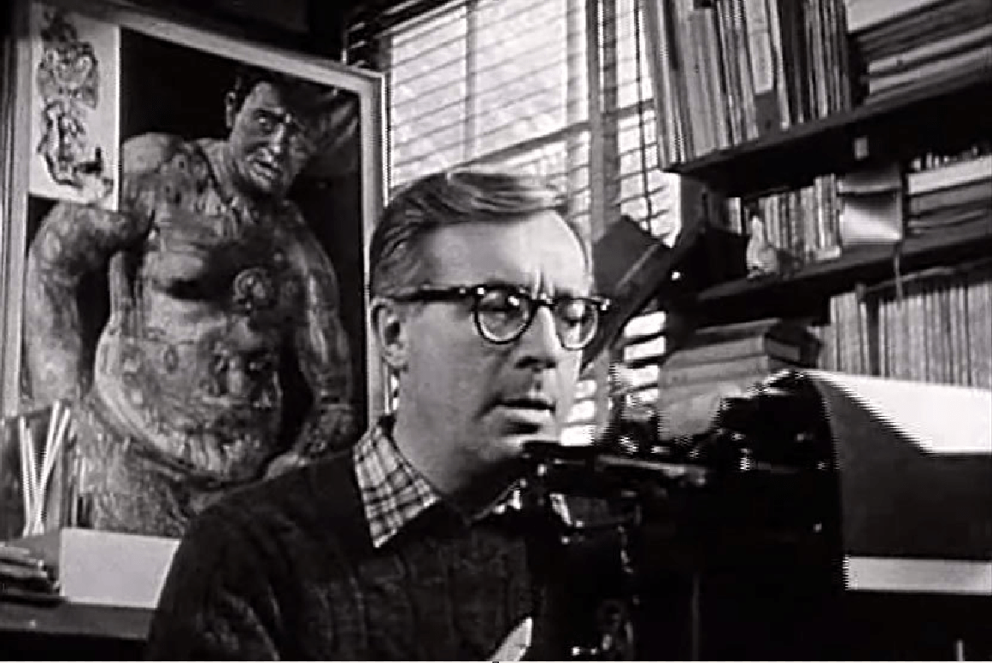

No News, or What Killed the Dog? Ray Bradbury

No News, or What Killed the Dog?

It was a day of holocausts, cataclysms, tornadoes, earthquakes, blackouts, mass murders, eruptions, and miscellaneous dooms, at the peak of which the sun swallowed the earth and the stars vanished.

But to put it simply, the most respected member of the Bentley family up and died.

Dog was his name, and dog he was.

The Bentleys, arising late Saturday morning, found Dog stretched on the kitchen floor, his head toward Mecca, his paws neatly folded, his tail not a-thump but silent for the first time in twenty years.

Twenty years! My God, everyone thought, could it really have been that long? And now, without permission, Dog was cold and gone.

Susan, the younger daughter, woke everyone yelling:

“Something’s wrong with Dog. Quick!”

Without bothering to don his bathrobe, Roger Bentley, in his underwear, hurried out to look at that quiet beast on the kitchen tiles. His wife, Ruth, followed, and then their son Skip, twelve. The rest of the family, married and flown, Rodney and Sal, would arrive later. Each in turn would say the same thing:

“No! Dog was forever.”

Dog said nothing, but lay there like World War II, freshly finished, and a devastation.

Tears poured down Susan’s cheeks, then down Ruth Bentley’s, followed in good order by tears from Father and, at last, when it had sunk in, Skip.

Instinctively, they made a ring around Dog, kneeling to the floor to touch him, as if this might suddenly make him sit up, smile as he always did at his food, bark, and beat them to the door. But their touching did nothing but increase their tears.

But at last they rose, hugged each other, and went blindly in search of breakfast, in the midst of which Ruth Bentley said, stunned, “We can’t just leave him there.”

Roger Bentley picked Dog up, gently, and moved him out on the patio, in the shade, by the pool.

“What do we do next?”

“I don’t know,” said Roger Bentley. “This is the first death in the family in years and—” He stopped, snorted, and shook his head. “I mean—”

“You meant exactly what you said,” said Ruth Bentley. “If Dog wasn’t family, he was nothing. God, I loved him.”

A fresh burst of tears ensued, during which Roger Bentley brought a blanket to put over Dog, but Susan stopped him.

“No, no. I want to see him. I won’t be able to see him ever again. He’s so beautiful. He’s so—old.”

They all carried their breakfasts out on the patio to sit around Dog, somehow feeling they couldn’t ignore him by eating inside.

Roger Bentley telephoned his other children, whose response, after the first tears, was the same: they’d be right over. Wait.

When the other children arrived, first Rodney, twenty-one, and then the older daughter, Sal, twenty-four, a fresh storm of grief shook everyone and then they sat silently for a moment, watching Dog for a miracle.

“What are your plans?” asked Rodney at last.

“I know this is silly,” said Roger Bentley after an embarrassed pause. “After all, he’s only a dog—”

“Only!?” cried everyone instantly.

Roger had to back off. “Look, he deserves the Taj Mahal. What he’ll get is the Orion Pet Cemetery over in Burbank.”

“Pet Cemetery!?” cried everyone, but each in a different way.

“My God,” said Rodney, “that’s silly!”

“What’s so silly about it?” Skip’s face reddened and his lip trembled. “Dog, why, Dog was a pearl of . . . rare price.”

“Yeah!” added Susan.

“Well, pardon me.” Roger Bentley turned away to look at the pool, the bushes, the sky. “I suppose I could call those trash people who pick up dead bodies—”

“Trash people?” exclaimed Ruth Bentley.

“Dead bodies?” said Susan. “Dog isn’t a dead body!”

“What is he, then?” asked Skip bleakly.

They all stared at Dog lying quietly there by the pool.

“He’s,” blurted Susan at last, “he’s . . . he’s my love!”

Before the crying could start again, Roger Bentley picked up the patio telephone, dialed the Pet Cemetery, talked, and put the phone down.

“Two hundred dollars,” he informed everyone. “Not bad.”

“For Dog?” said Skip. “Not enough!”

“Are you really serious about this?” asked Ruth Bentley.

“Yeah,” said Roger. “I’ve made fun of those places all my life. But, now, seeing as how we’ll never be able to visit Dog again—” He let a moment pass. “They’ll come take Dog at noon. Services tomorrow.”

“Services!” Snorting, Rodney stalked to the rim of the pool and waved his arms. “You won’t get me to that!”

Everyone stared. Rodney turned at last and let his shoulders slump. “Hell, I’ll be there.”

“Dog would never forgive you if you didn’t.” Susan snuffed and wiped her nose.

But Roger Bentley had heard none of this. Staring at Dog, then his family, and up to the sky, he shut his eyes and exhaled a great whisper:

“Oh, my God!” he said, eyes shut. “Do you realize that this is the first terrible thing that’s happened to our family? Have we ever been sick, gone to the hospital? Been in an accident?”

He waited.

“No,” said everyone.

“Gosh,” said Skip.

“Gosh, indeed! You sure as hell notice accidents, sickness, hospitals.”

“Maybe,” said Susan, and had to stop and wait because her voice broke. “Maybe Dog died just to make us notice how lucky we are.”

“Lucky?!” Roger Bentley opened his eyes and turned. “Yes! You know what we are—”

“The science fiction generation,” offered Rodney, lighting a cigarette casually.

“What?”

“You rave on about that, your school lectures, or during dinner. Can openers? Science fiction. Automobiles. Radio, TV, films. Everything! So science fiction!”

“Well, dammit, they are!” cried Roger Bentley and went to stare at Dog, as if the answers were there among the last departing fleas. “Hell, not so long ago there were no cars, can openers, TV. Someone had to dream them. Start of lecture. Someone had to build them. Mid-lecture. So science fiction dreams became finished science fact. Lecture finis!”

“I bet!” Rodney applauded politely.

Roger Bentley could only sink under the weight of his son’s irony to stroke the dear dead beast.

“Sorry. Dog bit me. Can’t help myself. Thousands of years, all we did is die. Now, that time’s over. In sum: science fiction.”

“Bull.” Rodney laughed. “Stop reading that junk, Dad.”

“Junk?” Roger touched Dog’s muzzle. “Sure. But how about Lister, Pasteur, Salk? Hated death. Jumped to stop it. That’s all science fiction was ever about. Hating the way things are, wanting to make things different. Junk?!”

“Ancient history, Pop.”

“Ancient?” Roger Bentley fixed his son with a terrible eye. “Christ. When I was born in 1920, if you wanted to visit your family on Sundays you—”

“Went to the graveyard?” said Rodney.

“Yes. My brother and sister died when I was seven. Half of my family gone! Tell me, dear children, how many of your friends died while you were growing up. In grammar school? High school?”

He included the family in his gaze, and waited.

“None,” said Rodney at last.

“None! You hear that? None! Christ. Six of my best friends died by the time I was ten! Wait! I just remembered!”

Roger Bentley hurried to rummage in a hall closet and brought out an old 78-rpm record into the sunlight, blowing off the dust. He squinted at the label:

“No News, Or What Killed The Dog?”

Everyone came to look at the ancient disc.

“Hey, how old is that?”

“Heard it a hundred times when I was a kid in the twenties,” said Roger.

“No News, Or What Killed The Dog?” Sal glanced at her father’s face.

“This gets played at Dog’s funeral,” he said.

“You’re not serious?” said Ruth Bentley.

Just then the doorbell rang.

“That can’t be the Pet Cemetery people come to take Dog—?”

“No!” cried Susan. “Not so soon!”

Instinctively, the family formed a wall between Dog and the doorbell sound, holding off eternity.

Then they cried, one more time.

The strange and wonderful thing about the funeral was how many people came.

“I didn’t know Dog had so many friends,” Susan blubbered.

“He freeloaded all around town,” said Rodney.

“Speak kindly of the dead.”

“Well, he did, dammit. Otherwise why is Bill Johnson here, or Gert Skall, or Jim across the street?”

“Dog,” said Roger Bentley, “I sure wish you could see this.”

“He does.” Susan’s eyes welled over. “Wherever he is.”

“Good old Sue,” whispered Rodney, “who cries at telephone books—”

“Shut up!” cried Susan.

“Hush, both of you.”

And Roger Bentley moved, eyes down, toward the front of the small funeral parlor where Dog was laid out, head on paws, in a box that was neither too rich nor too simple but just right.

Roger Bentley placed a steel needle down on the black record which turned on top of a flake-painted portable phonograph. The needle scratched and hissed. All the neighbors leaned forward.

“No funeral oration,” said Roger quickly. “Just this . . .”

And a voice spoke on a day long ago and told a story about a man who returned from vacation to ask friends what had happened while he was gone.

It seemed that nothing whatsoever had happened.

Oh, just one thing. Everyone wondered what had killed the dog.

The dog? asked the vacationer. My dog died?

Yes, and maybe it was the burned horseflesh did it.

Burned horseflesh!? cried the vacationer.

Well, said his informant, when the barn burned, the horseflesh caught fire, so the dog ate the burned horseflesh, died.

The barn!? cried the vacationer. How did it catch fire?

Well, sparks from the house blew over, torched the barn, burned the horseflesh, dog ate them, died.

Sparks from the house!? shouted the vacationer. How—?

It was the curtains in the house, caught fire.

Curtains? Burned!?

From the candles around the coffin.

Coffin!?

Your aunt’s funeral coffin, candles there caught the curtains, house burned, sparks from the house flew over, burned down the barn, dog ate the burned horseflesh—

In sum: no news, or what killed the dog!

The record hissed and stopped.

In the silence, there was a little quiet laughter, even though the record had been about dogs and people dying.

“Now, do we get the lecture?” said Rodney.

“No, a sermon.”

Roger Bentley put his hands on the pulpit to stare for long moments at notes he hadn’t made.

“I don’t know if we’re here for Dog or ourselves. Both, I suppose. We’re the nothing-ever-happened-to-us people. Today is a first. Not that I want a rush of doom or disease. God forbid. Death, come slowly, please.”

He turned the phonograph record round and round in his hands, trying to read the words under the grooves.

“No news. Except the aunt’s funeral candles catch the curtains, sparks fly, and the dog goes west. In our lives, just the opposite. No news for years. Good livers, healthy hearts, good times. So—what’s it all about?”

Roger Bentley glanced at Rodney, who was checking his wristwatch.

“Someday we must die, also.” Roger Bentley hurried on. “Hard to believe. We’re spoiled. But Susan was right. Dog died to tell us this, gently, and we must believe. And at the same time celebrate. What? The fact that we’re the start of an amazing, dumbfounding history of survival that will only get better as the centuries pass. You may argue that the next war will take us all. Maybe.

“I can only say I think you will grow to be old, very old people. Ninety years from now, most people will have cured hearts, stopped cancers, and jumped life cycles. A lot of sadness will have gone out of the world, thank God. Will this be easy to do? No. Will we do it? Yes. Not in all countries, right off. But, finally, in most.

“As I said yesterday, fifty years ago, if you wanted to visit your aunts, uncles, grandparents, brothers, sisters, the graveyard was it. Death was all the talk. You had to talk it. Time’s up, Rodney?”

Rodney signaled his father he had one last minute.

Roger Bentley wound it down:

“Sure, kids still die. But not millions. Old folks? Wind up in Sun City instead of Marble Orchard.”

The father surveyed his family, bright-eyed, in the pews.

“God, look at you! Then look back. A thousand centuries of absolute terror, absolute grief. How parents stayed sane to raise their kids when half of them died, damned if I know. Yet with broken hearts, they did. While millions died of flu or the Plague.

“So here we are in a new time that we can’t see because we stand in the eye of the hurricane, where everything’s calm.

“I’ll shut up now, with a last word for Dog. Because we loved him, we’ve done this almost silly thing, this service, but now suddenly we’re not ashamed or sorry we bought him a plot or had me speak. We may never come visit him, who can say? But he has a place. Dog, old boy, bless you. Now, everyone, blow your nose.”

Everyone blew his nose.

“Dad,” said Rodney suddenly, “could—we hear the record again?”

Everyone looked at Rodney, surprised.

“Just,” said Roger Bentley, “what I was going to suggest.”

He put the needle on the record. It hissed.

About a minute in, when the sparks from the house flew over to burn the barn and torch the horseflesh and kill the dog, there was a sound at the back doorway to the small parlor.

Everyone turned.

A strange man stood in the door holding a small wicker basket from which came familiar, small yapping sounds.

And even as the flames from the candles around the coffin caught the curtains and the last sparks blew on the wind . . .

The whole family, drawn out into the sunlight, gathered around the stranger with the wicker basket, waiting for Father to arrive to throw back the coverlet on the small carrier so they could all dip their hands in.

That moment, as Susan said later, was like reading the telephone book one more time.

The End