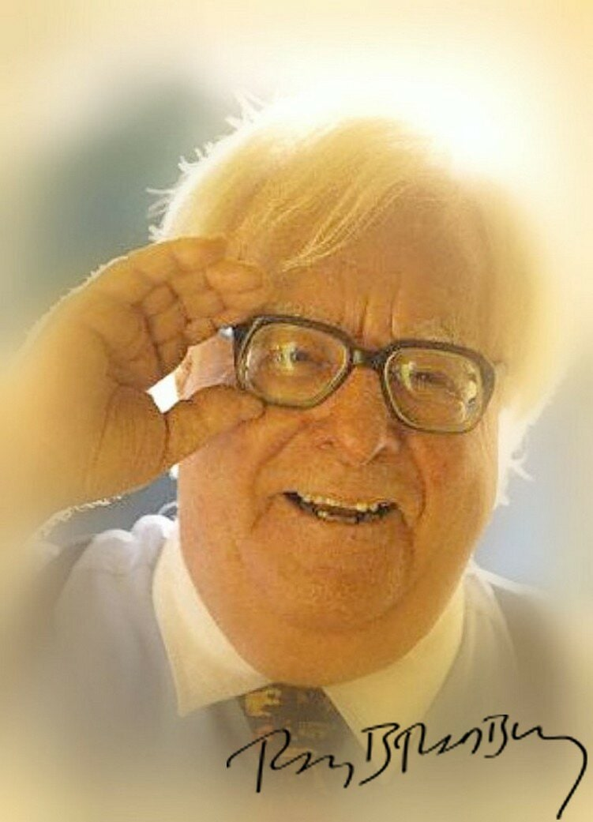

One Night in Your Life , Ray Bradbury

One Night in Your Life

He came into Green River, Iowa, on a really fine late spring morning, driving swiftly. His convertible Cadillac was hot in the direct sun outside the town, but then the green overhanging forests, the abundances of soft shade and whispering coolness slowed his car as he moved toward the town.

“Thirty miles an hour,” he thought, “is fast enough.”

Leaving Los Angeles, he had rocketed his car across burning country, between stone canyons and meteor rocks, places where you had to go fast because everything seemed fast and hard and clean.

But here, the very greenness of the air made a river through which no car could rush. You could only idle on the tide of leafy shadow, drifting on the sunlight-speckled concrete like a river barge on its way to a summer sea.

Looking up through the great trees was like lying at the bottom of a deep pool, letting the tide drift you.

He stopped for a hot-dog at an outdoor stand on the edge of town.

“Lord”, he whispered to himself, “I haven’t been back through here in fifteen years. You forget how fast trees can grow.”

He turned back to his car. A tall man, with a sunburned, wry, thin face and thinning dark hair. “Why am I driving to New York?” he wondered. “Why don’t I just stay and drown myself here, in the grass?”

He drove slowly through the old town. He saw a rusty train, abandoned on old side-spur track, its whistle long silent, its steam long gone. He watched the people moving in and out of stores and houses, so slowly they were under a great sea of clean, warm water. Moss was everywhere, so every motion came to rest on softness and silence. It was a barefoot, Mark Twain town. a town where childhood lingered without anticipation and old age came without regret.

He snorted gently at himself, or so it seemed.

“I’m glad Helen didn’t come on this trip”, he thought. He could hear her now: “My God, this place is small! Good grief, look at those hicks! Hit the gas! Where in hell is New York?”

He shook his head, closed his eyes, and Helen was in Reno. He had phoned her last night.

“Getting divorced’s not bad,” she’d said, a thousand miles back in the heat. “It’s Reno that’s awful. Thank God for the swimming pool. Well, what are you up to?”

“Driving east in slow stages.” That was a lie. He was rushing east like a shot bullet, to lose the past, to tear away as many things behind him as he could leave. “Driving’s fun.”

“Fun?” Helen protested. “When you could fly? Cars are so boring.”

“Goodbye, Helen.”

He drove out of town. He was supposed to be in New York in five days, to talk over the play he didn’t want to write for Broadway, in order to rush back to Hollywood in time to not enjoy finishing a screenplay, so that he could rush to Mexico City for a quick vacation next December.

“Sometimes,” he mused, “I resemble those Mexican rockets bashing between the town buildings on a hot wire, bashing my head on one wall, turning and zooming back to crash against another.”

He found himself going seventy miles an hour suddenly, and cautioned it down to thirty-five, through rolling, green, noon country.

He took deep breaths of the clear air and pulled over to the side of the road. Far away, between immense trees on the top of a meadow hill, he thought he saw, walking but motionless in the strange heat, a young woman. And then she was gone. And he wasn’t certain she had been there at all.

It was one o’clock, and the land was full of a great powerhouse humming. Darning needles flashed by the car windows, like prickles of heat before his eyes. Bees swarmed and the grass bent under a tender wind.

He opened the car door and stepped out into the straight heat.

Here was a lonely path that sang beetle sounds at late noon to itself, and there was a cool shadowed forest waiting fifty yards from the road, from which blew a good, tunnel-moist air. On all sides were rolling clover hills and an open sky.

Standing there, he could feel the stone dissolve in his arms and his neck, and the iron go out of his cold stomach, and the tremor cease in his fingers.

And then, suddenly, still further away, going over a forest hill through a small rift in the brush, he saw the young woman again, walking and walking into the warm distances, gone.

He locked the car door slowly. He struck off into the forest idly, drawn steadily by a sound that was large enough to fill the universe - the sound of a river going somewhere and not caring, the most beautiful sound of all.

When he found the river, it was dark and light, and dark and light, flowing, and he undressed and swam in it, and then lay out on the pebbled bank, drying, feeling relaxed. He put his clothes back on leisurely, and then it came to him: the old desire, the old dream, when he was seventeen years old. He had often confided and repeated it to a friend.

“I’d like to go walking some spring night - you know, one of those nights that are warm all night long. I’d like to walk. With a girl. Walk for an hour, to a place where you can barely hear or see anything. Climb a hill and sit.

Look at the stars. I’d like to hold the girl’s hand. I’d like to smell the grass and the wheat growing in the fields, and know I was in the centre of the entire country, in the very centre of the United States, and towns all around and highways away off, but nobody knowing we’re right there on top of that hill, in the grass, watching the night.

“And just holding her hand would be good. Can you understand that? Do you know that holding someone’s hand can be the thing? Such a thing that your hands move while not moving. You can remember a thing like that, rather than any other thing about a night, all your life. Just holding hands can mean more. I believe it. When everything is repeated, and over, and familiar, it’s the first things rather than the last that count.

“So, for a long time,” he had continued, “I’d like to just sit there, not saying a word. There aren’t any words for a night like that. We wouldn’t even look at each other. We’d see the lights of the town far off and know that other people had climbed other hills before us and that there was nothing better in the world. Nothing could be made better; all of the houses and ceremonies and guarantees in the world are nothing compared to a night like this. The cities and the people in the rooms in the houses in those cities at night are one thing; the hills and the open air and the stars and holding hands are something else.

“And then, finally, without speaking, the two of you will turn your heads in the moonlight and look at each other.

“And so you’re on the hill all night long. Is there anything really wrong with this, can you honestly say there is anything wrong?”

“No,” said a voice, “the only thing wrong on a night like that is that there is a world and you must come back to it.”

That was his friend Joseph speaking fifteen years ago. Dear Joseph, with whom he had talked so many days through, their adolescent philosophisings, their problems of great import. Now Joseph was married and swallowed by the black streets of Chicago. And himself, taken west by time, and all of their philosophy for nothing.

He remembered the month after he had married Helen. They had driven across country, the first and last time she had consented to the “brutal”, as she called it, journey by automobile. In the moonlit evenings they had gone through the wheat country and the corn country of the middle west, and once at twilight, looking straight ahead, Thomas had said:

“What do you say? Would you like to spend the night out?”

“Out?” Helen said.

“Here,” he said, with a great appearance of casualness. He motioned his hand to the side of the road. “Look at all that land, the hills. It’s a warm night. It’d be nice to sleep out.”

“My God!” Helen had cried. “You’re not serious?”

“I just thought.”

“The damn country’s running with snakes and bugs! What a way to spend the night, getting burrs in my stockings, tramping around some farmer’s property.”

“No-one would ever know.”

“But I’d know, my dear,” said Helen.

“It was just a suggestion.”

“Dear Tom, you were only joking, weren’t you?”

“Forget I ever said anything,” he said.

They had driven on in the moonlight to a boiling little night motel where moths fluttered about the raw electric lights. There had been an iron bed in a paint-smelling tiny room where you could hear the beer tunes from the roadhouse all night and hear the continental vans pounding by, late, late toward dawn.

He walked through the green forest and listened to the various silences there. Not one silence, but several. The silence that the moss made underfoot. The silence the shadows made, descending from the trees. The silence of small streams exploring tiny countries on all sides as he came into a clearing.

He found some wild strawberries and ate them. “To hell with the car,” he thought. “I don’t care if someone takes it apart wheel by wheel and carries it off. I don’t care if the sun melts it into slag on the spot.”

He lay down and cradled his head on his arms, and went to sleep.

The first thing he saw when he wakened was his wristwatch. Six forty-five! He had slept most of the day away. Cool shadows had crept up all about him. He shivered and moved to sit up, and then did not move again, but lay there with his face upon his arm, looking ahead.

The girl, who sat a few yards away from him with her hands in her lap, smiled.

“I didn’t hear you come up,” he said. She had been very quiet.

For no reason at all in the world, except a secret reason, Thomas felt his heart pounding silently and swiftly.

She remained silent. He rolled over on his back and closed his eyes.

“Do you live near here?”

She lived not far away.

“Born and raised here?”

She had never been anywhere else.

“It’s a beautiful country,” he said.

A bird flew into a tree.

“Aren’t you afraid?”

He waited, but there was no answer.

“You don’t know me,” he said.

But on the other hand, neither did he know her.

“That’s different,” he said.

Why was it different?

“Oh, you know. It just is.”

After what seemed half an hour of waiting, he opened his eyes and looked at her for a long while. “You are real, aren’t you? I’m not dreaming this?”

She wanted to know where he was going.

“Somewhere I don’t want to go.”

Yes, that was what so many people said. So many passed through on their way to somewhere they didn’t like.

“That’s me,” he said. He raised himself slowly. “Do you know, I’ve just realised I haven’t eaten since early today.”

She offered him the bread and cheese and cookies she was carrying from town. They didn’t speak while he ate, and he ate very slowly, afraid that some motion, some gesture, some word, might make her run away. The sun was down the sky and the air was even fresher now, and he examined everything very carefully. He looked at her, and she was beautiful. Twenty-one, fair, healthy, pink-cheeked and self-contained.

The sun was gone. The sky lingered its colours for a time while they sat in the clearing. At last, he heard a whispering. She was getting up. She put out her hand to take his. He stood beside her, and they looked at the woods around them and the distant hills. They began to walk away from the path and the car, away from the highway and the town. A spring moon rose over the land while they were walking.

The breath of nightfall was rising up out of the separate blades of grass, a warm sighing of air, quiet and endless. They reached the top of the hill, and without a word, sat there watching the sky.

He thought to himself that this was impossible; that such things did not happen. He wondered who she was, and what she was doing here.

Ten miles away, a train whistled in the spring night and went on its way over the dark evening earth, flashing a brief fire. And then, again, he remembered the old story, the old dream. The thing he and his friend had discussed, so many years ago.

There must be one night in your life that you will remember forever. There must be one night for everyone. And if you know that the night is coming on and that this night will be that particular night, then take it and donât question it and donât talk about it to anyone ever after that.

For if you let it pass it might not come again. Many have let it pass, many have seen it go by and have never seen another like it, when all the circumstances of weather, light, moon and time, of night hill and warm grass and train and town and distance were balanced upon the trembling of a finger.

He thought of Helen and he thought of Joseph. Joseph. Did it ever work out for you, Joseph? Were you ever at the right place at the right time, and did all go well with you?

There was no way of knowing. The brick city had taken Joseph and lost him in the tiled subways and black elevateds and noise. As for Helen, not only had she never known a night like this, but she had never dreamed of such a thing. There was no place in her mind for this.

“So here I am,” he thought quietly. “Thousands of miles from everything and everyone.” Across the soft, black country now came the sound of a courthouse clock, ringing the hour.

One, two, three.

One of those great stone courthouses that stood in the green square of every small American town at the turn of the century - cool stone in the summertime, high in the night sky, with round dial faces glowing in four directions.

Five, six.

He counted the bronze announcements of the hour, stopping at nine. Nine o’clock on a late spring night, on a breathing, warm moonlit hill in the interior of a great continent, his hand touching another hand, thinking, “This year I’ll be thirty-three. But it didn’t come too late, and I didn’t let it pass, and this is the night.”

Slowly now, carefully, like a statue coming to life, turning and turning still more, he saw her head move about so her eyes could look upon him. He felt his own head turning also, as it had done so many times in his imagination.

They gazed at each other for a long time.

He woke during the night. She was awake, near him.

“Who are you?” he whispered.

She said nothing.

“I could stay another night,” he said.

But he knew that one can never stay another night. One night is the night, and only one. After that, the gods turn their backs.

“I could come back in a year or so.”

Her eyes were closed, but she was awake.

“But I don’t know who you are,” he said.

“You could come with me,” he said, “to New York.”

But he knew that she could never be there, or anywhere but here, on this night.

“And I can’t stay here,” he said, knowing that this was the truest and most empty part of all.

He waited for a time and then said again, “Are you real? Are you really real?”

They slept. The moon went down the sky toward morning.

He walked out of the hills and the forest at dawn, to find the car covered with dew. He unlocked it and climbed in behind the wheel, and sat for a moment looking back at the path he had made in the wet grass.

He moved over, preparatory to getting out of the car again. He put his hand on the inside of the door and gazed steadily out. The forest was empty and still. The path was deserted. The highway was motionless and serene. There was no movement anywhere in a thousand miles.

He started the car motor and let it idle. The car was pointed east, where the orange sun was now rising slowly.

“All right,” he said quietly. “Everyone, here I come. What a shame you’re all still alive. What a shame the world isn’t just hills and hills, and nothing else to drive over but hills, and never coming to a town.”

He drove away east, without looking back.

The End