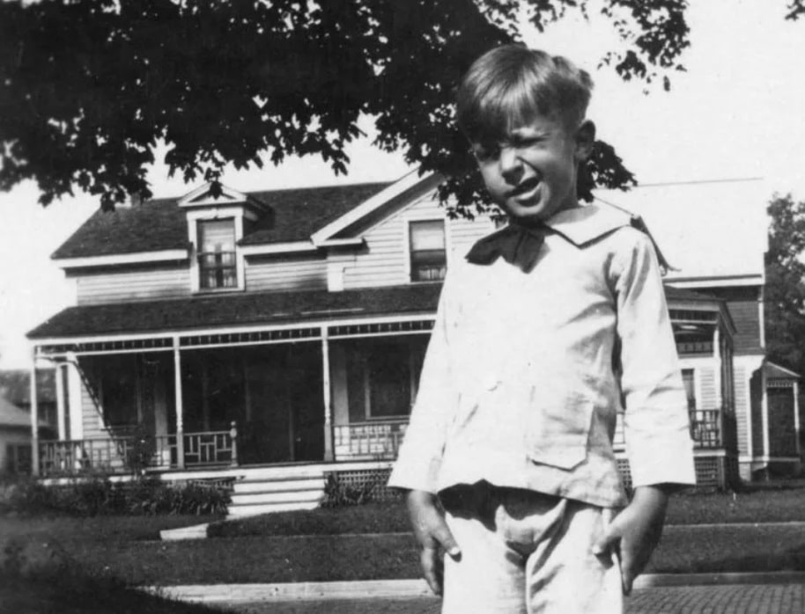

One for His Lordship, and One for the Road! Ray Bradbury

One for His Lordship, and One for the Road!

Someone’s born, and it may take the best part of a day for the news to ferment, percolate, or otherwise circumnavigate across the Irish meadows to the nearest town, and the nearest pub, which is Heeber Finn’s.

But let someone die, and a whole symphonic band lifts in the fields and hills. The grand ta-ta slams across country to ricochet off the pub slates and shake the drinkers to calamitous cries for: more!

So it was this hot summer day. The pub was no sooner opened, aired, and mobbed than Finn, at the door, saw a dust flurry up the road.

“That’s Doone,” muttered Finn.

Doone was the local anthem sprinter, fast at getting out of cinemas ahead of the damned national tune, and swift at bringing news.

“And the news is bad,” murmured Finn. “It’s that fast he’s running!”

“Ha!” cried Doone, as he leaped across the sill. “It’s done, and he’s dead!”

The mob at the bar turned.

Doone enjoyed his moment of triumph, making them wait.

“Ah, God, here’s a drink. Maybe that’ll make you talk!”

Finn shoved a glass in Doone’s waiting paw. Doone wet his whistle and arranged the facts.

“Himself,” he gasped, at last. “Lord Kilgotten. Dead. And not an hour past!”

“Ah, God,” said one and all, quietly. “Bless the old man. A sweet nature. A dear chap.”

For Lord Kilgotten had wandered their fields, pastures, barns, and this bar all the years of their lives. His departure was like the Normans rowing back to France or the damned Brits pulling out of Bombay.

“A fine man,” said Finn, drinking to the memory, “even though he did spend two weeks a year in London.”

“How old was he?” asked Brannigan. “Eighty-five? Eighty-eight? We thought we might have buried him long since.”

“Men like that,” said Doone, “God has to hit with an axe to scare them off the place. Paris, now, we thought that might have slain him, years past, but no. Drink, that should have drowned him, but he swam for the shore, no, no. It was that teeny bolt of lightning in the field’s midst, an hour ago, and him under the tree picking strawberries with his nineteen-year-old secretary lady.”

“Jesus,” said Finn. “There’s no strawberries this time of year. It was her hit him with a bolt of fever. Burned to a crisp!”

That fired off a twenty-one-gun salute of laughs that hushed itself down when they considered the subject and more townsfolk arrived to breathe the air and bless himself.

“I wonder,” mused Heeber Finn, at last, in a voice that would make the Valhalla gods sit still at table, and not scratch, “I wonder. What’s to become of all that wine? The wine, that is, which Lord Kilgotten has stashed in barrels and bins, by the quarts and the tons, by the scores and precious thousands in his cellars and attics, and, who knows, under his bed?”

“Aye,” said everyone, stunned, suddenly remembering. “Aye. Sure. What?”

“It has been left, no doubt, to some damn Yank driftabout cousin or nephew, corrupted by Rome, driven mad by Paris, who’ll jet in tomorrow, who’ll seize and drink, grab and run, and Kilcock and us left beggared and buggered on the road behind!” said Doone, all in one breath.

“Aye.” Their voices, like muffled dark velvet drums, marched toward the night. “Aye.”

“There are no relatives!” said Finn. “No dumb Yank nephews or dimwit nieces falling out of gondolas in Venice, but swimming this way. I have made it my business to know.”

Finn waited. It was his moment now. All stared. All leaned to hear his mighty proclamation.

“Why not, I been thinking, if Kilgotten, by God, left all ten thousand bottles of Burgundy and Bordeaux to the citizens of the loveliest town in Eire? To us!”

There was an antic uproar of comment on this, cut across when the front doorflaps burst wide and Finn’s wife, who rarely visited the sty, stepped in, glared around and snapped.

“Funeral’s in an hour!”

“An hour?” cried Finn. “Why, he’s only just cold—”

“Noon’s the time,” said the wife, growing taller the more she looked at this dreadful tribe. “The doc and the priest have just come from the Place. Quick funerals was his lordship’s will. ‘Uncivilized,’ said Father Kelly, ‘and no hole dug.’ ‘But there is!’ said the Doc. ‘Hanrahan was supposed to die yesterday but took on a fit of mean and survived the night. I treated and treated him, but the man persists! Meanwhile, there’s his hole, unfilled. Kilgotten can have it, dirt and headstone.’ All’s invited. Move your bums!”

The double-wing doors whiffled shut. The mystic woman was gone.

“A funeral!” cried Doone, prepared to sprint.

“No!” Finn beamed. “Get out. Pub’s closed. A wake!”

“Even Christ,” gasped Doone, mopping the sweat from his brow, “wouldn’t climb down off the cross to walk on a day like this.”

“The heat,” said Mulligan, “is intolerable.”

Coats off, they trudged up the hill, past the Kilgotten gatehouse, to encounter the town priest, Father Padraic Kelly, doing the same. He had all but his collar off, and was beet faced in the bargain.

“It’s hell’s own day,” he agreed, “none of us will keep!”

“Why all the rush?” said Finn, matching fiery stride for stride with the holy man. “I smell a rat. What’s up?”

“Aye,” said the priest. “There was a secret codicil in the will—”

“I knew it!” said Finn.

“What?” asked the crowd, fermenting close behind in the sun.

“It would have caused a riot if it got out,” was all Father Kelly would say, his eyes on the graveyard gates. “You’ll find out at the penultimate moment.”

“Is that the moment before or the moment after the end, Father?” asked Doone, innocently.

“Ah, you’re so dumb you’re pitiful,” sighed the priest. “Get your ass through that gate. Don’t fall in the hole!”

Doone did just that. The others followed, their faces assuming a darker tone as they passed through. The sun, as if to observe this, moved behind a cloud, and a sweet breeze came up for some moment of relief.

“There’s the hole.” The priest nodded. “Line up on both sides of the path, for God’s sake, and fix your ties, if you have some, and check your flies, above all. Let’s run a nice show for Kilgotten, and here he comes!”

And here, indeed, came Lord Kilgotten, in a box carried on the planks of one of his farm wagons, a simple good soul to be sure, and behind that wagon, a procession of other vehicles, cars, trucks that stretched half down the hill in the now once more piercing light.

“What a procession!” cried Finn.

“I never seen the like!” cried Doone.

“Shut up,” said the priest, politely.

“My God,” said Finn. “Do you see the coffin?”

“We see, Finn, we see!” gasped all.

For the coffin, trundling by, was beautifully wrought, finely nailed together with silver and gold nails, but the special strange wood of it?

Plankings from wine-crates, staves from boxes that had sailed from France only to collide and sink in Lord Kilgotten’s cellars!

A storm of exhalations swept the men from Finn’s pub. They toppled on their heels. They seized each other’s elbows.

“You know the words, Finn,” whispered Doone. “Tell us the names!”

Finn eyed the coffin made of vintage shipping crates, and at last exhaled:

“Pull out my tongue and jump on it. Look! There’s Château Lafite Rothschild, nineteen seventy. Château-neuf du Pape, ’sixty-eight! Upside down, that label, Le Corton! Downside up: La Lagune! What style, my God, what class! I wouldn’t so much mind being buried in burned-stamp-labeled wood like that, myself!”

“I wonder,” mused Doone, “can he read the labels from inside?”

“Put a sock in it,” muttered the priest. “Here comes the rest!”

If the body in the box was not enough to pull clouds over the sun, this second arrival caused an even greater ripple of uneasiness to oil the sweating men.

“It was as if,” Doone recalled, later, “someone had slipped, fallen in the grave, broken an ankle, and spoiled the whole afternoon!”

For the last part of the procession was a series of cars and trucks ramshackle-loaded with French vineyard crates, and finally a great old brewery wagon from early Guinness days, drawn by a team of proud white horses, draped in black, and sweating with the surprise they drew behind.

“I will be damned,” said Finn. “Lord Kilgotten’s brought his own wake with him!”

“Hurrah!” was the cry. “What a dear soul.”

“He must’ve known the day would ignite a nun, or kindle a priest, and our tongues on our chests!”

“Gangway! Let it pass!”

The men stood aside as all the wagons, carrying strange labels from southern France and northern Italy, making tidal sounds of bulked liquids, lumbered into the churchyard.

“Someday,” whispered Doone, “we must raise a statue to Kilgotten, a philosopher of friends!”

“Pull up your socks,” said the priest. “It’s too soon to tell. For here comes something worse than an undertaker!”

“What could be worse?”

With the last of the wine wagons drawn up about the grave, a single man strode up the road, hat on, coat buttoned, cuffs properly shot, shoes polished against all reason, mustache waxed and cool, unmelted, a prim case like a lady’s purse tucked under his clenched arm, and about him an air of the ice house, a thing fresh born from a snowy vault, tongue like an icicle, stare like a frozen pond.

“Jesus,” said Finn.

“It’s a lawyer!” said Doone.

All stood aside.

The lawyer, for that is what it was, strode past like Moses as the Red Sea obeyed, or King Louis on a stroll, or the haughtiest tart on Piccadilly: choose one.

“It’s Kilgotten’s law,” hissed Muldoon. “I seen him stalking Dublin like the Apocalypse. With a lie for a name: Clement! Half-ass Irish, full-ass Briton. The worst!”

“What can be worse than death?” someone whispered.

“We,” murmured the priest, “shall soon see.”

“Gentlemen!”

A voice called. The mob turned.

Lawyer Clement, at the rim of the grave, took the prim briefcase from under his arm, opened it, and drew forth a symboled and ribboned document, the beauty of which bugged the eye and rammed and sank the heart.

“Before the obsequies,” he said. “Before Father Kelly orates, I have a message, this codicil in Lord Kilgotten’s will, which I shall read aloud.”

“I bet it’s the eleventh Commandment,” murmured the priest, eyes down.

“What would the eleventh Commandment be?” asked Doone, scowling.

“Why not: ‘THOU SHALT SHUT UP AND LISTEN’” said the priest. “Ssh.”

For the lawyer was reading from his ribboned document and his voice floated on the hot summer wind, like this:

“‘And whereas my wines are the finest—’”

“They are that!” said Finn.

“‘—and whereas the greatest labels from across the world fill my cellars, and whereas the people of this town, Kilcock, do not appreciate such things, but prefer the—er—hard stuff . . .’”

“Who says?!” cried Doone.

“Back in your ditch,” warned the priest, sotto voce.

“‘I do hereby proclaim and pronounce,’” read the lawyer, with a great smarmy smirk of satisfaction, “‘that contrary to the old adage, a man can indeed take it with him. And I so order, write, and sign this codicil to my last will and testament in what might well be the final month of my life.’ Signed, William, Lord Kilgotten. Last month, on the seventh.”

The lawyer stopped, folded the paper and stood, eyes shut, waiting for the thunderclap that would follow the lightning bolt.

“Does that mean,” asked Doone, wincing, “that the lord intends to—?”

Someone pulled a cork out of a bottle.

It was like a fusillade that shot all the men in their tracks.

It was only, of course, the good lawyer Clement, at the rim of the damned grave, corkscrewing and yanking open the plug from a bottle of La Vieille Ferme ’73!

“Is this the wake, then?” Doone laughed, nervously.

“It is not,” mourned the priest.

With a smile of summer satisfaction, Clement, the lawyer, poured the wine, glug by glug, down into the grave, over the wine-carton box in which Lord Kilgotten’s thirsty bones were hid.

“Hold on! He’s gone mad! Grab the bottle! No!”

There was a vast explosion, like that from the crowd’s throat that has just seen its soccer champion slain midfield!

“Wait! My God!”

“Quick. Run get the lord!”

“Dumb,” muttered Finn. “His lordship’s in that box, and his wine is in the grave!”

Stunned by this unbelievable calamity, the mob could only stare as the last of the first bottle cascaded down into the holy earth.

Clement handed the bottle to Doone, and uncorked a second.

“Now, wait just one moment!” cried the voice of the Day of Judgment.

And it was, of course, Father Kelly, who stepped forth, bringing his higher law with him.

“Do you mean to say,” cried the priest, his cheeks blazing, his eyes smoldering with bright sun, “you are going to dispense all that stuff in Kilgotten’s pit?”

“That,” said the lawyer, “is my intent.”

He began to pour the second bottle. But the priest stiff-armed him, to tilt the wine back.

“And do you mean for us to just stand and watch your blasphemy?!”

“At a wake, yes, that would be the polite thing to do.” The lawyer moved to pour again.

“Just hold it, right there!” The priest stared around, up, down, at his friends from the pub, at Finn their spiritual leader, at the sky where God hid, at the earth where Kilgotten lay playing Mum’s the Word, and at last at lawyer Clement and his damned, ribboned codicil. “Beware, man, you are provoking civil strife!”

“Yah!” cried everyone, atilt on the air, fists at their sides, grinding and ungrinding invisible rocks.

“What year is this wine?” Ignoring them, Clement calmly eyed the label in his hands. “Le Corton. Nineteen-seventy. The best wine in the finest year. Excellent.” He stepped free of the priest and let the wine spill.

“Do something!” shouted Doone. “Have you no curse handy?”

“Priests do not curse,” said Father Kelly. “But, Finn, Doone, Hannahan, Burke. Jump! Knock heads.”

The priest marched off and the men rushed after to knock their heads in a bent-down ring and a great whisper with the father. In the midst of the conference the priest stood up to see what Clement was doing. The lawyer was on his third bottle.

“Quick!” cried Doone. “He’ll waste the lot!”

A fourth cork popped, to another outcry from Finn’s team, the Thirsty Warriors, as they would later dub themselves.

“Finn!” the priest was heard to say, deep in the heads-together, “you’re a genius!”

“I am!” agreed Finn, and the huddle broke and the priest hustled back to the grave.

“Would you mind, sir,” he said, grabbing the bottle out of the lawyer’s grip, “reading one last time, that damned codicil?”

“Pleasure.” And it was. The lawyer’s smile flashed as he fluttered the ribbons and snapped the will.

“‘—that contrary to the old adage, a man can indeed take it with him—’”

He finished and folded the paper, and tried another smile, which worked to his own satisfaction, at least. He reached for the bottle confiscated by the priest.

“Hold on.” Father Kelly stepped back. He gave a look to the crowd who waited on each fine word. “Let me ask you a question, Mr. Lawyer, sir. Does it anywhere say there just how the wine is to get into the grave?”

“Into the grave is into the grave,” said the lawyer.

“As long as it finally gets there, that’s the important thing, do we agree?” asked the priest, with a strange smile.

“I can pour it over my shoulder, or toss it in the air,” said the lawyer, “as long as it lights to either side or atop the coffin, when it comes down, all’s well.”

“Good!” exclaimed the priest. “Men! One squad here. One battalion over there. Line up! Doone!”

“Sir?”

“Spread the rations. Jump!”

“Sir!” Doone jumped.

To a great uproar of men bustling and lining up.

“I,” said the lawyer, “am going to find the police!”

“Which is me,” said a man at the far side of the mob, “Officer Bannion. Your complaint?”

Stunned, lawyer Clement could only blink and at last in a squashed voice, bleat: “I’m leaving.”

“You’ll not make it past the gate alive,” said Doone, cheerily.

“I,” said the lawyer, “am staying. But—”

“But?” inquired Father Kelly, as the corks were pulled and the corkscrew flashed brightly along the line.

“You go against the letter of the law!”

“No,” explained the priest, calmly, “we but shift the punctuation, cross new t’s, dot new i’s.”

“Tenshun!” cried Finn, for all was in readiness.

On both sides of the grave, the men waited, each with a full bottle of vintage Château Lafite Rothschild or Le Corton or Chianti.

“Do we drink it all?” asked Doone.

“Shut your gab,” observed the priest. He eyed the sky. “Oh, Lord.” The men bowed their heads and grabbed off their caps. “Lord, for what we are about to receive, make us truly thankful. And thank you, Lord, for the genius of Heeber Finn, who thought of this—”

“Aye,” said all, gently.

“Twas nothin’,” said Finn, blushing.

“And bless this wine, which may circumnavigate along the way, but finally wind up where it should be going. And if today and tonight won’t do, and all the stuff not drunk, bless us as we return each night until the deed is done and the soul of the wine’s at rest.”

“Ah, you do speak dear,” murmured Doone.

“Sh!” hissed all.

“And in the spirit of this time, Lord, should we not ask our good lawyer friend Clement, in the fullness of his heart, to join with us?”

Someone slipped a bottle of the best in the lawyer’s hands. He seized it, lest it should break.

“And finally, Lord, bless the old Lord Kilgotten, whose years of saving-up now help us in this hour of putting-away. Amen.”

“Amen,” said all.

“Tenshun!” cried Finn.

The men stiffened and lifted their bottles.

“One for his lordship,” said the priest.

“And,” added Finn, “one for the road!”

There was a dear sound of drinking and, years later, Doone remembered, a glad sound of laughter from the box in the grave.

“It’s all right,” said the priest, in amaze.

“Yes.” The lawyer nodded, having heard. “It’s all right.”

The End