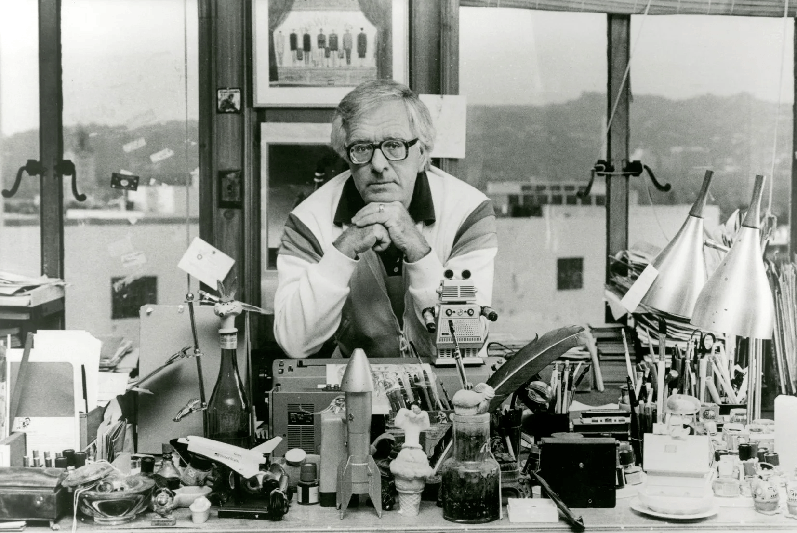

Remember Sascha? Ray Bradbury

Remember Sascha?

Remember? Why, how could they forget? Although they knew him for only a little while, years later his name would arise and they would smile or even laugh and reach out to hold hands, remembering.

Sascha. What a tender, witty comrade, what a sly, hidden individual, what a child of talent; teller of tales, bon vivant, late-night companion, ever-present illumination on foggy noons.

Sascha!

He, whom they had never seen, to whom they spoke often at three A.M. in their small bedroom, away from friends who might roll their eyeballs under their lids, doubting their sanity, hearing his name.

Well, then, who and what was Sascha, and where did they meet or perhaps only dream him, and who were they?

Quickly: they were Maggie and Douglas Spaulding and they lived by the loud sea and the warm sand and the rickety bridges over the almost dead canals of Venice, California. Though lacking money in the bank or Goodwill furniture in their tiny two-room apartment, they were incredibly happy. He was a writer, and she worked to support him while he finished the great American novel.

Their routine was: she would arrive home each night from downtown Los Angeles and he would have hamburgers waiting or they would walk down the beach to eat hot dogs, spend ten or twenty cents in the Penny Arcade, go home, make love, go to sleep, and repeat the whole wondrous routine the next night: hot dogs, Penny Arcade, love, sleep, work, etc. It was all glorious in that year of being very young and in love; therefore it would go on forever . . .

Until he appeared.

The nameless one. For then he had no name. He had threatened to arrive a few months after their marriage to destroy their economy and scare off the novel, but then he had melted away, leaving only his echo of a threat.

But now the true collision loomed.

One night over a ham omelet with a bottle of cheap red and the conversation loping quietly, leaning on the card table and promising each other grander and more ebullient futures, Maggie suddenly said, “I feel faint.”

“What?” said Douglas Spaulding.

“I’ve felt funny all day. And I was sick, a little bit, this morning.”

“Oh, my God.” He rose and came around the card table and took her head in his hands and pressed her brow against his side, and looked down at the beautiful part in her hair, suddenly smiling.

“Well, now,” he said, “don’t tell me that Sascha is back?”

“Sascha! Who’s that?”

“When he arrives, he’ll tell us.”

“Where did that name come from?”

“Don’t know. It’s been in my mind all year.”

“Sascha?” She pressed his hands to her cheeks, laughing. “Sascha!”

“Call the doctor tomorrow,” he said.

“The doctor says Sascha has moved in for light housekeeping,” she said over the phone the next day.

“Great!” He stopped. “I guess.” He considered their bank deposits. “No. First thoughts count. Great! When do we meet the Martian invader?”

“October. He’s infinitesimal now, tiny, I can barely hear his voice. But now that he has a name, I hear it. He promises to grow, if we take care.”

“The Fabulous Invalid! Shall I stock up on carrots, spinach, broccoli for what date?”

“Halloween.”

“Impossible!”

“True!”

“People will claim we planned him and my vampire book to arrive that week, things that go bump and cry in the night.”

“Oh, Sascha will surely do that! Happy?”

“Frightened, yes, but happy, Lord, yes. Come home, Mrs. Rabbit, and bring him along!”

It must be explained that Maggie and Douglas Spaulding were best described as crazed romantics. Long before the interior christening of Sascha, they, loving Laurel and Hardy, had called each other Stan and Ollie. The machines, the dustbusters and can openers around the apartment, had names, as did various parts of their anatomy, revealed to no one.

So Sascha, as an entity, a presence growing toward friendship, was not unusual. And when he actually began to speak up, they were not surprised. The gentle demands of their marriage, with love as currency instead of cash, made it inevitable.

Someday, they said, if they owned a car, it too would be named.

They spoke on that and a dozen score of things late at night. When hyperventilating about life, they propped themselves up on their pillows as if the future might happen right now. They waited, anticipating, in séance, for the silent small offspring to speak his first words before dawn.

“I love our lives,” said Maggie, lying there, “all the games. I hope it never stops. You’re not like other men, who drink beer and talk poker. Dear God, I wonder, how many other marriages play like us?”

“No one, nowhere. Remember?”

“What?”

He lay back to trace his memory on the ceiling.

“The day we were married—”

“Yes!”

“Our friends driving and dropping us off here and we walked down to the drugstore by the pier and bought a tube of toothpaste and two toothbrushes, big bucks, for our honeymoon . . .? One red toothbrush, one green, to decorate our empty bathroom. And on the way back along the beach, holding hands, suddenly, behind us, two little girls and a boy followed us and sang:

“Happy marriage day to you,

Happy marriage day to you.

Happy marriage day, happy marriage day,

Happy marriage day to you . . .”

She sang it now, quietly. He chimed in, remembering how they had blushed with pleasure at the children’s voices, but walked on, feeling ridiculous but happy and wonderful.

“How did they guess? Did we look married?”

“It wasn’t our clothes! Our faces, don’t you think? Smiles that made our jaws ache. We were exploding. They got the concussion.”

“Those dear children. I can still hear their voices.”

“And so here we are, seventeen months later.” He put his arm around her and gazed at their future on the dark ceiling.

“‘And here I am,” a voice murmured.

“Who?” Douglas said.

“Me,” the voice whispered. “Sascha.”

Douglas looked down at his wife’s mouth, which had barely trembled.

“So, at last, you’ve decided to speak?” said Douglas.

“Yes,” came the whisper.

“We wondered,” said Douglas, “when we would hear from you.” He squeezed his wife gently.

“It’s time,” the voice murmured. “So here I am.”

“Welcome, Sascha,” both said.

“Why didn’t you talk sooner?” asked Douglas Spaulding.

“I wasn’t sure that you liked me,” the voice whispered.

“Why would you think that?”

“First I was, then I wasn’t. Once I was only a name. Remember, last year, I was ready to come and stay. Scared you.”

“We were broke,” said Douglas quietly. “And nervous.”

“What’s so scary about life?” said Sascha. Maggie’s lips twitched. “It’s that other thing. Not being, ever. Not being wanted.”

“On the contrary.” Douglas Spaulding moved down on his pillow so he could watch his wife’s profile, her eyes shut, but her mouth breathing softly. “We love you. But last year it was bad timing. Understand?”

“No,” whispered Sascha. “I only understand you didn’t want me. And now you do. I should leave.”

“But you just got here!”

“Here I go, anyway.”

“Don’t, Sascha! Stay!”

“Good-bye.” The small voice faded. “Oh, good-bye.”

And then silence.

Maggie opened her eyes with quiet panic.

“Sascha’s gone,” she said.

“He can’t be!”

The room was still.

“Can’t be,” he said. “It’s only a game.”

“More than a game. Oh, God, I feel cold. Hold me.”

He moved to hug her.

“It’s okay.”

“No. I had the funniest feeling just now, as if he were real.”

“He is. He’s not gone.”

“Unless we do something. Help me.”

“Help?” He held her even tighter, then shut his eyes, and at last called:

“Sascha?”

Silence.

“I know you’re there. You can’t hide.”

His hand moved to where Sascha might be.

“Listen. Say something. Don’t scare us, Sascha. We don’t want to be scared or scare you. We need each other. We three against the world. Sascha?”

Silence.

“Well?” whispered Douglas.

Maggie breathed in and out.

They waited.

“Yes?”

There was a soft flutter, the merest exhalation on the night air.

“Yes.”

“You’re back!” both cried.

Another silence.

“Welcome?” asked Sascha.

“Welcome!” both said.

And that night passed and the next day and the night and day after that, until there were many days, but especially midnights when he dared to declare himself, pipe opinions, grow stronger and firmer and longer in half-heard declarations, as they lay in anticipatory awareness, now she moving her lips, now he taking over, both open as warm, live ventriloquists’ mouthpieces. The small voice shifted from one tongue to the other, with soft bouts of laughter at how ridiculous but loving it all seemed, never knowing what Sascha might say next, but letting him speak on until dawn and a smiling sleep.

“What’s this about Halloween?” he asked, somewhere in the sixth month.

“Halloween?” both wondered.

“Isn’t that a death holiday?” Sascha murmured.

“Well, yes . . .”

“I’m not sure I want to be born on a night like that.”

“Well, what night would you like to be born on?”

Silence as Sascha floated a while.

“Guy Fawkes,” he finally whispered.

“Guy Fawkes??!!”

“That’s mainly fireworks, gunpowder plots, Houses of Parliament, yes? Please to remember the fifth of November?”

“Do you think you could wait until then?”

“I could try. I don’t think I want to start out with skulls and bones. Gunpowder’s more like it. I could write about that.”

“Will you be a writer, then?”

“Get me a typewriter and a ream of paper.”

“And keep us awake with the typing?”

“Pen, pencil, and pad, then?”

“Done!”

So it was agreed and the nights passed into weeks and the weeks leaned from summer into the first days of autumn and his voice grew stronger, as did the sound of his heart and the small commotions of his limbs. Sometimes as Maggie slept, his voice would stir her awake and she would reach up to touch her mouth, where the surprise of his dreaming came forth.

“There, there, Sascha. Rest now. Sleep.”

“Sleep,” he whispered drowsily, “sleep.” And faded away.

“Pork chops, please, for supper.”

“No pickles with ice cream?” both said, almost at once.

“Pork chops,” he said, and more days passed and more dawns arose and he said: “Hamburgers!”

“For breakfast?”

“With onions,” he said.

October stood still for one day and then . . .

Halloween departed.

“Thanks,” said Sascha, “for helping me past that. What’s up ahead in five nights?”

“Guy Fawkes!”

“Ah, yes!” he cried.

And at one minute after midnight five days later, Maggie got up, wandered to the bathroom, and wandered back, stunned.

“Dear,” she said, sitting on the edge of the bed.

Douglas Spaulding turned over, half awake. “Yes?”

“What day is it?” whispered Sascha.

“Guy Fawkes, at last. So?”

“I don’t feel well,” said Sascha. “Or, no, I feel fine. Full of pep. Ready to go. It’s time to say good-bye. Or is it hello? What do I mean?”

“Spit it out.”

“Are there neighbors who said, no matter when, they’d take us to the hospital?”

“Yes.”

“Call the neighbors,” said Sascha.

They called the neighbors.

At the hospital, Douglas kissed his wife’s brow and listened.

“It’s been nice,” said Sascha.

“Only the best.”

“We won’t talk again. Good-bye,” said Sascha.

“Good-bye,” both said.

At dawn there was a small clear cry somewhere.

Not long after, Douglas entered his wife’s hospital room. She looked at him and said, “Sascha’s gone.”

“I know,” he said quietly.

“But he left word and someone else is here. Look.”

He approached the bed as she pulled back a coverlet.

“Well, I’ll be damned.”

He looked down at a small pink face and eyes that for a brief moment flickered bright blue and then shut.

“Who’s that?” he asked.

“Your daughter. Meet Alexandra.”

“Hello, Alexandra,” he said.

“And do you know what the nickname for Alexandra is?” she said.

“What?”

“Sascha,” she said.

He touched the small cheek very gently.

“Hello, Sascha,” he said.

The End