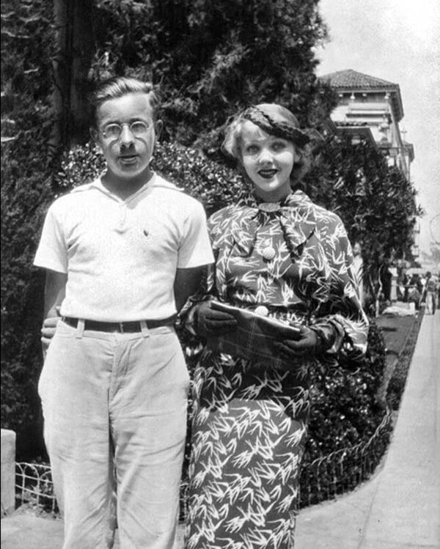

Remembrance, Ohio, Ray Bradbury

Remembrance, Ohio

They came running through the hot still dust of town, with their shadows burned black under them by the sun.

They held on to picket fences. They clutched trees. They seized lilac bushes, which gave no support, so they swayed and grabbed at each other, then ran on and looked back. With abrupt focus, the empty street rushed at them. They gasped and wheeled in a clumsy dance.

And then they saw it and made sounds like travelers at noon finding a landfall mirage, an incredible isle promising cool breezeways and water glades melted out of forgotten snows.

Ahead stood a cream-white house with a grape-arbor porch hummed about by bees with golden pelts.

‘Home,’ said the woman. ‘We’ll be safe there!’

The man blinked at the house in surprise. ‘I don’t understand…’

But they helped each other up onto the porch and sat precisely down in the swing, which hung like a special scale weighing them, and them afraid of the total.

The only movement for a long time now was the drift of the swing going nowhere with two people perched precariously, birdlike, in it. The street laid out its hot roll of dust on which no footprints or tire marks were stenciled. On occasion a wind paraded from nowhere, down the center of the dusty road to lie down under cool green trees.

Beyond that, everything was baked solid. If you ran up on any porch and spat on any window and rubbed the grime away, you might peek in to find the dead, like so many clay mummies, scattered on the carpetless floors. But nobody ran, spat, or looked.

‘Shh,’ she whispered.

There were hummingbird flickers of leafy sunlight on their still faces.

‘Youhear?’

Somewhere far off, a drift of voices slid away. A siren bubbled, rose, then stopped. The dust settled. The noises of the world drifted lazily to rest.

The woman glanced over at her husband on the seat beside her.

‘Will they find us? We did escape, wearefree,aren’twe?’

He barely nodded. He was about thirty-five, a man all bristly and pink. The pink veins in his eyes made the rest of him seem infinitely redder, warmer, more irritable. He often told her he had this great hair ball in him, which made it hard to speak, much less breathe, in hot weather. Panic was a continual way of life for both of them. If one drop of rain fell on his hand from the blind sky now, it might jolt him into rabbiting off and leaving her alone.

She moved her tongue on her lips.

The small motion fretted him. Her coolness was a bother.

She took a chance on speaking again. ‘It’s nice to sit.’

His nod made the porch swing glide.

‘Mrs Haydecker’ll be coming up the street with a whole crate of fresh-picked strawberries any moment,’ she said.

He frowned.

‘Right out of her garden,’ she added.

The grapevines grew quietly over the cool dark porch. They felt like children hiding out from parents.

Sunlight picked the tiny silver hairs on a geranium stalk potted on the railing. It made the man feel like he was trapped in his winter underwear.

She arose suddenly and went to peer at the doorbell button and reached out as if to touch it.

‘Don’t!’ he said.

Too late; she had planted her thumb on the button.

‘It’s not working.’ She slapped her hand over her mouth and talked through the fingers. ‘Silly! Ringing your own doorbell. To see if I came to the door and looked out at myself?’

‘Get away from there.’ He was on his feet now. ‘You’ll spoil everything!’

But she could not keep her child’s hand from prowling to twist the doorknob.

‘Unlocked! Why, it was always locked!’

‘Hands off!’

‘I won’t try to go in.’ Suddenly she reached up to run her fingertips along the top of the sill. ‘Someone stole the key, that explains it. Stole it and went in and I bet robbed the house. We stayed away too long.’

‘We only been gone an hour.’

‘Don’t lie,’ she said. ‘You know it’s been months. No…what? Years.’

‘An hour,’ he said. ‘Sit down.’

‘It was such a long trip. I think I will.’ But she still held on to the doorknob. ‘I want to be fresh when I yell at Mama, “Mama, we’re here!” I wonder where Benjamin is? Such a good dog.’

‘Dead,’ said the man, forgetting. ‘Ten years ago.’

‘Oh…’ She backed off and her voice softened. ‘Yes…’ She eyed the door, the porch, and beyond, the town. ‘Something’s wrong. I can’t name it. But something’s wrong!’

The only sound was the sun burning the sky.

‘Is this California or Ohio?’ she said, at last turning to him.

‘Don’tdothat!’ He seized her wrist. ‘This is California.’

‘What’s our town doing here?’ she demanded, wildly out of breath. ‘When it used to be in Ohio!’

‘We’re lucky we found this! Don’t talk about it!’

‘Or maybe thisisOhio. Maybe we never went west, years ago.’

‘This,’ he said, ‘is California.’

‘What’s the name of this place?’

‘Coldwater.’

‘Yousure?’

‘On a hot day likethis? Coldwater.’

‘You sure this isn’t Mellow Glen? Or Breezeway Falls?’

‘At high noon, those all sound good.’

‘Maybe it’s Inclement, Nebraska.’ She smiled. ‘Or Devil’s Prong, Idaho. Or Boiling Sands, Montana.’

‘Go back to the icehouse names,’ he said.

‘Mint Willow, Illinois.’

‘Ahh.’ He closed his eyes.

‘Snow Mountain, Missouri.’

‘Yes.’ He stirred the swing and they swung back and forth.

‘But I know the best,’ she said. ‘Remembrance. That’s where we are. Remembrance, Ohio.’

And by his smiling silence, eyes shut as they glided, she knew that indeed was were they were.

‘Willtheyfind us here?’ she asked, suddenly apprehensive.

‘Not if we’re careful, not if we hide.’

‘Oh!’ she said.

Because at the far end of the street, in the glare of bright sun, a group of men appeared suddenly, fanning out in the dust.

‘There they are! Oh, what’ve we done that they chase us this way? Are we robbers, Tom, or thieves, did we kill someone?’

‘No, but they followed us here to Ohio, anyway.’

‘I thought you said this was California.’

He lolled his head back and stared into the blazing sky. ‘God, I don’t know anymore. Maybe they put the town on rollers.’

The strangers, a short way off in their own world of dust, were pausing now. You could hear their voices barking under the trees.

‘We’ve got to run, Tom! Let’s move!’ She tugged at his elbow, tried to pull him to his feet.

‘Yeah, but look. All the little things that’re wrong. The town…’ He glided, loose-mouthed, loose-eyed, in the swing. ‘This house. Something about the porch. Used to be three steps coming up. Now it’s four.’

‘No!’

‘I felt the change, with my feet. And those stained-glass panes around the door window, they’re blue and red. Used to be orange and milk white.’

He gestured with a tired hand.

‘And the sidewalks, trees, houses. Whole damn town. I can’tfigureit.’

She stared and it began to come clear what it was. Someone with a big hand had scooped up the entire known familiar town of her childhood–the churches, garages, windows, porches, attics, bushes, lawns, lampposts–and poured it into a glass oven, there to know a fever so intense that everything melted and warped.

Houses expanded a little too large or shrunk too small from their old size, sidewalks tilted, steeples grew. Whoever had glued the town back together had lost the blueprint. It was beautiful but strange.

‘Yes,’ she murmured. ‘Yes, you’re right. I used to know every crack in the sidewalk with my roller skates. It’snotthe same.’

The strangers came running and turned off at an alley.

‘They’re going around the block,’ she said. ‘Then they’ll find us here.’

‘I don’t know,’ he said. ‘Maybe, maybe not.’

They sat, not moving, listening to the hot green silence.

‘I know what I want,’ she said. ‘I want to go in the house and open the icebox door and drink some cold milk and go in the pantry and smell the bananas hung on a string from the ceiling, and eat a powdered doughnut out of the bin.’

‘Don’t try to go into the house,’ he said, eyes shut. ‘You’ll be sorry.’

She leaned over to look into his drawn face.

‘You’re scared.’

‘Me?’

‘To do a simple thing like open the front door!’

‘Yes,’ he said, finally. ‘I’m scared. We can’t run any further. They’ll catch us and take us back to that place.’

She laughed suddenly. ‘Weren’t they funny people? Wouldn’t take money from us for staying there. I liked the women’s costumes, all white and starched.’

‘I didn’t like the windows,’ he said. ‘The metal grating. Remember when I made a noise like a hacksaw and the men came running?’

‘Yes. Why do they always run?’

‘Because we know too much, that’s why.’

‘I don’t know anything,’ she said.

‘They hate you for being you and me for being me.’

They heard voices in the distance.

The woman took a mirror from a wadded handkerchief in her pocket, breathed on it, and smiled in welcome. ‘I’m alive. Sometimes, in that place, I lay on the floor and said I was dead and they couldn’t bother me anymore. But they threw water on me and made me stand up.’

Shouting, six men turned the corner fifty yards away and started toward the house where the man and woman sat in the swing, fanning their faces with their hands.

‘What did we do to be hunted like this?’ said the woman. ‘Will they kill us?’

‘No, they’ll talk soft and kind and walk us back out of town.’

He jumped up, suddenly.

‘Now what?’ she cried.

‘I’m going inside and wake your mother from her nap,’ he said. ‘And we’ll sit at the round table in the living room and have peach shortcake with whipped cream, and when those men knock on the door, your mother’ll just tell them to go away. We’ll eat with the silverware your mother got from theChicago Tribunein 1928 with those pictures of Thomas Meighan and Mary Pickford on the handles.’

She smiled. ‘We’ll play the phonograph. We’ll play the record “The Three Trees, There, There, and–There!”’

‘Come on,’ he said. ‘We have to go!’

The six men spied the man and woman on the dim front porch, shouted, and ran forward.

‘Hurry!’ screamed the woman. ‘Get inside, call Mother and Sister, oh, hurry, here theycome!’

He flung the front door wide.

She rushed in after him, slammed the door, and turned.

There was nothing behind the front wall of the house except strutworks, canvas, boards, a small meadow, and a creek. A few arc-lights stood to each side. Stenciled on one papier-mâché inner wall was STUDIO #12.

Footsteps thundered on the front porch.

The door banged open. The men piled in.

‘Oh!’ the woman screamed. ‘Theleastyou could do isknock!’

The End