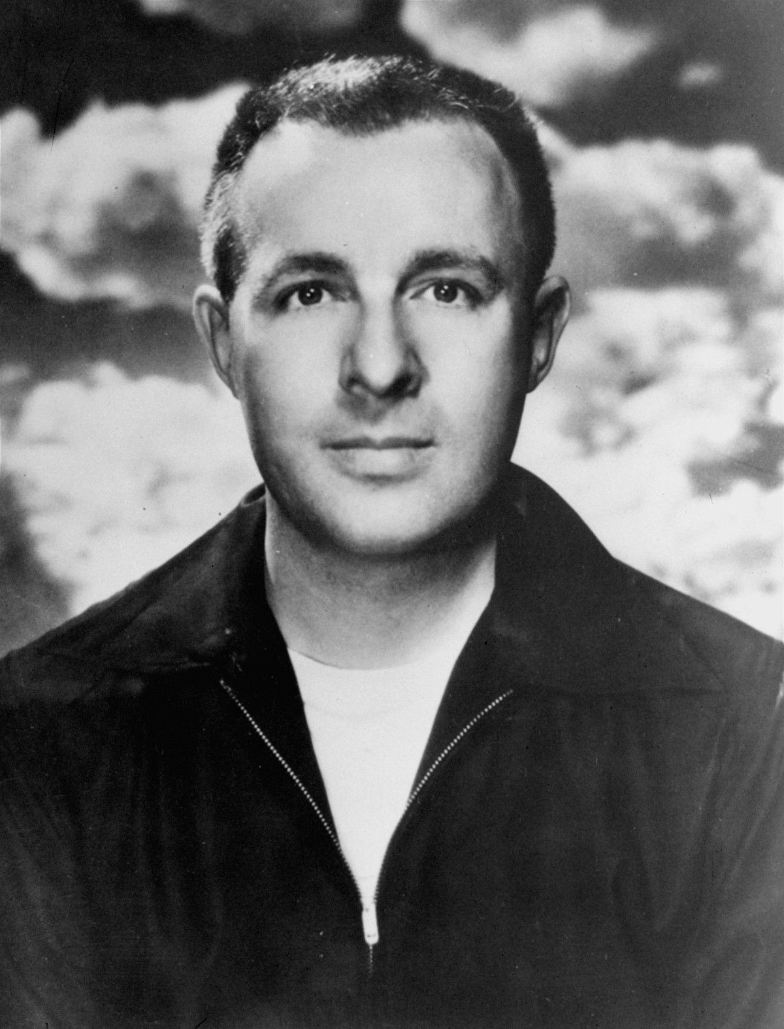

Season of Disbelief, Ray Bradbury

Season of Disbelief

How it began with the children, old Mrs. Bentley never knew. She often saw them, like moths and monkeys, at the grocer’s, among the cabbages and hung bananas, and she smiled at them and they smiled back. Mrs. Bentley watched them making footprints in winter snow, filling their lungs with autumn smoke, shaking down blizzards of spring apple-blossoms, but felt no fear of them.

As for herself, her house was in extreme good order, everything set to its station, the floors briskly swept, the foods neatly tinned, the hatpins thrust through cushions, and the drawers of her bedroom bureaus crisply filled with the paraphernalia of years.

Mrs. Bentley was a saver. She saved tickets, old theater programs, bits of lace, scarves, rail transfers; all the tags and tokens of existence.

“I’ve a stack of records,” she often said. “Here’s Caruso. That was in 1916, in New York; I was sixty and John was still alive. Here’s June Moon, 1924, I think, right after John died.”

That was the huge regret of her life, in a way.

The one thing she had most enjoyed touching and listening to and looking at she hadn’t saved. John was far out in the meadow country, dated and boxed and hidden under grasses, and nothing remained of him but his high silk hat and his cane and his good suit in the closet. So much of the rest of him had been devoured by moths.

But what she could keep she had kept. Her pink-flowered dresses crushed among moth balls in vast black trunks, and cut-glass dishes from her childhood—she had brought them all when she moved to this town five years ago.

Her husband had owned rental property in a number of towns, and, like a yellow ivory chess piece, she had moved and sold one after another, until now she was here in a strange town, left with only the trunks and furniture, dark and ugly, crouched about her like the creatures of a primordial zoo.

The thing about the children happened in the middle of summer. Mrs. Bentley, coming out to water the ivy upon her front porch, saw two cool-colored sprawling girls and a small boy lying on her lawn, enjoying the immense prickling of the grass.

At the very moment Mrs. Bentley was smiling down upon them with her yellow mask face, around a corner like an elfin band came an ice-cream wagon. It jingled out icy melodies, as crisp and rimmed as crystal wineglasses tapped by an expert, summoning all. The children sat up, turning their heads, like sunflowers after the sun.

Mrs. Bentley called, “Would you like some? Here!” The ice-cream wagon stopped and she exchanged money for pieces of the original Ice Age. The children thanked her with snow in their mouths, their eyes darting from her buttoned-up shoes to her white hair.

“Don’t you want a bite?” said the boy.

“No, child. I’m old enough and cold enough; the hottest day won’t thaw me,” laughed Mrs. Bentley.

They carried the miniature glaciers up and sat, three in a row, on the shady porch glider.

“I’m Alice, she’s Jane, and that’s Tom Spaulding.”

“How nice. And I’m Mrs. Bentley. They called me Helen.”

They stared at her.

“Don’t you believe they called me Helen?” said the old lady.

“I didn’t know old ladies had first names,” said Tom, blinking.

Mrs. Bentley laughed dryly.

“You never hear them used, he means,” said Jane.

“My dear, when you are as old as I, they won’t call you Jane, either. Old age is dreadfully formal. It’s always ‘Mrs.’ Young People don’t like to call you ‘Helen.’ It seems much too flip.”

“How old are you?” asked Alice.

“I remember the pterodactyl.” Mrs. Bentley smiled.

“No, but how old?”

“Seventy-two.”

They gave their cold sweets an extra long suck, deliberating.

“That’s old,” said Tom.

“I don’t feel any different now than when I was your age,” said the old lady.

“Our age?”

“Yes. Once I was a pretty little girl just like you, Jane, and you, Alice.”

They did not speak.

“What’s the matter?”

“Nothing.” Jane got up.

“Oh, you don’t have to go so soon, I hope. You haven’t finished eating. . . . Is something the matter?”

“My mother says it isn’t nice to fib,” said Jane.

“Of course it isn’t. It’s very bad,” agreed Mrs. Bentley.

“And not to listen to fibs.”

“Who was fibbing to you, Jane?”

Jane looked at her and then glanced nervously away. “You were.”

“I?” Mrs. Bentley laughed and put her withered claw to her small bosom. “About what?”

“About your age. About being a little girl.”

Mrs. Bentley stiffened. “But I was, many years ago, a little girl just like you.”

“Come on, Alice, Tom.”

“Just a moment,” said Mrs. Bentley. “Don’t you believe me?”

“I don’t know,” said Jane. “No.”

“But how ridiculous! It’s perfectly obvious. Everyone was young once!”

“Not you,” whispered Jane, eyes down, almost to herself. Her empty ice stick had fallen in a vanilla puddle on the porch floor.

“But of course I was eight, nine, ten years old, like all of you.”

The two girls gave a short, quickly-sealed-up laugh.

Mrs. Bentley’s eyes glittered. “Well, I can’t waste a morning arguing with ten-year-olds. Needless to say, I was ten myself once and just as silly.”

The two girls laughed. Tom looked uneasy.

“You’re joking with us,” giggled Jane. “You weren’t really ten ever, were you, Mrs. Bentley?”

“You run on home!” the woman cried suddenly, for she could not stand their eyes. “I won’t have you laughing.”

“And your name’s not really Helen?”

“Of course it’s Helen!”

“Good-bye,” said the two girls, giggling away across the lawn under the seas of shade, Tom followed them slowly. “Thanks for the ice cream!”

“Once I played hopscotch!” Mrs. Bentley cried after them, but they were gone.

Mrs. Bentley spent the rest of the day slamming teakettles about, loudly preparing a meager lunch, and from time to time going to the front door, hoping to catch those insolent fiends on their laughing excursions through the late day. But if they had appeared, what could she say to them, why should she worry about them?

“The idea!” said Mrs. Bentley to her dainty, rose-clustered teacup. “No one ever doubted I was a girl before. What a silly, horrible thing to do. I don’t mind being old—not really—but I do resent having my childhood taken away from me.”

She could see the children racing off under the cavernous trees with her youth in their frosty fingers, invisible as air.

After supper, for no reason at all, with a senseless certainty of motion, she watched her own hands, like a pair of ghostly gloves at a séance, gather together certain items in a perfumed kerchief. Then she went to her front porch and stood there stiffly for half an hour.

As suddenly as night birds the children flew by, and Mrs. Bentley’s voice brought them to a fluttering rest.

“Yes, Mrs. Bentley?”

“Come up on this porch!” she commanded them, and the girls climbed the steps, Tom trailing after.

“Yes, Mrs. Bentley?” They thumped the “Mrs.” like a bass piano chord, extra heavily, as if that were her first name.

“I’ve some treasures to show you.” She opened the perfumed kerchief and peered into it as if she herself might be surprised. She drew forth a hair comb, very small and delicate, its rim twinkling with rhinestones.

“I wore this when I was nine,” she said.

Jane turned it in her hand and said, “How nice.”

“Let’s see!” cried Alice.

“And here is a tiny ring I wore when I was eight,” said Mrs. Bentley. “It doesn’t fit my finger now. You look through it and see the Tower of Pisa ready to fall.”

“Let’s see it lean!” The girls passed it back and forth between them until Jane fitted it to her hand. “Why, it’s just my size!” she exclaimed.

“And the comb fits my head!” gasped Alice.

Mrs. Bentley produced some jackstones. “Here,” she said. “I once played with these.”

She threw them. They made a constellation on the porch.

“And here!” In triumph she flashed her trump card, a postal picture of herself when she was seven years old, in a dress like a yellow butterfly, with her golden curls and blown blue-glass eyes and angelic pouting lips.

“Who’s this little girl?” asked Jane.

“It’s me!”

The two girls held onto it.

“But it doesn’t look like you,” said Jane simply. “Anybody could get a picture like this, somewhere.”

They looked at her for a long moment.

“Any more pictures, Mrs. Bentley?” asked Alice. “Of you, later? You got a picture of you at fifteen, and one at twenty, and one at forty and fifty?”

The girls chortled.

“I don’t have to show you anything!” said Mrs. Bentley.

“Then we don’t have to believe you,” replied Jane.

“But this picture proves I was young!”

“That’s some other little girl, like us. You borrowed it.”

“I was married!”

“Where’s Mr. Bentley?”

“He’s been gone a long time. If he were here, he’d tell you how young and pretty I was when I was twenty-two.”

“But he’s not here and he can’t tell, so what does that prove?”

“I have a marriage certificate.”

“You could have borrowed that, too. Only way I’ll believe you were ever young”—Jane shut her eyes to emphasize how sure she was of herself—“is if you have someone say they saw you when you were ten.”

“Thousands of people saw me but they’re dead, you little fool—or ill, in other towns. I don’t know a soul here, just moved here a few years ago, so no one saw me young.”

“Well, there you are!” Jane blinked at her companions. “Nobody saw her!”

“Listen!” Mrs. Bentley seized the girl’s wrist. “You must take these things on faith. Someday you’ll be as old as I. People will say the same. ‘Oh, no,’ they’ll say, ‘those vultures were never hummingbirds, those owls were never orioles, those parrots were never bluebirds!’ One day you’ll be like me!”

“No, we won’t!” said the girls. “Will we?” they asked one another.

“Wait and see!” said Mrs. Bentley.

And to herself she thought, Oh, God, children are children, old women are old women, and nothing in between. They can’t imagine a change they can’t see.

“Your mother,” she said to Jane. “Haven’t you noticed, over the years, the change?”

“No,” said Jane. “She’s always the same.”

And that was true. You lived with people every day and they never altered a degree. It was only when people had been off on a long trip, for years, that they shocked you. And she felt like a woman who has been on a roaring black train for seventy-two years, landing at last upon the rail platform and everyone crying: “Helen Bentley, is that you?”

“I guess we better go home,” said Jane. “Thanks for the ring. It just fits me.”

“Thanks for the comb. It’s fine.”

“Thanks for the picture of the little girl.”

“Come back—you can’t have those!” Mrs. Bentley shouted as they raced down the steps. “They’re mine!”

“Don’t!” said Tom, following the girls. “Give them back!”

“No, she stole them! They belonged to some other little girl. She stole them. Thanks!” cried Alice.

So no matter how she called after them, the girls were gone, like moths through darkness.

“I’m sorry,” said Tom, on the lawn, looking up at Mrs. Bentley. He went away.

They took my ring and my comb and my picture, thought Mrs. Bentley, trembling there on the steps. Oh, I’m empty, empty; it’s part of my life.

She lay awake for many hours into the night, among her trunks and trinkets. She glanced over at the neat stacks of materials and toys and opera plumes and said, aloud, “Does it really belong to me?”

Or was it the elaborate trick of an old lady convincing herself that she had a past? After all, once a time was over, it was done. You were always in the present. She may have been a girl once, but was not now. Her childhood was gone and nothing could fetch it back.

A night wind blew in the room. The white curtain fluttered against a dark cane, which had leaned against the wall near the other bric-a-brac for many years. The cane trembled and fell out into a patch of moonlight, with a soft thud. Its gold ferrule glittered. It was her husband’s opera cane. It seemed as if he were pointing it at her, as he often had, using his soft, sad, reasonable voice when they, upon rare occasions, disagreed.

“Those children are right,” he would have said. “They stole nothing from you, my dear. These things don’t belong to you here, you now. They belonged to her, that other you, so long ago.”

Oh, thought Mrs. Bentley.

And then, as though an ancient phonograph record had been set hissing under a steel needle, she remembered a conversation she had once had with Mr. Bentley—Mr. Bentley, so prim, a pink carnation in his whisk-broomed lapel, saying, “My dear, you never will understand time, will you? You’re always trying to be the things you were, instead of the person you are tonight. Why do you save those ticket stubs and theater programs? They’ll only hurt you later. Throw them away, my dear.”

But Mrs. Bentley had stubbornly kept them.

“It won’t work,” Mr. Bentley continued, sipping his tea. “No matter how hard you try to be what you once were you can only be what you are here and now. Time hypnotizes. When you’re nine, you think you’ve always been nine years old and will always be.

When you’re thirty, it seems you’ve always been balanced there on that bright rim of middle life. And then when you turn seventy, you are always and forever seventy. You’re in the present, you’re trapped in a young now or an old now, but there is no other now to be seen.”

It had been one of the few, but gentle, disputes of their quiet marriage. He had never approved of her bric-a-brackery. “Be what you are, bury what you are not,” he had said. “Ticket stubs are trickery. Saving things is a magic trick, with mirrors.”

If he were alive tonight, what would he say?

“You’re saving cocoons.” That’s what he’d say. “Corsets, in a way, you can never fit again. So why save them? You can’t really prove you were ever young. Pictures? No, they lie. You’re not the picture.”

“Affidavits?”

“No, my dear, you’re not the dates, or the ink, or the paper. You’re not these trunks of junk and dust. You’re only you, here, now—the present you.”

Mrs. Bentley nodded at the memory, breathing easier.

“Yes, I see. I see.”

The gold-ferruled cane lay silently on the moonlit rug.

“In the morning,” she said to it, “I will do something final about this, and settle down to being only me, and nobody else from any other year. Yes, that’s what I’ll do.”

She slept. . . .

The morning was bright and green, and there at her door, bumping softly on the screen, were the two girls. “Got any more to give us, Mrs. Bentley? More of the little girl’s things?”

She led them down the hall to the library.

“Take this.” She gave Jane the dress in which she had played the mandarin’s daughter at fifteen. “And this, and this.” A kaleidoscope, a magnifying glass. “Pick anything you want,” said Mrs. Bentley. “Books, skates, dolls, everything—they’re yours.”

“Ours?”

“Only yours. And will you help me with a little work in the next hour? I’m building a big fire in my back yard. I’m emptying the trunks, throwing out this trash for the trashman. It doesn’t belong to me. Nothing ever belongs to anybody.”

“We’ll help,” they said.

Mrs. Bentley led the procession to the back yard, arms full, a box of matches in her hand.

So the rest of the summer you could see the two little girls and Tom like wrens on a wire, on Mrs. Bentley’s front porch, waiting. And when the silvery chimes of the icicle man were heard, the front door opened, Mrs. Bentley floated out with her hand deep down the gullet of her silver-mouthed purse, and for half an hour you could see them there on the porch, the children and the old lady putting coldness into warmness, eating chocolate icicles, laughing. At last they were good friends.

“How old are you, Mrs. Bentley?”

“Seventy-two.”

“How old were you fifty years ago?”

“Seventy-two.”

“You weren’t ever young, were you, and never wore ribbons or dresses like these?”

“No.”

“Have you got a first name?”

“My name is Mrs. Bentley.”

“And you’ve always lived in this one house?”

“Always.”

“And never were pretty?”

“Never.”

“Never in a million trillion years?” The two girls would bend toward the old lady, and wait in the pressed silence of four o’clock on a summer afternoon.

“Never,” said Mrs. Bentley, “in a million trillion years.”

The End