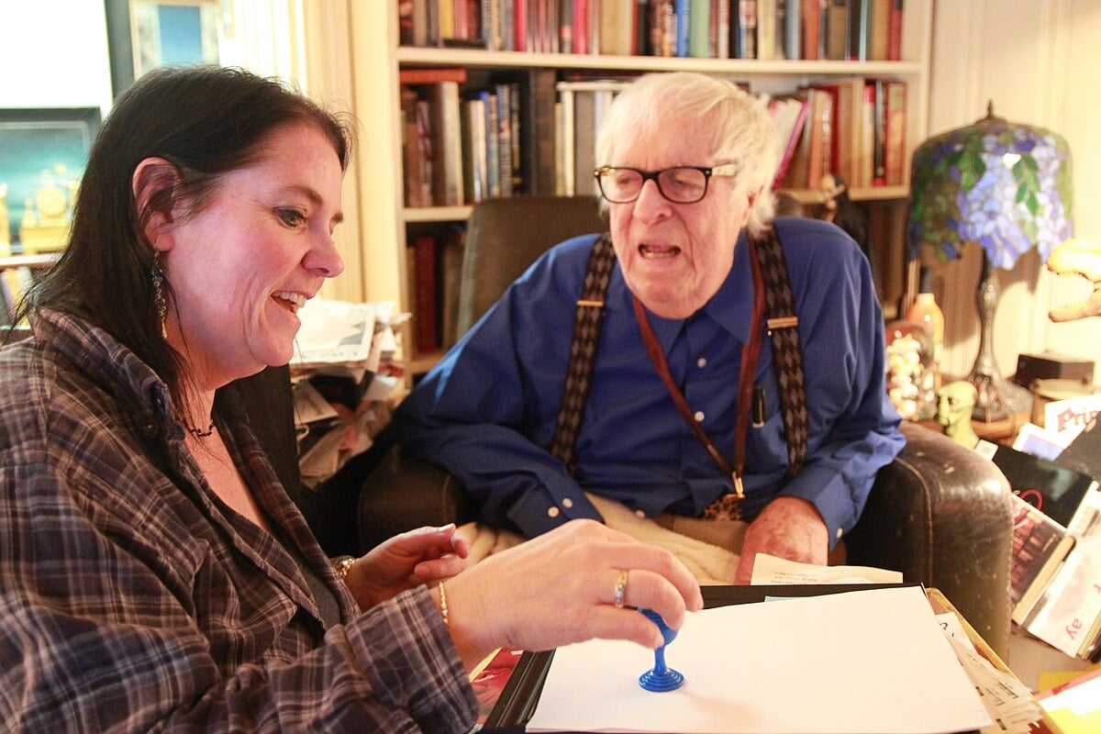

That Old Dog Lying in the Dust, Ray Bradbury

That Old Dog Lying in the Dust

They say that Mexicali has changed. They say it has many people and more lights and the nights are not so long there anymore and the days are better.

But I will not go see.

For I remember Mexicali when it was small and alone and like an old dog lying out in the dust in the middle of the road. And if you drove up and honked it just lay there and twitched its tail and smiled with its rusty brown eyes.

But most of all I remember a lost-and-gone one-ring Mexican circus.

In the late summer of 1945, with the war ending beyond the world somewhere, and tires and gas rationed, a friend called to ask if I would like to ramble down past the Salton Sea to Calexico.

We headed south in a beat-up Model A which steamed and seeped brown rust-water when we stopped in the late hot afternoon to skinny-dip in the cool irrigation canals that make the desert green along the Mexican border. That night we drove across into Mexico and ate cold watermelon in one of those palm-fringed outdoor stands where whole families gather happy and loud and spitting black seeds.

We strolled the unlit border town, barefoot, treading the soft brown talcum dust of its unpaved summer roads.

The warm dust blew us around a corner. The little one-ring Mexican circus lay there: an old tent full of moth holes and half-sewn wounds, propped up from within by an ancient set of dinosaur bones.

Two bands played.

One was a Victrola which hissed "La Cucaracha" from two black funeral horns buried high in the trees.

The second band was mortal flesh. It consisted of a bass-drummer who slammed his drum as if killing his wife, a tuba player sunk and crushed in brass coils, a trumpeter with a pint of sour saliva in his horn, and a trap-drummer whose effervescent palsy enabled him to gunshot everyone: musicians quick or musicians dead. Their mouth-to-mouth breathing brought forth "La Raspa."

To both calamities, my friend and I crossed the warm night-wind street, a thousand crickets frolicking at our pants cuffs.

The ticket-seller raved into his wet microphone. Volcanoes of clowns, camels, trapeze acrobats waited just inside to fall upon us! Think!

We thought. In a mob of young, old, well-dressed, poor, we hustled to buy tickets. At the entrance a tiny lady with great white piano-teeth fried tacos and tore tickets. Under her faded shawl, starlight spangled. I knew that soon she would shed her moth wings to become a butterfly, eh? She saw my face guess this. She laughed. She tore a taco in half, handed it to me, laughed again.

Pretending nonchalance, I ate my ticket.

Inside was a single ring around which were tiered three hundred slat-board seats cleverly built to kill the spines of plain meadow-beast folk like us. Down circling the ring stood two dozen rickety tables and chairs where sat the town aristocrats in their licorice-dark suits with black ties. There also sat their proper wives and uncomfortable children, all meticulous, all quiet as behooves the owners of the town cigar store, the town store that sells liquor, or the best car mechanic in Mexicali.

The show was to start at eight p.m. or as soon as the tent was full; by rare luck, the tent was full by eight-thirty. The extravaganzas lit their fuses. A whistle shrieked. The musicians, outside, flung down their instruments and ran.

They reappeared, some in coveralls to haul rope, others as clowns to bounce across the ring.

The ticket-seller lurched in, bringing with him the Victrola which he banged onto a band platform near the ring. In a great shower of sparks and minor explosions, he plugged it in, looked around, shrugged, spun a record, poised the needle. We could have either a live band or live acrobats and trapeze artists. We chose the latter.

The huge circus began—small.

Now a sword-swallower choked on a sword, sprayed kerosene in a gout of flame, and wandered out to applause from five small girls.

Three clowns knocked each other across the ring and bounded off to aching silence.

Then, thank God, the little woman leaped into the ring.

I knew those spangles. I sat up swiftly. I knew those vast teeth, those quick brown eyes.

It was the taco-seller!

But now she was—

The beer-keg juggler!

She rolled flat on her back. She shouted. The sword-swallower tossed a red-white-green keg. She caught it deftly with her white ballet-slippered feet. She spun it, as a John Philip Sousa record beat hell out of the tent canvas with a big brass swatter. The tiny lady kicked the whirling keg twenty feet up. By the time it fell to crush her, she was gone, running.

"Hey!Andale!Vamanos! Ah!"

Out beyond in the dusting night I could see the colossal grand parade corseting itself together, girding its gouty loins. A small mob of men was leaning against what looked like an irritable camel out by the watermelon stands. I thought I heard the camel curse. I knew I saw its lips move with obscene belches. Were they or were they not slipping a stomach belt on the beast?Didit have multiple hernias?

But now one of the sweating rope-haulers jumped on the bandstand, crammed a red fez on his head, mouthed the trombone in a great wail. A new record trumpeted like a herd of elephants.

The great parade dusted in, led and followed by ten million crickets who had nothing else to do.

First in the parade was a donkey led by a fourteen-year-old boy in blue overalls with an Arabian Nights turban over his eyes. Then six dogs ran in, barking. I suspected that the dogs, like the crickets, had gotten tired of the nearest street corner and came every night to volunteer their services. There they were, anyway, dashing about, watching from the corners of their eyes to see if we saw them. We did. That drove them wild. They cavorted and yipped and danced until their tongues hung out their mouths like bright red ties.

This, for the first time, stirred the audience. As one, we burst into shouts and applause. The dogs went mad. They bit their tails on the way out.

Next came an old horse with a champanzee on his back, picking his nose and showing results to all. More applause from the children.

And then, the grandest part of the sultan's vast parade.

The camel.

It was a high-society camel.

Which is to say that while it was patched at the seams, needled and glued together with bits of yellow thread and old hemp, with floppy turrets, torn flanks, and bleeding gums, it nevertheless had one of those looks which say, I smell bad but you smell worse. That mask of utter disdain which only rich old women and dying dromedaries share.

My heart leaped.

Riding on the back of this beast, in charge of tinsel, was the tiny woman who had taken tickets, sold tacos, juggled beer kegs, and was now—

Queen of Sheba.

Flashing her lighthouse-smile to all, she waved a salute as she rode between the coming-and-going tides of camel-humps, jolting.

I shouted.

For, half round the ring, the camel, seized with an earthquake of arthritis, collapsed.

It fell as if its tendons were chopped.

With a ridiculous leer, with a grimace that begged our pardon, the camel crashed like a wall of canvas and dung.

It knocked one of the ringside tables flat. Beer bottles shattered amidst one elegant funeral-director husband, his hysterical wife, and two sons made joyous by this event which they would tell about for the rest of their lives.

The tiny lady with the big teeth, waving bravely, smiling her own pardon, went down with the ship of the desert.

Somehow she retained her seat. Somehow she was not rolled on or crushed. Pretending that nothing whatsoever was wrong, she continued to wave and smile as the various rope-haulers, trombone players, and trapeze artists, half-in half-out of their new-old disguises, ran to butt, kick, pummel, and spit on the eye-rolling beast. Meanwhile the rest of the parade circled the ring, making a wide detour around this point of collapse.

Getting the camel put back together this leg here, that joint there, and the neck, so! was like putting up an Arab tent in a hurricane. No sooner had these sweating architects established one leg and nailed it to the earth, than another leg creaked and broke apart.

The camel's humps flopped in opposite directions, wildly. The little woman stayed bravely sidesaddle. The phonograph brass-band pulsed, and at last the camel was reassembled; the great homely jigsaw of bad breath and Band-Aid-covered pelt reared up to shamble, walking wounded, drunk and disorderly, threatening to crack yet other tables flat, one last time around the ring.

The tiny lady way up there on the smelly dune of beast waved a final time. The audience cheered. The parade limped out. The trombone player rushed over to the platform to shut the fanfare off.

I found that I was standing, my mouth open and aching, my lungs raw with shouts of encouragement I had not heard myself give. I saw that there were dozens of others, like myself, who had been caught up in the despair of the woman and the embarrassment of the camel.

Now we all sat down, giving each other quick proud looks, glad for happy endings. The band shuffled back in, wearing gold epaulettes on their work-coveralls. They struck a brass note.

"The Great Lucretia! The Butterfly of Berlin!" cried the ringmaster, appearing for the first time by the very proper tables, his trumpet hidden behind his back. "Lucretia!"

Lucretia danced out.

But of course it was not just Lucretia who danced, but tiny Melba and Roxanne and Ramona Gonzales. With many hats, many costumes, she ran with the same vast piano smile. Oh, Lucretia, Lucretia, I thought.

O woman who rides camels that fail, O woman who juggles kegs and rips tacos—

O woman, I added, who tomorrow will drive one of those flimsy tin locust-scourge trucks across the Mexican desert toward some lonely town inhabited by 200 dogs, 400 cats, 1,000 candles, and 200 forty-watt bulbs, plus 400 people.

And of those 400 people, 300 will be old women and old men, 80 will be children and 20 young women waiting for young men who will never come back from across the desert where they have vanished toward San Luis Potosi, Juarez, and sea-bottoms dry and empty and baked to salt.

And here comes the circus, packed in a few grasshopper-plague cars, flicking, rattling, jouncing over the pothole roads, squashing tarantulas to strawberry phlegm, crushing slow dogs to tarpaulin papier-mache shapes left to flake at high noon on an empty turnpike, and the circus, not looking back, gone.

And this small woman, I thought, why, she is almost the whole thing. Ifsheever dies ...

Ta-ta! said the orchestra, calling me back from reveries of dust and sun.

A silver buckle flew down out of the tent sky on a fishing line. It had come to fish for—her!

She attached the silver buckle to her smile.

"Oh my God, look!" said my friend. "She … she's goingto—fly!"

The tiny woman with the biceps of a truck driver and the legs of a six-day bike-rider jumped.

God, on his long fishing line, drew her whizzing into the brown flapping-tent sky.

The music soared with her.

Applause shattered the air.

"How high would you say she is?" whispered my friend.

I would not answer. Twenty feet, maybe twenty-five.

But somehow, with this tent and these people and this night, it seemed a hundred.

And then, the tent began to die. Or rather the Smile began to collapse the tent.

Which is to say, the teeth of the tiny woman attached to the silver buckle pulling one way, toward the center of the earth, caused all the tent-poles to groan. Wire hummed. The canvas boomed like a drum.

The audience gasped and stared.

The Butterfly spun and whirled in her bright unfurled cocoon.

But the ancient tent gave up. Like a hairy mammoth despairing of his bones, the tent leaned, wishing to roll over and sleep.

The men holding to the rope, which had yanked the Smile, the Teeth, and Head, the Body of the brave little muscled woman fifteen and then twenty feet into the air, these men now alsogazedup in terror.

The poles would crush, the canvas smother their insignificant lives. Their eyes flicked to the ringmaster who snapped his whip and cried "Higher!" as if there was somewhere yet to go.

She was almost to the top of the tent now and all the poles were vibrating, shaking, leaning. The orchestra brassed out a single note as if to summon an evil wind. The wind came. Outside in the night, a very dry Santa Ana indeed arrived, picked up the skirts of the tent, let the night peer under, blew a vast whiff of hot oven air in on us with dust and crickets, and fled.

The tent boomed its canvas. The crowd shivered.

"Higher!" cried the ringmaster, bravely. "Finale! The Great Lucretia!" Then he hissed in an explosive aside: "Lucy,vamanos!" Which translates to: "God sleeps, Lucy. Down!"

But she gave an impatient shake, twist, ripple of her entire muscled Mickey Rooney body. She shed her wings. She became an angry hornet cutting swathes. She spun faster, divesting herself of silks. The band played "Dance of the Seven Veils." She whipped off layer on layer of red, blue, white, green! With a series of amazing metamorphoses she spellbound our uplifted eyes.

"Madre de Dios,Lucretia!" cried the ringmaster.

For the canvas heaved, exhaled. The tent skeleton groaned. The angle-pullers, the rope-haulers shut their eyes, moaning, afraid to see that insanity in the air.

Lucy-Lucretia snapped both hands. Zap! A Mexican flag, an American flag sprang from nowhere into her fingers. Crick!

The band, seeing this, played the Mexican national anthem (four bars), and ended with Francis Scott Key (two).

The audience clapped, yelled! With luck, that midget dynamo would be down on the earth instead of the tent down on our heads!Ole!

The three ropemen let her drop.

She fell a full ten feet before they remembered she had no net. They seized the smoking rope again. You could smell their burning skin. Devil's fire leaped from their palms. They laughed with pain.

The little toy lady hit the sawdust, her smile still attached to the buckle. She reached up, unplucked the rope, and stood waving the two bright flags at the gone-mad crowd.

The tent, relieved of 110 pounds of mighty muscle, sighed. Through the many moth holes in the gray-brown canvas skin, I saw a thousand stars twinkling in celebration. The circus was to live for yet another day.

Pursued by a tidal wave of applause, the Smile and the tiny lady who owned it ran along the sawdust shore, gone.

Now: the finale.

Now, an act which would put out our lives, blow out our souls, destroy our sanity by its beauty, terror, weight, power, and imagination!

So said a rope-hauler over the lilyhorns!

The rope-hauler waved his trumpet. The band fell in a heap of super-induced affection upon a triumphal march.

The lion-tamer, in a banging cloud of pistol-fire, bounded into the ring.

He wore a white African hunter's helmet, a Clyde Beatty blouse and puttees, and Frank Buck boots.

He cracked a black whip. He fired his pistol to wake us up. The air was filled with an immense bloom of scent.

But under the shadow of his white helmet, and behind his fierce new mustache, I saw the face of the ticket-seller out front an hour ago, and the eyes of the ringmaster.

Another pistol crack. Ta!

The round lion-tamer's cage, hidden until now under a bright tarpaulin toward the rear of the tent, was revealed as its brilliant cover was yanked off.

The ring-attendants came trudging in, pulling a crate inside which we could smell a single lion. This they pushed up to the far side of the cage. Doors were opened. The lion-tamer leaped into the main cage, slammed the door, and fired his weapon at the open door of the lion's shadowy crate.

"Leo!Andale!" cried the tamer.

The audience leaned forward.

But … no Leo.

He was asleep somewhere in that small portable crate.

"Leo!Vamanos!Andale! Presto!" The tamer snapped in through the small crate door with his whip, like someone turning meat on a tired spit.

A big fluff of yellow mane rolled over with an irritable mumble.

"Gah!" The pistol was next fired into the deaf old lion's ear.

There was a most deliciously satisfying roar.

The audience beamed and settled back.

Leo suddenly manifested in the crate door. He blinked into the damned light. And he was—

The oldest lion I have ever seen.

It was a beast come forth from a retirement farm in the Dublin Zoo on a bleak day in December. So wrinkled was his face, it was a smashed window, and his gold was old gold left out in the long rains and beginning to run.

The lion needed glasses, this we could guess from his furious blinking and squinting. Some of his teeth had fallen out in his breakfast gruel only that morning. His ribs could be seen under his mangy pelt which had the look of a welcome mat trampled on by a billion lion-tamers' feet.

There was no more outrage in him. He was angered out. There was only one thing to do. Fire his pistol into the beast's left nostril—bang! "Leo."

Roar! went the lion. Ah! said the audience. The drummer stirred up a storm on his snare drum.

The lion took a step. The tamer took a step. Suspense!

Then a dreadful thing ...

The lion opened his mouth and yawned.

Then an even more dreadful thing ...

A small boy, no more than three years old, somehow freed from his mother's clutch, left the elite table at the edge of the ring and toddled forward across the sawdust toward the monstrous iron cage. Cries filled the tent: No, no! But before anyone could move, the small boy plunged laughing forward and seized the bars.

No! came the gasp.

But worse still, the little boy shook not just two bars, but theentirecage.

With the littlest move of his tiny pink-brown fists, the boy threatened to topple the whole jungle edifice.

No! cried everyone silently, leaning forward, gesticulating at the boy with fingers and eyebrows.

The lion-tamer, with his whip and pistol upraised, sweated, waited.

The lion exhaled through his fangless mouth, eyes shut.

The small boy gave the bars a last rattling shake of terrible Doom.

Just as his father, in one swift run, scooped him up, half hid him under his Sunday coat, and retreated to the nearest formal table.

Bang! The audience exhaled, collapsed in relief, the lion roared, circled round after its own tail, and leaped upon a flake-painted pedestal, there to rear up on its hind feet.

By now, the shaken cage had stopped trembling.

Bang! The tamer fired into that vast yellow-sun face. The lion blazed a real scream of anguish and leaped! The tamer ran pell-mell. The lion raced. The tamer reached the cage door, with the lion not one pace behind.

The audience shrieked. The tamer flung the door wide, spun, fired, bang, bang! then out, clang! and the door locked safe, he whipped his toupee off, flung his pistol to earth, cracked his whip, and smiled a smile that swallowed us all!

Roar! That's what the crowd did. On its feet, it imitated the lion-beast. Roar!

The show was over.

The two bands were playing outside in-the watermelon-eating dust-blowing cricket-jumping night and the audience was going out and my friend and I sat for a long while until we were almost alone in the moth-eaten tent through which the stars moved yet new bright constellations into place and would continue to move their small strange fires during the night.

The tent flapped its wings in a hot wind of ancient applause. We went out with the last of the crowd in silence.

We looked back in at the empty ring, at the high line at the tent-top where the silver buckle waited to be attached to the Smile.

I felt a taco in my hand and looked up. There before me was the tiny lady who rode disorganized camels, juggled kegs, tore tickets, and changed from moth to butterfly each night in the small sky.

Her Smile was near, her eyes searched to find the cynic in me, and found but a friend. We both had hold of opposite ends of one taco. At last she let go. With my gift, I went.

Nearby, the phonograph hissed "La Galondrina." And there stood the lion-tamer, perspiration falling from his brow to make a suit of lights where it touched his khaki shirt. Lips pressed to his horn, eyes shut, he did not see me pass.

Under dusty trees, we turned a corner, and the circus was gone.

All night the wind blew warm up out of Mexico, taking the dry land with it. All night the crickets rained on our bungalow windowpanes.

We drove north. For weeks after, I beat the hot dust out of my clothes and picked the dead crickets out of my typewriter and luggage.

And still nights, twenty-nine years later, I hear that one-ring circus playing its two bands, one real, one hiccuping on records, a long way off on a warm Santa Ana wind, and I wake and sit up in bed, alone, and it is not there.

The End