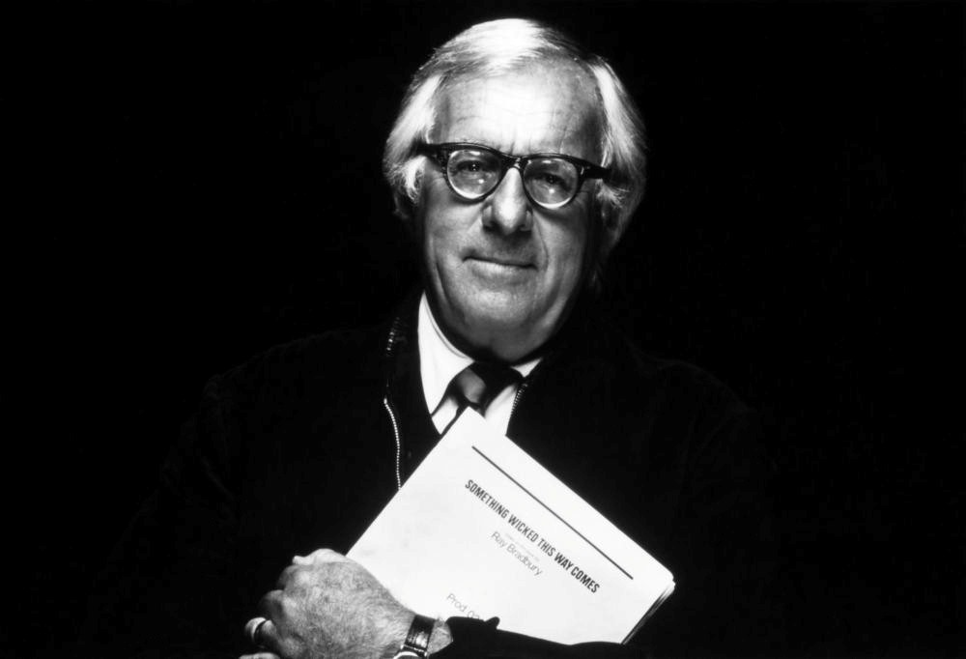

The Dragon, Ray Bradbury

The Dragon

The night blew in the short grass on the moor; there was no other motion. It had been years since a single bird had flown by in the great blind shell of sky. Long ago a few small stones had simulated life when they crumbled and fell into dust.

Now only the night moved in the souls of the two men bent by their lonely fire in the wilderness; darkness pumped quietly in their veins and ticked silently in their temples and their wrists.

Firelight fled up and down their wild faces and welled in their eyes in orange tatters. They listened to each other’s faint, cool breathing and the lizard blink of their eyelids. At last, one man poked the fire with his sword.

“Don’t, idiot; you’ll give us away!”

“No matter,” said this second man. “The dragon can smell us miles off anyway. God’s breath, it’s cold. I wish I was back at the castle.”

“It’s death, not sleep we’re after. . . .”

“Why? Why? The dragon never sets foot in the town!”

“Quiet, fool! He eats men traveling alone from our town to the next!”

“Let them be eaten and let us get home!”

“Wait now; listen!”

The two men froze.

They waited a long time, but there was only the shake of their horses’ nervous skin like black velvet tambourines jingling the silver stirrup buckles, softly, softly.

“Ah.” The second man sighed. “What a land of nightmares. Everything happens here. Someone blows out the sun; it’s night. And then, and then, oh, sweet mortality, listen! This dragon, they say his eyes are fire. His breath a white gas; you can see him burn across the dark lands.

He runs with sulfur and thunder and kindles the grass. Sheep panic and die insane. Women deliver forth monsters. The dragon’s fury is such that tower walls shake back to dust. His victims, at sunrise, are strewn hither thither on the hills. How many knights, I ask, have gone for this monster and failed, even as we shall fail?”

“Enough of that!”

“More than enough! Out here in this desolation I cannot tell what year this is!”

“Nine hundred years since the Nativity.”

“No, no,” whispered the second man, eyes shut. “On this moor is no Time, is only Forever. I feel if I ran back on the road the town would be gone, the people yet unborn, things changed, the castles unquarried from the rocks, the timbers still uncut from the forests; don’t ask how I know; the moor knows and tells me. And here we sit alone in the land of the fire dragon, God save us!”

“Be you afraid, then gird on your armor!”

“What use? The dragon runs from nowhere; we cannot guess its home. It vanishes in fog; we know not where it goes. Aye, on with our armor, we’ll die well dressed.”

Half into his silver corselet, the second man stopped again and turned his head.

Across the dim country, full of night and nothingness from the heart of the moor itself, the wind sprang full of dust from clocks that used dust for telling time. There were black suns burning in the heart of this new wind and a million burned leaves shaken from some autumn tree beyond the horizon. The wind melted landscapes, lengthened bones like white wax, made the blood roil and thicken to a muddy deposit in the brain.

The wind was a thousand souls dying and all Time confused and in transit. It was a fog inside of a mist inside of a darkness, and this place was no man’s place and there was no year or hour at all, but only these men in a faceless emptiness of sudden frost, storm and white thunder which moved behind the great falling pane of green glass that was the lightning. A squall of rain drenched the turf; all faded away until there was unbreathing hush and the two men waiting alone with their warmth in a cool season.

“There,” whispered the first man, “Oh, there . . .”

Miles off, rushing with a great chant and a roar—the dragon.

In silence the men buckled on their armor and mounted their horses. The midnight wilderness was split by a monstrous gushing as the dragon roared nearer, nearer; its flashing yellow glare spurted above a hill and then, fold on fold of dark body, distantly seen, therefore indistinct, flowed over that hill and plunged vanishing into a valley.

“Quick!”

They spurred their horses forward to a small hollow.

“This is where it passes!”

They seized their lances with mailed fists and blinded their horses by flipping the visors down over their eyes.

“Lord!”

“Yes, let us use His name.”

On the instant, the dragon rounded a hill. Its monstrous amber eye fed on them, fired their armor in red glints and glitters. With a terrible wailing cry and a grinding rush it flung itself forward.

“Mercy, mercy!”

The lance struck under the unlidded yellow eye, buckled, tossed the man through the air. The dragon hit, spilled him over, down, ground him under. Passing, the black brunt of its shoulder smashed the remaining horse and rider a hundred feet against the side of a boulder, wailing, wailing, the dragon shrieking, the fire all about, around, under it, a pink, yellow, orange sun-fire with great soft plumes of blinding smoke.

“Did you see it?” cried a voice. “Just like I told you!”

“The same! The same! A knight in armor, by the Lord Harry! We hit him!”

“You goin’ to stop?”

“Did once; found nothing. Don’t like to stop on this moor. I get the willies. Got a feel, it has.”

“But we hit something!”

“Gave him plenty of whistle; chap wouldn’t budge!”

A steaming blast cut the mist aside.

“We’ll make Stokely on time. More coal, eh, Fred?”

Another whistle shook dew from the empty sky. The night train, in fire and fury, shot through a gully, up a rise, and vanished away over cold earth toward the north, leaving black smoke and steam to dissolve in the numbed air minutes after it had passed and gone forever.

The End