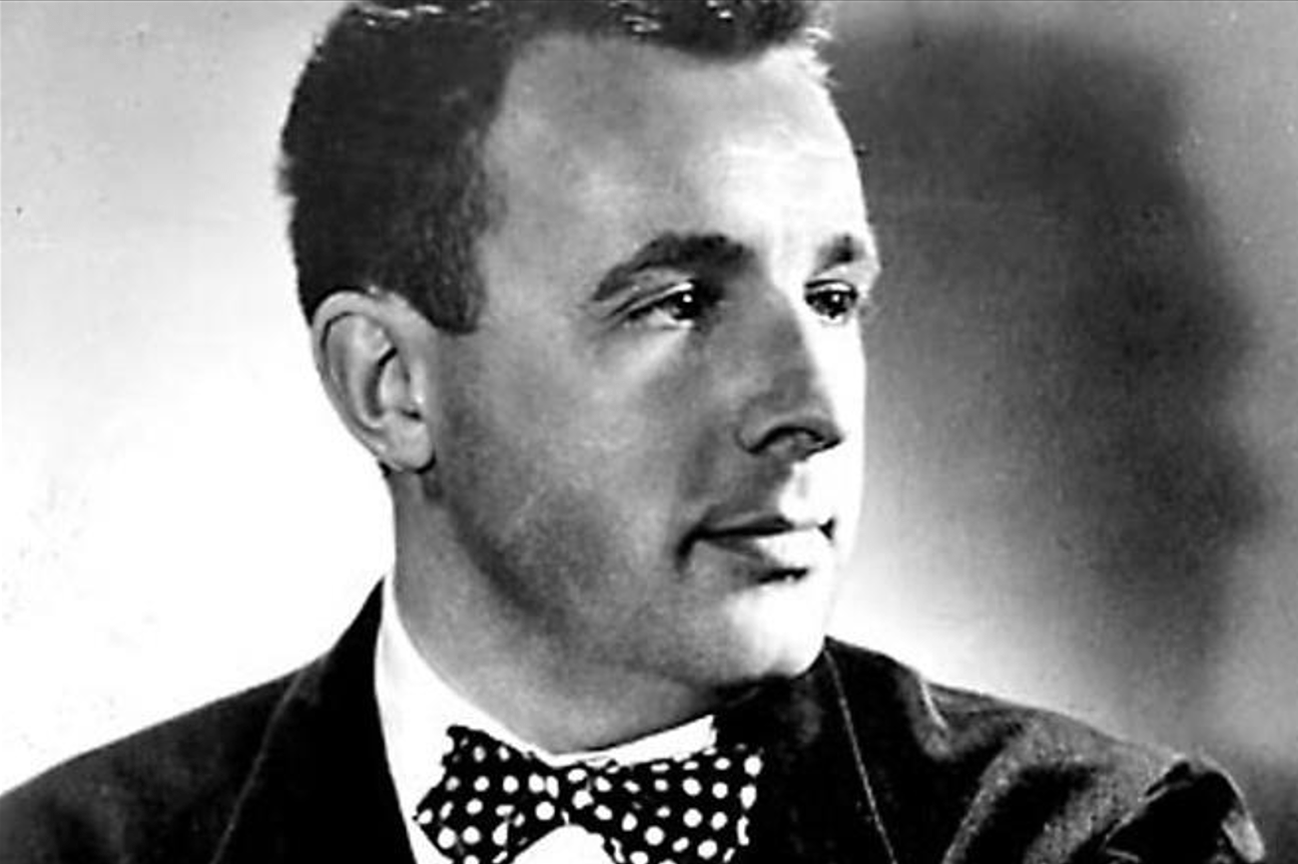

The Drummer Boy of Shiloh, Ray Bradbury

The Drummer Boy of Shiloh

In the april night, more than once, blossoms fell from the orchard trees and lit with rustling taps on the drumskin. At midnight a peach stone left miraculously on a branch through winter, flicked by a bird, fell swift and unseen, struck once, like panic, which jerked the boy upright.

In silence he listened to his own heart ruffle away, away, at last gone from his ears and back in his chest again.

After that, he turned the drum on its side, where its great lunar face peered at him whenever he opened his eyes.

His face, alert or at rest, was solemn. It was indeed a solemn time and a solemn night for a boy just turned fourteen in the peach field near the Owl Creek not far from the church at Shiloh.

“. . . thirty-one, thirty-two, thirty-three . . .”

Unable to see, he stopped counting.

Beyond the thirty-three familiar shadows, forty thousand men, exhausted by nervous expectation, unable to sleep for romantic dreams of battles yet unfought, lay crazily askew in their uniforms. A mile yet farther on, another army was strewn helter-skelter, turning slow, basting themselves with the thought of what they would do when the time came: a leap, a yell, a blind plunge their strategy, raw youth their protection and benediction.

Now and again the boy heard a vast wind come up, that gently stirred the air. But he knew what it was, the army here, the army there, whispering to itself in the dark. Some men talking to others, others murmuring to themselves, and all so quiet it was like a natural element arisen from south or north with the motion of the earth toward dawn.

What the men whispered the boy could only guess, and he guessed that it was: Me, I’m the one, I’m the one of all the rest won’t die. I’ll live through it. I’ll go home. The band will play. And I’ll be there to hear it.

Yes, thought the boy, that’s all very well for them, they can give as good as they get!

For with the careless bones of the young men harvested by night and bindled around campfires were the similarly strewn steel bones of their rifles, with bayonets fixed like eternal lightning lost in the orchard grass.

Me, thought the boy, I got only a drum, two sticks to beat it, and no shield.

There wasn’t a man-boy on this ground tonight did not have a shield he cast, riveted or carved himself on his way to his first attack, compounded of remote but nonetheless firm and fiery family devotion, flag-blown patriotism and cocksure immortality strengthened by the touchstone of very real gunpowder, ramrod, miniéball and flint.

But without these last the boy felt his family move yet farther off away in the dark, as if one of those great prairie-burning trains had chanted them away never to return, leaving him with this drum which was worse than a toy in the game to be played tomorrow or some day much too soon.

The boy turned on his side. A moth brushed his face, but it was peach blossom. A peach blossom flicked him, but it was a moth. Nothing stayed put. Nothing had a name. Nothing was as it once was.

If he lay very still, when the dawn came up and the soldiers put on their bravery with their caps, perhaps they might go away, the war with them, and not notice him lying small here, no more than a toy himself.

“Well, by God, now,” said a voice.

The boy shut up his eyes, to hide inside himself, but it was too late. Someone, walking by in the night, stood over him.

“Well,” said the voice quietly, “here’s a soldier crying before the fight. Good. Get it over. Won’t be time once it all starts.”

And the voice was about to move on when the boy, startled, touched the drum at his elbow. The man above, hearing this, stopped. The boy could feel his eyes, sense him slowly bending near. A hand must have come down out of the night, for there was a little rat-tat as the fingernails brushed and the man’s breath fanned his face.

“Why, it’s the drummer boy, isn’t it?”

The boy nodded, not knowing if his nod was seen. “Sir, is that you?” he said.

“I assume it is.” The man’s knees cracked as he bent still closer.

He smelled as all fathers should smell, of salt sweat, ginger tobacco, horse and boot leather, and the earth he walked upon. He had many eyes. No, not eyes, brass buttons that watched the boy.

He could only be, and was, the General.

“What’s your name, boy?” he asked.

“Joby,” whispered the boy, starting to sit up.

“All right, Joby, don’t stir.” A hand pressed his chest gently, and the boy relaxed. “How long you been with us, Joby?”

“Three weeks, sir.”

“Run off from home or joined legitimately, boy?”

Silence.

“Damn-fool question,” said the General. “Do you shave yet, boy? Even more of a damn-fool. There’s your cheek, fell right off the tree overhead. And the others here not much older. Raw, raw, damn raw, the lot of you. You ready for tomorrow or the next day, Joby?”

“I think so, sir.”

“You want to cry some more, go on ahead. I did the same last night.”

“You, sir?”

“God’s truth. Thinking of everything ahead. Both sides figuring the other side will just give up, and soon, and the war done in weeks, and us all home. Well, that’s not how it’s going to be. And maybe that’s why I cried.”

“Yes, sir,” said Joby.

The General must have taken out a cigar now, for the dark was suddenly filled with the Indian smell of tobacco unlit as yet, but chewed as the man thought what next to say.

“It’s going to be a crazy time,” said the General. “Counting both sides, there’s a hundred thousand men, give or take a few thousand out there tonight, not one as can spit a sparrow off a tree, or knows a horse clod from a miniéball.

Stand up, bare the breast, ask to be a target, thank them and sit down, that’s us, that’s them. We should turn tail and train four months, they should do the same. But here we are, taken with spring fever and thinking it blood lust, taking our sulfur with cannons instead of with molasses as it should be, going to be a hero, going to live forever. And I can see all of them over there nodding agreement, save the other way around.

It’s wrong, boy, it’s wrong as a head put on hind side front and a man marching backward through life. It will be a double massacre if one of their itchy generals decides to picnic his lads on our grass. More innocents will get shot out of pure Cherokee enthusiasm than ever got shot before.

Owl Creek was full of boys splashing around in the noonday sun just a few hours ago. I fear it will be full of boys again, just floating, at sundown tomorrow, not caring where the tide takes them.”

The General stopped and made a little pile of winter leaves and twigs in the darkness, as if he might at any moment strike fire to them to see his way through the coming days when the sun might not show its face because of what was happening here and just beyond.

The boy watched the hand stirring the leaves and opened his lips to say something, but did not say it. The General heard the boy’s breath and spoke himself.

“Why am I telling you this? That’s what you wanted to ask, eh? Well, when you got a bunch of wild horses on a loose rein somewhere, somehow you got to bring order, rein them in. These lads, fresh out of the milkshed, don’t know what I know, and I can’t tell them: men actually die, in war. So each is his own army. I got to make one army of them. And for that, boy, I need you.”

“Me!” The boy’s lips barely twitched.

“Now, boy,” said the General quietly, “you are the heart of the army. Think of that. You’re the heart of the army. Listen, now.”

And, lying there, Joby listened.

And the General spoke on.

If he, Joby, beat slow tomorrow, the heart would beat slow in the men. They would lag by the wayside. They would drowse in the fields on their muskets. They would sleep forever, after that, in those same fields, their hearts slowed by a drummer boy and stopped by enemy lead.

But if he beat a sure, steady, ever faster rhythm, then, then their knees would come up in a long line down over that hill, one knee after the other, like a wave on the ocean shore! Had he seen the ocean ever? Seen the waves rolling in like a well-ordered cavalry charge to the sand? Well, that was it, that’s what he wanted, that’s what was needed! Joby was his right hand and his left. He gave the orders, but Joby set the pace!

So bring the right knee up and the right foot out and the left knee up and the left foot out. One following the other in good time, in brisk time. Move the blood up the body and make the head proud and the spine stiff and the jaw resolute.

Focus the eye and set the teeth, flare the nostrils and tighten the hands, put steel armor all over the men, for blood moving fast in them does indeed make men feel as if they’d put on steel.

He must keep at it, at it! Long and steady, steady and long! Then, even though shot or torn, those wounds got in hot blood—in blood he’d helped stir—would feel less pain. If their blood was cold, it would be more than slaughter, it would be murderous nightmare and pain best not told and no one to guess.

The General spoke and stopped, letting his breath slack off. Then, after a moment, he said, “So there you are, that’s it. Will you do that, boy? Do you know now you’re general of the army when the General’s left behind?”

The boy nodded mutely.

“You’ll run them through for me then, boy?”

“Yes, sir.”

“Good. And, God willing, many nights from tonight, many years from now, when you’re as old or far much older than me, when they ask you what you did in this awful time, you will tell them—one part humble and one part proud—‘I was the drummer boy at the battle of Owl Creek,’ or the Tennessee River, or maybe they’ll just name it after the church there. ‘I was the drummer boy at Shiloh.’

Good grief, that has a beat and sound to it fitting for Mr. Longfellow. ‘I was the drummer boy at Shiloh.’ Who will ever hear those words and not know you, boy, or what you thought this night, or what you’ll think tomorrow or the next day when we must get up on our legs and move?”

The General stood up. “Well, then. God bless you, boy. Good night.”

“Good night, sir.”

And, tobacco, brass, boot polish, salt sweat and leather, the man moved away through the grass.

Joby lay for a moment, staring but unable to see where the man had gone.

He swallowed. He wiped his eyes. He cleared his throat. He settled himself. Then, at last, very slowly and firmly, he turned the drum so that it faced up toward the sky.

He lay next to it, his arm around it, feeling the tremor, the touch, the muted thunder as, all the rest of the April night in the year 1862, near the Tennessee River, not far from the Owl Creek, very close to the church named Shiloh, the peach blossoms fell on the drum.

The End