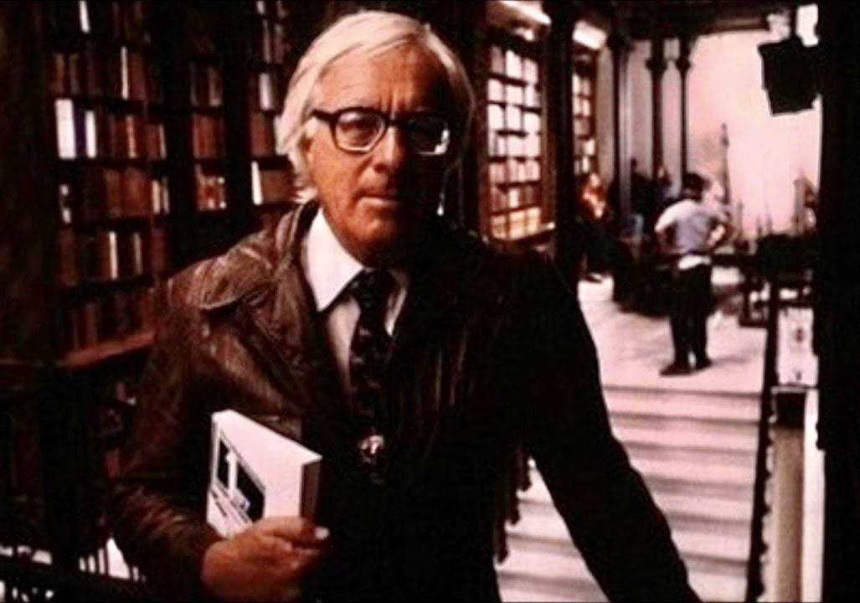

The Dwarf, Ray Bradbury

The Dwarf

Aimee watched the sky, quietly.

Tonight was one of those motionless hot summer nights. The concrete pier empty, the strung red, white, yellow bulbs burning like insects in the air above the wooden emptiness. The managers of the various carnival pitches stood, like melting wax dummies, eyes staring blindly, not talking, all down the line.

Two customers had passed through an hour before. Those two lonely people were now in the roller coaster, screaming murderously as it plummeted down the blazing night, around one emptiness after another.

Aimee moved slowly across the strand, a few worn wooden hoopla rings sticking to her wet hands. She stopped behind the ticket booth that fronted the MIRROR MAZE. She saw herself grossly misrepresented in three rippled mirrors outside the Maze.

A thousand tired replicas of herself dissolved in the corridor beyond, hot images among so much clear coolness.

She stepped inside the ticket booth and stood looking a long while at Ralph Banghart’s thin neck. He clenched an unlit cigar between his long uneven yellow teeth as he laid out a battered game of solitaire on the ticket shelf.

When the roller coaster wailed and fell in its terrible avalanche again, she was reminded to speak.

“What kind of people go up in roller coasters?”

Ralph Banghart worked his cigar a full thirty seconds. “People wanna die. That rollie coaster’s the handiest thing to dying there is.” He sat listening to the faint sound of rifle shots from the shooting gallery. “This whole damn carny business’s crazy.

For instance, that dwarf. You seen him? Every night, pays his dime, runs in the Mirror Maze all the way back through to Screwy Louie’s Room. You should see this little runt head back there. My God!”

“Oh, yes,” said Aimee, remembering. “I always wonder what it’s like to be a dwarf. I always feel sorry when I see him.”

“I could play him like an accordion.”

“Don’t say that!”

“My Lord.” Ralph patted her thigh with a free hand. “The way you carry on about guys you never even met.” He shook his head and chuckled. “Him and his secret. Only he don’t know I know, see? Boy howdy!”

“It’s a hot night.” She twitched the large wooden hoops nervously on her damp fingers.

“Don’t change the subject. He’ll be here, rain or shine.”

Aimee shifted her weight.

Ralph seized her elbow. “Hey! You ain’t mad? You wanna see that dwarf, don’t you? Sh!” Ralph turned. “Here he comes now!”

The Dwarf’s hand, hairy and dark, appeared all by itself reaching up into the booth window with a silver dime. An invisible person called, “One!” in a high, child’s voice.

Involuntarily, Aimee bent forward.

The Dwarf looked up at her, resembling nothing more than a dark-eyed, dark-haired, ugly man who has been locked in a winepress, squeezed and wadded down and down, fold on fold, agony on agony, until a bleached, outraged mass is left, the face bloated shapelessly, a face you know must stare wide-eyed and awake at two and three and four o’clock in the morning, lying flat in bed, only the body asleep.

Ralph tore a yellow ticket in half. “One!”

The Dwarf, as if frightened by an approaching storm, pulled his black coat-lapels tightly about his throat and waddled swiftly. A moment later, ten thousand lost and wandering dwarfs wriggled between the mirror flats, like frantic dark beetles, and vanished.

“Quick!”

Ralph squeezed Aimee along a dark passage behind the mirrors. She felt him pat her all the way back through the tunnel to a thin partition with a peekhole.

“This is rich,” he chuckled. “Go on—look.”

Aimee hesitated, then put her face to the partition.

“You see him?” Ralph whispered.

Aimee felt her heart beating. A full minute passed.

There stood the Dwarf in the middle of the small blue room. His eyes were shut. He wasn’t ready to open them yet. Now, now he opened his eyelids and looked at a large mirror set before him. And what he saw in the mirror made him smile. He winked, he pirouetted, he stood sidewise, he waved, he bowed, he did a little clumsy dance.

And the mirror repeated each motion with long, thin arms, with a tall, tall body, with a huge wink and an enormous repetition of the dance, ending in a gigantic bow!

“Every night the same thing,” whispered Ralph in Aimee’s ear. “Ain’t that rich?”

Aimee turned her head and looked at Ralph steadily out of her motionless face, for a long time, and she said nothing. Then, as if she could not help herself, she moved her head slowly and very slowly back to stare once more through the opening. She held her breath. She felt her eyes begin to water.

Ralph nudged her, whispering.

“Hey, what’s the little gink doin’ now?”

They were drinking coffee and not looking at each other in the ticket booth half an hour later, when the Dwarf came out of the mirrors. He took his hat off and started to approach the booth, when he saw Aimee and hurried away.

“He wanted something,” said Aimee.

“Yeah.” Ralph squashed out his cigarette, idly. “I know what, too. But he hasn’t got the nerve to ask. One night in this squeaky little voice he says, ‘I bet those mirrors are expensive.’ Well, I played dumb. I said yeah they were. He sort of looked at me, waiting, and when I didn’t say any more, he went home, but next night he said, ‘I bet those mirrors cost fifty, a hundred bucks.’ I bet they do, I said. I laid me out a hand of solitaire.”

“Ralph,” she said.

He glanced up. “Why you look at me that way?”

“Ralph,” she said, “why don’t you sell him one of your extra ones?”

“Look, Aimee, do I tell you how to run your hoop circus?”

“How much do those mirrors cost?”

“I can get ’em secondhand for thirty-five bucks.”

“Why don’t you tell him where he can buy one, then?”

“Aimee, you’re not smart.” He laid his hand on her knee. She moved her knee away. “Even if I told him where to go, you think he’d buy one? Not on your life. And why? He’s self-conscious. Why, if he even knew I knew he was flirtin’ around in front of that mirror in Screwy Louie’s Room, he’d never come back.

He plays like he’s goin’ through the Maze to get lost, like everybody else. Pretends like he don’t care about that special room.

Always waits for business to turn bad, late nights, so he has that room to himself. What he does for entertainment on nights when business is good, God knows. No, sir, he wouldn’t dare go buy a mirror anywhere.

He ain’t got no friends, and even if he did he couldn’t ask him to buy him a thing like that. Pride, by God, pride. Only reason he even mentioned it to me is I’m practically the only guy he knows. Besides, look at him—he ain’t got enough to buy a mirror like those.

He might be savin’ up, but where in hell in the world today can a dwarf work? Dime a dozen, drug on the market, outside of circuses.”

“I feel awful. I feel sad.” Aimee sat staring at the empty boardwalk. “Where does he live?”

“Flytrap down on the waterfront. The Ganghes Arms. Why?”

“I’m madly in love with him, if you must know.”

He grinned around his cigar. “Aimee,” he said. “You and your very funny jokes.”

A warm night, a hot morning, and a blazing noon. The sea was a sheet of burning tinsel and glass.

Aimee came walking, in the locked-up carnival alleys out over the warm sea, keeping in the shade, half a dozen sun-bleached magazines under her arm. She opened a flaking door. The world of Giants far away, an ugly rumor beyond the garden wall.

Poor mama, papa! They meant only the best for me. They kept me, like a porcelain vase, small and treasured, to themselves, in our ant world, our beehive rooms, our microscopic library, our land of beetle-sized doors and moth windows. Only now do I see the magnificent size of my parents’ psychosis!

They must have dreamed they would live forever, keeping me like a butterfly under glass. But first father died, and then fire ate up the little house, the wasp’s nest, and every postage-stamp mirror and saltcellar closet within. Mama, too, gone! And myself alone, watching the fallen embers, tossed out into a world of Monsters and Titans, caught in a landslide of reality, rushed, rolled, and smashed to the bottom of the cliff!

“It took me a year to adjust. A job with a sideshow was unthinkable. There seemed no place for me in the world. And then, a month ago, the Persecutor came into my life, clapped a bonnet on my unsuspecting head, and cried to friends, ‘I want you to meet the little woman!’”

Aimee stopped reading. Her eyes were unsteady and the magazine shook as she handed it to Ralph. “You finish it. The rest is a murder story. It’s all right. But don’t you see? That little man. That little man.”

Ralph tossed the magazine aside and lit a cigarette lazily. “I like Westerns better.”

‘Ralph, you got to read it. He needs someone to tell him how good he is and keep him writing.”

Ralph looked at her, his head to one side. “And guess who’s going to do it? Well, well, ain’t we just the Savior’s right hand?”

“I won’t listen!”

“Use your head, damn it! You go busting in on him he’ll think you’re handing him pity. He’ll chase you screamin’ outa his room.”

She sat down, thinking about it slowly, trying to turn it over and see it from every side. “I don’t know. Maybe you’re right. Oh, it’s not just pity, Ralph, honest. But maybe it’d look like it to him. I’ve got to be awful careful.”

He shook her shoulder back and forth, pinching softly, with his fingers. “Hell, hell, lay off him, is all I ask; you’ll get nothing but trouble for your dough. God, Aimee, I never seen you so hepped on anything.

Look, you and me, let’s make it a day, take a lunch, get us some gas, and just drive on down the coast as far as we can drive; swim, have supper, see a good show in some little town—to hell with the carnival, how about it? A damn nice day and no worries. I been savin’ a coupla bucks.”

“It’s because I know he’s different,” she said, looking off into darkness. “It’s because he’s something we can never be—you and me and all the rest of us here on the pier. It’s so funny, so funny. Life fixed him so he’s good for nothing but carny shows, yet there he is on the land.

And life made us so we wouldn’t have to work in the carny shows, but here we are, anyway, way out here at sea on the pier. Sometimes it seems a million miles to shore. How come, Ralph, that we got the bodies, but he’s got the brains and can think things we’ll never even guess?”

“You haven’t even been listening to me!” said Ralph.

She sat with him standing over her, his voice far away. Her eyes were half shut and her hands were in her lap, twitching.

“I don’t like that shrewd look you’re getting on,” he said, finally.

She opened her purse slowly and took out a small roll of bills and started counting. “Thirty-five, forty dollars. There. I’m going to phone Billie Fine and have him send out one of those tall-type mirrors to Mr. Bigelow at the Ganghes Arms. Yes, I am!”

“What!”

“Think how wonderful for him, Ralph, having one in his own room any time he wants it. Can I use your phone?”

“Go ahead, be nutty.”

Ralph turned quickly and walked off down the tunnel. A door slammed.

Aimee waited, then after a while put her hands to the phone and began to dial, with painful slowness. She paused between numbers, holding her breath, shutting her eyes, thinking how it might seem to be small in the world, and then one day someone sends a special mirror by.

A mirror for your room where you can hide away with the big reflection of yourself, shining, and write stories and stories, never going out into the world unless you had to. How might it be then, alone, with the wonderful illusion all in one piece in the room. Would it make you happy or sad, would it help your writing or hurt it?

She shook her head back and forth, back and forth. At least this way there would be no one to look down at you. Night after night, perhaps rising secretly at three in the cold morning, you could wink and dance around and smile and wave at yourself, so tall, so tall, so very fine and tall in the bright looking-glass.

A telephone voice said, “Billie Fine’s.”

“Oh, Billie!” she cried.

Night came in over the pier. The ocean lay dark and loud under the planks. Ralph sat cold and waxen in his glass coffin, laying out the cards, his eyes fixed, his mouth stiff. At his elbow, a growing pyramid of burned cigarette butts grew larger. When Aimee walked along under the hot red and blue bulbs, smiling, waving, he did not stop setting the cards down slow and very slow. “Hi, Ralph!” she said.

“How’s the love affair?” he asked, drinking from a dirty glass of iced water. “How’s Charlie Boyer, or is it Cary Grant?”

“I just went and bought me a new hat,” she said, smiling. “Gosh, I feel good! You know why? Billie Fine’s sending a mirror out tomorrow! Can’t you just see the nice little guy’s face?”

“I’m not so hot at imagining.”

“Oh, Lord, you’d think I was going to marry him or something.”

“Why not? Carry him around in a suitcase. People say, Where’s your husband? all you do is open your bag, yell, Here he is! Like a silver cornet. Take him outa his case any old hour, play a tune, stash him away. Keep a little sandbox for him on the back porch.”

“I was feeling so good,” she said.

“Benevolent is the word.” Ralph did not look at her, his mouth tight. “Ben-eve-o-lent. I suppose this all comes from me watching him through that knothole, getting my kicks? That why you sent the mirror? People like you run around with tambourines, taking the joy out of my life.”

“Remind me not to come to your place for drinks anymore. I’d rather go with no people at all than mean people.”

Ralph exhaled a deep breath. “Aimee, Aimee. Don’t you know you can’t help that guy? He’s bats. And this crazy thing of yours is like saying, Go ahead, be batty, I’ll help you, pal.”

“Once in a lifetime anyway, it’s nice to make a mistake if you think it’ll do somebody some good,” she said.

“God deliver me from do-gooders, Aimee.”

“Shut up, shut up!” she cried, and then said nothing more.

He let the silence lie awhile, and then got up, putting his finger-printed glass aside. “Mind the booth for me?”

“Sure. Why?”

She saw ten thousand cold white images of him stalking down the glassy corridors, between mirrors, his mouth straight and his fingers working themselves.

She sat in the booth for a full minute and then suddenly shivered. A small clock ticked in the booth and she turned the deck of cards over, one by one, waiting. She heard a hammer pounding and knocking and pounding again, far away inside the Maze; a silence, more waiting, and then ten thousand images folding and refolding and dissolving, Ralph striding, looking out at ten thousand images of her in the booth. She heard his quiet laughter as he came down the ramp.

“Well, what’s put you in such a good mood?” she asked, suspiciously.

“Aimee,” he said carelessly, “we shouldn’t quarrel. You say tomorrow Billie’s sending that mirror to Mr. Big’s?”

“You’re not going to try anything funny?”

“Me?” He moved her out of the booth and took over the cards, humming, his eyes bright. “Not me, oh no, not me.” He did not look at her, but started quickly to slap out the cards. She stood behind him. Her right eye began to twitch a little. She folded and unfolded her arms.

A minute ticked by. The only sound was the ocean under the night pier, Ralph breathing in the heat, the soft ruffle of the cards. The sky over the pier was hot and thick with clouds. Out at sea, faint glows of lightning were beginning to show.

“Ralph,” she said at last.

“Relax, Aimee,” he said.

“About that trip you wanted to take down the coast—”

“Tomorrow,” he said. “Maybe next month. Maybe next year. Old Ralph Banghart’s a patient guy. I’m not worried, Aimee. Look.” He held up a hand. “I’m calm.”

She waited for a roll of thunder at sea to fade away.

“I just don’t want you mad, is all. I just don’t want anything bad to happen, promise me.”

The wind, now warm, now cool, blew along the pier. There was a smell of rain in the wind. The clock ticked. Aimee began to perspire heavily, watching the cards move and move. Distantly, you could hear targets being hit and the sound of the pistols at the shooting gallery.

And then, there he was.

Waddling along the lonely concourse, under the insect bulbs, his face twisted and dark, every movement an effort. From a long way down the pier he came, with Aimee watching. She wanted to say to him, This is your last night, the last time you’ll have to embarrass yourself by coming here, the last time you’ll have to put up with being watched by Ralph, even in secret. She wished she could cry out and laugh and say it right in front of Ralph. But she said nothing.

“Hello, hello!” shouted Ralph. “It’s free, on the house, tonight! Special for old customers!”

The Dwarf looked up, startled, his little black eyes darting and swimming in confusion. His mouth formed the word thanks and he turned, one hand to his neck, pulling his tiny lapels tight up about his convulsing throat, the other hand clenching the silver dime secretly.

Looking back, he gave a little nod, and then scores of dozens of compressed and tortured faces, burned a strange dark color by the lights, wandered in the glass corridors.

“Ralph,” Aimee took his elbow. “What’s going on?”

He grinned. “I’m being benevolent, Aimee, benevolent.”

“Ralph,” she said.

“Sh,” he said. “Listen.”

They waited in the booth in the long warm silence.

Then, a long way off, muffled, there was a scream.

“Ralph!” said Aimee.

“Listen, listen!” he said.

There was another scream, and another and still another, and a threshing and a pounding and a breaking, a rushing around and through the Maze. There, there, wildly colliding and ricocheting, from mirror to mirror, shrieking hysterically and sobbing, tears on his face, mouth gasped open, came Mr. Bigelow. He fell out in the blazing night air, glanced about wildly, wailed, and ran off down the pier.

“Ralph, what happened?”

Ralph sat laughing and slapping at his thighs.

She slapped his face. “What’d you do?”

He didn’t quite stop laughing. “Come on. I’ll show you!”

And then she was in the Maze, rushed from white-hot mirror to mirror, seeing her lipstick all red fire a thousand times repeated on down a burning silver cavern where strange hysterical women much like herself followed a quick-moving, smiling man. “Come on!” he cried. And they broke free into a dust-smelling tiny room.

“Ralph!” she said.

They both stood on the threshold of the little room where the Dwarf had come every night for a year. They both stood where the Dwarf had stood each night, before opening his eyes to see the miraculous image in front of him.

Aimee shuffled slowly, one hand out, into the dim room.

The mirror had been changed.

This new mirror made even tall people little and dark and twisted smaller as you moved forward.

And Aimee stood before it thinking and thinking that if it made big people small, standing here, God, what would it do to a dwarf, a tiny dwarf, a dark dwarf, a startled and lonely dwarf?

She turned and almost fell. Ralph stood looking at her. “Ralph,” she said. “God, why did you do it?”

“Aimee, come back!”

She ran out through the mirrors, crying. Staring with blurred eyes, it was hard to find the way, but she found it. She stood blinking at the empty pier, started to run one way, then another, then still another, then stopped.

Ralph came up behind her, talking, but it was like a voice heard behind a wall late at night, remote and foreign.

“Don’t talk to me,” she said.

Someone came running up the pier. It was Mr. Kelly from the shooting gallery. “Hey, any you see a little guy just now? Little stiff swiped a pistol from my place, loaded, run off before I’d get a hand on him! You help me find him?”

And Kelly was gone, sprinting, turning his head to search between all the canvas sheds, on away under the hot blue and red and yellow strung bulbs.

Aimee rocked back and forth and took a step.

“Aimee, where you going?”

She looked at Ralph as if they had just turned a corner, strangers passing, and bumped into each other. “I guess,” she said, “I’m going to help search.”

“You won’t be able to do nothing.”

“I got to try anyway. Oh God, Ralph, this is all my fault! I shouldn’t have phoned Billie Fine! I shouldn’t’ve ordered a mirror and got you so mad you did this! It’s me should’ve gone to Mr. Big, not a crazy thing like I bought! I’m going to find him if it’s the last thing I ever do in my life.”

Swinging about slowly, her cheeks wet, she saw the quivery mirrors that stood in front of the Maze, Ralph’s reflection was in one of them. She could not take her eyes away from the image; it held her in a cool and trembling fascination, with her mouth open.

“Aimee, what’s wrong? What’re you—”

He sensed where she was looking and twisted about to see what was going on. His eyes widened.

He scowled at the blazing mirror.

A horrid, ugly little man, two feet high, with a pale, squashed face under an ancient straw hat, scowled back at him. Ralph stood there glaring at himself, his hands at his sides.

Aimee walked slowly and then began to walk fast and then began to run. She ran down the empty pier and the wind blew warm and it blew large drops of hot rain out of the sky on her all the time she was running.

The End