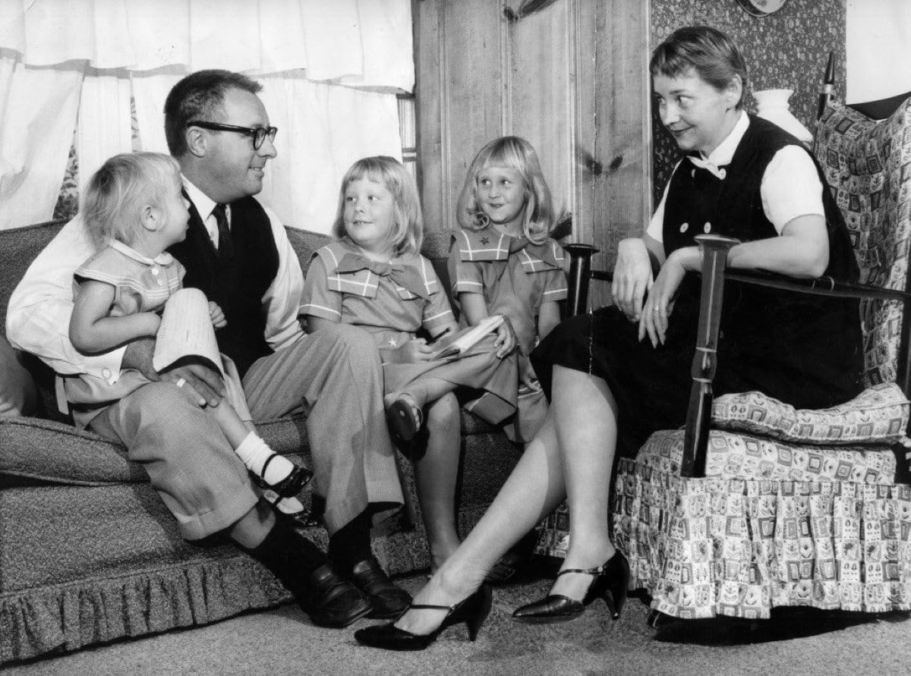

The First Night of Lent, Ray Bradbury

The First Night of Lent

So you want to know all the whys and wherefores of the Irish? What shapes them to their Dooms and runs them on their way? you ask. Well, listen, then. For though I’ve known but a single Irishman in all my life, I knew him, without pause, for one hundred and forty-four consecutive nights.

Stand close; perhaps in him you’ll see that entire race which marches out of the rains but to vanish through the mists; hold on, here they come! Look out, there they go!

This Irishman, his name was Nick.

During the autumn of 1953, I began a screenplay in Dublin, and each afternoon a hired cab drove me thirty miles out from the River Liffey to the huge gray Georgian country house where my producer-director rode to hounds.

There, we discussed my eight pages of daily script through the long fall, winter, and early spring evenings. Then, each midnight, ready to turn back to the Irish Sea and the Royal Hibernian Hotel, I’d wake the operator in the Kilcock village exchange and have her put me through to the warmest, if totally unheated, spot in town.

“Heber Finn’s pub?” I’d shout, once connected. “Is Nick there? Could you send him along here, please?”

My mind’s eye saw them, the local boys, lined up, peering over the barricade at that freckled mirror so like a frozen winter pond and themselves discovered all drowned and deep under that lovely ice. Amid all their jostlings and their now-here’s-a-secret-in-a-stage-whisper commotion stood Nick, my village driver, his quietness abounding. I heard Heber Finn sing out from the phone. I heard Nick start up and reply:

“Just look at me, headin’ for the door!”

Early on, I learned that “headin’ for the door” was no nerve-shattering process that might affront dignity or destroy the fine filigree of any argument being woven with great and breathless beauty at Heber Finn’s.

It was, rather, a gradual disengagement, a leaning of the bulk so one’s gravity was diplomatically shifted toward that far empty side of the public room where the door, shunned by all, stood neglected. Meantime, a dozen conversational warps and woofs must be ticked, tied, and labeled so next morn, with hoarse cries of recognition, patterns might be seized and the shuttle thrown with no pause for breath or thought.

Timing it, I figured the long part of Nick’s midnight journey—the length of Heber Finn’s—took half an hour. The short part—from Finn’s to the house where I waited—took but five minutes.

So it was on the night before the first night of Lent. I called. I waited.

And at last, down through the night forest, thrashed the 1931 Chevrolet, peat-turf colored on top like Nick. Car and driver gasped, sighed, wheezed softly, easily, gently as they nudged into the courtyard and I groped down the front steps under a moonless but brightly starred sky.

I peered through the car window at unstirred dark; the dashboard had been dead these many years.

“Nick . . .?”

“None other,” he whispered secretly. “And ain’t it a fine warm evenin’?”

The temperature was fifty. But, Nick’d been no nearer Rome than the Tipperary shore line; so weather was relative.

“A fine warm evening.” I climbed up front and gave the squealing door its absolutely compulsory, rust-splintering slam. “Nick, how’ve you been since?”

“Ah.” He let the car bulk and grind itself down the forest path. “I got me health. Ain’t that all-and-everything with Lent comin’ on tomorra?”

“Lent,” I mused. “What will you give up for Lent, Nick?”

“I been turnin’ it over.” Nick sucked his cigarette suddenly; the pink, lined mask of his face blinked off the smoke. “And why not these terrible things ya see in me mouth? Dear as gold-fillin’s, and a dread congestor of the lungs they be. Put it all down, add ’em up, and ya got a sick loss by the year’s turnin’, ya know. So ya’ll not find these filthy creatures in me face again the whole time of Lent, and, who knows, after!”

“Bravo!” said I, a non-smoker.

“Bravo, says I to meself,” wheezed Nick, one eye flinched with smoke.

“Good luck,” I said.

“I’ll need it,” whispered Nick, “with the Sin’s own habit to be broke.”

And we moved with firm control, with thoughtful shift of weight, down and around a turfy hollow and through a mist and into Dublin at thirty-one easy miles an hour.

Bear with me while I stress it: Nick was the most careful driver in all God’s world, including any sane, small, quiet, butter-and-milk producing country you name.

Above all, Nick stands innocent and sainted when compared to those motorists who key that small switch marked paranoia each time they fuse themselves to their bucket seats in Los Angeles, Mexico City, or Paris.

Also, to those blind men who, forsaking tin cups and canes, but still wearing their Hollywood dark-glasses, laugh insanely down the Via Veneto, shaking brake-drum lining like carnival serpentine out their race-car windows. Consider the Roman ruins; surely they are the wreckage strewn and left by those motor-biking otters who, all night beneath your hotel window, shriek down dark Roman alleys, Christians hell-bent for the Colosseum lion pits.

Nick, now. See his easy hands loving the wheel in a slow clocklike turning as soft and silent as winter constellations snow down the sky. Listen to his mist-breathing voice all night-quiet as he charms the road, his foot a tenderly benevolent pat on the whispering accelerator, never a mile under thirty, never two miles over. Nick, Nick, and his steady boat gentling a mild sweet lake where all Time slumbers. Look, compare. And bind such a man to you with summer grasses, gift him with silver, shake his hand warmly at each journey’s end.

“Good night, Nick,” I said at the hotel. “See you tomorrow.”

“God willing,” whispered Nick.

And he drove softly away.

Let twenty-three hours of sleep, breakfast, lunch, supper, late night-cap pass. Let hours of writing bad script into fair script fade to peat mist and rain, and there I come again, another midnight, out of that Georgian mansion, its door throwing a warm hearth of color before me as I tread down the steps to feel Braille-wise in fog for the car I know hulks there; I hear its enlarged and asthmatic heart gasping in the blind air, and Nick coughing his “gold by the ounce is not more precious” cough.

“Ah, there you are, sir!” said Nick.

And I climbed in the sociable front seat and gave the door its slam. “Nick,” I said, smiling.

And then the impossible happened. The car jerked as if shot from the blazing mouth of a cannon, roared, took off, bounced, skidded, then cast itself in full, stoning ricochet down the path among shattered bushes and writhing shadows. I snatched my knees as my head hit the car top four times.

Nick! I almost shouted. Nick!

Visions of Los Angeles, Mexico City, Paris, jumped through my mind. I gazed in frank dismay at the speedometer. Eighty, ninety, one hundred kilometers; we shot out a great blast of gravel behind and hit the main road, rocked over a bridge and slid down in the midnight streets of Kilcock. No sooner in than out of town at one hundred ten kilometers, I felt all Ireland’s grass put down its ears when we, with a yell, jumped over a rise.

Nick! I thought, and turned, and there he sat, only one thing the same. On his lips a cigarette burned, blinding first one eye, then the other.

But the rest of Nick, behind the cigarette, was changed as if the Adversary himself had squeezed and molded and fired him with a dark hand. There he was, whirling the wheel round-about, over-around; here we frenzied under trestles, out of tunnels, here knocked crossroad signs spinning like weathercocks in whirlwinds.

Nick’s face; the wisdom was drained from it, the eyes neither gentle nor philosophical, the mouth neither tolerant, nor at peace. It was a face washed raw, a scalded, peeled potato, a face more like a blinding searchlight raking its steady and meaningless glare ahead while his quick hands snaked and bit and bit the wheel again to lean us round curves and jump us off cliff after cliff of night.

It’s not Nick, I thought, it’s his brother. Or a dire thing’s come in his life, some destroying affliction or blow, a family sorrow or sickness, yes, that’s the answer.

And then Nick spoke, and his voice, it was changed too. Gone was the mellow peat bog, the moist sod, the warm fire in out of the cold rain, gone the gentle grass. Now the voice fairly cracked at me, a clarion, a trumpet, all iron and tin.

“Well, how ya been since!” Nick shouted. “How is it with ya!” he cried.

And the car, it too had suffered violence. It protested the change, yes, for it was an old and much-beaten thing that had done its time and now only wished to stroll along, like a crusty beggar toward sea and sky, careful of its breath and bones.

But Nick would have none of that, and cadged the wreck on as if thundering toward Hell, there to warm his cold hands at some special blaze. Nick leaned, the car leaned; great livid gases blew out in fireworks from the exhaust. Nick’s frame, my frame, the car’s frame, all together, were wracked and shuddered and ticked wildly.

My sanity was saved from being torn clean off the bone by a simple act. My eyes, seeking the cause of our plaguing flight, ran over the man blazing here like a sheet of ignited vapor from the Abyss, and laid hands to the answering clue.

“Nick,” I gasped, “it’s the first night of Lent!”

“So?” Nick said, surprised.

“So,” I said, “remembering your Lenten promise, why’s that cigarette in your mouth?”

Nick did not know what I meant for a moment. Then he cast his eyes down, saw the jiggling smoke, and shrugged.

“Ah,” he said, “I give up the other.”

And suddenly it all came clear.

The other one hundred forty-odd nights, at the door of the old Georgian house I had accepted from my employer a fiery douse of scotch or bourbon or some-such drink “against the chill.”

Then, breathing summer wheat or barley or oats or whatever from my scorched and charcoaled mouth, I had walked out to a cab where sat a man who, during all the long evenings’ wait for me to phone for his services, had lived in Heber Finn’s pub.

Fool! I thought, how could you have forgotten this!

And there in Heber Finn’s, during the long hours of lacy talk that was like planting and bringing to crop a garden among busy men, each contributing his seed or flower, and wielding the implements, their tongues, and the raised, foam-hived glasses, their own hands softly curled about the dear drinks, there Nick had taken into himself a mellowness.

And that mellowness had distilled itself down in a slow rain that damped his smoldering nerves and put the wilderness fires in every limb of him out. Those same showers laved his face to leave the tidal marks of wisdom, the lines of Plato and Aeschylus there.

The harvest mellowness colored his cheeks, warmed his eyes soft, lowered his voice to a husking mist, and spread in his chest to slow his heart to a gentle jog trot. It rained out his arms to loosen his hard-mouthed hands on the shuddering wheel and sit him with grace and ease in his horse-hair saddle as he gentled us through the fogs that kept us and Dublin apart.

And with the malt on my own tongue, fluming up my sinus with burning vapors, I had never detected the scent of any spirits on my old friend here.

“Ah,” said Nick again. “Yes; I give up the other.”

The last bit of jigsaw fell in place.

Tonight, the first night of Lent.

Tonight, for the first time in all the nights I had driven with him, Nick was sober.

All those other one hundred and forty-odd nights, Nick hadn’t been driving careful and easy just for my safety, no, but because of the gentle weight of mellowness sloping now on this side, now on that side of him as we took the long, scything curves.

Oh, who really knows the Irish, say I, and which half of them is which? Nick?—who is Nick?—and what in the world is he? Which Nick’s the real Nick, the one that everyone knows?

I will not think on it!

There is only one Nick for me. The one that Ireland shaped herself with her weathers and waters, her seedings and harvestings, her brans and mashes, her brews, bottlings, and ladlings-out, her summer-grain-colored pubs astir and advance with the wind in the wheat and barley by night, you may hear the good whisper way out in forest, on bog, as you roll by. That’s Nick to the teeth, eye, and heart, to his easygoing hands. If you ask what makes the Irish what they are, I’d point on down the road and tell where you turn to Heber Finn’s.

The first night of Lent, and before you count nine, we’re in Dublin! I’m out of the cab and it’s puttering there at the curb and I lean in to put my money in the hands of my driver. Earnestly, pleadingly, warmly, with all the friendly urging in the world, I look into that fine man’s raw, strange, torchlike face.

“Nick,” I said.

“Sir!” he shouted.

“Do me a favor,” I said.

“Anything!” he shouted.

“Take this extra money,” I said, “and buy the biggest bottle of Irish moss you can find. And just before you pick me up tomorrow night, Nick, drink it down, drink it all. Will you do that, Nick? Will you promise me, cross your heart and hope to die, to do that?”

He thought on it, and the very thought damped down the ruinous blaze in his face.

“Ya make it terrible hard on me,” he said.

I forced his fingers shut on the money. At last he put it in his pocket and faced silently ahead.

“Good night, Nick,” I said. “See you tomorrow.”

“God willing,” said Nick.

And he drove away.

The End