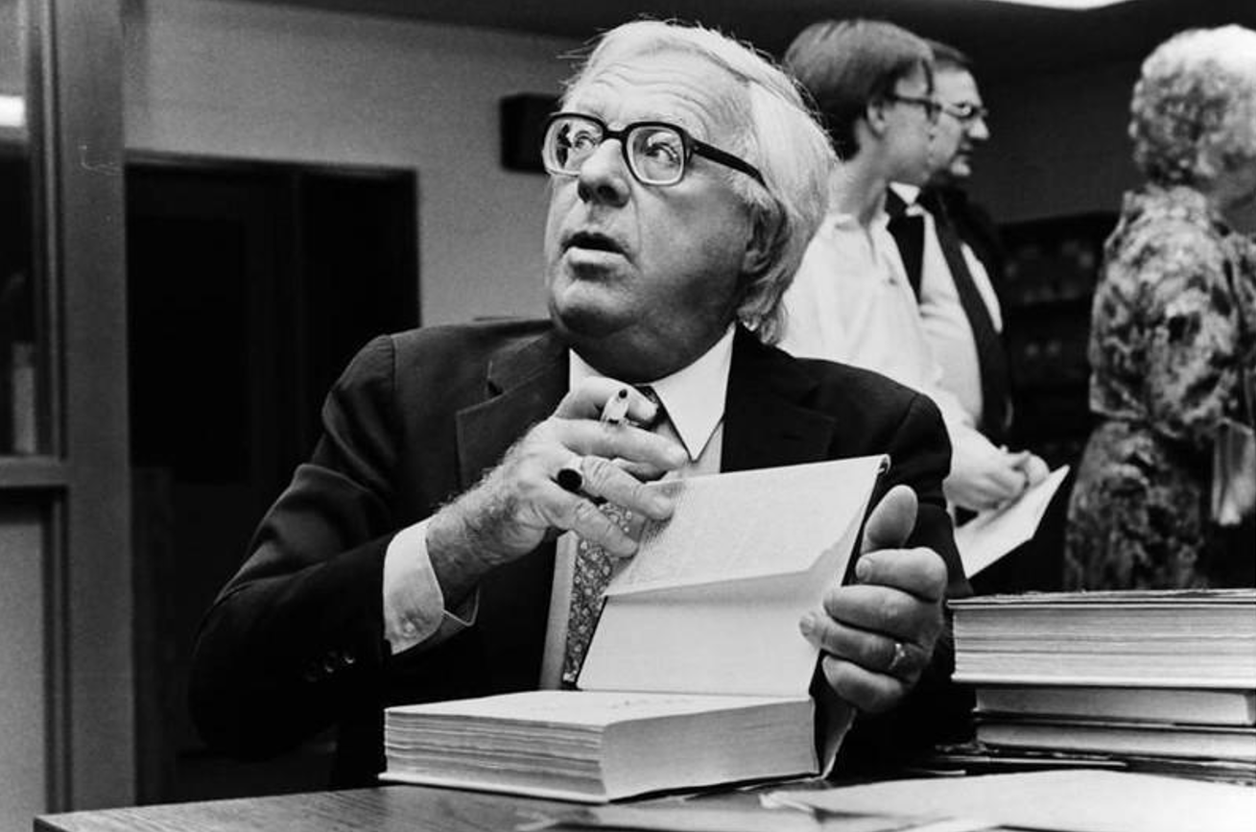

The Flying Machine, Ray Bradbury

The Flying Machine

In the year a.d. 400, the emperor yuan held his throne by the Great Wall of China, and the land was green with rain, readying itself toward the harvest, at peace, the people in his dominion neither too happy nor too sad.

Early on the morning of the first day of the first week of the second month of the new year, the Emperor Yuan was sipping tea and fanning himself against a warm breeze when a servant ran across the scarlet and blue garden tiles, calling, “Oh, Emperor, Emperor, a miracle!”

“Yes,” said the Emperor, “the air is sweet this morning.”

“No, no, a miracle!” said the servant, bowing quickly.

“And this tea is good in my mouth, surely that is a miracle.”

“No, no, Your Excellency.”

“Let me guess then—the sun has risen and a new day is upon us. Or the sea is blue. That now is the finest of all miracles.”

“Excellency, a man is flying!”

“What?” The Emperor stopped his fan.

“I saw him in the air, a man flying with wings. I heard a voice call out of the sky, and when I looked up there he was, a dragon in the heavens with a man in its mouth, a dragon of paper and bamboo, colored like the sun and the grass.”

“It is early,” said the Emperor, “and you have just wakened from a dream.”

“It is early, but I have seen what I have seen! Come, and you will see it too.”

“Sit down with me here,” said the Emperor. “Drink some tea. It must be a strange thing, if it is true, to see a man fly. You must have time to think of it, even as I must have time to prepare myself for the sight.”

They drank tea.

“Please,” said the servant at last, “or he will be gone.”

The Emperor rose thoughtfully. “Now you may show me what you have seen.”

They walked into a garden, across a meadow of grass, over a small bridge, through a grove of trees, and up a tiny hill.

“There!” said the servant.

The Emperor looked into the sky.

And in the sky, laughing so high that you could hardly hear him laugh, was a man; and the man was clothed in bright papers and reeds to make wings and a beautiful yellow tail, and he was soaring all about like the largest bird in a universe of birds, like a new dragon in a land of ancient dragons.

The man called down to them from high in the cool winds of morning, “I fly, I fly!”

The servant waved to him. “Yes, yes!”

The Emperor Yuan did not move. Instead he looked at the Great Wall of China now taking shape out of the farthest mist in the green hills, that splendid snake of stones which writhed with majesty across the entire land. That wonderful wall which had protected them for a timeless time from enemy hordes and preserved peace for years without number. He saw the town, nestled to itself by a river and a road and a hill, beginning to waken.

“Tell me,” he said to his servant, “has anyone else seen this flying man?”

“I am the only one, Excellency,” said the servant, smiling at the sky, waving.

The Emperor watched the heavens another minute and then said, “Call him down to me.”

“Ho, come down, come down! The Emperor wishes to see you!” called the servant, hands cupped to his shouting mouth.

The Emperor glanced in all directions while the flying man soared down the morning wind. He saw a farmer, early in his fields, watching the sky, and he noted where the farmer stood.

The flying man alit with a rustle of paper and a creak of bamboo reeds. He came proudly to the Emperor, clumsy in his rig, at last bowing before the old man.

“What have you done?” demanded the Emperor.

“I have flown in the sky, Your Excellency,” replied the man.

“What have you done?” said the Emperor again.

“I have just told you!” cried the flier.

“You have told me nothing at all.” The Emperor reached out a thin hand to touch the pretty paper and the birdlike keel of the apparatus. It smelled cool, of the wind.

“Is it not beautiful, Excellency?”

“Yes, too beautiful.”

“It is the only one in the world!” smiled the man. “And I am the inventor.”

“The only one in the world?”

“I swear it!”

“Who else knows of this?”

“No one. Not even my wife, who would think me mad with the sun. She thought I was making a kite. I rose in the night and walked to the cliffs far away. And when the morning breezes blew and the sun rose, I gathered my courage, Excellency, and leaped from the cliff. I flew! But my wife does not know of it.”

“Well for her, then,” said the Emperor. “Come along.”

They walked back to the great house. The sun was full in the sky now, and the smell of the grass was refreshing. The Emperor, the servant, and the flier paused within the huge garden.

The Emperor clapped his hands. “Ho, guards!”

The guards came running.

“Hold this man.”

The guards seized the flier.

“Call the executioner,” said the Emperor.

“What’s this!” cried the flier, bewildered. “What have I done?” He began to weep, so that the beautiful paper apparatus rustled.

“Here is the man who has made a certain machine,” said the Emperor, “and yet asks us what he has created. He does not know himself. It is only necessary that he create, without knowing why he has done so, or what this thing will do.”

The executioner came running with a sharp silver ax. He stood with his naked, large-muscled arms ready, his face covered with a serene white mask.

“One moment,” said the Emperor. He turned to a nearby table upon which sat a machine that he himself had created. The Emperor took a tiny golden key from his own neck. He fitted this key to the tiny, delicate machine and wound it up. Then he set the machine going.

The machine was a garden of metal and jewels. Set in motion, birds sang in tiny metal trees, wolves walked through miniature forests, and tiny people ran in and out of sun and shadow, fanning themselves with miniature fans, listening to the tiny emerald birds, and standing by impossibly small but tinkling fountains.

“Is it not beautiful?” said the Emperor. “If you asked me what I have done here, I could answer you well. I have made birds sing, I have made forests murmur, I have set people to walking in this woodland, enjoying the leaves and shadows and songs. That is what I have done.”

“But, oh, Emperor!” pleaded the flier, on his knees, the tears pouring down his face. “I have done a similar thing! I have found beauty. I have flown on the morning wind. I have looked down on all the sleeping houses and gardens. I have smelled the sea and even seen it, beyond the hills, from my high place.

And I have soared like a bird; oh, I cannot say how beautiful it is up there, in the sky, with the wind about me, the wind blowing me here like a feather, there like a fan, the way the sky smells in the morning! And how free one feels! That is beautiful, Emperor, that is beautiful too!”

“Yes,” said the Emperor sadly, “I know it must be true. For I felt my heart move with you in the air and I wondered: What is it like? How does it feel? How do the distant pools look from so high? And how my houses and servants? Like ants? And how the distant towns not yet awake?”

“Then spare me!”

“But there are times,” said the Emperor, more sadly still, “when one must lose a little beauty if one is to keep what little beauty one already has. I do not fear you, yourself, but I fear another man.”

“What man?”

“Some other man who, seeing you, will build a thing of bright papers and bamboo like this. But the other man will have an evil face and an evil heart, and the beauty will be gone. It is this man I fear.”

“Why? Why?”

“Who is to say that someday just such a man, in just such an apparatus of paper and reed, might not fly in the sky and drop huge stones upon the Great Wall of China?” said the Emperor.

No one moved or said a word.

“Off with his head,” said the Emperor.

The executioner whirled his silver ax.

“Burn the kite and the inventor’s body and bury their ashes together,” said the Emperor.

The servants retreated to obey.

The Emperor turned to his hand-servant, who had seen the man flying. “Hold your tongue. It was all a dream, a most sorrowful and beautiful dream. And that farmer in the distant field who also saw, tell him it would pay him to consider it only a vision. If ever the word passes around, you and the farmer die within the hour.”

“You are merciful, Emperor.”

“No, not merciful,” said the old man. Beyond the garden wall he saw the guards burning the beautiful machine of paper and reeds that smelled of the morning wind. He saw the dark smoke climb into the sky. “No, only very much bewildered and afraid.” He saw the guards digging a tiny pit wherein to bury the ashes. “What is the life of one man against those of a million others? I must take solace from that thought.”

He took the key from its chain about his neck and once more wound up the beautiful miniature garden. He stood looking out across the land at the Great Wall, the peaceful town, the green fields, the rivers and streams. He sighed.

The tiny garden whirred its hidden and delicate machinery and set itself in motion; tiny people walked in forests, tiny foxes loped through sun-speckled glades in beautiful shining pelts, and among the tiny trees flew little bits of high song and bright blue and yellow color, flying, flying, flying in that small sky.

“Oh,” said the Emperor, closing his eyes, “look at the birds, look at the birds!”

The End