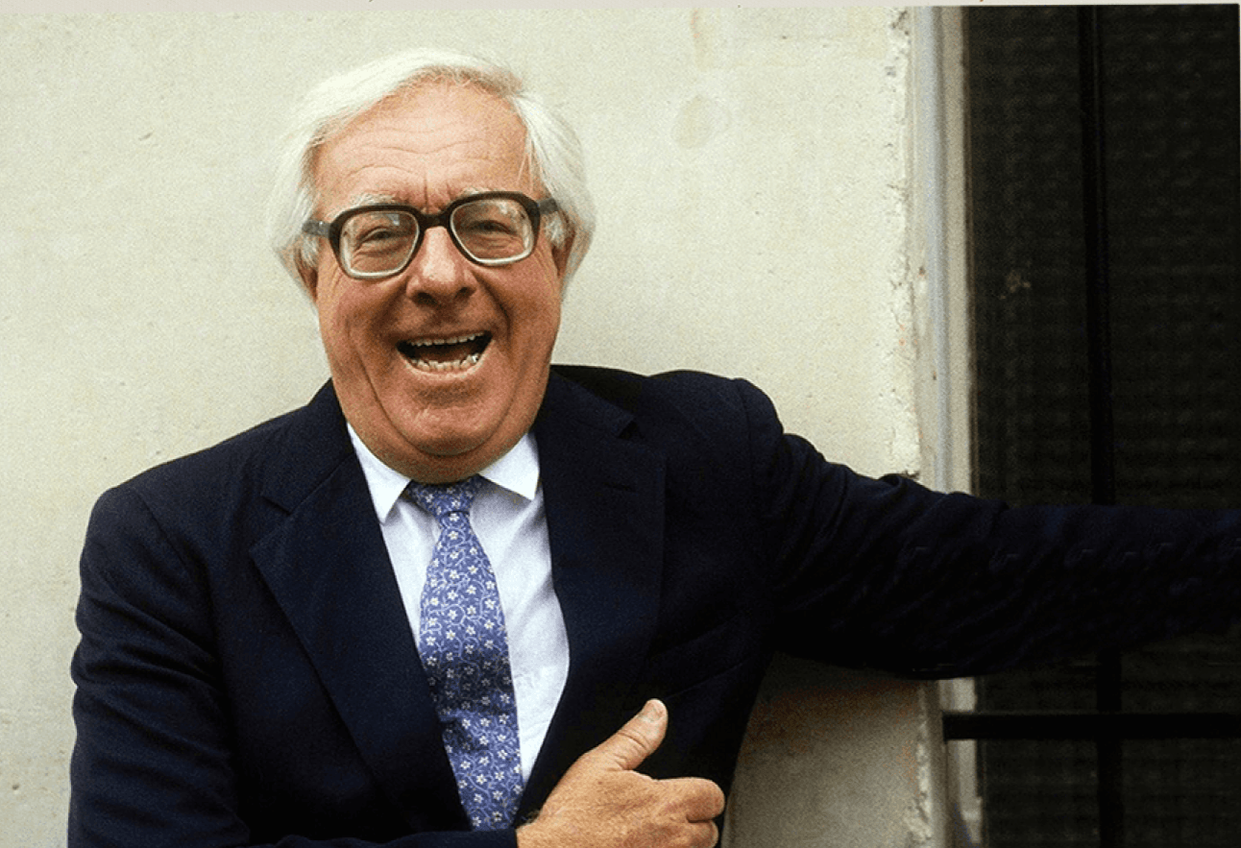

The Great Collision of Monday Last, Ray Bradbury

The Great Collision of Monday Last

The man staggered through the flung-wide doors of Heber Finn’s pub as if struck by lightning. Reeling, blood on his face, coat, and torn pants, his moan froze every customer at the bar.

For a time you heard only the soft foam popping in the lacy mugs, as the customers turned, some faces pale, some pink, some veined and wattle-red. Every eyelid down the line gave a blink.

The stranger swayed in his ruined clothes, eyes wide, lips trembling. The drinkers clenched their fist. Yes! they cried, silently—go on, man! what happened?

The stranger leaned far out on the air.

“Collision,” he whispered. “Collision on the road.”

Then, chopped at the knees, he fell.

“Collision!” A dozen men rushed at the body.

“Kelly!” Heber Finn vaulted the bar. “Get to the road! Mind the victim; easy does it! Joe, run for the Doc!”

“Wait!” said a quiet voice.

From the private stall at the dark end of the pub, the cubby where a philosopher might brood, a dark man blinked out at the crowd.

“Doc!” cried Heber Finn. “It’s you!”

Doctor and men hustled out into the night.

“Collision . . .” The man on the floor twitched his lips.

“Softly, boys.” Heber Finn and two others gentled the victim atop the bar. He looked handsome as death on the fine inlaid wood with the prismed mirror making him two dread calamities for the price of one.

Outside on the steps, the crowd halted, shocked as if an ocean had sunk Ireland in the dusk and now bulked all about them. Fog in fifty-foot rollers and breakers put out the moon and stars. Blinking, cursing, the men leaped out to vanish in the deeps.

Behind, in the bright doorframe, a young man stood. He was neither red enough nor pale enough of face, nor dark enough or light enough in spirit to be Irish, and so must be American. He was. That established, it follows he dreaded interfering with what seemed village ritual.

Since arriving in Ireland, he could not shake the feeling that at all times he was living stage center of the Abbey Theatre. Now, not knowing his lines, he could only stare after the rushing men.

“But,” he protested weakly, “I didn’t hear any cars on the road.”

“You did not!” said an old man almost pridefully. Arthritis limited him to the top step where he teetered, shouting at the white tides where his friends had submerged. “Try the crossroad, boys! That’s where it most often does!”

“The crossroad!” Far and near, footsteps rang.

“Nor,” said the American, “did I hear a collision.”

The old man snorted with contempt. “Ah, we don’t be great ones for commotion, nor great crashing sounds. But collision you’ll see if you step on out there. Walk, now, don’t run! It’s the devil’s own night.

Running blind you might hit into Kelly, beyond, who’s a great one for running just to squash his lungs. Or you might head on with Feeney, too drunk to find any road, never mind what’s on it! You got a torch, a flash? Blind you’ll be, but use it. Walk now, you hear?”

The American groped through the fog to his car, found his flashlight, and, immersed in the night beyond Heber Finn’s, made direction by the heavy clubbing of shoes and a rally of voices ahead. A hundred yards off in eternity the men approached, grunting whispers: “Easy now!” “Ah, the shameful blight!” “Hold on, don’t jiggle him!”

The American was flung aside by a steaming lump of men who swept suddenly from the fog, bearing atop themselves a crumpled object. He glimpsed a bloodstained and livid face high up there, then someone cracked his flashlight down.

By instinct, sensing the far whiskey-colored light of Heber Finn’s, the catafalque surged on toward that fixed and familiar harbor.

Behind came dim shapes and a chilling insect rattle.

“Who’s that!” cried the American.

“Us, with the vehicles,” someone husked. “You might say—we got the collision.”

The flashlight fixed them. The American gasped. A moment later, the battery failed.

But not before he had seen two village lads jogging along with no trouble at all, easily, lightly, toting under their arms two ancient black bicycles minus front and tail lights.

“What . . . ?” said the American.

But the lads trotted off, the accident with them. The fog closed in. The American stood abandoned on an empty road, his flashlight dead in his hand.

By the time he opened the door at Heber Finn’s, both “bodies” as they called them, had been stretched on the bar.

“We got the bodies on the bar,” said the old man, turning as the American entered.

And there was the crowd lined up not for drinks, but blocking the way so the Doc had to shove sidewise from one to another of these relics of blind driving by night on the misty roads.

“One’s Pat Nolan,” whispered the old man.

“Not working at the moment. The other’s Mr. Peevey from Meynooth, in candy and cigarettes mostly.” Raising his voice, “Are they dead now, Doc?”

“Ah, be still, won’t you?” The Doc resembled a sculptor troubled at finding some way to finish up two full-length marble statues at once. “Here, let’s put one victim on the floor!”

“The floor’s a tomb,” said Heber Finn. “He’ll catch his death down there. Best leave him up where the warm air gathers from our talk.”

“But,” said the American quietly, confused, “I’ve never heard of an accident like this in all my life. Are you sure there were absolutely no cars? Only these two men on their bikes?”

“Only!” The old man shouted.

“Great God, man, a fellow working up a drizzling sweat can pump along at sixty kilometers. With a long downhill glide his bike hits ninety or ninety-five! So here they come, these two, no front or tail lights—”

“Isn’t there a law against that?”

“To hell with government interference! So here the two come, no lights, flying home from one town to the next. Thrashing like Sin Himself’s at their behinds! Both going opposite ways but both on the same side of the road. Always ride the wrong side of the road, it’s safer, they say.

But look on these lads, fair destroyed by all that official palaver. Why? Don’t you see? One remembered it, but the other didn’t! Better if the officials kept their mouths shut! For here the two be, dying.”

“Dying?” The American stared.

“Well, think on it, man! What stands between two able-bodied hell-bent fellas jumping along the path from Kilcock to Meynooth? Fog! Fog is all! Only fog to keep their skulls from bashing together. Why, look when two chaps hit at a cross like that, it’s like a strike in bowling alleys, tenpins flying! Bang!

There go your friends, nine feet up, heads together like dear chums met, flailing the air, their bikes clenched like two tomcats. Then they all fall down and just lay there, feeling around for the Dark Angel.”

“Surely these men won’t—”

“Oh, won’t they? Why, last year alone in all the Free State no night passed some soul did not meet in fatal collision with another!”

“You mean to say over three hundred Irish bicyclists die every year, hitting each other?”

“God’s truth and a pity.”

“I never ride my bike nights.” Heber Finn eyed the bodies. “I walk.”

“But still then the damn bikes run you down!” said the old man. “Awheel or afoot, some idiot’s always panting up Doom the other way. They’d sooner split you down the seam than wave hello.

Oh, the brave men I’ve seen ruined or half-ruined or worse, and headaches their lifetimes after.” The old man trembled his eyelids shut. “You might almost think, mightn’t you, that human beings was not made to handle such delicate instruments of power.”

“Three hundred dead each year.” The American seemed dazed.

“And that don’t count the ‘walking wounded’ by the thousands every fortnight who, cursing, throw their bikes in the bog forever and take government pensions to salve their all-but-murdered bodies.”

“Should we stand here talking?” The American gestured helplessly toward the victims. “Is there a hospital?”

“On a night with no moon,” Heber Finn continued, “best walk out through the middle of fields and be damned to the evil roads! That’s how I have survived into this my fifth decade.”

“Ah . . .” The men stirred restlessly.

The Doc, sensing he had withheld information too long, feeling his audience drift away, now snatched their attention back by straightening up briskly and exhaling.

“Well!”

The pub quickened into silence.

“This chap here—” The Doc pointed. “Bruises, lacerations, and agonizing backaches for two weeks running. As for the other lad, however—” And here the Doc let himself scowl for a long moment at the paler one there looking rouged, waxed, and ready for final rites. “Concussion.”

“Concussion!”

The quiet wind rose and fell in the silence.

“He’ll survive if we run him quick now to Meynooth Clinic. So whose car will volunteer?”

The crowd turned as a staring body toward the American. He felt the gentle shift as he was drawn from outside the ritual to its deep and innermost core. He flushed, remembering the front of Heber Finn’s pub, where seventeen bicycles and one automobile were parked at this moment. Quickly, he nodded.

“There! A volunteer, lads! Quick now, hustle this boy—gently!—to our good friend’s vehicle!”

The men reached out to lift the body, but froze when the American coughed. They saw him circle his hand to all, and tip his cupped fingers to his lips. They gasped in soft surprise. The gesture was not done when drinks foamed down the bar.

“For the road!”

And now even the luckier victim, suddenly revived, face like cheese, found a mug gentled to his hand with whispers.

“Here, lad, here . . . tell us . . .”

“. . . what happened, eh? eh?”

Then the body was gone off the bar, the potential wake over, the room empty save for the American, the Doc, the revived lad, and two softly cudgeling friends. Outside you could hear the crowd putting the one serious result of the great collision into the volunteer’s car.

The Doc said, “Finish your drink, Mr.—?”

“McGuire,” said the American.

“By the saints, he’s Irish!”

No, thought the American, far away, looking numbly around at the pub, at the recovered bicyclist seated, waiting for the crowd to come back and mill about him, seeing the blood-spotted floor, the two bicycles tilted near the door like props from a vaudeville turn, the dark night waiting outside with its improbable fog, listening to the roll and cadence and gentle equilibrium of these voices balanced each in its own throat and environment. No, thought the American named McGuire, I’m almost, but certainly not quite, Irish . . .

“Doctor,” he heard himself say as he placed money on the bar, “do you often have auto wrecks, collisions, between people in cars?”

“Not in our town!” The Doc nodded scornfully east. “If you like that sort of thing, now, Dublin’s the very place for it!”

Crossing the pub together, the Doc took his arm as if to impart some secret which would change his Fates. Thus steered, the American found the stout inside himself a shifting weight he must accommodate from side to side as the Doc breathed soft in his ear.

“Look here now, McGuire, admit it, you’ve driven but little in Ireland, right? Then, listen! Driving to Meynooth, fog and all, you’d best take it fast! Raise a din! Why? Scare the cyclists and cows off the path, both sides! If you drive slow, why you’ll creep up on and do away with dozens before they know what took them off!

And another thing: when a car approaches, douse your lights! Pass each other, lights out, in safety. Them devil’s own lights have put out more eyes and demolished more innocents than all of seeing’s worth. Is it clear, now? Two things: speed, and douse your lights when cars loom up!”

At the door, the American nodded. Behind him he heard the one victim, settled easy in his chair, working the stout around on his tongue, thinking, preparing, beginning his tale:

“Well, I’m on me way home, blithe as you please, asailing downhill near the cross when—”

Outside in the car with the other collision victim moaning softly in the back seat, the Doc offered final advice.

“Always wear a cap, lad. If you want to walk nights ever, on the roads, that is. A cap’ll save you the frightful migraines should you meet Kelly or Moran or any other hurtling full-tilt the other way, full of fiery moss and hard-skulled from birth.

Even on foot, these men are dangerous. So you see, there’s rules for pedestrians too in Ireland, and wear a cap at night is Number One!”

Without thinking, the American fumbled under the seat, brought forth a brown tweed cap purchased in Dublin that day, and put it on. Adjusting it, he looked out at the dark mist boiling across the night.

He listened to the empty highway waiting for him ahead, quiet, quiet, quiet, but not quiet somehow. For hundreds of long strange miles up and down all of Ireland he saw a thousand crossroads covered with a thousand fogs through which one thousand tweed-capped, gray-mufflered phantoms wheeled along in midair, singing, shouting, and smelling of Guinness Stout.

He blinked. The phantoms shadowed off. The road lay empty and dark and waiting.

Taking a deep breath, shutting his eyes, the American named McGuire turned the key in the switch and stepped on the starter.

The End