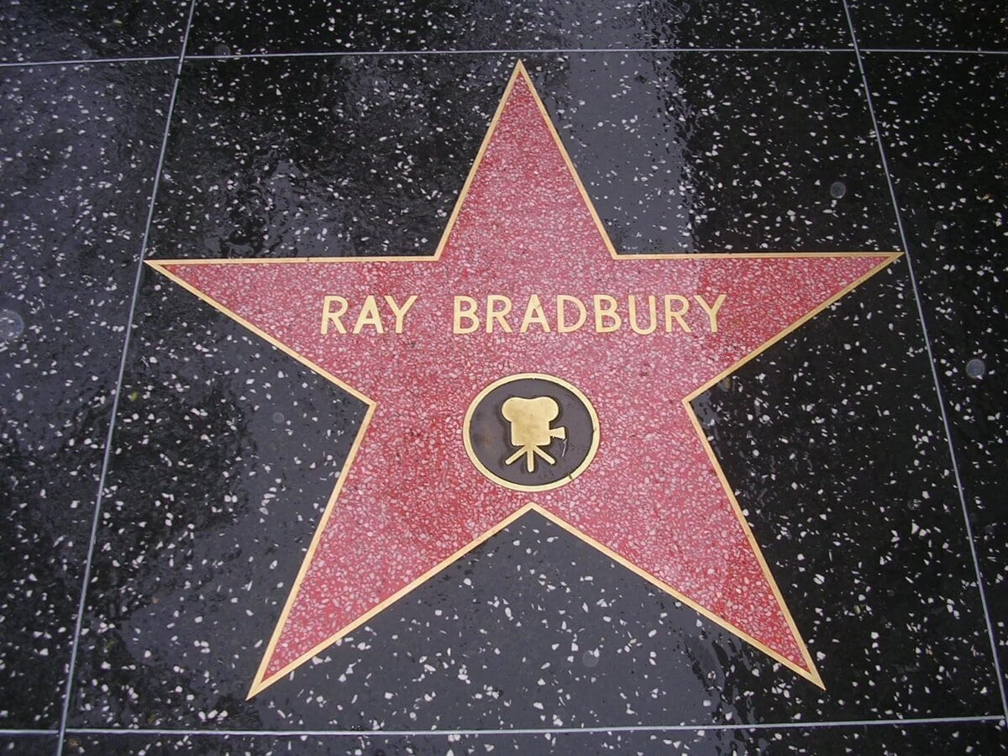

The Inspired Chicken Motel, Ray Bradbury

It was in the Depression, deep down in the empty soul of the Depression in 1932, when we were heading west by 1928 Buick, that my mother, father, my brother Skip, and I came upon what we ever after called the Inspired Chicken Motel.

It was, my father said, a motel straight out of Revelations. And the one strange chicken at that motel could no more help making said Revelations, writ on eggs, than a holy roller can help going wild with utterances of God, Time, and Eternity writhing along his limbs, seeking passage out the mouth.

Some creatures are given to talents inclined one way, some another. But chickens are the greatest dumb brute mystery of them all. Especially hens who think or intuit messages calcium-scrawled forth in a nice neat hand upon the shells wherein their offspring twitch asleep.

Little did we know that long autumn of 1932, as we blew tires and flung fan belts like lost garters down Highway 66, that somewhere ahead that motel, and that most peculiar chicken, were waiting.

Along the way, our family was a wonderful nest of amiable contempt. Holding the maps, my brother and I knew we were a helluva lot smarter than Dad, Dad knew he was smarter than Mom, and Mom knew she could brain the whole bunch, any time.

That makes for perfection.

I mean, any family that has a proper disrespect, each for the other, can stay together. As long as there is something to fight about, people will come to meals. Lose that and the family disintegrates.

So we leaped out of bed each day hardly able to wait to hear what dumb thing someone might say over the hard-fried bacon and the under-fried scrambleds. The toast was too dark or too light. There was jam for only one person.

Or it was a flavor that two out of four hated. Hand us a set of bells and we could ring all the wrong changes. If Dad claimed he was still growing, Skip and I ran the tape measure out to prove he'd shrunk during the night. That's humanity. That's nature. That's family.

But like I said, there we were grousing down Illinois, quarreling through the leaf change in the Ozarks autumn where we stopped sniping all of ten minutes to see the fiery colors. Then, pot-shotting and sniveling across Kansas and Oklahoma we plowed into a fine deep-red muck and slid off the road on a detour where each of us could bless himself and blame others for the excavations, the badly painted signs, and the lack of brakeage in our old Buick.

Out of the ditch, we unloaded ourselves into a great Buck-a-Night Bungalow Court in a murderers' ambush behind a woods and on the rim of a deep rock-quarry where our bodies might be found years later at the bottom of a lost and sourceless lake, and spent the night counting the rain that leaked in through the shingle-sieve roof and fighting over who had the most covers on the wrong side of the bed.

The next day was even better. We steamed out of the rain into 100-degree heat that took the sap and spunk out of us, save for a few ricochet slaps Dad threw at Skip but landed on me. By noon we were sweated fresh out of contempt, and were settling into a rather refined if exhausted period of familiar insult, when we drove up by this chicken farm outside Amarillo, Texas.

We sat up, instantly.

Why?

Because we found that chickens are kicked the same as families kick each other, to get them out of the way.

We saw an old man boot a rooster and smile as he came toward the auto gate. We all beamed. He leaned in to say he rented rooms for fifty cents a night, the price being low because the smell was high.

The starch being out of Dad, and him sunk in a despond of good will, and this looking like another dandy place to raise grouse, he turned in his chauffeur's cap and shelled out fifty cents in nickels and pennies.

Our great expectations were not punctured. The flimsy room we moved into was a beaut. Not only did all the springs give injections wherever you put flesh down, but the entire bungalow suffered from an oft-rehearsed palsy. Its foundations were still in shock from the thousand mean invaders who had cried "Timber!" and fallen upon the impaling beds.

By its smell, some wild parries had died here. There was an odor of false sincerity and lust masquerading as love. A wind blew up between the floorboards redolent of chickens under the bungalow who spent nights running crazy from diarrhea induced by pecking the bathtub liquor that seeped down through the fake Oriental linoleum.

Anyway, once we had hunched in out of the sun and slunk through a cold pork-and-beans-on-bread lunch, with white oleo-margarine greasing it down the ways, my brother and I found a desert creek nearby and heaved rocks at each other to cool off.

That night we went into town and found a greasy spoon and read the flyspecks and fought off the crickets that came into the cafe to skinnydip in the soup. We saw a ten-cent James Cagney gangster movie and came out heading back to the chicken ranch delighted with all the mayhem, the Great Depression gone and forgotten.

At eleven that hot night everyone in Texas was awake because of the heat. The landlady, a frail woman whose picture I had seen in every newsphoto of Dust Bowl country, eroded down to the bones but with a fragile sort of candlelight hollowed in her eyes, came to sit and chat with us about the eighteen million unemployed and what might happen next and where we were going and what would next year bring.

Which was the first cool respite of the day. A cold wind blew out of tomorrow. We grew restive. I looked at my brother, he looked at Mom, Mom looked at Dad, and we were a family, no matter what, and we were together tonight, going somewhere.

"Well … " Dad took out a road map and unfolded it and showed the lady where he had marked in red ink as if it was a chart of our four lives' territory, just how we would live in the days ahead, just how survive, just how make do, sleep just so, eat how much, and sleep with no dreams guaranteed. "Tomorrow"—he touched the roads with one nicotine-stained finger—"we'll be in Tombstone. Day after that Tucson.

Stay in Tucson looking for work. We got enough cash for two 'weeks there if we cut it close. No jobs there, we move on to San Diego. Got a cousin there in Customs Inspection on the docks. We figure one week in San Diego, three weeks in Los Angeles.

Then we've just enough money to head home to Illinois, where we can put in on relief or, who knows, maybe get our job back at the Power and Light Company that laid me off six months ago."

"I see," said the landlady.

And she did see. For all eighteen million people had come along this road and stopped here going somewhere anywhere nowhere and then going back to the nowhere somewhere anywhere they had got lost from in the first place and, not needed, gone wandering away.

"What kind of job are you looking for?" asked the landlady.

And it was a joke. She knew it as soon as she said it. Dad thought about it and laughed. Mother laughed. My brother and I laughed. We all laughed together.

For of course no one asked whatkindof job, there were just jobs to be found, jobs without names, jobs to buy gas and feed faces and maybe, on occasion, buy ice-cream cones. Movies? They were something to be seen once a month, perhaps.

Beyond that, my brother and I snuck in around back theaters or in side doors or down through basements up through orchestra pits or up fire escapes and down into balconies. Nothing could keep us from Saturday matinees except Adolph Menjou.

We all stopped laughing. Sensing that a proper time had come for a particular act, the landlady excused herself, went out, and in a few minutes returned. She brought with her two small gray cardboard boxes.

The way she carried them at first it almost seemed she was bearing the family heirlooms or the ashes of a beloved uncle. She sat and held the two small boxes on her aproned lap for a long moment, shielding them quietly. She waited with the inherent sense of drama most people learn when small quick events must be slowed and made to seem large.

And strangely, we were moved by the hush of the woman herself, by the lostness of her face. For it was a face in which a whole lifetime of lostness showed. It was a face in which children, never born, gave cry.

Or it was a face in which children, born, had passed to be buried not in the earth but in her flesh. Or it was a face in which children, born, raised, had gone off over the world never to write.

It was a face in which her life and the life of her husband and the ranch they lived on struggled to survive and somehow managed. God's breath threatened to blow out her wits, but somehow, with awe at her own survival, her soul stayed lit.

Any face like that, with so much loss in it, when it finds something to hold and look at, how can you help but pay attention?

For now our landlady was holding out the boxes and opening the small lid of the first.

And inside the first box …

"Why," said Skip, "it's just an egg … "

"Look close," she said.

And we all looked close at the fresh white egg lying on a small bed of aspirin-bottle cotton.

"Hey," said Skip.

"Oh, yeah," I whispered. "Hey."

For there in the center of the egg, as if cracked, bumped and formed by mysterious nature, was the skull and horns of a longhorn steer.

It was as fine and beautiful as if a jewelsmith had worked the egg some magic way to raise the calcium in obedient ridges to shape that skull and those prodigious horns. It was, therefore, an egg any boy would have proudly worn on a string about his neck or carried to school for friends to gasp over and appraise.

"This egg," said our landlady, "was laid, with this design on it, exactly three days ago."

Our hearts beat once or twice. We opened our mouths to speak. "It—"

She shut the box. Which shut our mouths. She took a deep breath, half closed her eyes, then opened the lid of the second box.

Skip cried, "I bet I know what's—"

His guess would have been right.

In the second box, revealed, lay a second fat white egg on cotton.

"There," said the lady who owned the motel and the chicken ranch way out in the middle of the land under a sky that went on forever and fell over the horizon into more land that went on forever and more sky over that.

We all bent forward, squinting.

For there were words written on this egg in white calcium outline, as if the nervous system of the chicken, moved by strange night talks that only it could hear, had lettered the shell in painful half-neat inscriptions.

And the words we saw upon the egg were these:

REST IN PEACE. PROSPERITY IS NEAR.

And suddenly it was very quiet.

We had begun to ask questions about that: first egg. Our mouths had jumped wide to ask: Flow could a chicken, in its small insides, make marks on shells? Was the hen's wristwatch machinery tampered with by outside influences? Had God used that small and simple beast as a Ouija board on which to spell out shapes, forms, remonstrances, unveilings?

But now, with the second egg before us, our mouths stayed numbly shut.

REST IN PEACE. PROSPERITY IS NEAR.

Dad could not take his eyes from that egg.

Nor could any of us.

Our lips moved at last, saying the words soundlessly.

Dad looked up, once, at our landlady. She gazed back at him with a gaze that was as calm, steady and honest as the plains were long, hot, empty, and dry. The light of fifty years withered and bloomed there.

She neither complained nor explained. She had found an egg beneath a hen. Here the egg was. Look at it, her face said. Read the words. Then … please … read them again.

We inhaled and exhaled.

Dad turned slowly at last and walked away. At the screen door he looked back and his eyes were blinking rapidly. He did not put his hand up to his eyes, but they were wet and bright and nervous. Then he went out the door and down the steps and between the old bungalows, his hands deep in his pockets.

My brother and I were still staring at that egg, when the landlady closed the lid, carefully, rose, and went to the door. We followed, silent.

Outside, we found Dad standing in the last of the sun and the first of the moon by the wire fence. We all looked over at ten thousand chickens veering this way and that in tides, suddenly panicked by wind or startled by cloud shadows or dogs barking off on the prairie, or a lone car moving on the hot-tar road.

"There," said our landlady. "There she is."

She pointed at the sea of rambling fowl.

We saw thousands of chickens hustling, heard thousands of bird voices suddenly raised, suddenly dying away.

"There's my pet, there's my precious. See?"

She held her hand steady, moving it slowly to point to one particular hen among the ten thousand. And somewhere in all the flurry …

"Isn't shegrand?"said our landlady.

I looked, I stood on tiptoe, I squinted. I stared wildly.

"There! I think—!" cried my brother.

"The white one," supplied our landlady, "with ginger flecks."

I looked at her. Her face was very serene. She knew her hen. She knew the look of her love. Even if we could not find and see, the hen was there, like the world and the sky, a small fact in much that was large.

"There," said my brother, and stopped, confused. "No, there. No, wait … overthere!"

"Yeah," I said. "I see him!"

"Her, you dimwit!"

"Her!" I said.

And for a brief moment I thought Ididsee one chicken among many, one grand bird whiter than the rest, plumper than the rest, happier than the rest, faster, more frolicsome and somehow strutting proud.

It was as if the sea of creatures parted before our Bible gaze to show us, alone among island shadows of moon on warm grass, a single bird transfixed for an instant before a final dog bark and a rifle shot from a passing car exhaust panicked and scattered the fowls. The hen was gone.

"Yousaw?" asked the landlady, holding to the wire fence, searching for her love lost in the rivering hens.

"Yes." T could not see my father's face, whether it was serious or if he gave a dry smile to himself. "I saw."

He and mother walked back to our bungalow.

But the landlady and Skip and I stayed on at the fence not saying anything, not even pointing any more, for at least another ten minutes.

Then it was time for bed.

I lay there wide awake with Skip. For I remembered all the other nights when Dad and Mom talked and we liked to listen to them talk about grown-up things and grown-up places, Mother asking concerned and Dad answering final and very sure and calm and quiet.

Pot of Gold, End of Rainbow. I didn't believe in that. Land of Milk and Honey. I didn't believe in that. We had traveled far and seen too much for me to believe … but …

Someday My Ship Will Come in …

I believed that.

Whenever I heard Dad say it, tears welled in my eyes. I had seen such ships on Lake Michigan summer morns coming in from festivals across the water full of merry people, confetti on the air, horns blowing, and in my private dream, projected onmybedroom wall through countless nights, there we stood on the dock, Mom, Dad, Skip, and I, and the ship huge, snow-white, coming in with millionaires on her upper decks tossing not confetti but greenbacks and gold coins down in a clattering rain all around, so we danced to catch and dodge and cry Ouch! when hit about the ears by especially fierce coins or laughed, when licked by a snow flurry of cash … Mom asked about it. Dad answered. And in the night, Skip and I went down in the same dream to wait on a dock.

And this night here, lying in bed, after a long while I said, "Dad? What does it mean?"

"What doeswhatmean?" said Dad, way over there in the dark with Mom.

"The message on the egg. Does it mean the Ship? It'll come in soon?" There was a long silence.

"Yes," said Dad. "That's what it means. Go to sleep, Doug."

"Yes, sir." And, weeping tears, I turned away.

We drove out of Amarillo at six the next morning in order to beat the heat, and for the first hour out we didn't say anything because we weren't awake, and for the second hour we said nothing because we were thinking about the night before. And then at last Dad's coffee started perking in him and he said:

"Ten thousand."

We waited for him to go on and he did, shaking his head slowly:

"Ten thousand dumb chickens. Andoneof them, out of nowhere, takes it to mind to scribble us a note."

"Dad," said Mom.

And her voice by its inflection said, You don't reallybelieve?

"Yeah, Dad," said my brother in the same voice, with the same faint criticism.

"It's something to think about," said Dad, his eyes just on the road, riding easy, his hands on the wheel not gripping tight, steering our small raft over the desert. Just beyond the hill was another hill and beyond that another hill, but just beyondthat … ?

Mother looked over at Dad's face and hadn't the heart to say his name in just that way right now. She looked back at the road and said so we could barely hear it:

"How did it go again?"

Dad took us around a long turn in the desert highway toward White Sands, and then he cleared his throat and cleared a space on the sky ahead as he drove and said, remembering:

"Rest in Peace. Prosperity Is Near."

I let another mile go by before I said, "How much … unh. How much … an egg like that worth. Dad?"

"There's no putting a human price on a thing like that," he said, not looking back, just driving for the horizon, just going on. "Boy, you can't set a price on an egg like that, laid by an inspired chicken at the Inspired Chicken Motel. Years from now, that's what we'll call it. The Inspired Chicken Motel."

We drove on at an even forty miles an hour into the heat and dust of day-after-tomorrow.

My brother didn't hit me, I didn't hit my brother, carefully, secretly, until just before noon when we got out to water the flowers by the side of the road.

The End