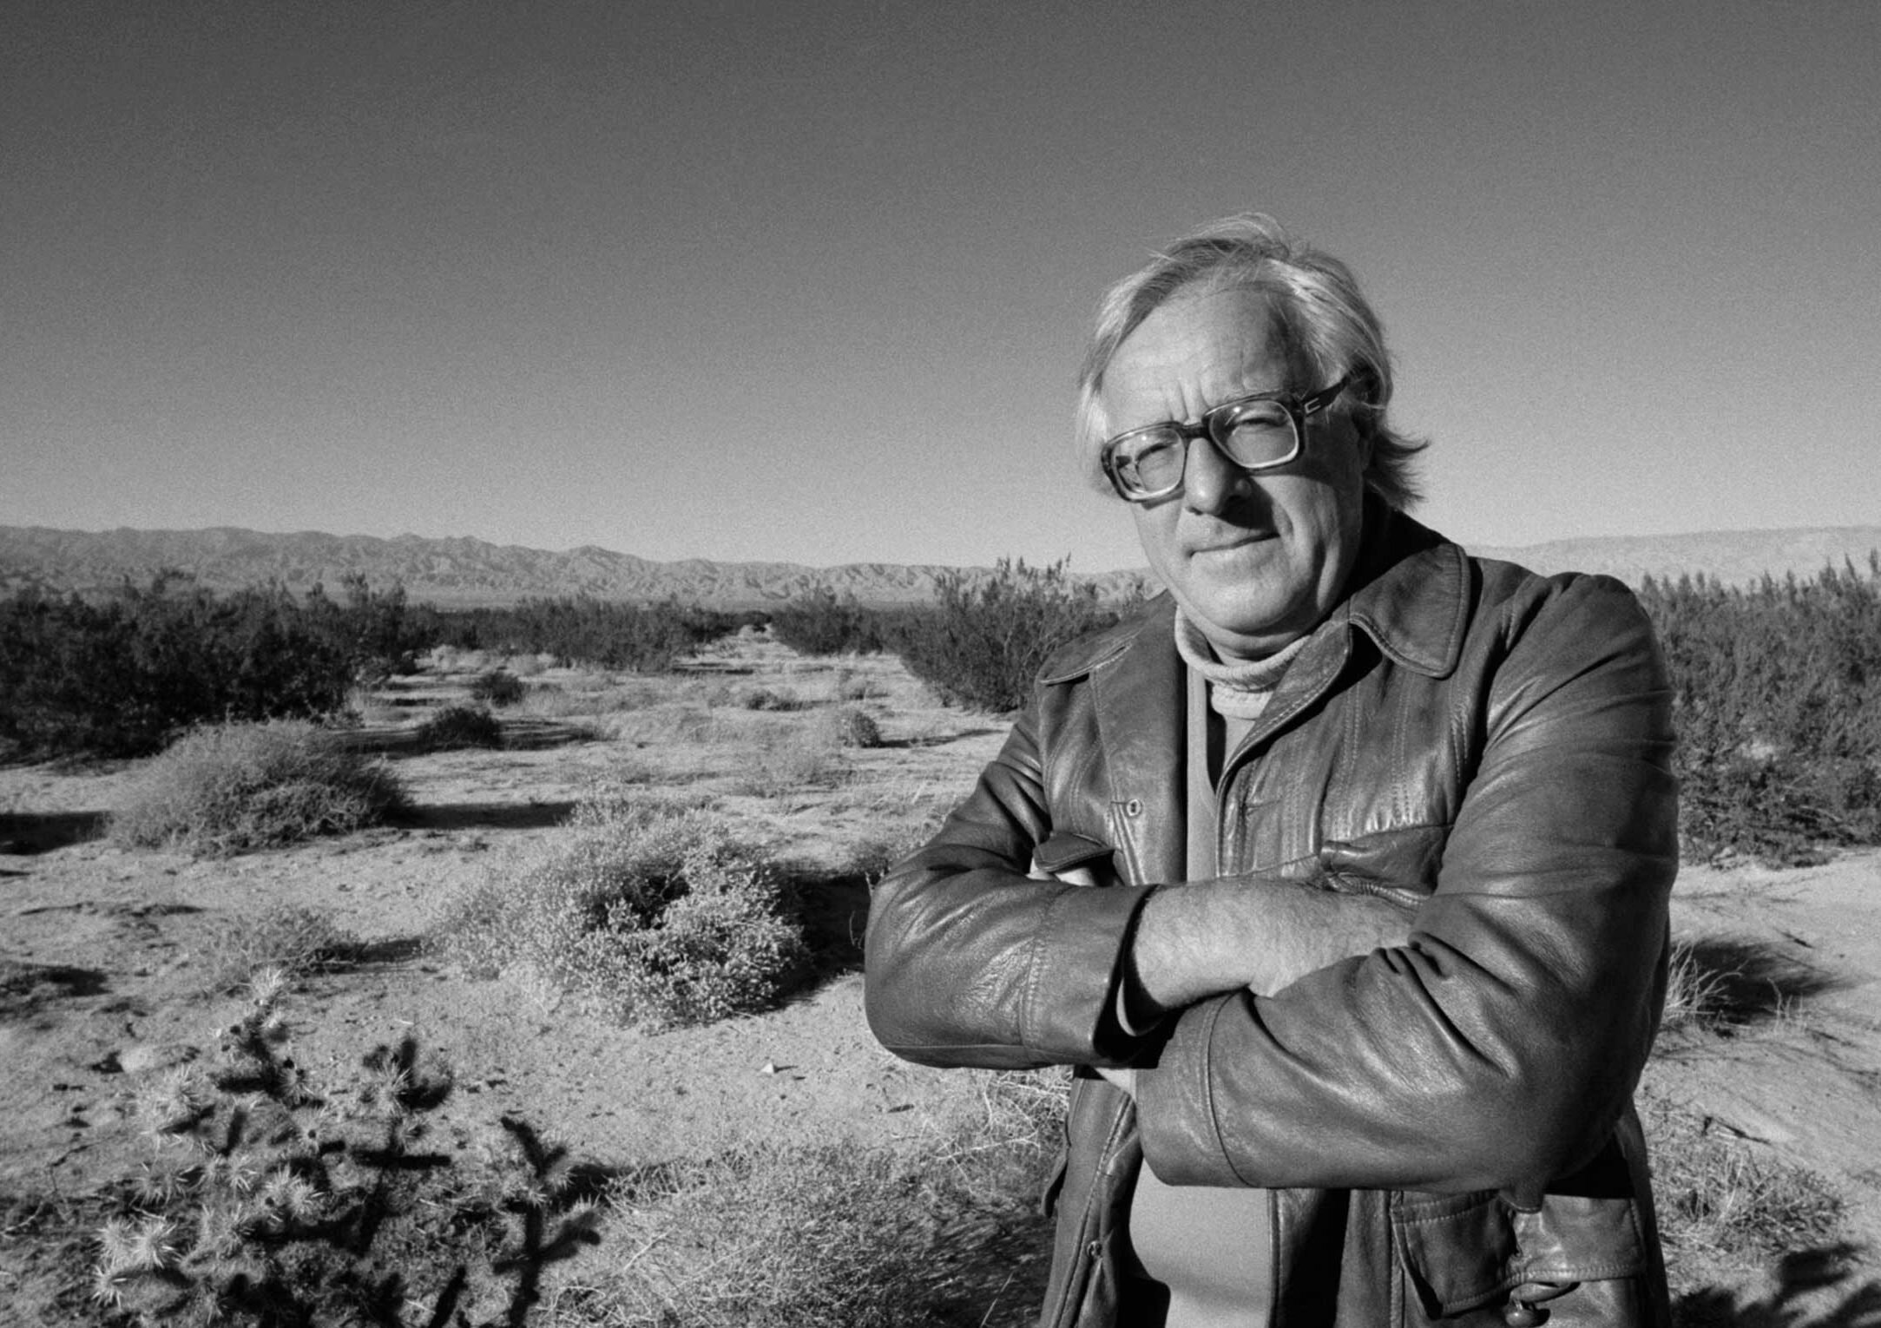

The Laurel and Hardy Love Affair, Ray Bradbury

The Laurel and Hardy Love Affair

He called her stanley, she called him ollie.

That was the beginning, that was the end, of what we will call the Laurel and Hardy love affair.

She was twenty-five, he was thirty-two when they met at one of those dumb cocktail parties where everyone wonders what they are doing there. But no one goes home, so everyone drinks too much and lies about how grand a late afternoon it all was.

They did not, as often happens, see each other across a crowded room, and if there was romantic music to background their collision, it couldn’t be heard. For everyone was talking at one person and staring at someone else.

They were, in fact, ricocheting through a forest of people, but finding no shade trees. He was on his way for a needed drink, she was eluding a love-sick stranger, when they locked paths in the exact center of the fruitless mob.

They dodged left and right a few times, then laughed and he, on impulse, seized his tie and twiddled it at her, wiggling his fingers. Instantly, smiling, she lifted her hand to pull the top of her hair into a frowzy tassel, blinking and looking as if she had been struck on the head.

“Stan!” he cried, in recognition.

“Ollie!” she exclaimed. “Where have you been?”

“Why don’t you do something to help me!” he exclaimed, making wide fat gestures.

They grabbed each other’s arms, laughing again.

“I—” she said, and her face brightened even more. “I—I know the exact place, not two miles from here, where Laurel and Hardy, in nineteen thirty, carried that piano crate up and down one hundred and fifty steps!”

“Well,” he cried, “let’s get out of here!”

His car door slammed, his car engine roared.

Los Angeles raced by in late afternoon sunlight.

He braked the car where she told him to park. “Here!”

“I can’t believe it,” he murmured, not moving. He peered around at the sunset sky. Lights were coming on all across Los Angeles, down the hill. He nodded. “Are those the steps?”

“All one hundred and fifty of them.” She climbed out of the open-topped car. “Come on, Ollie.”

“Very well,” he said, “Stan.”

They walked over to the bottom of yet another hill and gazed up along the steep incline of concrete steps toward the sky. The faintest touch of wetness rimmed his eyes. She was quick to pretend not to notice, but she took his elbow. Her voice was wonderfully quiet:

“Go on up,” she said. “Go on. Go.”

She gave him a tender push.

He started up the steps, counting, and with each half-whispered count, his voice took on an extra decibel of joy. By the time he reached fifty-seven he was a boy playing a wondrous old-new game, and he was lost in time, and whether he was carrying the piano up the hill or whether it was chasing him down, he could not say.

“Hold it!” he heard her call, far away, “right there!”

He held still, swaying on step fifty-eight, smiling wildly, as if accompanied by proper ghosts, and turned.

“Okay,” she called, “now come back down.”

He started down, color in his cheeks and a peculiar suffering of happiness in his chest. He could hear the piano following now.

“Hold it right there!”

She had a camera in her hands. Seeing it, his right hand flew instinctively to his tie to flutter it on the evening air.

“Now, me!” she shouted, and raced up to hand him the camera. And he marched down and looked up and there she was, doing the thin shrug and the puzzled and hopeless face of Stan baffled by life but loving it all. He clicked the shutter, wanting to stay here forever.

She came slowly down the steps and peered into his face.

“Why,” she said, “you’re crying.”

She placed her thumbs under his eyes to press the tears away. She tasted the result. “Yep,” she said. “Real tears.”

He looked at her eyes, which were almost as wet as his.

“Another fine mess you’ve got us in,” he said.

“Oh, Ollie,” she said.

“Oh, Stan,” he said.

He kissed her, gently.

And then he said:

“Are we going to know each other forever?”

“Forever,” she said.

And that was how the long love affair began.

They had real names, of course, but those don’t matter, for Laurel and Hardy always seemed the best thing to call themselves.

For the simple fact was that she was fifteen pounds underweight and he was always trying to get her to add a few pounds. And he was twenty pounds overweight and she was always trying to get him to take off more than his shoes. But it never worked and was finally a joke, the best kind, which wound up being:

“You’re Stan, no two ways about it, and I’m Ollie, let’s face it. And, oh God, dear young woman, let’s enjoy the mess, the wonderful mess, all the while we’re in!”

It was, then, while it lasted, and it lasted some while, a French parfait, an American perfection, a wildness from which they would never recover to the end of their lives.

From that twilight hour on the piano stairs on, their days were long, heedless, and full of that amazing laughter that paces the beginning and the run-along rush of any great love affair. They only stopped laughing long enough to kiss and only stopped kissing long enough to laugh at how odd and miraculous it was to find themselves with no clothes to wear in the middle of a bed as vast as life and as beautiful as morning.

And sitting there in the middle of warm whiteness, he shut his eyes and shook his head and declared, pompously:

“I have nothing to say!”

“Yes, you do!” she cried. “Say it!”

And he said it and they fell off the edge of the earth.

Their first year was pure myth and fable, which would grow outsize when remembered thirty years on. They went to see new films and old films, but mainly Stan and Ollie. They memorized all the best scenes and shouted them back and forth as they drove around midnight Los Angeles. He spoiled her by treating her childhood growing up in Hollywood as very special, and she spoiled him by pretending that his yesteryear on roller skates out front of the studios was not in the past but right now.

She proved it one night. On a whim she asked where he had roller-skated as a boy and collided with W. C. Fields. Where had he asked Fields for his autograph, and where was it that Fields signed the book, handed it back, and cried, “There you are, you little son-of-a-bitch!”

“Drive me there,” she said.

And at ten o’clock that night they got out of the car in front of Paramount Studio and he pointed to the pavement near the gate and said, “He stood there,” and she gathered him in her arms and kissed him and said, gently, “Now where was it you had your picture taken with Marlene Dietrich?”

He walked her fifty feet across the street from the studio. “In the late afternoon sun,” he said, “Marlene stood here.” And she kissed him again, longer this time, and the moon rising like an obvious magic trick, filling the street in front of the empty studio. She let her soul flow over into him like a tipped fountain, and he received it and gave it back and was glad.

“Now,” she said, quietly, “where was it you saw Fred Astaire in nineteen thirty-five and Ronald Colman in nineteen thirty-seven and Jean Harlow in nineteen thirty-six?”

And he drove her to those three different places all around Hollywood until midnight and they stood and she kissed him as if it would never end.

And that was the first year. And during that year they went up and down those long piano steps at least once a month and had champagne picnics halfway up, and discovered an incredible thing:

“I think it’s our mouths,” he said. “Until I met you, I never knew I had a mouth. Yours is the most amazing in the world, and it makes me feel as if mine were amazing, too. Were you ever really kissed before I kissed you?”

“Never!”

“Nor was I. To have lived this long and not known mouths.”

“Dear mouth,” she said, “shut up and kiss.”

But then at the end of the first year they discovered an even more incredible thing. He worked at an advertising agency and was nailed in one place. She worked at a travel agency and would soon be flying everywhere. Both were astonished they had never noticed before. But now that Vesuvius had erupted and the fiery dust was beginning to settle, they sat and looked at each other one night and she said, faintly:

“Good-bye . . .”

“What?” he asked.

“I can see good-bye coming,” she said.

He looked at her face and it was not sad like Stan in the films, but just sad like herself.

“I feel like the ending of that Hemingway novel where two people ride along in the late day and say how it would be if they could go on forever but they know now they won’t,” she said.

“Stan,” he said, “this is no Hemingway novel and this can’t be the end of the world. You’ll never leave me.”

But it was a question, not a declaration and suddenly she moved and he blinked at her and said:

“What are you doing down there?”

“Nut,” she said, “I’m kneeling on the floor and I’m asking for your hand. Marry me, Ollie. Come away with me to France. I’ve got a new job in Paris. No, don’t say anything. Shut up. No one has to know I’ve got the money this year and will support you while you write the great American novel—”

“But—” he said.

“You’ve got your portable typewriter, a ream of paper, and me. Say it, Ollie, will you come? Hell, don’t marry me, we’ll live in sin, but fly with me, yes?”

“And watch us go to hell in a year and bury us forever?”

“Are you that afraid, Ollie? Don’t you believe in me or you or anything? God, why are men such cowards, and why the hell do you have such thin skins and are afraid of a woman like a ladder to lean on. Listen, I’ve got things to do and you’re coming with me.

I can’t leave you here, you’ll fall down those damn stairs. But if I have to, I will. I want everything now, not tomorrow. That means you, Paris, and my job. Your novel will take time, but you’ll do it. Now, do you do it here and feel sorry for yourself, or do we live in a cold-water walk-up flat in the Latin Quarter a long way off from here?

This is my one and only offer, Ollie. I’ve never proposed before, I won’t ever propose again, it’s hard on my knees. Well?”

“Have we had this conversation before?” he said.

“A dozen times in the last year, but you never listened, you were hopeless.”

“No, in love and helpless.”

“You’ve got one minute to make up your mind. Sixty seconds.” She was staring at her wristwatch.

“Get up off the floor,” he said, embarrassed.

“If I do, it’s out the door and gone,” she said. “Forty-nine seconds to go, Ollie.”

“Stan,” he groaned.

“Thirty,” she read her watch. “Twenty. I’ve got one knee off the floor. Ten. I’m beginning to get the other knee up. Five. One.”

And she was standing on her feet.

“What brought this on?” he asked.

“Now,” she said, “I am heading for the door. I don’t know. Maybe I’ve thought about it more than I dared even notice. We are very special wondrous people, Ollie, and I don’t think our like will ever come again in the world, at least not to us, or I’m lying to myself and I probably am. But I must go and you are free to come along, but can’t face it or don’t know it. And now—” she reached out. “My hand is on the door and—”

“And?” he said, quietly.

“I’m crying,” she said.

He started to get up but she shook her head.

“No, don’t. If you touch me I’ll cave in, and to hell with that. I’m going. But once a year will be forbearance day, or forgiveness day or whatever in hell you want to call it. Once a year I’ll show up at our flight of steps, no piano, same hour, same time as that night when we first went there and if you’re there to meet me I’ll kidnap you or you me, but don’t bring along and show me your damn bank balance or give me any of your lip.”

“Stan,” he said.

“My God,” she mourned.

“What?”

“This door is heavy. I can’t move it.” She wept. “There. It’s moving. There.” She wept more. “I’m gone.”

The door shut.

“Stan!” He ran to the door and grabbed the knob. It was wet. He raised his fingers to his mouth and tasted the salt, then opened the door.

The hall was already empty. The air where she had passed was just coming back together. Thunder threatened when the two halves met. There was a promise of rain.

He went back to the steps on October 4 every year for three years, but she wasn’t there. And then he forgot for two years but in the autumn of the sixth year, he remembered and went back in the late sunlight and walked up the stairs because he saw something halfway up and it was a bottle of good champagne with a ribbon and a note on it, delivered by someone, and the note read:

“Ollie, dear Ollie. Date remembered. But in Paris. Mouth’s not the same, but happily married. Love. Stan.”

And after that, every October he simply did not go to visit the stairs. The sound of that piano rushing down that hillside, he knew, would catch him and take him along to where he did not know.

And that was the end, or almost the end, of the Laurel and Hardy love affair.

There was, by amiable accident, a final meeting.

Traveling through France fifteen years later, he was walking on the Champs Elysées at twilight one afternoon with his wife and two daughters, when he saw this handsome woman coming the other way, escorted by a very sober-looking older man and a very handsome dark-haired boy of twelve, obviously her son.

As they passed, the same smile lit both their faces in the same instant.

He twiddled his necktie at her.

She tousled her hair at him.

They did not stop. They kept going. But he heard her call back along the Champs Elysées, the last words he would ever hear her say:

“Another fine mess you’ve got us in!” And then she added the old, the familiar name by which he had gone in the years of their love.

And she was gone and his daughters and wife looked at him and one daughter said, “Did that lady call you Ollie?”

“What lady?” he said.

“Dad,” said the other daughter, leaning in to peer at his face. “You’re crying.”

“No.”

“Yes, you are. Isn’t he, Mom?”

“Your papa,” said his wife, “as you well know, cries at telephone books.”

“No,” he said, “just one hundred and fifty steps and a piano. Remind me to show you girls, someday.”

They walked on and he turned and looked back a final time. The woman with her husband and son turned at that very moment. Maybe he saw her mouth pantomime the words, So long, Ollie. Maybe he didn’t. He felt his own mouth move, in silence: So long, Stan.

And they walked in opposite directions along the Champs Elysées in the late light of an October sun.

The End