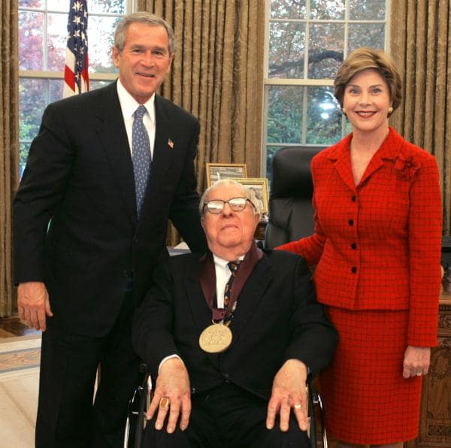

The Library, Ray Bradbury

The Library

The people poured into the room. health officials reeking of disinfectant, sprinklers in their hands. Police officials, fierce with blazing badges. Men with metal torches and roach exterminators, piling one on another, murmuring, shouting, bending, pointing. The books came down in avalanched thunders. The books were torn and rent and splintered like beams. Whole towns and towers of books collapsed and shattered.

Axes beat at the windows, drapes fell in black sooty clouds of dust. Outside the door, the boy with the golden eyes looked in, stood silently, draped in his robin’s egg sari, his rocket father and plastics mother behind him.

The health official pronounced pronunciations. A doctor bent. “He’s dying,” was said, faintly, in the din. Antiseptic men lifted him on a stretcher, carried him through the collapsing room. Books were being piled into a portable incinerator; they were crackling and leaping and burning and twisting and vanishing into paper flame.

“No! No!” screamed A. “Don’t do it! The last ones in the world! The last ones!”

“Yes, yes,” soothed the health official mechanically.

“If you burn them, burn them, there are no other copies!”

“We know, we know. The law, the law,” said the health official.

“Fools, idiots, dolts! Stop!”

The books climbed and stoned down into baskets which were carried out. There was the brisk suction of a vacuum cleaner.

“And when the books are burned, the last books”—A. was weakening—“then there will be only myself, and the memories in my mind. And when I die, then it will all be gone. All of it gone forever. All of us gone. All us dark nights and Halloweens and white bone masks and closeted skeletons, all the Bierces and the Poes, Anubis and Set and the Niebelungen, the Machens and the Lovecrafts and the Frankensteins and the black vampire bats hovering, the Draculas and the Golems, gone, all gone.”

“We know, gone, gone,” whispered the official.

He shut his eyes. “Gone. Gone. Tear my books, burn my books, cleanse, rip, clean away. Unearth the coffins, incinerate, do away with. Kill us, oh, kill us, for we are bleak castles on midnight mornings, we are blowing wind webs and scuttling spiders, and we are doors that swing unoiled and banging shutters banging, and we are darknesses so vast that ten million nights of darkness are held in one braincell. We are buried hearts in murdered bedrooms, hearts glowing under floorboards. We are clanking chains and gossamer veils, and vapors of enchanted and long dead and lovely ladies on grand castle stairs, float, afloat, windy and whispering and wailing.

We are the Monkey’s Paw, and the catacomb and the gurgling Amontillado bottle and the mortared brick, and the three wishes. We are the caped figure, the glass eye, the bloodied mouth, the sharp fang, the veined wing, the autumn leaf in the cold black sky, the wolf shining its white rimed morning pelt, we are the old days that come not again upon the earth, we are the red wild eye and the sudden instrument of knife or gun. We are all things violent and black. We are winds that keen and sad snows falling. We are October, burning down the lands into fused ruin, all flame, all blue and melancholy smoke. We are deep frozen winter. We are monumented mound yard, we are the chiseled marble name and the birth and death years. We are the tapping awake coffin and we are the scream in the night.”

“Yes, yes,” whispered the official.

“Carry me away, burn me up, let flames take me. Put me in a catacomb of books, brick me in with books, mortar me up with books and burn the whole of us together.”

“Rest easily,” whispered the official. “I’m dying,” said Mr. A.

“No, no.”

“Yes, I am. You’re carrying me.”

The stretcher was moving. His heart paled within him, fainter, fainter. “Dying. In a moment now—dead.”

“Rest, please.”

“All of it gone, forever, and nobody to know it ever lived, the dark nights, Poe, Bierce, the rest of us. Gone, all gone.”

“Yes,” said the official in the moving dark.

There was a crackle of flame. They were burning out the room scientifically, with controlled fire. There was a vast blowing wind of flame that tore away the interior of darkness. He could see the books explode like so many kernels of dark corn.

“For the love of God, Montresor!”

The sedge withered, the vast ancient lawn of the room sizzled and flumed.

“Yes, for the love of God,” murmured the official.

“A very good joke indeed—an excellent jest! We will have many a rich laugh about it at the palazzo—over our wine! Let us be gone—”

In the dimness, the health official: “Yes. Let us be gone.”

A. fell down in soft blackness. All black, all gone. He heard his own dry lips repeat, repeat the only thing thought of to repeat as he felt his old heart cease and grow cold within him:

“Requiescat in pace.”

He dreamed that he was walling himself in with bricks and more bricks of books.

For the love of god, Montresor!

Yes, for the love of God!

HE WENT DOWN into the soft blackness, and before it was all black and all gone he heard his own dry lips repeating and repeating the only thing he could think of to repeat as he felt his heart cease and desist within him.

“Requiescat in pace.”

The End