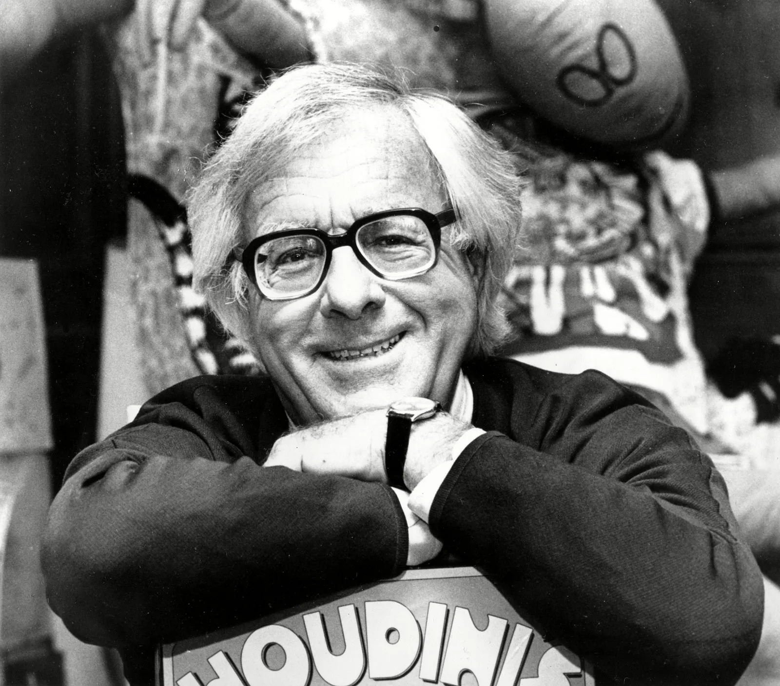

The Long Rain, Ray Bradbury

The Long Rain

The rain continued. It was a hard rain, a perpetual rain, a sweating and steaming rain; it was a mizzle, a downpour, a fountain, a whipping at the eyes, an undertow at the ankles; it was a rain to drown all rains and the memory of rains.

It came by the pound and the ton, it hacked at the jungle and cut the trees like scissors and shaved the grass and tunneled the soil and molted the bushes. It shrank men's hands into the hands of wrinkled apes; it rained a solid glassy rain, and it never stopped.

"How much farther, Lieutenant?"

"I don't know. A mile, ten miles, a thousand."

"Aren't you sure?"

"How can I be sure?"

"I don't like this rain. If we only knew how far it is to the Sun Dome, I'd feel better."

"Another hour or two from here."

"You really think so, Lieutenant?"

"Of course."

"Or are you lying to keep us happy?"

"I'm lying to keep you happy. Shut up!"

The two men sat together in the rain. Behind them sat two other men who were wet and tired and slumped like clay that was melting.

The lieutenant looked up. He had a face that once had been brown and now the rain had washed it pale, and the rain had washed the color from his eyes and they were white, as were his teeth, and as was his hair. He was all white. Even his uniform was beginning to turn white, and perhaps a little green with fungus.

The lieutenant felt the rain on his cheeks. "How many million years since the rain stopped raining here on Venus?"

"Don't be crazy," said one of the two other men. "It never stops raining on Venus. It just goes on and on. I've lived here for ten years and I never saw a minute, or even a second, when it wasn't pouring."

"It's like living under water," said the lieutenant, and rose up, shrugging his guns into place. "Well, we'd better get going. We'll find that Sun Dome yet."

"Or we won't find it," said the cynic.

"It's an hour or so."

"Now you're lying to me, Lieutenant."

"No, now I'm lying to myself. This is one of those times when you've got to lie. I can't take much more of this."

They walked down the jungle trail, now and then looking at their compasses. There was no direction anywhere, only what the compass said. There was a gray sky and rain falling and jungle and a path, and, far back behind them somewhere, a rocket in which they had ridden and fallen. A rocket in which lay two of their friends, dead and dripping rain.

They walked in single file, not speaking. They came to a river which lay wide and flat and brown, flowing down to the great Single Sea. The surface of it was stippled in a billion places by the rain.

"All right, Simmons."

The lieutenant nodded and Simmons took a small packet from his back which, with a pressure of hidden chemical, inflated into a large boat. The lieutenant directed the cutting of wood and the quick making of paddles and they set out into the river, paddling swiftly across the smooth surface in the rain.

The lieutenant felt the cold rain on his cheeks and on his neck and on his moving arms. The cold was beginning to seep into his lungs. He felt the rain on his ears, on his eyes, on his legs.

"I didn't sleep last night," he said.

"Who could? Who has? When? How many nights have we slept? Thirty nights, thirty days! Who can sleep with rain slamming their head, banging away. . . . I'd give anything for a hat. Anything at all, just so it wouldn't hit my head any more. I get headaches. My head is sore; it hurts all the time."

"I'm sorry I came to China," said one of the others.

"First time I ever heard Venus called China."

"Sure, China. Chinese water cure. Remember the old torture? Rope you against a wall. Drop one drop of water on your head every half-hour. You go crazy waiting for the next one. Well, that's Venus, but on a big scale.

We're not made for water. You can't sleep, you can't breathe right, and you're crazy from just being soggy. If we'd been ready for a crash, we'd have brought waterproofed uniforms and hats. It's this beating rain on your head gets you, most of all. It's so heavy. It's like BB shot. I don't know how long I can take it."

"Boy, me for the Sun Dome! The man who thoughtthemup, thought of something."

They crossed the river, and in crossing they thought of the Sun Dome, somewhere ahead of them, shining in the jungle rain. A yellow house, round and bright as the sun. A house forty feet high by one hundred feet in diameter, in which was warmth and quiet and hot food and freedom from rain. And in the center of the Sun Dome, of course, was a sun.

A small floating free globe of yellow fire, drifting in a space at the top of the building where you could look at it from where you sat, smoking or reading a book or drinking your hot chocolate crowned with marshmallow dollops or drinking something else. There it would be, the yellow sun, just the size of the Earth sun, and it was warm and continuous, and the rain world of Venus would be forgotten as long as you stayed in that house and idled your time.

The lieutenant turned and looked back at the three men using their oars and gritting their teeth. They were as white as mushrooms, as white as he was. Venus bleached everything away in a few months.

Even the jungle was an immense cartoon nightmare, for how could the jungle be green with no sun, with always rain falling and always dusk? The white, white jungle with the pale cheese-colored leaves, and the earth carved of wet Camembert, and the tree boles like immense toadstools — everything black and white. And how often could you see the soil itself? Wasn't it mostly a creek, a stream, a puddle, a pool, a lake, a river, and then, at last, the sea?

"Here we are!"

They leaped out on the farthest shore, splashing and sending up showers. The boat was deflated and stored in a cigar-box packet. Then, standing on the rainy shore, they tried to light up a few smokes for themselves, and it was five minutes or so before, shuddering, they worked the inverted lighter and, cupping their hands, managed a few drags upon cigarettes that all too quickly were limp and beaten away from their lips by a sudden slap of rain.

They walked on.

"Wait just a moment," said the lieutenant "I thought I saw something ahead."

"The Sun Dome?"

"I'm not sure. The rain closed in again."

Simmons began to run. "The Sun Dome!"

"Come back, Simmons!"

"The Sun Dome!"

Simmons vanished in the rain. The others ran after him.

They found him in a little clearing, and they stopped and looked at him and what he had discovered.

The rocket ship.

It was lying where they had left it. Somehow they had circled back and were where they had started. In the ruin of the ship green fungus was growing up out of the mouths of the two dead men. As they watched, the fungus took flower, the petals broke away in the rain, and the fungus died.

"How did we do it?"

"An electrical storm must be nearby. Threw our compasses off. That explains it."

"You're right."

"What'll we do now?"

"Start out again."

"Good Lord, we're not any closer to anywhere!"

"Let's try to keep calm about it, Simmons."

"Calm, calm! This rain's driving me wild!"

"We've enough food for another two days if we're careful."

The rain danced on their skin, on their wet uniforms;- the rain streamed from their noses and ears, from their fingers and knees. They looked like stone fountains frozen in the jungle, issuing forth water from every pore.

And, as they stood, from a distance they heard a roar.

And the monster came out of the rain.

The monster was supported upon a thousand electric blue legs. It walked swiftly and terribly. It struck down a leg with a driving blow. Everywhere a leg struck a tree fell and burned. Great whiffs of ozone filled the rainy air, and smoke blew away and was broken up by the rain. The monster was a half mile wide and a mile high and it felt of the ground like a great blind thing. Sometimes, for a moment, it had no legs at all. And then, in an instant, a thousand whips would fall out of its belly, white-blue whips, to sting the jungle.

"There's the electrical storm," said one of the men. "There's the thing ruined our compasses. And it's coming this way."

"Lie down, everyone," said the lieutenant.

"Run!" cried Simmons.

"Don't be a fool. Lie down. It hits the highest points. We may get through unhurt. Lie down about fifty feet from the rocket. It may very well spend its force there and leave us be. Get down!"

The men flopped.

"Is it coming?" they asked each other, after a moment.

"Coming."

"Is it nearer?"

"Two hundred yards off."

"Nearer?"

"Here she is!"

The monster came and stood over them. It dropped down ten blue bolts of lightning which struck the rocket. The rocket flashed like a beaten gong and gave off a metal ringing. The monster let down fifteen more bolts which danced about in a ridiculous pantomime, feeling of the jungle and the watery soil.

"No, no!" One of the men jumped up.

"Get down, you fool!" said the lieutenant.

"No!"

The lightning struck the rocket another dozen times. The lieutenant turned his head on his arm and saw the blue blazing flashes. He saw trees split and crumple into ruin. He saw the monstrous dark cloud turn like a black disk overhead and hurl down a hundred other poles of electricity.

The man who had leaped up was now running, like someone in a great hall of pillars. He ran and dodged between the pillars and then at last a dozen of the pillars slammed down and there was the sound a fly makes when landing upon the grill wires of an exterminator. The lieutenant remembered this from his childhood on a farm. And there was a smell of a man burned to a cinder.

The lieutenant lowered his head. "Don't look up," he told the others. He was afraid that he too might run at any moment.

The storm above them flashed down another series of bolts and then moved on away. Once again there was only the rain, which rapidly cleared the air of the charred smell, and in a moment the three remaining men were sitting and waiting for the beat of their hearts to subside into quiet once more.

They walked over to the body, thinking that perhaps they could still save the man's life. They couldn't believe that there wasn't some way to help the man. It was the natural act of men who have not accepted death until they have touched it and turned it over and made plans to bury it or leave it there for the jungle to bury in an hour of quick growth.

The body was twisted steel, wrapped in burned leather. It looked like a wax dummy that had been thrown into an incinerator and pulled out after the wax had sunk to the charcoal skeleton. Only the teeth were white, and they shone like a strange white bracelet dropped half through a clenched black fist.

"He shouldn't have jumped up." They said it almost at the same time.

Even as they stood over the body it began to vanish, for the vegetation was edging in upon it, little vines and ivy and creepers, and even flowers for the dead.

At a distance the storm walked off on blue bolts of lightning and was gone.

They crossed a river and a creek and a stream and a dozen other rivers and creeks and streams. Before their eyes rivers appeared, rushing, new rivers, while old rivers changed their courses — rivers the color of mercury, rivers the color of silver and milk.

They came to the sea.

The Single Sea. There was only one continent on Venus. This land was three thousand miles long by a thousand miles wide, and about this island was the Single Sea, which covered the entire raining planet. The Single Sea, which lay upon the pallid shore with little motion . . .

"This way." The lieutenant nodded south. "I'm sure there are two Sun Domes down that way."

"While they were at it, why didn't they build a hundred more?"

"There're a hundred and twenty of them now, aren't there?"

"One hundred and twenty-six, as of last month. They tried to push a bill through Congress back on Earth a year ago to provide for a couple dozen more, but oh no, you know howthatis. They'd rather a few men went crazy with the rain."

They started south.

The lieutenant and Simmons and the third man, Pickard, walked in the rain, in the rain that fell heavily and lightly, heavily and lightly; in the rain that poured and hammered and did not stop falling upon the land and the sea and the walking people.

Simmons saw it first. "There it is!"

"There's what?"

"The Sun Dome!"

The lieutenant blinked the water from his eyes and raised his hands to ward off the stinging blows of the rain.

At a distance there was a yellow glow on the edge of the jungle, by the sea. It was, indeed, the Sun Dome.

The men smiled at each other.

"Looks like you were right, Lieutenant."

"Luck."

"Brother, that puts muscle in me, just seeing it. Come on!" Simmons began to trot. The others automatically fell in with this, gasping, tired, but keeping pace.

"A big pot of coffee for me," panted Simmons, smiling. "And a pan of cinnamon buns. Boy! And just lie there and let the old sun hit you. The guy that invented the Sun Domes, he should have got a medal!"

They ran faster. The yellow glow grew brighter.

"Guess a lot of men went crazy before they figured out the cure. Think it'd be obvious! Right off." Simmons panted the words in cadence to his running. "Rain, rain! Years ago. Found a friend. Of mine. Out in the jungle. Wandering around. In the rain. Saying over and over, 'Don't know enough, to come in, outta the rain. Don't know enough, to come in, outta the rain. Don't know enough — ' On and on. Like that. Poor crazy fool."

"Save your breath!"

They ran.

They all laughed. They reached the door of the Sun Dome, laughing.

Simmons yanked the door wide. "Hey!" he yelled. "Bring on the coffee!"

There was no reply.

They stepped through the door.

The Sun Dome was empty and dark. There was no synthetic yellow sun floating in a high gaseous whisper at the center of the blue ceiling. There was no food waiting. It was cold as a vault.

And through a thousand holes which had been newly punctured in the ceiling water streamed, the rain fell down, soaking into the thick rugs and the heavy modern furniture and splashing on the glass tables. The jungle was growing up like a moss in the room, on top of the bookcases and the divans. The rain slashed through the holes and fell upon the three men's faces.

Pickard began to laugh quietly.

"Shut up, Pickard!"

"Ye gods, look what's here for us — no food, no sun, nothing. The Venusians — they did it! Of course!"

Simmons nodded, with the rain tunneling down on his face. The water ran in his silvered hair and on his white eyebrows.

"Every once in a while the Venusians come up out of the sea and attack a Sun Dome. They know if they ruin the Sun Domes they can ruin us."

"But aren't the Sun Domes protected with guns?"

"Sure." Simmons stepped aside to a place that was relatively dry. "But it's been five years since the Venusians tried anything. Defense relaxes. They caught this Dome unaware."

"Where are the bodies?"

"The Venusians took them all down into the sea. I hear they have a delightful way of drowning you. It takes about eight hours to drown the way they work it. Really delightful."

"I bet there isn't any food here at all." Pickard laughed.

The lieutenant frowned at him, nodded at him so Simmons could see. Simmons shook his head and went back to a room at one side of the oval chamber. The kitchen was strewn with soggy loaves of bread, and meat that had grown a faint green fur. Rain came through a hundred holes in the kitchen roof.

"Brilliant." The lieutenant glanced up at the holes. "I don't suppose we can plug up all those holes and get snug here."

"Without food, sir?" Simmons snorted. "I notice the sun machine's dismantled. Our best bet is to make our way to the next Sun Dome. How far is that from here?"

"Not far. As I recall, they built two rather close together here. Perhaps if we waited, a rescue mission from the other might — "

"It's probably been here and gone already, some days ago. They'll send a crew to repair this place in about six months, when they get the money from Congress. I don't think we'd better wait."

"All right then, we'll eat what's left of our rations and get on to the next Dome."

Pickard said, "If only the rain wouldn't hit my head, just for a few minutes. If I could only remember what it's like not to be bothered." He put his hands on his skull and held it tight. "I remember when I was in school a bully used to sit in back of me and pinch me and pinch me and pinch me every five minutes, all day long. He did that for weeks and months. My arms were sore and black and blue all the time.

And I thought I'd go crazy from being pinched. One day I must have gone a little mad from being hurt and hurt, and I turned around and took a metal trisquare I used in mechanical drawing and I almost cut his lousy head off.

I almost scalped him before they dragged me out of the room, and I kept yelling, 'Why don't he leave me alone? Why don't he leave me alone?' Brother!" His hands clenched the bone of his head, shaking, tightening, his eyes shut. "But what do I donow? Who do I hit, who do I tell to lay off, stop bothering me, this damn rain, like the pinching, alwaysonyou, that's all you hear, that's all you feel!"

"We'll be at the other Sun Dome by four this afternoon."

"Sun Dome? Look at this one! What if all the Sun Domes on Venus are gone? What then? What if there are holes in all the ceilings, and the rain coming in!"

"We'll have to chance it."

"I'm tired of chancing it. All I want is a roof and some quiet. I want to be alone."

"That's only eight hours off, if you hold on."

"Don't worry, I'll hold on all right." And Pickard laughed, not looking at them.

"Let's eat," said Simmons, watching him.

They set off down the coast, southward again. After four hours they had to cut inland to go around a river that was a mile wide and so swift it was not navigable by boat. They had to walk inland six miles to a place where the river boiled out of the earth, suddenly, like a mortal wound. In the rain, they walked on solid ground and returned to the sea.

"I've got to sleep," said Pickard at last. He slumped. "Haven't slept in four weeks. Tried, but couldn't. Sleep here."

The sky was getting darker. The night of Venus was setting in and it was so completely black that it was dangerous to move. Simmons and the lieutenant fell to their knees also, and the lieutenant said, "All right, we'll see what we can do. We've tried it before, but I don't know. Sleep doesn't seem one of the things you can get in this weather."

They lay out full, propping their heads so the water wouldn't come to their mouths, and they closed their eyes.

The lieutenant twitched.

He did not sleep.

There were things that crawled on his skin. Things grew upon him in layers. Drops fell and touched other drops and they became streams that trickled over his body, and while these moved down his flesh, the small growths of the forest took root in his clothing.

He felt the ivy cling and make a second garment over him; he felt the small flowers bud and open and petal away, and still the rain pattered on his body and on his head.

In the luminous night — for the vegetation glowed in the darkness — he could see the other two men outlined, like logs that had fallen and taken upon themselves velvet coverings of grass and flowers.

The rain hit his face. He covered his face with his hands. The rain hit his neck. He turned over on his stomach in the mud, on the rubbery plants, and the rain hit his back and hit his legs.

Suddenly he leaped up and began to brush the water from himself. A thousand hands were touching him and he no longer wanted to be touched. He no longer could stand being touched.

He floundered and struck something else and knew that it was Simmons, standing up in the rain, sneezing moisture, coughing and choking. And then Pickard was up, shouting, running about.

"Wait a minute, Pickard!"

"Stop it, stop it!" Pickard screamed. He fired off his gun six times at the night sky. In the flashes of powdery illumination they could see armies of raindrops, suspended as in a vast motionless amber, for an instant, hesitating as if shocked by the explosion, fifteen billion droplets, fifteen billion tears, fifteen billion ornaments, jewels standing out against a white velvet viewing board.

And then, with the light gone, the drops which had waited to have their pictures taken, which had suspended their downward rush, fell upon them, stinging, in an insect cloud of coldness and pain.

"Stop it! Stop it!"

"Pickard!"

But Pickard was only standing now, alone. When the lieutenant switched on a small hand lamp and played it over Pickard's wet face, the eyes of the man were dilated, and his mouth was open, his face turned up, so the water hit and splashed on his tongue, and hit and drowned the wide eyes, and bubbled in a whispering froth on the nostrils.

"Pickard!"

The man would not reply. He simply stood there for a long while with the bubbles of rain breaking out in his whitened hair and manacles of rain jewels dripping from his wrists and his neck.

"Pickard! We're leaving. We're going on. Follow us."

The rain dripped from Pickard's ears.

"Do you hear me, Pickard!"

It was like shouting down a well.

"Pickard!"

"Leave him alone," said Simmons.

"We can't go on without him."

"What'll we do, carry him?" Simmons spat. "He's no goodtous or himself. You know what he'll do? He'll just stand here and drown."

"What?"

"You ought to know that by now. Don't you know the story? He'll just stand here with his head up and let the rain come in his nostrils and his mouth. He'll breathe the water."

"No."

"That's how they found General Mendt that time. Sitting on a rock with his head back, breathing the rain. His lungs were full of water."

The lieutenant turned the light back to the unblinking face. Pickard's nostrils gave off a tiny whispering wet sound.

"Pickard!" The lieutenant slapped the face.

"He can't even feel you," said Simmons. "A few days in this rain and you don't have any face or any legs or hands."

The lieutenant looked at his own hand in horror. He could no longer feel it.

"But we can't leave Pickard here."

"I'll show you what we can do." Simmons fired his gun.

Pickard fell into the raining earth.

Simmons said, "Don't move, Lieutenant. I've got my gun ready for you too. Think it over; he would only have stood or sat there and drowned. It's quicker this way."

The lieutenant blinked at the body. "But you killed him."

"Yes, because he'd have killed us by being a burden. You saw his face. Insane."

After a moment the lieutenant nodded.

They walked off into the rain.

It was dark and their hand lamps threw a beam that pierced the rain for only a few feet. After a half hour they had to stop and sit through the rest of the night, aching with hunger, waiting for the dawn to come; when it did come it was gray and continually raining as before, and they began to walk again.

"We've miscalculated," said Simmons.

"No. Another hour."

"Speak louder. I can't hear you." Simmons stopped and smiled. He touched his ears. "My ears. They've gone out on me. All the rain pouring finally numbed me right down to the bone."

"Can't you hear anything?" said the lieutenant.

"What?" Simmons' eyes were puzzled.

"Nothing. Come on."

"I think I'll wait here. You go on ahead."

"You can't do that."

"I can't hear you. You go on. I'm tired. I don't think the Sun Dome is down this way. And, if it is, it's probably got holes in the roof, like the last one. I think I'll just sit here."

"Get up from there!"

"So long. Lieutenant."

"You can't give up now."

"I've got a gun here that says I'm staying. I just don't care any more. I'm not crazy yet, but I'm the next thing to it. I don't want to go out that way. As soon as you get out of sight I'm going to use this gun on myself."

"Simmons!"

"You said my name. I can read that much off your lips."

"Simmons."

"Look, it's a matter of time. Either I die now or in a few hours. Wait'll you get to that next Dome, if you ever get there, and find rain coming in through the roof. Won't that be nice?"

The lieutenant waited and then splashed off in the rain.

He turned and called back once, but Simmons was only sitting there with the gun in his hands, waiting for him to get out of sight. He shook his head and waved the lieutenant on.

The lieutenant didn't even hear the sound of the gun.

He began to eat the flowers as he walked. They stayed down for a time, and weren't poisonous; neither were they particularly sustaining, and he vomited them up, sickly, a minute or so later.

Once he took some leaves and tried to make himself a hat, but he had tried that before; the rain melted the leaves from his head. Once picked, the vegetation rotted quickly and fell away into gray masses in his fingers.

"Another five minutes," he told himself. "Another five minutes and then I'll walk into the sea and keep walking. We weren't made for this; no Earthman was or ever will be able to take it. Your nerves, your nerves."

He floundered his way through a sea of slush and foliage and came to a small hill.

At a distance there was a faint yellow smudge in the cold veils of water.

The next Sun Dome.

Through the trees, a long round yellow building, far away. For a moment he only stood, swaying, looking at it.

He began to run and then he slowed down, for he was afraid. He didn't call out. What if it's the same one? What if it's the dead Sun Dome, with no sun in it? he thought.

He slipped and fell. Lie here, he thought; it's the wrong one. Lie here. It's no use. Drink all you want.

But he managed to climb to his feet again and crossed several creeks, and the yellow light grew very bright, and he began to run again, his feet crashing into mirrors and glass, his arms flailing at diamonds and precious stones.

He stood before the yellow door. The printed letters over it said the sun dome . He put his numb hand up to feel it. Then he twisted the doorknob and stumbled in.

He stood for a moment looking about. Behind him the rain whirled at the door. Ahead of him, upon a low table, stood a silver pot of hot chocolate, steaming, and a cup, full, with a marshmallow in it.

And beside that, on another tray, stood thick sandwiches of rich chicken meat and fresh-cut tomatoes and green onions. And on a rod just before his eyes was a great thick green Turkish towel, and a bin in which to throw wet clothes, and, to his right, a small cubicle in which heat rays might dry you instantly.

And upon a chair, a fresh change of uniform, waiting for anyone — himself, or any lost one — to make use of it. And farther over, coffee in steaming copper urns, and a phonograph from which music would soon play quietly, and books bound in red and brown leather.

And near the books a cot, a soft deep cot upon which one might lie, exposed and bare, to drink in the rays of the one great bright thing which dominated the long room.

He put his hands to his eyes. He saw other men moving toward him, but said nothing to them. He waited, and opened his eyes, and looked. The water from his uniform pooled at his feet, and he felt it drying from his hair and his face and his chest and his arms and his legs.

He was looking at the sun.

It hung in the center of the room, large and yellow and warm. It made not a sound, and there was no sound in the room. The door was shut and the rain only a memory to his tingling body. The sun hung high in the blue sky of the room, warm, hot, yellow,and very fine.

He walked forward, tearing off his clothes as he went.

The End