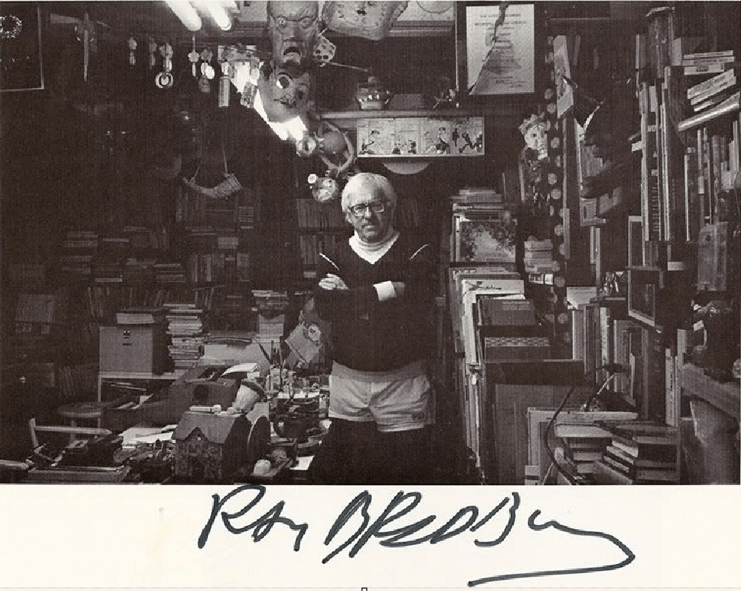

The Murderer by Ray Bradbury

Music moved with him in the white halls. He passed an office door The Merry Widow Waltz. Another door Afternoon of a Faun. A Third Kiss Me Again. He turned into a cross-corridor The Sword Dance buried him in cymbals, drums, pots, pans, knives, forks, thunder, and tin lightning.

All washed away as he hurried through an anteroom where a secretary sat nicely stunned by Beethoven's Fifth. He moved himself before her eyes like a hand; she didn't see him.

His wrist radio buzzed.

Yes

This is Lee, Dad. Don't forget about my allowance.

Yes, Son, yes. I'm busy.

Just didn't want you to forget, Dad, said the wrist radio. Tchaikovsky's Romeo and Juliet swarmed about the voice and flushed into the long halls.

The psychiatrist moved in the beehive of offices, in the cross-pollination of themes, Stravinsky mating with Bach, Haydn unsuccessfully repulsing Rachmaninoff, Schubert slain by Duke Ellington.

He nodded to the humming secretaries and the whistling doctors fresh to their morning work. At his office he checked a few papers with his stenographer, who sang under her breath, then phoned the police captain upstairs. A few minutes later a red light blinked, a voice said from the ceiling

Prisoner delivered to Interview Chamber Nine.

He unlocked the chamber door, stepped in, heard the door lock behind him.

Go away, said the prisoner, smiling.

The psychiatrist was shocked by that smile. Page 1

A very sunny, pleasant warm thing, a thing that shed bright light upon the room. Dawn among the dark hills.

High noon at midnight, that smile. The blue eyes sparkled serenely above that display of self-assured dentistry.

I'm here to help you, said the psychiatrist, frowning. Something was wrong with the room. He had hesitated the moment he entered. He glanced around. The prisoner laughed. If you're wondering why it's so quiet in here, I just kicked the radio to death.

Violent, thought the doctor.

The prisoner read this thought, smiled, put out a gentle hand. No, only to machines that yak-yak-yak.

Bits of the wall radio's tubes and wires lay on the gray carpeting. Ignoring these, feeling that smile upon him like a heat lamp, the psychiatrist sat across from his patient in the unusual silence which was like the gathering of a storm.

You're Mr. Albert Brock, who calls himself The Murderer

Brock nodded pleasantly. Before we start . . . He moved quietly and quickly to detach the wrist radio from the doctor's arm. He tucked it in his teeth like a walnut, gritted, heard it crack, handed it back to the appalled psychiatrist as if he had done them both a favor. That's better.

The psychiatrist stared at the ruined machine. You're running up quite a damage bill.

I don't care, smiled the patient. As the old song goes 'Don't Care What Happens to Me!' He hummed it.

The psychiatrist said Shall we start

Fine. The first victim, or one of the first, was my telephone. Murder most foul.

I shoved it in the kitchen Insinkerator! Stopped the disposal unit in mid-swallow. Poor thing strangled to death. After that I shot the television set!

The psychiatrist said, Mmm.

Fired six shots right through the cathode.(1) Made a beautiful tinkling crash, like a dropped chandelier.

Nice imagery.

Thanks, I always dreamt of being a writer.

Suppose you tell me when you first began to hate the telephone.

It frightened me as a child. Uncle of mine called it the Ghost Machine. Voices without bodies. Scared the living hell out of me. Later in life I was never comfortable. Seemed to me a phone was an impersonal instrument.

If it felt like it, it let your personality go through its wires. If it didn't want to, it just drained your personality away until what slipped through at the other end was some cold fish of a voice, all steel, copper, plastic, no warmth, no reality.

It's easy to say the wrong thing on telephones; the telephone changes your meaning on you. First thing you know, you've made an enemy. Then, of course, the telephone's such a convenient thing; it just sits there and demands you call someone who doesn't want to be called.

Friends were always calling, calling, calling me. Hell, I hadn't any time of my own. When it wasn't the telephone it was the television, the radio, the phonograph. When it wasn't the television or radio or the phonograph it was motion pictures at the corner theater, motion pictures projected, with commercials on low-lying cumulus clouds. It doesn't rain rain any more, it rains soapsuds.

When it wasn't High-Fly Cloud advertisements, it was music by Mozzek (2) in every restaurant; music and commercials on the busses I rode to work. When it wasn't music, it was interoffice communications, and my horror chamber of a radio wristwatch on which my friends and my wife phoned every five minutes.

What is there about such 'conveniences' that makes them so temptingly convenient The average man thinks, Here I am, time on my hands, and there on my wrist is a wrist telephone, so why not just buzz old Joe up, eh 'Hello, hello!'

I love my friends, my wife, humanity, very much, but when one minute my wife calls to say, 'Where are you now, dear' and a friend calls and says, 'Got the best off-color joke to tell you. Seems there was a guy-' And a stranger calls and cries out, 'This is the Find-Fax Poll. What gum are you chewing at this very instant' Well!

How did you feel during the week

The fuse lit. On the edge of the cliff. That same afternoon I did what I did at the office.

Which was

I poured a paper cup of water into the intercommunications system.

The psychiatrist wrote on his pad.

And the system shorted

Beautifully! The Fourth of July on wheels! My God, stenographers ran around looking lost! What an uproar!

Felt better temporarily, eh

Fine! Then I got the idea at noon of stomping my wrist radio on the sidewalk. A shrill voice was just yelling out of it at me, 'This is People's Poll Number Nine. What did you eat for lunch' when I kicked the wrist radio!

Felt even better, eh

It grew on me! Brock rubbed his hands together. Why didn't I start a solitary revolution, deliver man from certain 'conveniences' 'Convenient for who' I cried. Convenient for friends 'Hey, Al, thought I'd call you from the locker room out here at Green Hills. Just made a sockdolager (3) hole in one!

A hole in one, Al! A beautiful day. Having a shot of whiskey now.

Thought you'd want to know, Al!' Convenient for my office, so when I'm in the field with my radio car there's no moment when I'm not in touch. In touch! There's a slimy phrase. Touch, hell. Gripped! Pawed, rather. Mauled and massaged and pounded by FM voices.

You can't leave your car without checking in 'Have stopped to visit gas-station men's room.' 'Okay, Brock, step on it!' 'Brock, what took you so long' 'Sorry, sir.' 'Watch it next time, Brock.' 'Yes, sir!' So, do you know what I did, Doctor I bought a quart of French chocolate ice cream and spooned it into the car radio transmitter.

Was there any special reason for selecting French chocolate ice cream to spoon into the broadcasting unit

Brock thought about it and smiled. It's my favorite flavor.

Oh, said the doctor.

I figured, hell, what's good enough for me is good enough for the radio transmitter.

What made you think of spooning ice cream into the radio

It was a hot day.

The doctor paused.

And what happened next

Silence happened next. God, it was beautiful. That car radio cackling all day, 'Brock go here, Brock go there, Brock check in, Brock check out, okay Brock, hour lunch, Brock, lunch over, Brock, Brock, Brock.' Well, that silence was like putting ice cream in my ears.

You seem to like ice cream a lot.

I just rode around feeling of the silence. It's a big bolt of the nicest, softest flannel ever made. Silence. A whole hour of it. I just sat in my car, smiling, feeling of that flannel with my ears. I felt drunk with Freedom!

Go on.

Then I got the idea of the portable diathermy machine.(4) I rented one, took it on the bus going home that night. There sat all the tired commuters with their wrist radios, talking to their wives, saying, 'Now I'm at Forty-third, now I'm at Forty-fourth, here I am at Forty-ninth, now turning at Sixty-first.' One husband cursing, 'Well, get out of that bar, damn it, and get home and get dinner started, I'm at Seventieth!'

And the transit-system radio playing 'Tales from the Vienna Woods,' a canary singing words about a first-rate wheat cereal. Then-I switched on my diathermy! Static! Interference! All wives cut off from husbands grousing about a hard day at the office.

All husbands cut off from wives who had just seen their children break a window! The 'Vienna Woods' chopped down, the canary mangled. Silence! A terrible, unexpected silence. The bus inhabitants faced with having to converse with each other. Panic! Sheer, animal panic!

The police seized you

The bus had to stop. After all, the music was being scrambled, husbands and wives were out of touch with reality. Pandemonium, riot, and chaos. Squirrels chattering in cages! A trouble unit arrived, triangulated on me (5) instantly, had me reprimanded, fined, and home, minus my diathermy machine, in jig time.

Mr. Brock, may I suggest that so far your whole pattern here is not very- practical If you didn't like transit radios or office radios or car business radios, why didn't you join a fraternity of radio haters, start petitions, get legal and constitutional rulings After all, this is a democracy.

And I, said Brock, am that thing best called a minority. I did join fraternities, picket, pass petitions, take it to court. Year after year I protested. Everyone laughed. Everyone else loved bus radios and commercials. I was out of step.

Then you should have taken it like a good soldier, don't you think The majority rules.

But they went too far. If a little music and 'keeping in touch' was charming, they figured a lot would be ten times as charming. I went wild! I got home to find my wife hysterical. Why Because she had been completely out of touch with me for half a day. Remember, I did a dance on my wrist radio Well, that night I laid plans to murder my house.

Are you sure that's how you want me to write it down

That's semantically (6) accurate. Kill it dead. It's one of those talking, singing, humming, weather-reporting, poetry-reading, novel-reciting, jingle-jangling, rockaby-crooning- when-you-go-to-bed houses.

A house that screams opera to you in the shower and teaches you Spanish in your sleep. One of those blathering caves where all kinds of electronic Oracles make you feel a trifle larger than a thimble, with stoves that say, 'I'm apricot pie, and I'm done,' or 'I'm prime roast beef, so baste me!' and other nursery gibberish like that. With beds that rock you to sleep and shake you awake.

A house that barely tolerates humans, I tell you. A front door that barks 'You've mud on your feet, sir!' And an electronic vacuum hound that snuffles around after you from room to room, inhaling every fingernail or ash you drop. . . .

Quietly, suggested the psychiatrist.

Remember that Gilbert and Sullivan song-'I've Got It on My List, It Never Will Be Missed' All night I listed grievances. Next morning early I bought a pistol. I purposely muddied my feet. I stood at our front door. The front door shrilled, 'Dirty feet, muddy feet! Wipe your feet! Please be neat!'

I shot the damn thing in its keyhole! I ran to the kitchen, where the stove was just whining, 'Turn me over!' In the middle of a mechanical omelet I did the stove to death. Oh, how it sizzled and screamed, 'I'm shorted!' Then the telephone rang like a spoiled brat.

I shoved it down the Insinkerator. I must state here and now I have nothing whatever against the Insinkerator; it was an innocent bystander. I feel sorry for it now, a practical device indeed, which never said a word, purred like a sleepy lion most of the time, and digested our leftovers.

I'll have it restored. Then I went in and shot the televisor, that insidious beast, that Medusa,(7) which freezes a billion people to stone every night, staring fixedly, that Siren which called and sang and promised so much and gave, after all, so little, but myself always going back, going back, hoping and waiting until-bang! Like a headless turkey, gobbling, my wife whooped out the front door. The police came. Here I am!

He sat back happily and lit a cigarette.

And did you realize, in committing these crimes, that the wrist radio, the broadcasting transmitter, the phone, the bus radio, the office intercoms, all were rented or were someone else's property

I would do it all over again, so help me God. The psychiatrist sat there in the sunshine of that beatific (8) smile.

You don't want any further help from the Office of Mental Health You're ready to take the consequences

This is only the beginning, said Mr. Brock. I'm the vanguard (9) of the small public which is tired of noise and being taken advantage of and pushed around and yelled at, every moment music, every moment in touch with some voice somewhere, do this, do that, quick, quick, now here, now there. You'll see. The revolt begins. My name will go down in history!

Mmm. The psychiatrist seemed to be thinking.

It'll take time, of course. It was all so enchanting at first. The very idea of these things, the practical uses, was wonderful. They were almost toys, to be played with, but the people got too involved, went too far, and got wrapped up in a pattern of social behavior and couldn't get out, couldn't admit they were in, even.

So they rationalized their nerves as something else. 'Our modern age,' they said. 'Conditions,' they said. 'High-strung,' they said. But mark my words, the seed has been sown. I got world-wide coverage on TV, radio, films; there's an irony for you.

That was five days ago. A billion people know about me. Check your financial columns. Any day now. Maybe today. Watch for a sudden spurt, a rise in sales for French chocolate ice cream!

I see, said the psychiatrist.

Can I go back to my nice private cell now, where I can be alone and quiet for six months

Yes, said the psychiatrist quietly.

Don't worry about me, said Mr. Brock, rising. I'm just going to sit around for a long time stuffing that nice soft bolt of quiet material in both ears.

Mmm, said the psychiatrist, going to the door.

Cheers, said Mr. Brock.

Yes, said the psychiatrist.

He pressed a code signal on a hidden button, the door opened, he stepped out, the door shut and locked. Alone, he moved in the offices and corridors. The first twenty yards of his walk were accompanied by Tambourine Chinois.

Then it was Tzigane, Bach's Passacaglia and Fugue in something Minor, Tiger Rag, Love Is Like a Cigarette. He took his broken wrist radio from his pocket like a dead praying mantis. He turned in at his office. A bell sounded; a voice came out of the ceiling, Doctor

Just finished with Brock, said the psychiatrist.

Diagnosis

Seems completely disoriented, but convivial.(10) Refuses to accept the simplest realities of his environment and work with them.

Prognosis(11)

Indefinite. Left him enjoying a piece of invisible material.

Three phones rang. A duplicate wrist radio in his desk drawer buzzed like a wounded grasshopper. The intercom flashed a pink light and click-clicked. Three phones rang. The drawer buzzed. Music blew in through the open door.

The psychiatrist, humming quietly, fitted the new wrist radio to his wrist, flipped the intercom, talked a moment, picked up one telephone, talked, picked up another telephone, talked, picked up the third telephone, talked, touched the wrist-radio button, talked calmly and quietly, his face cool and serene, in the middle of the music and the lights flashing, the phones ringing again, and his hands moving, and his wrist radio buzzing, and the intercoms talking, and voices speaking from the ceiling.

And he went on quietly this way through the remainder of a cool, air-conditioned, and long afternoon; telephone, wrist radio, intercom, telephone, wrist radio, intercom, telephone, wrist radio, intercom, telephone, wrist radio, intercom, telephone, wrist radio, intercom, telephone, wrist radio . . .

The End

Note

1 a cathode-ray tube, used in television picture tubes

2 a company that made musical recordings for use as background music in such places as elevators and restaurants 3 something outstanding

4 a machine that is used for medical purposes and that produces a high-frequency electric current

5 a reference to triangulation, the process of locating something by means of taking measurements from two fixed points, as can be done with radio signals

6 in a manner that has to do with the meaning of words

7 in Greek mythology, a beautiful woman who was punished for loving a god by having her hair turned into snakes; after that, anyone who looked at her turned to stone

8 angelic

9 the leader of thought, taste, or opinion in a field 10 merry

11 a forecast of the probable course of a disease