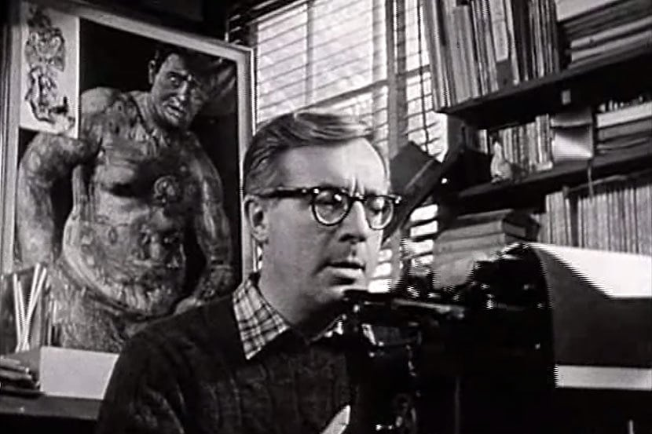

The Pedestrian, Ray Bradbury

The Pedestrian

To enter out into that silence that was the city at eight o’clock of a misty evening in November, to put your feet upon that buckling concrete walk, to step over grassy seams and make your way, hands in pockets, through the silences, that was what Mr. Leonard Mead most dearly loved to do. He would stand upon the corner of an intersection and peer down long moonlit avenues of sidewalk in four directions, deciding which way to go, but it really made no difference; he was alone in this world of A.D. 2131, or as good as alone, and with a final decision made, a path selected, he would stride off, sending patterns of frosty air before him like the smoke of a cigar.

Sometimes he would walk for hours and miles and return only at midnight to his house. And on his way he would see the cottages and homes with their dark windows, and it was not unequal to walking through a graveyard, because only the faintest glimmers of firefly light appeared in flickers behind the windows. Sudden gray phantoms seemed to manifest themselves upon inner walls where a curtain was still undrawn against the night, or there were whisperings and murmurs where a window in a tomblike building was still open.

MR. LEONARD MEAD WOULD PAUSE, cock his head, listen, look, and march on, his feet making no noise on the lumpy walk. For a long while now the sidewalks had been vanishing under flowers and grass. In ten years of walking by night or day, for thousands of miles, he had never met another person walking, not one in all that time.

He now wore sneakers when strolling at night, because the dogs in intermittent squads would parallel his journey with barkings if he wore hard heels, and lights might click on and faces appear, and an entire street be startled by the passing of a lone figure, himself, in the early November evening.

On this particular evening he began his journey in a westerly direction toward the hidden sea. There was a good crystal frost in the air; it cut the nose going in and made the lungs blaze like a Christmas tree inside; you could feel the cold light going on and off, all the branches filled with invisible snow. He listened to the faint push of his soft shoes through autumn leaves with satisfaction, and whistled a cold quiet whistle between his teeth, occasionally picking up a leaf as he passed, examining its skeletal pattern in the infrequent lamplights as he went on, smelling its rusty smell.

“Hello, in there,” he whispered to every house on every side as he moved. “What’s up tonight on Channel 4, Channel 7, Channel 9? Where are the cowboys rushing, and do I see the United States Cavalry over the next hill to the rescue?”

The street was silent and long and empty, with only his shadow moving like the shadow of a hawk in mid-country. If he closed his eyes and stood very still, frozen, he imagined himself upon the center of a plain, a wintry, windless Arizona country with no house in a thousand miles, and only dry riverbeds, the streets, for company.

“What is it now?” he asked the houses, noticing his wristwatch. “Eight-thirty p.m. Time for a dozen assorted murders? A quiz? A revue? A comedian falling off the stage?”

Was that a murmur of laughter from within a moon-white house? He hesitated, but went on when nothing more happened. He stumbled over a particularly uneven section of walk as he came to a cloverleaf intersection which stood silent where two main highways crossed the town. During the day it was a thunderous surge of cars, the gas stations open, a great insect rustling and ceaseless jockeying for position as the scarab beetles, a faint incense puttering from their exhausts, skimmed homeward to the far horizons. But now these highways too were like streams in a dry season, all stone and bed and moon radiance.

HE TURNED BACK on a side street, circling around toward his home. He was within a block of his destination when the lone car turned a corner quite suddenly and flashed a fierce white cone of light upon him. He stood entranced, not unlike a night moth, stunned by the illumination and then drawn toward it.

A metallic voice called to him:

“Stand still. Stay where you are! Don’t move!”

He halted.

“Put up your hands.”

“But—” he said.

“Your hands up! Or we’ll shoot!”

The police, of course, but what a rare, incredible thing; in a city of three million, there was only one police car left. Ever since a year ago, 2130, the election year, the force had been cut down from three cars to one. Crime was ebbing; there was no need now for the police, save for this one lone car wandering and wandering the empty streets.

“Your name?” said the police car in a metallic whisper. He couldn’t see the men in it for the bright light in his eyes.

“Leonard Mead,” he said.

“Speak up!”

“Leonard Mead!”

“Business or profession?”

”I guess you’d call me a writer.”

“No profession,” said the police car, as if talking to itself. The light held him fixed like a museum specimen, needle thrust through chest.

“You might say that,” said Mr. Mead. He hadn’t written in years. Magazines and books didn’t sell any more. Everything went on in the tomblike houses at night now, he thought, continuing his fancy. The tombs, ill-lit by television light, where the people sat like the dead, the gray or multicolored lights touching their expressionless faces but never really touching them.

“No profession,” said the phonograph voice, hissing. “What are you doing out?”

“Walking,” said Leonard Mead.

“Walking!”

“Just walking,” he said, simply, but his face felt cold.

“Walking, just walking, walking?”

“Yes, sir.”

“Walking where? For what?”

“Walking for air. Walking to see.”

“Your address!”

“Eleven South St. James Street.”

“And there is air in your house, you have an air-conditioner, Mr. Mead?”

“Yes.”

“And you have a viewing screen in your house to see with?”

“No.”

“NO?” THERE WAS A CRACKLING quiet that in itself was an accusation.

“Are you married, Mr. Mead?”

“No.”

“Not married,” said the police voice behind the fiery beam. The moon was high and clear among the stars and the houses were gray and silent.

“Nobody wanted me,” said Leonard Mead, with a smile.

“Don’t speak unless you’re spoken to!”

Leonard Mead waited in the cold night.

“Just walking, Mr. Mead?”

“Yes.”

“But you haven’t explained for what purpose.”

“I explained: for air and to see, and just to walk.”

“Have you done this often?”

“Every night for years.”

The police car sat in the center of the street with its radio throat faintly humming.

“Well, Mr. Mead,” it said.

“Is that all?” he asked politely.

“Yes,” said the voice. “Here.” There was a sigh, a pop. The back door of the police car sprang wide. “Get in.”

“Wait a minute, I haven’t done anything!”

“Get in.”

“I protest!”

“Mr. Mead.”

He walked like a man suddenly drunk. As he passed the front window of the car he looked in. As he had expected, there was no one in the front seat, no one in the car at all.

“Get in.”

He put his hand to the door and peered into the back seat, which was a little cell, a little black jail with bars. It smelled of riveted steel. It smelled of harsh antiseptic; it smelled too clean and hard and metallic. There was nothing soft there.

“Now if you had a wife to give you an alibi,” said the iron voice. “But—”

“Where are you taking me?”

The car hesitated, or rather gave a taint whirring click, as if information, somewhere, was dropping card by punch-slotted card under electric eyes. “To the psychiatric Center for Research on Regressive Tendencies.”

He got in. The door shut with a soft thud. The police car rolled through the night avenues, flashing its dim lights ahead.

They passed one house on one street a moment later, one house in an entire city of houses that were dark, but this one particular house had all its electric lights brightly lit, every window a loud yellow illumination, square and warm in the cool darkness.

“That’s my house,” said Leonard Mead.

No one answered him.

The car moved down the empty river bed streets and off away, leaving the empty streets with the empty sidewalks, and no sound and no motion all the rest of the chill November night.

The End