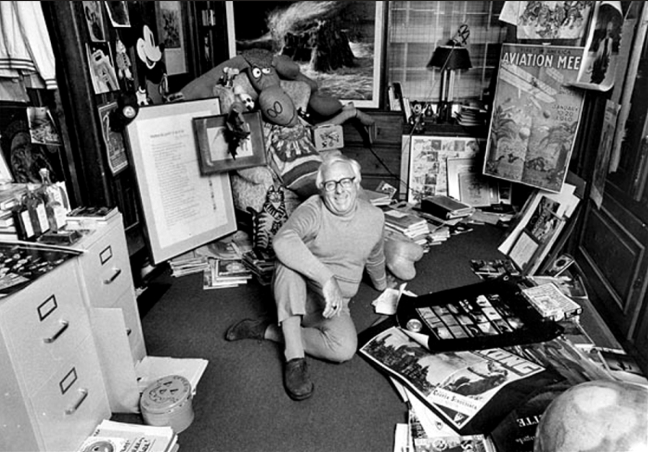

The Poems, Ray Bradbury

The Poems

It started out to be just another poem. And then David began sweating over it, stalking the rooms, talking to himself more than ever before in the long, poorly-paid years. So intent was he upon the poem’s facets that Lisa felt forgotten, left out, put away until such time as he finished writing and could notice her again.

Then, finally—the poem was completed.

With the ink still wet upon an old envelope’s back, he gave it to her with trembling fingers, his eyes red-rimmed and shining with a hot, inspired light. And she read it.

“David—” she murmured. Her hand began to shake in sympathy with his.

“It’s good, isn’t it?” he cried. Damn good!”

The cottage whirled around Lisa in a wooden torrent. Gazing at the paper she experienced sensations as if words were melting, flowing into animate things. The paper was a square, brilliantly sunlit casement through which one might lean into another and brighter amber land!

Her mind swung pendulum-wise. She had to clutch, crying out fearfully, at the ledges of this incredible window to support herself from being flung headlong into three-dimensional impossibility!

“David, how strange and wonderful and—frightening.”

It was as if she held a tube of light cupped in her hands, through which she could race into a vast space of singing and color and new sensation. Somehow, David had caught up, netted, skeined, imbedded reality, substance, atoms—mounting them upon paper with a simple imprisonment of ink!

He described the green, moist verdure of the dell, the eucalyptus trees and the birds flowing through their high, swaying branches. And the flowers cupping the propelled humming of bees.

“It is good, David.

The very finest poem you’ve ever written!” She felt her heart beat swiftly with the idea and urge that came to her in the next moment. She felt that she must see the dell, to compare its quiet contents with those of this poem. She took David’s arm. “Darling, let’s walk down the road—now.”

In high spirits, David agreed, and they set out together, from their lonely little house in the hills. Half down the road she changed her mind and wanted to retreat, but she brushed the thought aside with a move of her fine, thinly sculptured face.

It seemed ominously dark for this time of day, down there toward the end of the path. She talked lightly to shield her apprehension.

“You’ve worked so hard, so long, to write the perfect poem. I knew you’d succeed some day. I guess this is it.”

“Thanks to a patient wife,” he said.

They rounded a bend of gigantic rock and twilight came as swiftly as a purple veil drawn down.

“David!”

In the unexpected dimness she clutched and found his arm and held to him. “What’s happened? Is this the dell?”

“Yes, of course it is.”

“But, it’s so dark!”

“Well—yes—it is—” He sounded at a loss.

“The flowers are gone!”

“I saw them early this morning; they can’t be gone!”

“You wrote about them in the poem. And where are the grape vines?”

“They must be there. It’s only been an hour or more. It’s too dark. Let’s go back.” He sounded afraid himself, peering into the uneven light.

“I can’t find anything, David. The grass is gone, and the trees and bushes and vines, all gone!”

She cried it out, then stopped, and it fell upon them, the unnatural blank spaced silence, a vague timelessness, windlessness, a vacuumed sucked out feeling that oppressed and panicked them.

He swore softly and there was no echo. “It’s too dark to tell now. It’ll all be here tomorrow.”

“But what if it never comes back?” She began to shiver.

“What are you raving about?”

She held the poem out. It glowed quietly with a steady pure yellow shining, like a small niche in which a candle steadily lived.

“You’ve written the perfect poem. Too perfect. That’s what you’ve done.” She heard herself talking, tonelessly, far away.

She read the poem again. And a coldness moved through her.

“The dell is here. Reading this is like opening a gate upon a path and walking knee-high in grass, smelling blue grapes, hearing bees in yellow transits on the air, and the wind carrying birds upon it. The paper dissolves into things, sun, water, colors and life. It’s not symbols or reading anymore, it’s LIVING!”

“No,” he said. “You’re wrong. It’s crazy.”

They ran up the path together. A wind came to meet them after they were free of the lightless vacuum behind them.

In their small, meagerly furnished cottage they sat at the window, staring down at the dell. All around was the unchanged light of mid-afternoon. Not dimmed or diffused or silent as down in the cup of rocks.

“It’s not true. Poems don’t work that way,” he said.

“Words are symbols. They conjure up images in the mind.”

“Have I done more than that?” he demanded. “And how did I do it, I ask you?” He rattled the paper, scowling intently at each line. “Have I made more than symbols with a form of matter and energy.

Have I compressed, concentrated, dehydrated life? Does matter pass into and through my mind, like light through a magnifying glass to be focused into one narrow, magnificent blazing apex of fire? Can I etch life, burn it onto paper, with that flame? Gods in heaven, I’m going mad with thought!”

A wind circled the house.

“If we are not crazy, the two of us,” said Lisa, stiffening at the sound of the wind, “there is one way to prove our suspicions.”

“How?”

“Cage the wind.”

“Cage it? Bar it up? Build a mortar of ink around it?”

She nodded.

“No, I won’t fool myself.” He jerked his head. Wetting his lips, he sat for a long while. Then, cursing at his own curiosity, he walked to the table and fumbled self-consciously with pen and ink. He looked at her, then at the windy light outside. Dipping his pen, he flowed it out onto paper in regular dark miracles.

Instantly, the wind vanished.

“The wind,” he said. “It’s caged. The ink is dry.”

Over his shoulder she read it, became immersed in its cool heady current, smelling far oceans tainted on it, odors of distant wheat acres and green corn and the sharp brick and cement smell of cities far away.

David stood up so quickly the chair fell back like an old thin woman. Like a blind man he walked down the hill toward the dell, not turning, even when Lisa called after him, frantically.

When he returned he was by turns hysterical and immensely calm. He collapsed in a chair. By night, he was smoking his pipe, eyes closed, talking on and on, as calmly as possible.

“I’ve got power now no man ever had.

I don’t know its extensions, its boundaries or its governing limits. Somewhere, the enchantment ends. Oh, my god, Lisa, you should see what I’ve done to that dell. Its gone, all gone, stripped to the very raw primordial bones of its former self.

And the beauty is here!” He opened his eyes and stared at the poem, as at the Holy Grail. “Captured forever, a few bars of midnight ink on paper! I’ll be the greatest poet in history! I’ve always dreamed of that.”

“I’m afraid, David. Let’s tear up the poems and get away from here!”

“Move away? Now?”

“It’s dangerous. What if your power extends beyond the valley?”

His eyes shone fiercely. “Then I can destroy the universe and immortalize it at one and the same instant. It’s in the power of a sonnet, if I choose to write it.”

“But you won’t write it, promise me, David?”

He seemed not to hear her. He seemed to be listening to a cosmic music, a movement of bird wings very high and clear. He seemed to be wondering how long this land had waited here, for centuries perhaps, waiting for a poet to come and drink of its power. This valley seemed like the center of the universe, now.

“It would be a magnificent poem,” he said, thoughtfully. “The most magnificent poem ever written, shamming Keats and Shelley and Browning and all the rest. A poem about the universe. But no.” He shook his head sadly. “I guess I won’t ever write that poem.”

Breathless, Lisa waited in the long silence.

Another wind came from across the world to replace the one newly imprisoned. She let out her breath, at ease.

“For a moment I was afraid you’d overstepped the boundary and taken in all the winds of the earth. It’s all right now.”

“All right, hell,” he cried, happily. “It’s marvelous!”

And he caught hold of her, and kissed her again and again.

Fifty poems were written in fifty days. Poems about a rock, a stem, a blossom, a pebble, an ant, a dropped feather, a raindrop, an avalanche, a dried skull, a dropped key, a fingernail, a shattered light bulb.

Recognition came upon him like a rain shower. The poems were bought and read across the world. Critics referred to the masterpieces as “—chunks of amber in which are caught whole portions of life and living—” “—each poem a window looking out upon the world—”

He was suddenly a very famous man. It took him many days to believe it. When he saw his name on the printed books he didn’t believe it, and said so. And when he read the critics columns he didn’t believe them either.

Then it began to make a flame inside him, growing up, climbing and consuming his body and legs and arms and face.

Amidst the sound and glory, she pressed her cheek to his and whispered:

“This is your perfect hour. When will there ever be a more perfect time than this? Never again.”

He showed her the letters as they arrived.

“See? This letter. From New York.” He blinked rapidly and couldn’t sit still. “They want me to write more poems. Thousands more. Look at this letter. Here.” He gave it to her. “That editor says that if I can write so fine and great about a pebble or a drop of water, think what I can do when I—well experiment with real life. Real life. Nothing big. An amoeba perhaps. Or, well, just this morning. I saw a bird—”

“A bird?” She stiffened and waited for him to answer.

“Yes, a hummingbird—hovering, settling, rising—”

“You didn’t . . .?”

“Why NOT? Only a bird. One bird out of a billion,” he said self-consciously. “One little bird, one little poem. You can’t deny me that.”

“One amoeba,” she repeated, tonelessly. “And then next it will be one dog, one man, one city, one continent, one universe!”

“Nonsense.” His cheek twitched. He paced the room, fingering back his dark hair. “You dramatize things. Well, after all what’s one dog, even, or to go one step further, one man?”

She sighed. “It’s the very thing you talked of with fear, the danger we spoke of that first time we knew your power. Remember, David, it’s not really yours, it was only an accident our coming here to the valley house—”

He swore softly. “Who cares whether it was accident or Fate? The thing that counts is that I’m here, now, and they’re—they’re—” He paused, flushing.

“They’re what?” she prompted.

“They’re calling me the greatest poet who ever lived!”

“It’ll ruin you.”

“Let it ruin me, then! Let’s have silence, now.”

He stalked into his den and sat restlessly studying the dirt road. While in this mood, he saw a small brown dog come patting along the road, raising little dust-tufts behind.

“And a damn good poet I am,” he whispered, angrily, taking out pen and paper. He scratched out four lines swiftly.

The dog’s barking came in even shrill intervals upon the air as it circled a tree and bounded a green bush. Quite unexpectedly, half over one leap across a vine, the barking ceased, and the dog fell apart in the air, inch by inch, and vanished.

Locked in his den, he composed at a furious pace, counting pebbles in the garden and changing them to stars simply by giving them mention, immortalizing clouds, hornets, bees, lightning and thunder with a few pen flourishes.

It was inevitable that some of his more secret poems should be stumbled upon and read by his wife.

Coming home from a long afternoon walk he found her with the poems lying all unfolded upon her lap.

“David,” she demanded. “What does this mean?” She was very cold and shaken by it. “This poem. First a dog. Then a cat, some sheep and—finally—a man!”

He seized the papers from her. “So what!” Sliding them in a drawer, he slammed it, violently. “He was just an old man, they were old sheep, and it was a microbe-infested terrier! The world breathes better without them!”

“But here, THIS poem, too.” She held it straight out before her, eyes widened. “A woman. Three children from Charlottesville!”

“All right, so you don’t like it!” he said, furiously. “An artist has to experiment. With everything—I can’t just stand still and do the same thing over and over. I’ve got greater plans than you think. Yes, really good, fine plans. I’ve decided to write about everything. I’ll dissect the heavens if I wish, rip down the worlds, toy with suns if I damn please!”

“David,” she said, shocked.

“Well, I will! I will!”

“You’re such a child, David. I should have known. If this goes on, I can’t stay here with you.”

“You’ll have to stay,” he said.

“What do you mean?”

He didn’t know what he meant himself. He looked around, helplessly and then declared, “I mean. I mean—if you try to go all I have to do is sit at my desk and describe you in ink . . .”

“You . . .” she said, dazedly.

She began to cry. Very silently, with no noise, her shoulders moved, as she sank down on a chair.

“I’m sorry,” he said, lamely, hating the scene. “I didn’t mean to say that, Lisa. Forgive me.” He came and laid a hand upon her quivering body.

“I won’t leave you,” she said, finally.

And closing her eyes, she began to think.

It was much later in the day when she returned from a shopping trip to town with bulging grocery sacks and a large gleaming bottle of champagne.

David looked at it and laughed aloud. “Celebrating, are we?”

“Yes,” she said, giving him the bottle and an opener. “Celebrating you as the world’s greatest poet!”

“I detect sarcasm, Lisa,” he said, pouring drinks. “Here’s a toast to the—the universe.” He drank. “Good stuff.” He pointed at hers. “Drink up. What’s wrong?” Her eyes looked wet and sad about something.

She refilled his glass and lifted her own. “May we always be together. Always.”

The room tilted. “It’s hitting me,” he observed very seriously, sitting down so as not to fall. “On an empty stomach I drank. Oh, Lord!”

He sat for ten minutes while she refilled his glass. She seemed very happy suddenly, for no reason. He sat scowling, thinking, looking at his pen and ink and paper, trying to make a decision. “Lisa?”

“Yes?” She was now preparing supper, singing.

“I feel in a mood. I have been considering all afternoon and—”

“And what, darling?”

“I am going to write the greatest poem in history—NOW!”

She felt her heart flutter.

“Will your poem be about the valley?”

He smirked. “No. No! Bigger than that. Much bigger!”

“I’m afraid I’m not much good at guessing,” she confessed.

“Simple,” he said, gulping another drink of champagne. Nice of her to think of buying it, it stimulated his thoughts. He held up his pen and dipped it in ink. “I shall write my poem about the universe! Let me see now . . .”

“David!”

He winced. “What?”

“Oh, nothing. Just, have some more champagne, darling.”

“Eh?” He blinked fuzzily. “Don’t mind if I do. Pour.”

She sat beside him, trying to be casual.

“Tell me again. What is it you’ll write?”

“About the universe, the stars, the epileptic shamblings of comets, the blind black seekings of meteors, the heated embraces and spawnings of giant suns, the cold, graceful excursions of polar planets, asteroids plummeting like paramecium under a gigantic microscope, all and everything and anything my mind lays claim to! Earth, sun, stars!” he exclaimed.

“No!” she said, but caught herself. “I mean, darling, don’t do it all at once. One thing at a time—”

“One at a time.” He made a face. “That’s the way I’ve been doing things and I’m tied to dandelions and daisies.”

He wrote upon the paper with the pen.

“What’re you doing?” she demanded, catching his elbow.

“Let me alone!” He shook her off.

She saw the black words form:

“Illimitable universe, with stars and planets and suns—”

She must have screamed.

“No, David, cross it out, before it’s too late. Stop it!”

He gazed at her as through a long dark tube, and her far away at the other end, echoing. “Cross it out?” he said. “Why, it’s GOOD poetry! Not a line will I cross out. I want to be a GOOD poet!”

She fell across him, groping, finding the pen. With one instantaneous slash, she wiped out the words.

“Before the ink dries, before it dries!”

“Fool!” he shouted. “Let me alone!”

She ran to the window. The first evening stars were still there, and the crescent moon. She sobbed with relief. She swung about to face him and walked toward him. “I want to help you write your poem—”

“Don’t need your help!”

“Are you blind? Do you realize the power of your pen!”

To distract him, she poured more champagne, which he welcomed and drank. “Ah,” he sighed, dizzily. “My head spins.”

But it didn’t stop him from writing, and write he did, starting again on a new sheet of paper.

“UNIVERSE—VAST UNIVERSE—BILLION STARRED AND WIDE—”

She snatched frantically at shreds of things to say, things to stave off his writing.

“That’s poor poetry,” she said.

“What do you mean ‘poor’?” he wanted to know, writing.

“You’ve got to start at the beginning and build up,” she explained logically. “Like a watch spring being wound or the universe starting with a molecule building on up through stars into a stellar cartwheel—”

He slowed his writing and scowled with thought.

She hurried on, seeing this. “You see, darling, you’ve let emotion run off with you. You can’t start with the big things. Put them at the end of your poem. Build to a climax!”

The ink was drying. She stared at it as it dried. In another sixty seconds—

He stopped writing. “Maybe you’re right. Just maybe you are.” He put aside the pen a moment.

“I know I’m right,” she said, lightly, laughing. “Here. I’ll just take the pen and—there—”

She had expected him to stop her, but he was holding his pale brow and looking pained with the ache in his eyes from the drink.

She drew a bold line through his poem. Her heart slowed.

“Now,” she said, solicitously, “you take the pen, and I’ll help you. Start out with small things and build, like an artist.”

His eyes were gray-filmed. “Maybe you’re right, maybe, maybe.”

The wind howled outside.

“Catch the wind!” she cried, to give him a minor triumph to satisfy his ego. “Catch the wind!”

He stroked the pen. “Caught it!” he bellowed, drunkenly, weaving. “Caught the wind! Made a cage of ink!”

“Catch the flowers!” she commanded, excitedly. “Every one in the valley! And the grass!”

“There! Caught the flowers!”

“The hill next!” she said.

“The hill!”

“The valley!”

“The valley!”

“The sunlight, the odors, the trees, the shadows, the house and the garden, and the things inside the house!”

“Yes, yes, yes,” he cried, going on and on and on.

And while he wrote quickly she said, “David, I love you. Forgive me for what I do next, darling—”

“What?” he asked, not having heard her.

“Nothing at all. Except that we are never satisfied and want to go on beyond proper limits. You tried to do that, David, and it was wrong.”

He nodded over his work. She kissed him on the cheek. He reached up and patted her chin. “Know what, lady?”

“What?”

“I think I like you, yes, sir, I think I like you.”

She shook him. “Don’t go to sleep, David, don’t.”

“Want to sleep. Want to sleep.”

“Later, darling. When you’ve finished your poem, your last great poem, the very finest one, David. Listen to me—”

He fumbled with the pen. “What’ll I say?”

She smoothed his hair, touched his cheek with her fingers and kissed him, tremblingly. Then, closing her eyes, she began to dictate.

“There lived a fine man named David and his wife’s name was Lisa and—”

The pen moved slowly, achingly, tiredly forming words.

“Yes?” he prompted.

“—and they lived in a house in the garden of Eden—”

He wrote again, tediously. She watched.

He raised his eyes. “Well? What’s next?”

She looked at the house, and the night outside, and the wind returned to sing in her ears and she held his hands and kissed his sleepy lips.

“That’s all,” she said, “the ink is drying.”

The publishers from New York visited the valley months later and went back to New York with only three pieces of paper they had found blowing in the wind around and about the raw, scarred, empty valley.

The publishers stared at one another, blankly:

“Why, why, there was nothing left at all,” they said. “Just bare rock, not a sign of vegetation or humanity. The home he lived in—gone! The road, everything! He was gone! His wife, she was gone, too! Not a word out of them. It was like a river flood had washed through, scraping away the whole countryside! Gone! Washed out! And only three last poems to show for the whole thing!”

No further word was ever received from the poet or his wife. The Agricultural College experts traveled hundreds of miles to study the starkly denuded valley, and went away, shaking their heads and looking pale.

But it is all simply found again.

You turn the pages of his last small thin book and read the three poems.

She is there, pale and beautiful and immortal, you smell the sweet warm flash of her, young forever, hair blowing golden upon the wind.

And next to her, upon the opposite page, he stands gaunt, smiling, firm, hair like raven’s hair, hands on hips, face raised to look about him.

And on all sides of them, green with an immortal green, under a sapphire sky, with the odor of fat wine grapes, with the grass knee-high and bending to touch of exploring feet, with the trails waiting for any reader who takes them, one finds the valley, and the house, and the deep rich peace of sunlight and of moonlight and many stars, and the two of them, he and she, walking through it all, laughing together, forever and forever.

The End