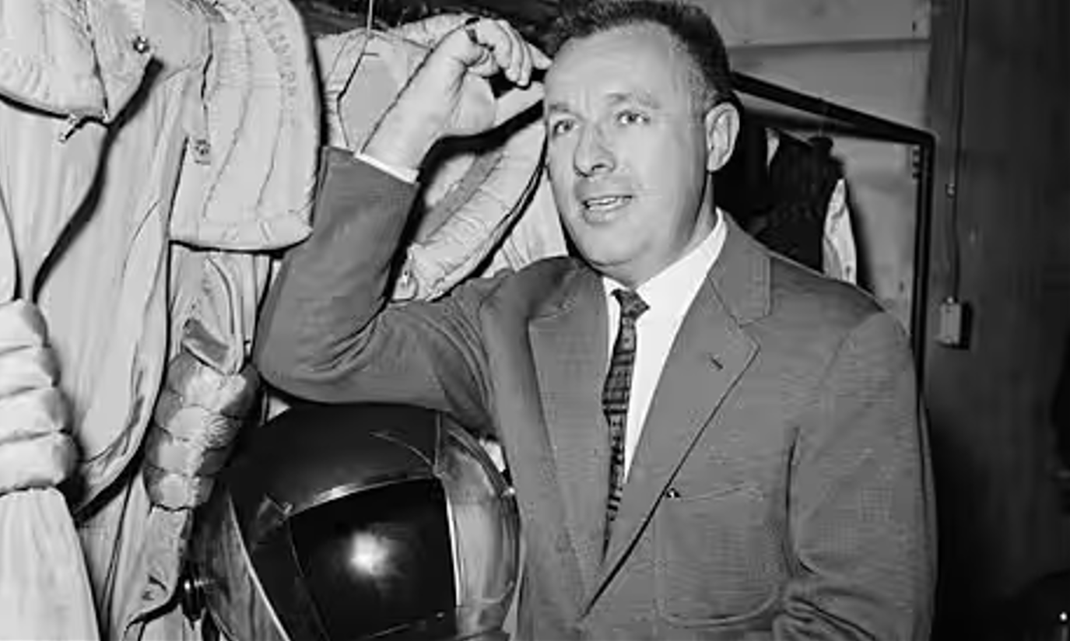

The Pumpernickel, Ray Bradbury

The Pumpernickel

Mr. And Mrs. Welles Walked Away from the movie theater late at night and went into the quiet little store, a combination restaurant and delicatessen. They settled in a booth, and Mrs. Welles said, “Baked ham on pumpernickel.” Mr. Welles glanced toward the counter, and there lay a loaf of pumpernickel.

“Why,” he murmured, “pumpernickel . . . Druce’s Lake . . .”

The night, the late hour, the empty restaurant—by now the pattern was familiar. Anything could set him off on a tide of reminiscence. The scent of autumn leaves, or midnight winds blowing, could stir him from himself, and memories would pour around him. Now in the unreal hour after the theater, in this lonely store, he saw a loaf of pumpernickel bread and, as on a thousand other nights, he found himself moved into the past.

“Druce’s Lake,” he said again.

“What?” His wife glanced up.

“Something I’d almost forgotten,” said Mr. Welles. “In 1910, when I was twenty, I nailed a loaf of pumpernickel to the top of my bureau mirror. . . .”

In the hard, shiny crust of the bread, the boys at Druce’s Lake had cut their names: Tom, Nick, Bill, Alec, Paul, Jack. The finest picnic in history! Their faces tanned as they rattled down the dusty roads. Those were the days when roads were really dusty; a fine brown talcum floured up after your car. And the lake was always twice as good to reach as it would be later in life when you arrived immaculate, clean, and unrumpled.

“That was the last time the old gang got together,” Mr. Welles said.

After that, college, work, and marriage separated you. Suddenly you found yourself with some other group. And you never felt as comfortable or as much at ease again in all your life.

“I wonder,” said Mr. Welles. “I like to think maybe we all knew, somehow, that this picnic might be the last we’d have. You first get that empty feeling the day after high-school graduation. Then, when a little time passes and no one vanishes immediately, you relax.

But after a year you realize the old world is changing. And you want to do some one last thing before you lose one another. While you’re all still friends, home from college for the summer, this side of marriage, you’ve got to have something like a last ride and a swim in the cool lake.”

Mr. Welles remembered that rare summer morning, he and Tom lying under his father’s Ford, reaching up their hands to adjust this or that, talking about machines and women and the future. While they worked, the day got warm. At last Tom said, “Why don’t we drive out to Druce’s Lake?”

As simple as that.

Yet, forty years later, you remember every detail of picking up the other fellows, everyone yelling under the green trees.

“Hey!” Alec beating everyone’s head with the pumpernickel and laughing. “This is for extra sandwiches, later.”

Nick had made the sandwiches that were already in the hamper—the garlic kind they would eat less of as the years passed and the girls moved in.

Then, squeezing three in the front, three in the rear, with their arms across one another’s shoulders, they drove through the boiling, dusty countryside, with a cake of ice in a tin washtub to cool the beer they’d buy.

What was the special quality of that day that it should focus like a stereoscopic image, fresh and clear, forty years later? Perhaps each of them had had an experience like his own.

A few days before the picnic, he had found a photograph of his father twenty-five years younger, standing with a group of friends at college. The photograph had disturbed him, made him aware as he had not been before of the passing of time, the swift flow of the years away from youth.

A picture taken of him as he was now would, in twenty-five years, look as strange to his own children as his father’s picture did to him—unbelievably young, a stranger out of a strange, never-returning time.

Was that how the final picnic had come about—with each of them knowing that in a few short years they would be crossing streets to avoid one another, or, if they met, saying, “We’ve got to have lunch sometime!” but never doing it?

Whatever the reason, Mr. Welles could still hear the splashes as they’d plunged off the pier under a yellow sun. And then the beer and sandwiches underneath the shady trees.

We never ate that pumpernickel, Mr. Welles thought. Funny, if we’d been a bit hungrier, we’d have cut it up, and I wouldn’t have been reminded of it by that loaf there on the counter.

Lying under the trees in a golden peace that came from beer and sun and male companionship, they promised that in ten years they would meet at the courthouse on New Year’s Day, 1920, to see what they had done with their lives. Talking their rough easy talk, they carved their names in the pumpernickel.

“Driving home,” Mr. Welles said, “we sang ‘Moonlight Bay.’”

He remembered motoring along in the hot, dry night with their swimsuits damp on the jolting floorboards. It was a ride of many detours taken just for the hell of it, which was the best reason in the world.

“Good night.” “So long.” “Good night.”

Then Welles was driving alone, at midnight, home to bed.

He nailed the pumpernickel to his bureau the next day.

“I almost cried when, two years later, my mother threw it in the incinerator while I was off at college.”

“What happened in 1920?” asked his wife. “On New Year’s Day?”

“Oh,” said Mr. Welles. “I was walking by the courthouse, by accident, at noon. It was snowing. I heard the clock strike. Lord, I thought, we were supposed to meet here today! I waited five minutes. Not right in front of the courthouse, no. I waited across the street.” He paused. “Nobody showed up.”

He got up from the table and paid the bill. “And I’ll take that loaf of unsliced pumpernickel there,” he said.

When he and his wife were walking home, he said, “I’ve got a crazy idea. I often wondered what happened to everyone.”

“Nick’s still in town with his café.”

“But what about the others?” Mr. Welles’s face was getting pink and he was smiling and waving his hands. “They moved away. I think Tom’s in Cincinnati.” He looked quickly at his wife. “Just for the heck of it, I’ll send him this pumpernickel!”

“Oh, but—”

“Sure!” He laughed, walking faster, slapping the bread with the palm of his hand. “Have him carve his name on it and mail it on to the others if he knows their addresses. And finally back to me, with all their names on it!”

“But,” she said, taking his arm, “it’ll only make you unhappy. You’ve done things like this so many times before and . . .”

He wasn’t listening. Why do I never get these ideas by day? he thought. Why do I always get them after the sun goes down?

In the morning, first thing, he thought, I’ll mail this pumpernickel off, by God, to Tom and the others. And when it comes back I’ll have the loaf just as it was when it got thrown out and burned! Why not?

“Let’s see,” he said, as his wife opened the screen door and let him walk into the stuffy-smelling house to be greeted by silence and warm emptiness. “Let’s see. We also sang ‘Row Row Row Your Boat,’ didn’t we?”

In the morning, he came down the hall stairs and paused a moment in the strong full sunlight, his face shaved, his teeth freshly brushed. Sunlight brightened every room. He looked in at the breakfast table.

His wife was busy there. Slowly, calmly, she was slicing the pumpernickel.

He sat down at the table in the warm sunlight, and reached for the newspaper.

She picked up a slice of the newly cut bread, and kissed him on the cheek. He patted her arm.

“One or two slices of toast, dear?” she asked gently.

“Two, I think,” he replied.

The End