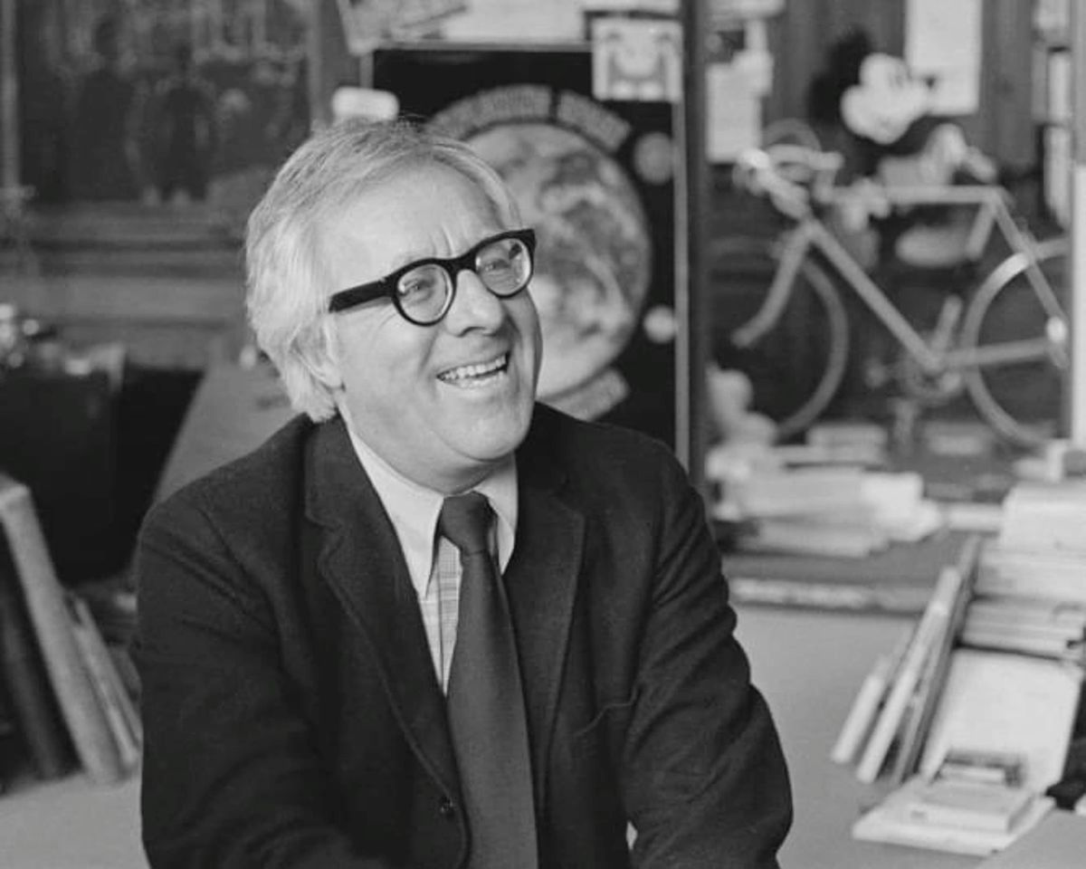

The Rocket, Ray Bradbury

The Rocket

Many nights fiorello bodoni would awaken to hear the rockets sighing in the dark sky. He would tiptoe from bed, certain that his kind wife was dreaming, to let himself out into the night air. For a few moments he would be free of the smells of old food in the small house by the river.

For a silent moment he would let his heart soar alone into space, following the rockets.

Now, this very night, he stood half naked in the darkness, watching the fire fountains murmuring in the air. The rockets on their long wild way to Mars and Saturn and Venus!

“Well, well, Bodoni.”

Bodoni started.

On a milk crate, by the silent river, sat an old man who also watched the rockets through the midnight hush.

“Oh, it’s you, Bramante!”

“Do you come out every night, Bodoni?”

“Only for the air.”

“So? I prefer the rockets myself,” said old Bramante. “I was a boy when they started. Eighty years ago, and I’ve never been on one yet.”

“I will ride up in one someday,” said Bodoni.

“Fool!” cried Bramante. “You’ll never go. This is a rich man’s world.” He shook his gray head, remembering. “When I was young they wrote it in fiery letters: THE WORLD OF THE FUTURE! Science, Comfort, and New Things for All! Ha! Eighty years. The Future becomes Now! Do we fly rockets? No! We live in shacks like our ancestors before us.”

“Perhaps my sons—” said Bodoni.

“No, nor their sons!” the old man shouted. “It’s the rich who have dreams and rockets!”

Bodoni hesitated. “Old man, I’ve saved three thousand dollars. It took me six years to save it. For my business, to invest in machinery. But every night for a month now I’ve been awake. I hear the rockets. I think. And tonight I’ve made up my mind. One of us will fly to Mars!” His eyes were shining and dark.

“Idiot,” snapped Bramante. “How will you choose? Who will go? If you go, your wife will hate you, for you will be just a bit nearer God, in space. When you tell your amazing trip to her, over the years, won’t bitterness gnaw at her?”

“No, no!”

“Yes! And your children? Will their lives be filled with the memory of Papa, who flew to Mars while they stayed here? What a senseless task you will set your boys. They will think of the rocket all their lives. They will lie awake. They will be sick with wanting it. Just as you are sick now. They will want to die if they cannot go. Don’t set that goal, I warn you. Let them be content with being poor. Turn their eyes down to their hands and to your junkyard, not up to the stars.”

“But—”

“Suppose your wife went? How would you feel, knowing she had seen and you had not? She would become holy. You would think of throwing her in the river. No, Bodoni, buy a new wrecking machine, which you need, and pull your dreams apart with it, and smash them to pieces.”

The old man subsided, gazing at the river in which, drowned, images of rockets burned down the sky.

“Good night,” said Bodoni.

“Sleep well,” said the other.

When the toast jumped from its silver box, Bodoni almost screamed. The night had been sleepless. Among his nervous children, beside his mountainous wife, Bodoni had twisted and stared at nothing. Bramante was right. Better to invest the money. Why save it when only one of the family could ride the rocket, while the others remained to melt in frustration?

“Fiorello, eat your toast,” said his wife, Maria.

“My throat is shriveled,” said Bodoni.

The children rushed in, the three boys fighting over a toy rocket, the two girls carrying dolls which duplicated the inhabitants of Mars, Venus, and Neptune, green mannequins with three yellow eyes and twelve fingers.

“I saw the Venus rocket!” cried Paolo.

“It took off, whoosh!” hissed Antonello.

“Children!” shouted Bodoni, hands to his ears.

They stared at him. He seldom shouted.

Bodoni arose. “Listen, all of you,” he said. “I have enough money to take one of us on the Mars rocket.”

Everyone yelled.

“You understand?” he asked. “Only one of us. Who?”

“Me, me, me!” cried the children.

“You,” said Maria.

“You,” said Bodoni to her.

They all fell silent.

The children reconsidered. “Let Lorenzo go—he’s oldest.”

“Let Miriamne go—she’s a girl!”

“Think what you would see,” said Bodoni’s wife to him. But her eyes were strange. Her voice shook. “The meteors, like fish. The universe. The Moon. Someone should go who could tell it well on returning. You have a way with words.”

“Nonsense. So have you,” he objected.

Everyone trembled.

“Here,” said Bodoni unhappily. From a broom he broke straws of various lengths. “The short straw wins.” He held out his tight fist. “Choose.”

Solemnly each took his turn.

“Long straw.”

“Long straw.”

Another.

“Long straw.”

The children finished. The room was quiet.

Two straws remained. Bodoni felt his heart ache in him. “Now,” he whispered. “Maria.”

She drew.

“The short straw,” she said.

“Ah,” sighed Lorenzo, half happy, half sad. “Mama goes to Mars.”

Bodoni tried to smile. “Congratulations. I will buy your ticket today.”

“Wait, Fiorello—”

“You can leave next week,” he murmured.

She saw the sad eyes of her children upon her, with the smiles beneath their straight, large noses. She returned the straw slowly to her husband. “I cannot go to Mars.”

“But why not?”

“I will be busy with another child.”

“What!”

She would not look at him. “It wouldn’t do for me to travel in my condition.”

He took her elbow. “Is this the truth?”

“Draw again. Start over.”

“Why didn’t you tell me before?” he said incredulously.

“I didn’t remember.”

“Maria, Maria,” he whispered, patting her face. He turned to the children. “Draw again.”

Paolo immediately drew the short straw.

“I go to Mars!” He danced wildly. “Thank you, Father!”

The other children edged away. “That’s swell, Paolo.”

Paolo stopped smiling to examine his parents and his brothers and sisters. “I can go, can’t I?” he asked uncertainly.

“Yes.”

“And you’ll like me when I come back?”

“Of course.”

Paolo studied the precious broomstraw on his trembling hand and shook his head. He threw it away. “I forgot. School starts. I can’t go. Draw again.”

But no one would draw. A full sadness lay on them.

“None of us will go,” said Lorenzo.

“That’s best,” said Maria.

“Bramante was right,” said Bodoni.

With his breakfast curdled within him, Fiorello Bodoni worked in his junkyard, ripping metal, melting it, pouring out usable ingots. His equipment flaked apart; competition had kept him on the insane edge of poverty for twenty years.

It was a very bad morning.

In the afternoon a man entered the junkyard and called up to Bodoni on his wrecking machine. “Hey, Bodoni, I got some metal for you!”

“What is it, Mr. Mathews?” asked Bodoni, listlessly.

“A rocket ship. What’s wrong? Don’t you want it?”

“Yes, yes!” He seized the man’s arm, and stopped, bewildered.

“Of course,” said Mathews, “it’s only a mockup. You know. When they plan a rocket they build a full-scale model first, of aluminum. You might make a small profit boiling her down. Let you have her for two thousand—”

Bodoni dropped his hand. “I haven’t the money.”

“Sorry. Thought I’d help you. Last time we talked you said how everyone outbid you on junk. Thought I’d slip this to you on the q.t. Well—”

“I need new equipment. I saved money for that.”

“I understand.”

“If I bought your rocket, I wouldn’t even be able to melt it down. My aluminum furnace broke down last week—”

“Sure.”

“I couldn’t possibly use the rocket if I bought it from you.”

“I know.”

Bodoni blinked and shut his eyes. He opened them and looked at Mr. Mathews. “But I am a great fool. I will take my money from the bank and give it to you.”

“But if you can’t melt the rocket down—”

“Deliver it,” said Bodoni.

“All right, if you say so. Tonight?”

“Tonight,” said Bodoni, “would be fine. Yes, I would like to have a rocket ship tonight.”

There was a moon. The rocket was white and big in the junkyard. It held the whiteness of the moon and the blueness of the stars. Bodoni looked at it and loved all of it. He wanted to pet it and lie against it, pressing it with his cheek, telling it all the secret wants of his heart.

He stared up at it. “You are all mine,” he said. “Even if you never move or spit fire, and just sit there and rust for fifty years, you are mine.”

The rocket smelled of time and distance. It was like walking into a clock. It was finished with Swiss delicacy. One might wear it on one’s watch fob. “I might even sleep here tonight,” Bodoni whispered excitedly.

He sat in the pilot’s seat.

He touched a lever.

He hummed in his shut mouth, his eyes closed.

The humming grew louder, louder, higher, higher, wilder, stranger, more exhilarating, trembling in him and leaning him forward and pulling him and the ship in a roaring silence and in a kind of metal screaming, while his fists flew over the controls, and his shut eyes quivered, and the sound grew and grew until it was a fire, a strength, a lifting and a pushing of power that threatened to tear him in half.

He gasped. He hummed again and again, and did not stop, for it could not be stopped, it could only go on, his eyes tighter, his heart furious. “Taking off!” he screamed. The jolting concussion! The thunder! “The Moon!” he cried, eyes blind, tight. “The meteors!” The silent rush in volcanic light. “Mars. Oh, yes! Mars! Mars!”

He fell back, exhausted and panting. His shaking hands came loose of the controls and his head tilted wildly. He sat for a long time, breathing out and in, his heart slowing.

Slowly, slowly, he opened his eyes.

The junkyard was still there.

He sat motionless. He looked at the heaped piles of metal for a minute, his eyes never leaving them. Then, leaping up, he kicked the levers. “Take off, blast you!”

The ship was silent.

“I’ll show you!” he cried.

Out in the night air, stumbling, he started the fierce motor of his terrible wrecking machine and advanced upon the rocket. He maneuvered the massive weights into the moonlit sky. He readied his trembling hands to plunge the weights, to smash, to rip apart this insolently false dream, this silly thing for which he had paid his money, which would not move, which would not do his bidding. “I’ll teach you!” he shouted.

But his hand stayed.

The silver rocket lay in the light of the Moon. And beyond the rocket stood the yellow lights of his home, a block away, burning warmly. He heard the family radio playing some distant music. He sat for half an hour considering the rocket and the house lights, and his eyes narrowed and grew wide.

He stepped down from the wrecking machine and began to walk, and as he walked he began to laugh, and when he reached the back door of his house he took a deep breath and called, “Maria, Maria, start packing. We’re going to Mars!”

“Oh!”

“Ah!”

“I can’t believe it!”

“You will, you will.”

The children balanced in the windy yard, under the glowing rocket, not touching it yet. They started to cry.

Maria looked at her husband. “What have you done?” she said. “Taken our money for this? It will never fly.”

“It will fly,” he said, looking at it.

“Rocket ships cost millions. Have you millions?”

“It will fly,” he repeated steadily. “Now, go to the house, all of you. I have phone calls to make, work to do. Tomorrow we leave! Tell no one, understand? It is a secret.”

The children edged off from the rocket, stumbling. He saw their small, feverish faces in the house windows, far away.

Maria had not moved. “You have ruined us,” she said. “Our money used for this—this thing. When it should have been spent on equipment.”

“You will see,” he said.

Without a word she turned away.

“God help me,” he whispered, and started to work.

Through the midnight hours trucks arrived, packages were delivered, and Bodoni, smiling, exhausted his bank account. With blowtorch and metal stripping he assaulted the rocket, added, took away, worked fiery magics and secret insults upon it. He bolted nine ancient automobile motors into the rocket’s empty engine room. Then he welded the engine room shut, so none could see his hidden labor.

At dawn he entered the kitchen. “Maria,” he said, “I’m ready for breakfast.”

She would not speak to him.

At sunset he called to the children. “We’re ready! Come on!” The house was silent.

“I’ve locked them in the closet,” said Maria.

“What do you mean?” he demanded.

“You’ll be killed in that rocket,” she said. “What kind of rocket can you buy for two thousand dollars? A bad one!”

“Listen to me, Maria.”

“It will blow up. Anyway, you are no pilot.”

“Nevertheless, I can fly this ship. I have fixed it.”

“You have gone mad,” she said.

“Where is the key to the closet?”

“I have it here.”

He put out his hand. “Give it to me.”

She handed it to him. “You will kill them.”

“No, no.”

“Yes, you will. I feel it.”

He stood before her. “You won’t come along?”

“I’ll stay here,” she said.

“You will understand; you will see then,” he said, and smiled. He unlocked the closet. “Come, children. Follow your father.”

“Good-bye, good-bye, Mama!”

She stayed in the kitchen window, looking out at them, very straight and silent.

At the door of the rocket the father said, “Children, this is a swift rocket. We will be gone only a short while. You must come back to school, and I to my business.” He took each of their hands in turn. “Listen. This rocket is very old and will fly only one more journey. It will not fly again. This will be the one trip of your life. Keep your eyes wide.”

“Yes, Papa.”

“Listen, keep your ears clean. Smell the smells of a rocket. Feel. Remember. So when you return you will talk of it all the rest of your lives.”

“Yes, Papa.”

The ship was quiet as a stopped clock. The airlock hissed shut behind them. He strapped them all, like tiny mummies, into rubber hammocks. “Ready? he called.

“Ready!” all replied.

“Blast-off!” He jerked ten switches. The rocket thundered and leaped. The children danced in their hammocks, screaming. “We’re moving! We’re off! Look!”

“Here comes the Moon!”

The moon dreamed by. Meteors broke into fireworks. Time flowed away in a serpentine of gas. The children shouted. Released from their hammocks, hours later, they peered from the ports. “There’s Earth!” “There’s Mars!”

The rocket dropped pink petals of fire while the hour dials spun; the child eyes dropped shut. At last they hung like drunken moths in their cocoon hammocks.

“Good,” whispered Bodoni, alone.

He tiptoed from the control room to stand for a long moment, fearful, at the airlock door.

He pressed a button. The airlock door swung wide. He stepped out. Into space? Into the inky tides of meteor and gaseous torch? Into swift mileages and infinite dimensions?

No. Bodoni smiled.

All about the quivering rocket lay the junkyard.

Rusting, unchanged, there stood the padlocked junkyard gate, the little silent house by the river, the kitchen window lighted, and the river going down to the same sea. And in the center of the junkyard, manufacturing a magic dream, lay the quivering, purring rocket. Shaking and roaring, bouncing the netted children like flies in a web.

Maria stood in the kitchen window.

He waved to her and smiled.

He could not see if she waved or not. A small wave, perhaps. A small smile.

The sun was rising.

Bodoni withdrew hastily into the rocket. Silence. All still slept. He breathed easily. Tying himself into a hammock, he closed his eyes. To himself he prayed, Oh, let nothing happen to the illusion in the next six days. Let all of space come and go, and red Mars come up under our ship, and the moons of Mars, and let there be no flaws in the color film. Let there be three dimensions; let nothing go wrong with the hidden mirrors and screens that mold the fine illusion. Let time pass without crisis.

He awoke.

Red Mars floated near the rocket.

“Papa!” The children thrashed to be free.

Bodoni looked and saw red Mars and it was good and there was no flaw in it and he was very happy.

At sunset on the seventh day the rocket stopped shuddering.

“We are home,” said Bodoni.

They walked across the junkyard from the open door of the rocket, their blood singing, their faces glowing. Perhaps they knew what he had done. Perhaps they guessed his wonderful magic trick. But if they knew, if they guessed, they never said. Now they only laughed and ran.

“I have ham and eggs for all of you,” said Maria, at the kitchen door.

“Mama, Mama, you should have come, to see it, to see Mars, Mama, and meteors, and everything!”

“Yes,” she said.

At bedtime the children gathered before Bodoni. “We want to thank you, Papa.”

“It was nothing.”

“We will remember it for always, Papa. We will never forget.”

Very late in the night Bodoni opened his eyes. He sensed that his wife was lying beside him, watching him. She did not move for a very long time, and then suddenly she kissed his cheeks and his forehead. “What’s this?” he cried.

“You’re the best father in the world,” she whispered.

“Why?”

“Now I see,” she said. “I understand.”

She lay back and closed her eyes, holding his hand. “Is it a very lovely journey?” she asked.

“Yes,” he said.

“Perhaps,” she said, “perhaps, some night, you might take me on just a little trip, do you think?”

“Just a little one, perhaps,” he said.

“Thank you,” she said. “Good night.”

“Good night,” said Fiorello Bodoni.

The end