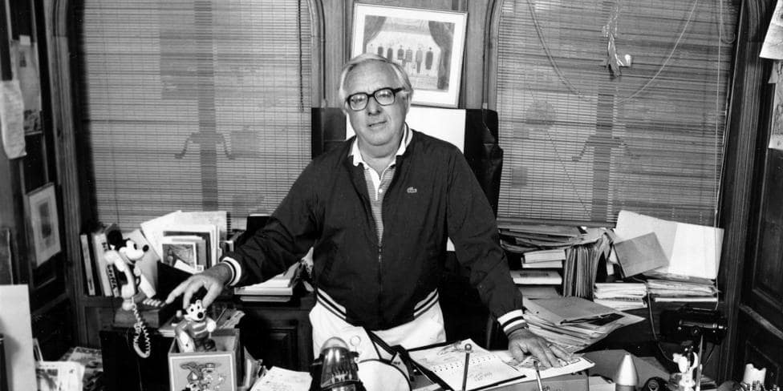

The Tombling Day, Ray Bradbury

The Tombling Day

It was the Tombling day, and all the people had walked up the summer road, including Grandma Loblilly, and they stood now in the green day and the high sky country of Missouri, and there was a smell of the seasons changing and the grass breaking out in flowers.

"Here we are," said Grandma Loblilly, over her cane, and she gave them all a flashing look of her yellow-brown eyes and spat into the dust.

The graveyard lay on the side of a quiet hill. It was a place of sunken mounds and wooden markers; bees hummed all about in quietudes of sound and butterflies withered and blossomed on the clear blue air. The tall sunburnt men and ginghamed women stood a long silent time looking in at their deep and buried relatives.

"Well, let's get to work!" said Grandma, and she hobbled across the moist grass, sticking it rapidly, here and there, with her cane.

The others brought the spades and special crates, with daisies and lilacs tied brightly to them. The government was cutting a road through here in August and since this graveyard had gone unused in fifty years the relatives had agreed to untuck all the old bones and pat them snug somewhere else.

Grandma Loblilly got right down on her knees and trembled a spade in her hand. The others were busy at their own places.

"Grandma," said Joseph Pikes, making a big shadow on her working. "Grandma, you shouldn't be workin' on this place. This's William Simmons's grave, Grandma."

At the sound of his voice, everyone stopped working, and listened, and there was just the sound of butterflies on the cool afternoon air.

Grandma looked up at Pikes. "You think I don'tknowit's his place? I ain't seen William Simmons in sixty years, but I intend to visit him today." She patted out trowel after trowel of rich soil and she grew quiet and introspective and said things to the day and those who might listen.

"Sixty years ago, and him a fine man, only twenty-three. And me, I was twenty and all golden about the head and all milk in my arms and neck and persimmon in my cheeks. Sixty years and a planned marriage and then a sickness and him dying away. And me alone, and I remember how the earth mound over him sank in the rains—"

Everybody stared at Grandma. "But still, Grandma—" said Joseph Pikes. The grave was shallow. She soon reached the long iron box.

"Gimme a hand!" she cried.

Nine men helped lift the iron box out of the earth,

Grandma poking at them with her cane. "Careful!" she shouted. "Easy!" she cried. "Now." They set it on the ground. "Now," she said, "if you be so kindly, you gentlemen might fetch Mr. Simmons on up to my house for a spell."

"We're takin' him on to the new cemetery," said Joseph Pikes.

Grandma fixed him with her needle eye. "You just trot that box right up to my house. Much obliged."

The men watched her dwindle down the road. They looked at the box, looked at each other, and then spat on their hands.

Five minutes later the men squeezed the iron coffin through the front door of Grandma's little white house and set the box down by the potbelly stove.

She gave them a drink all around. "Now, let's lift the lid," she said. "It ain't every day you see old friends."

The men did not move.

"Well, if you won't, I will." She thrust at the lid with her cane, again and again, breaking away the earth crust. Spiders went touching over the floor. There was a rich smell, like plowed spring earth. Now the men fingered the lid. Grandma stood back. "Up!" she said. She gestured her cane, like an ancient goddess. And up in the air went the lid. The men set it on the floor and turned.

There was a sound like wind sighing in October, from all their mouths.

There lay William Simmons as the dust filtered bright and golden through the air. There he slept, a little smile on his lips, hands folded, all dressed up and no place in all the world to go.

Grandma Loblilly gave a low moaning cry.

"He's all there!"

There he was, indeed. Intact as a beetle in his shell, his skin all fine and white, his small eyelids over his pretty eyes like flower petals put there, his lips still with color to them, his hair combed neat, his tie tied, his fingernails pared clean. All in all, he was as complete as the day they shoveled the earth upon his silent case.

Grandma stood tightening her eyes, her hands up to catch the breath that moved from her mouth. She couldn't see. "Where's my specs?" she cried. People searched. "Can't you find 'em?" she shouted. She squinted at the body. "Never mind," she said, getting close. The room settled. She sighed and quavered and cooed over the open box.

"He's kept," said one of the women. "He ain't crumbled."

"Things like that," said Joseph Pikes, "don't happen."

"Ithappened." said the woman.

"Sixty years underground. Stands to reason no man lasts that long."

The sunlight was late by each window, the last butterflies were settling amongst flowers to look like nothing more than other flowers.

Grandma Loblilly put out her wrinkly hand, trembling. "The earth kept him. The way the air is. That was good dry soil for keeping."

"He's young," wailed one of the women, quietly. "So young."

"Yes," said Grandma Loblilly, looking at him. "Him, lying there, twenty-three years old. And me, standing here, pushing eighty!" She shut her eyes.

"Now, Grandma," Joseph Pikes touched her shoulder.

"Yes, him lyin' there, all twenty-three and fine and party, andme—" She squeezed her eyes tight. "Me bending over him, never young agin, myself, only old and spindly, never to have a chance at being young agin.

Oh, Lord! Death keeps people young. Look how kind death's been to him." she ran her hands over her body and face slowly, turning to the others. "Death's nicer than life. Why didn' I die then too? Then we'd both be young now, together. Me in my box, in my white wedding gown all lace, and my eyes closed down, all shy with death. And my hands making a prayer on my bosom."

"Grandma, don't carry on."

"I got a right to carry on! Why didn't 1 die, too? Then, when he came back, like he came today, to see me, I wouldn't: be likethis!"

Her hands went wildly to feel her lined face, to twist the loose skin, to fumble the empty mouth, to yank the gray hair and look at it with appalled eyes.

"What a fine coming-back he's had!" She showed her skinny arms. "Think that a man of twenty-three years will want the likes of a seventy-nine-year-old woman with sump-rot in her veins? I been cheated! Death kept him young forever. Look at me; didLifedo so much?"

"They're compensations," said Joseph Pikes. "He ain't young, Grandma. He's long over eighty years."

"You're a fool, Joseph Pikes. He's fine as a stone, not touched by a thousand rains. And he's come back to see me and he'll be picking one of the younger girls now. What would he want with an old woman?"

"He's in no way to fetch nuthin' offa nobody," said Joseph Pikes.

Grandma pushed him back. "Get out now, all of you! Ain't your box, ain't your lid, and it ain't your almost-husband! You leave the box here, leastwise tonight, and tomorrow you dig a new burying place."

"Awright, Grandma; he was your beau. I'll come early tomorra. Don't you cry, now."

"I'll do what my eyes most need to do."

She stood stiff in the middle of the room until the last of them were out the door. After awhile she got a candle and lit it and she noticed someone standing on the hill outside. It was Joseph Pikes. He'd be there the rest of the night, she reckoned, and she did not shout for him to go away.

She did not look out the window again, but she knew he was there, and so was much better rested in the following hours.

She went to the coffin and looked down at William Simmons.

She gazed fully upon him. Seeing his hands was like seeing actions. She saw how they had been with reins of a horse in them, moving up and down. She remembered how the lips of him had clucked as the carriage had glided along with an even pacing of the horse through the meadowlands, the moonlight shadows all around.

She knew how it was when those hands held to you.

She touched his suit. "That's not the same suit he was buried in!" she cried suddenly. And yet she knew it was the same. Sixty years had changed not the suit but the linings of her mind.

Seized with a quick fear, she hunted a long time until she found her spectacles and put them on.

"Why,that'snot William Simmons!" she shouted.

But she knew this also was untrue. It was William Simmons. "His chin didn't go back that far!" she cried softly, logically. "Ordidit?" And his hair, "It was a wonderful sorrel color, I remember! This hair here's just plain brown. And his nose, I don't recall it being that tippy!"

She stood over this strange man and, gradually, as she watched, she knew that this indeed was William Simmons. She knew a thing she should have known all along: that dead people are like wax memory—you take them in your mind, you shape and squeeze them, push a bump here, stretch one out there, pull the body tall, shape and reshape, handle, sculp and finish a man-memory until he's all out of kilter.

There was a certain sense of loss and bewilderment in her. She wished she had never opened the box. Or, leastwise, had the sense to leave her glasses off. She had not seen him clearly at first; just enough so she filled in the rough spots with her mind. Now, with her glasses on …

She glanced again and again at his face. It became slowly familiar. That memory of him that she had torn apart and put together for sixty years faded to be replaced by the man she hadreallyknown. And he wasfineto look upon. The sense of having lost something vanished.

He was the same man, no more, no less. This was always the way when you didn't see people for years and they came back to say howdy-do. For a spell you felt so very uneasy with them. But then, at last you relaxed.

"Yes, that's you," she laughed. "I see you peeking out from behind all the strangeness. I see you all glinty and sly here and there and about."

She began to cry again. If only she could lie to herself, if only she could say, "Look at him, he don't look the same, he's not the same man I took a fetching on!" then she could feel better. But all the little inside-people sitting around in her head would rock back in their tiny rockers and cackle and say, "You ain't foolin' us none, Grandma."

Yes, how easy to deny it was him. And feel better. But she didn't deny it. She felt the great depressing sadness because here he was, young as creek water, and here she was, old as the sea.

"William Simmons!" she cried. "Don't look at me! I know you still love me, so I'll primp myself up!"

She stirred the stove-fire, quickly put irons on to heat, used irons on her hair till it was all gray curls. Baking powder whitened her cheeks! She bit a cherry to color her lips, pinched her cheeks to bring a flush. From a trunk she yanked old materials until she found a faded blue velvet dress which she put on.

She stared wildly in the mirror at herself.

"No, no." She groaned and shut her eyes. "There's nothing I can do to make me younger'n you, William Simmons! Even if I died now it wouldn't cure me of this old thing come on me, this disease—"

She had a violent wish to run forever in the woods, fall in a leaf pile and moulder down into smoking ruin with them. She ran across the room, intending never to come back. But as she yanked the door wide a cold wind exploded over her from outside and she heard a sound that made her hesitate.

The wind rushed about: the room, yanked at the coffin and pushed inside it.

William Simmons seemed to stir in his box.

Grandma slammed the door.

She moved slowly back to squint at him.

He was ten years older.

There were wrinkles and lines on his hands and face.

"William Simmons!"

During the next hour, William Simmons's face tolled away the years. His cheeks went in on themselves, like clenching a fist, like withering an apple in a bin. His flesh was made of carved pure white snow, and the cabin heat melted it. It got a charred look. The air made the eyes and mouth pucker. Then, as if struck a hammer blow, the face shattered into a million wrinkles. The body squirmed in an agony of time.

It was forty, then fifty, then sixty years old! It was seventy, eighty, one hundred years! Burning, burning away! There were small whispers and leaf-crackles from its face and its age-burning hands, one hundred ten, one hundred twenty years, lined upon etched, greaved, line!

Grandma Loblilly stood there all the cold night, aching her bird bones, watching, cold, over the changing man. She was a witness to all improbabilities. She felt something finally let loose of her heart. She did not feel sad any more. The weight lifted away from her.

She went peacefully to sleep, standing against a chair.

Sunlight came yellow through the woodland, birds and ants and creek waters were moving, each as quiet as the other, going somewhere.

It was morning.

Grandma woke and looked down upon William Simmons.

"Ah," said Grandma, looking and seeing.

Her very breath stirred and stirred his bones until they flaked, like a chrysalis, like a kind of candy all whittling away, burning with an invisible fire. The bones flaked and flew, light as pieces of dust on the sunlight. Each time she shouted the bones split asunder, there was a dry flaking rustle from the box.

If there was a wind and she opened the door, he'd be blown away on it like so many crackly leaves!

She bent for a long time, looking at the box. Then she gave a knowing cry, a sound of discovery arid moved back, putting her hands first to her face and then to her spindly breasts and then traveling all up and down her arms and legs and fumbling at her empty mouth,

Her shout brought Joseph Pikes running.

He pulled up at the door only in time to see Grandma Loblilly dancing and jumping around on her yellow, high-peg shoes in a wild gyration.

She clapped her hands, laughed, flung her skirts, ran in a circle, and did a little waltz with herself, tears on her face. And to the sunlight and the flashing image of herself in the wall mirror she cried:

"I'm young! I'm eighty, but I'm younger'nhim!"

She skipped, she hopped, and she curtsied.

"There are compensations, Joseph Pikes; you was right!" she chortled. "I'm younger'nallthe dead ones in the whole world!"

And she waltzed so violently the whirl of her dress pulled at the box and whispers of chrysalis leapt on the air to hang golden and powdery amidst her shouts.

"Whee-deee!" she cried. "Whee-heee!"

The End