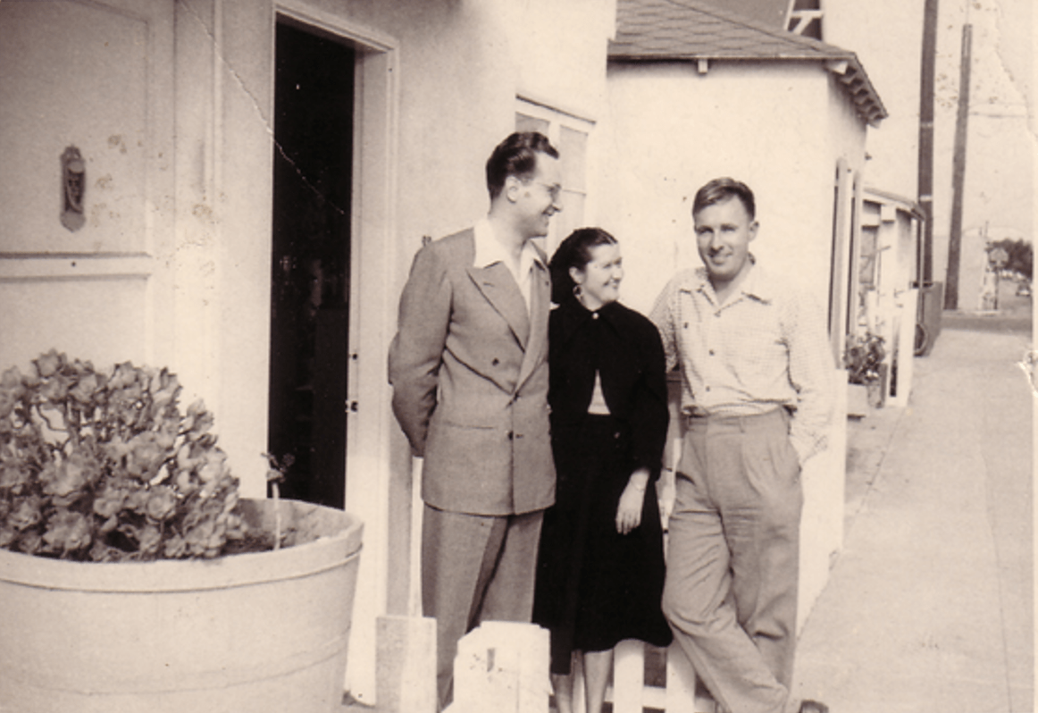

The Traveler, Ray Bradbury

The Traveler

Father looked into Cecy's attic-space just before dawn. She lay upon the riverbed sands, quietly. He shook his head and waved at her.

"Now, if you can tell me what good she does, lying there," he said, "I'll devour the crepe on our porch windows. Sleeping all night, eating breakfast, and then sleeping again all day."

"Oh, but she's helpful!" explained Mother, leading him downstairs away from Cecy's slumbering pale figure. "Why, she's one of the busiest members of the Family. What good are your brothers who sleep all day and do nothing?"

They glided down through the scent of black candles, the black crepe on the banister whispering as they passed.

"Well, we work nights," Father said. "Can we help it if we're as you put it old-fashioned?"

"Of course not. Everyone in the Family can't be of the age." She opened the cellar door and they stepped down in darkness. "It's really very lucky I don't have to sleep at all. If you were married to a night-sleeper, what a marriage!

Each of us to our own. All wild. That's how the Family goes. Sometimes like Cecy, all mind; and then there's Uncle Einar, all wing; and then again there's Timothy, all calm and worldly normal. You, sleeping days. And me, awake all and all of my life. So Cecy shouldn't be too much to understand. She helps in a million ways. She sails her mind to the greengrocer's for me! Or occupies the butcher's head to see if he's fresh out of good cuts. She warns me when gossips threaten to visit and spoil the afternoon. She's a travel pomegranate full of flights!"

They paused in the cellar near a large empty mahogany bin. He settled himself in. "But if she'd only contribute more," he said. "I must insist that she find real work."

"Sleep on it," she said. "You may change your mind by sunset."

She shut the bin on him.

"Well," he said.

"Good morning, dear," she said.

"Good morning," he said, muffled, enclosed.

The sun rose. She hurried upstairs.

Cecy awoke from a deep dream of sleep.

She looked upon reality and decided her wild and special world was the very world she preferred and needed. The dim outlines of the dry desert attic were familiar, as were the sounds below in a House that was all stir and bustle and wing-flurry at sunset, but now at noon was still with that dead stillness that the ordinary world assumes. The sun was fixed in the sky and the Egyptian sands that were her dreaming bed only waited for her mind with a mysterious hand to touch and inscribe there the charting of her travels.

All this she sensed and knew, and so with a dreamer's smile she settled back with her long and beautiful hair as cushion to sleep and dream and in her dreams …

She traveled.

Her mind slipped over the flowered yard, the fields, the green hills, over the ancient drowsy streets of town, into the wind and past the moist depression of the ravine. All day she would fly and meander. Her mind would pop into dogs to sit, all bristles, and taste ripe bones, sniff tangy-urined trees to hear as dogs hear, run as dogs run, all smiles. It was more than telepathy, up one flue and down another. It was entry to lazing cats, old lemony maids, hopscotch girls, lovers on morning beds, then unborn babes' pink, dream-small brains.

Where would she go today?

She decided.

She went!

At this very instant there burst into the silent House below a fury of madness. A man, a crazed uncle of such reputation as would cause all in the Family to start and pull back in their own midnights. An uncle from the times of the Transylvanian wars and a crazed lord of a dreadful manor who impaled his enemies on spikes thrust into their bowels to leave them suspended, thrashing in horrible deaths.

This uncle, John the Unjust, had arrived from dark lower Europe some months past only to discover there was no room for his decayed persona and his dreadful past. The Family was strange, perhaps outré, in some degree rococo, but not a scourge, a disease, an annihilation such as he represented with crimson eye, razored teeth, taloned claw, and the voice of a million impaled souls.

A moment after his mad burst into the noon-quiet House, empty save for Timothy and his mother who stood guard while the others slept under threat by the sun, John the Terrible elbowed them out of the way and ascended with ravening voice to rage the dreaming sands around Cecy, causing a Sahara storm about her peace.

"Damn!" he cried. "Is she here? Am I too late?"

"Get back," said the dark mother rising in the attic confines with Timothy near. "Are you blind? She's gone and might not be back for days!"

John the Terrible, the Unjust, kicked the sands at the sleeping maid. He seized her wrist to find a hidden pulse. "Damn!" he cried again. "Call her back. I need her!"

"You heard me!" Mother moved forward. "She's not to be touched. She's got to be left as she is."

Uncle John turned his head. His long hard red face was pocked and senseless.

"Where'd she go? I must find her!"

Mother spoke quietly. "You might find her in a child running in the ravine. You might find her in a crayfish under a rock in the creek. Or she might be playing chess behind an old man's face in the courthouse square." A wry look touched the mother's mouth. "She might be here now, looking out at you, laughing, not telling. This might be her talking with great fun."

"Why " He swung heavily around. "If I thought"

Mother continued, quietly. "Of course she's not here. And if she was, there'd be no way to tell." Her eyes gleamed with a delicate malice. "Why do you need her?"

He listened to a distant bell, tolling. He shook his head, angrily.

"Something … inside … " He broke off. He leaned over her warm, sleeping body. "Cecy! Come back! You can if you want!"

The wind blew softly outside the sun-feathered windows. The sand drifted under her quiet arms. The distant bell tolled again and he listened to the drowsy summer-day sound of it, far, far away.

"I've worked for her. The past month, awful thoughts. I was going to take the train to the city for help. But Cecy can catch these fears. She can clean the cobwebs, make me new. You see? She's got to help!"

"After all you've done to the Family?" said Mother.

"I did nothing!"

"When we had no room here, when we were full to the gables, you swore at us"

"You have always hated me!"

"We feared you, perhaps. You have a history that is dreadful."

"No reason to turn me away!"

"Much reason. Nevertheless, if there had been room"

"Lies. Lies!"

"Cecy wouldn't help you. The Family wouldn't approve."

"Damn the Family!"

"You have damned them. Some have disappeared in the past month since our refusal. You have been gossiping in town; it's only a matter of time before they might come after us."

"They might! I drink and talk. Unless you help, I might drink more. These damned bells! Cecy can stop them."

"These bells," said the lonely wraith of a woman. "When did they begin? How long have you heard them?"

"Long?" He paused and rolled his eyes back as if to see. "Since you locked me out. Since I went and" He froze.

"Drank and talked too much and made the winds blow the wrong way around our roofs?"

"I did no such thing!"

"It's in your face. You speak one thing and threaten another."

"Hear this, then," John the Terrible said. "Listen, dreamer." He stared at Cecy. "If you don't return by sunset, to shake my mind, clear my head … "

"You have a list of all our dearest souls, which you will revise and publish with your drunken tongue?"

"You said it, I didn't."

He stopped, eyes shut. The distant bell, the holy, holy bell was tolling again. It tolled, it tolled, it tolled.

He shouted over its sound. "You heard me!"

He reared to plunge out of the attic.

His heavy shoes pounded away, down the stairs. When the noises were gone, the pale woman turned to look, quietly, at the sleeper.

"Cecy," she called softly. "Come home!"

There was only silence. Cecy lay, not moving, for as long as her mother waited.

John the Terrible, the Unjust, strode through the fresh open country and into the streets of town, searching for her in every child that licked an ice pop and in every small white dog that padded by on its way to some eagerly anticipated nowhere.

Uncle John stopped to wipe his face with his handkerchief. I'm afraid, he thought. Afraid.

He saw a code of birds strung dot-dash on the high telephone wires. Was she up there laughing at him with sharp bird eyes, shuffling feathers, singing?

Distantly, as on a sleepy Sunday morning, he heard the bells ringing in a valley in his head. He stood in blackness where pale faces drifted.

"Cecy!" he cried, to everything, everywhere. "I know you can help! Shake me! Shake me!"

Standing with the downtown cigar store Indian for conversation, John shook his head violently.

What if he never found her? What if the winds had borne her off to Elgin where she dearly loved to bide her time? The asylum for the insane, might she now be touching and turning their confetti thoughts?

Far-flung in the afternoon a great metal whistle sighed and echoed; steam shuffled as a train cut across valley trestles, over cool rivers through ripe corn-fields, into tunnels, under arches of shimmering walnut trees. John stood, afraid. What if Cecy hid in the cabin of the engineer's head? She loved riding the monster engines. Yank the whistle rope to shriek across sleeping night land or drowsy day country.

He walked along a shady street. From the corners of his eyes he thought he saw an old woman, wrinkled as a fig, naked as a thistle-seed, among the branches of a hawthorn tree, a cedar stake driven in her chest.

Something screamed and thumped his head. A blackbird, soaring, snatched his hair.

"Damn!"

He saw the bird circle, awaiting another chance.

He heard a whirring sound.

He grabbed.

He had the bird! It squalled in his hands.

"Cecy!" he cried at his caged fingers and the wild black creature. "Cecy, I'll kill you if you don't help!"

The bird shrieked.

He closed his fingers tight, tight!

He walked away from where he dropped the dead thing and did not look back.

He walked down into the ravine and on the creek bank he laughed to think of the Family scurrying madly, trying to find some escape from him.

BB-shot eyes lay deep in the water, staring up.

On blazing hot summer noons, Cecy had often entered into the soft-shelled grayness of the mandibled heads of crayfish, peeking from the black egg eyes on their sensitive filamentary stalks to feel the creek sluice, steadily, in veils of coolness and captured light.

The realization that she might be near, in squirrels or chipmunks, or even … my god, think!

On sweltering summer noons, Cecy would thrive in amoebae, vacillating, deep in the philosophical dark waters of a kitchen well. On days when the world was a dreaming nightmare of heat printed on each object of the land, she'd lie, quivering, cool, and distant, in the well-throat.

John stumbled, fell flat into the creek water.

The bells rang louder. And now, one by one, a procession of bodies seemed to float by. Worm-white creatures drifting like marionettes. Passing, the tide bobbed their heads so their faces rolled, revealing the features of the Family.

He began to weep, sitting in the water. Then he stood up, shaking, and walked out of the creek and up the hill. There was only one thing to do.

John the Unjust, the Terrible, staggered into the police station in the late afternoon, barely able to stand, his voice a retching whisper.

The sheriff took his feet down off his desk and waited for the wild man to gain his breath and speak.

"I am here to report a family," he gasped. "A family of sin and wickedness who abide, who hide, seen but unseen, here, there, nearby."

The sheriff sat up. "A family? And wicked, you say?" He picked up a pencil. "Just where?"

"They live" The wild man stopped. Something had struck him in the chest. Blinding lights burned his eyes. He swayed.

"Could you give me a name?" said the sheriff, mildly curious.

"Their name" Again a terrific blow struck his midriff. The church bells exploded.

"Your voice, my god, your voice!" cried John.

"My voice?"

"It sounds like" John pushed his hand out toward the sheriff's face. "Like"

"Yes?"

"It's her voice. She's behind your eyes, back of your face, on your tongue!"

"Fascinating," said the sheriff, smiling, his voice terribly soft and sweet. "You were going to give me a name, a family, a place"

"No use. If she's here. If your tongue is her tongue. Gods!"

"Try," said the fine and gentle voice inside the sheriffs face.

"The Family is!" cried the staggering, raving man. "The House is!" He fell back, struck again in his heart. The bells roared. The church bells wielded him as iron clapper.

He cried a name. He shouted a place.

Then, riven, he lunged out of the office.

After a long moment the sheriffs face relaxed. His voice changed. Low now and brusque, he seemed stunned in recall.

"What," he asked himself, "did someone say? Damn, damn. What was that name? Quick, write it down. And that house? Where did someone say?"

He looked at his pencil.

"Oh, yeah," he said at last. And again, "Yeah."

The pencil moved. He wrote.

The trapdoor to the attic burst upward and the terrible, the unjust man was there. He stood over Cecy's dreaming body.

"The bells," he said, his hands to his ears. "They're yours! I should've known. Hurting me, punishing me. Stop! We'll burn you! I'll bring the mob. Oh God, my head!"

With one last crushing gesture he crammed his fist to his ears and dropped dead.

The lonely woman of the House moved to look down at the body while Timothy, in the shadows, felt his companions panic and twitch and hide.

"Oh, Mother," said Cecy's quiet voice from her wakened lips. "I tried to stop him. Didn't. He named our name, he said our place. Will the sheriff remember?"

The lonely woman of midnights had no answer.

Timothy, in the shadows, listened.

From Cecy's lips far off and now near and clear came the soundings of the bells, the bells, the awful holy bells.

The sounding of the bells.

The End