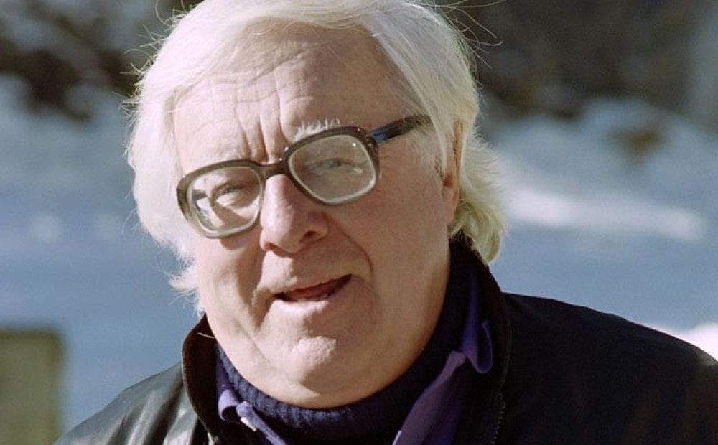

The Utterly Perfect Murder, Ray Bradbury

The Utterly Perfect Murder

It was such an utterly perfect, such an incredibly delightful idea for murder, that I was half out of my mind all across America.

The idea had come to me for some reason on my forty-eighth birthday. Why it hadn't come to me when I was thirty or forty, I cannot say. Perhaps those were good years and I sailed through them unaware of time and clocks and the gathering of frost at my temples or the look of the lion about my eyes. …

Anyway, on my forty-eighth birthday, lying in bed that night beside my wife, with my children sleeping through all the other quiet moonlit rooms of my house, I thought:

I will arise and go now and kill Ralph Underhill. Ralph Underhill I cried, who is he?

Thirty-six years later, kill him? For what?

Why, I thought, for what he did to me when I was twelve. My wife woke, an hour later, hearing a noise.

"Doug?" she called. "What are you doing?" "Packing," I said. "For a journey."

"Oh," she murmured, and rolled over and went to sleep.

"Board! All aboard!" the porter's cries went down the train platform. The train shuddered and banged.

"See you!" I cried, leaping up the steps. "Someday," called my wife, "I wish you'd fly!"

Fly? I thought, and spoil thinking about murder all across the plains? Spoil oiling the pistol and loading it and thinking of Ralph Underhill's face when I show up thirty-six years late to settle old scores? Fly? Why, I would rather pack cross-country on foot, pausing by night to build fires and fry my bile and sour spit and eat again my old, mummified but still-living antagonisms and touch those bruises which have never healed. Fly?!

The train moved. My wife was gone. I rode off into the Past.

Crossing Kansas the second night, we hit a beaut of a thunderstorm. I stayed up until four in the morning, listening to the rave of winds and thunders. At the height of the storm, I saw my face, a darkroom negative-print on the cold window glass, and thought:

Where is that fool going? To kill Ralph Underhill! Why? Because!

Remember how he hit my arm? Bruises. I was covered with bruises, both arms; dark blue, mottled black, strange yellow bruises. Hit and run, that was Ralph, hit and run—

And yet . . . you loved him?

Yes, as boys love boys when boys are eight, ten, twelve, and the world is innocent and boys are evil beyond evil because they know what they do, but do it anyway. So, on some secret level, I had to be hurt. We dear fine friends needed each other. I to be hit. He to strike. My scars were the emblem and symbol of our love.

What else makes you want to murder Ralph so late in time?

The train whistle shrieked. Night country rolled by.

And I recalled one spring when I came to school in a new tweed knicker suit and Ralph knocking me down, rolling me in snow and fresh brown mud. And Ralph laughing and me going home, shamefaced, covered with slime, afraid of a beating, to put on fresh dry clothes.

Yes! And what else?

Remember those toy clay statues you longed to collect from the Tarzan radio show? Statues of Tarzan and Kala the Ape and Nurna the Lion,' for just twenty-five cents?! Yes, yes! Beautiful! Even now, in memory, 0 the sound of the Ape man swinging through green jungles far away, ululating!' But who had twenty-five cents in the middle of the Great Depression? No one.

Except Ralph Underhill.

And one day Ralph asked you if you wanted one of the statues. Wanted! you cried. Yes! Yes!

That was the same week your brother in a strange seizure of love mixed with contempt gave you his old, but expensive, baseball-catcher's mitt.

"Well," said Ralph, "I'll give you my extra Tarzan statue if you'll give me that catcher's mitt."

Fool! I thought. The statue's worth twenty-five cents. The glove cost two dollars! No fair! Don't!

But I raced back to Ralph's house with the glove and gave it to him and he, smiling a worse contempt than my brother's, handed me the Tarzan statue and, bursting with joy, I ran home.

My brother didn't find out about his catcher's mitt and the statue for two weeks, and when he did he ditched me when we hiked out in farm country and left me lost because I was such a sap. "Tarzan statues! Baseball mitts!" he cried. "That's the last thing I ever give you!"

And somewhere on a country road I just lay down and wept and wanted to die but didn't know how to give up the final vomit that was my miserable ghost.

The thunder murmured.

The rain fell on the cold Pullman-car windows. What else? Is that the list?

No. One final thing, more terrible than all the rest.

In all the years you went to Ralph's house to toss up small bits of gravel on his Fourth of July six-in-the-morning fresh dewy window or to call him forth for the arrival of dawn circuses in the cold fresh blue railroad stations in late June or late August, in all those years, never once did Ralph run to your house.

Never once in all the years did he, or anyone else, prove their friendship by coming by. The door never knocked. The window of your bedroom never faintly clattered and belled with a high-tossed confetti of small dusts and rocks.

And you always knew that the day you stopped going to Ralph's house, calling up in the morn, that would be the day your friendship ended.

You tested it once. You stayed away for a whole week. Ralph never called. It was as if you had died, and no one came to your funeral.

When you saw Ralph at school, there was no surprise, no query, not even the faintest lint of curiosity to be picked off your coat. Where were you, Doug? I need someone to beat. Where you been, Doug, I got no one to pinch?

Add all the sins up. But especially think on the last:

He never came to my house. He never sang up to my early-morning bed or tossed a wedding rice of gravel on the clear panes to call me down to joy and summer days.

And for this last thing, Ralph Underhill, I thought, sitting in the train at four in the morning, as the storm faded, and I found tears in my eyes, for this last and final thing, for that I shall kill you tomorrow night.

Murder, I thought, after thirty-six years. Why, you're madder than Ahab.

The train wailed. We ran crosscountry like a mechanical Greek Fate carried by a black metal Roman Fury.

They say you can't go home again. That is a lie.

If you are lucky and time it right, you arrive at sunset when the old town is filled with yellow light.

I got off the train and walked up through Green Town and looked at the courthouse, burning with sunset light. Every tree was hung with gold doubloons of color. Every roof and coping and bit of gingerbread was purest brass and ancient gold.

I sat in the courthouse square with dogs and old men until the sun had set and Green Town was dark. I wanted to savor Ralph Underhill's death.

No one in history had ever done a crime like this.

I would stay, kill, depart, a stranger among strangers.

How would anyone dare to say, finding Ralph Underhill's body on his doorstep, that a boy aged twelve, arriving on a kind of Time Machine train, traveled out of hideous self-contempt, had gunned down the Past? It was beyond all reason. I was safe in my pure insanity.

Finally, at eight-thirty on this cool October night, I walked across town, past the ravine.

I never doubted Ralph would still be there. People do, after all, move away. . . .

I turned down Park Street and walked two hundred yards to a single streetlamp and looked across. Ralph Underhill's white two-story Victorian house waited for me.

And I could feel him in it.

He was there, forty-eight years old, even as I felt myself here, forty-eight, and full of an old and tired and self-devouring spirit.

I stepped out of the light, opened my suitcase, put the pistol in my right-hand coat pocket, shut the case, and hid it in the bushes where, later, I would grab it and walk down into the ravine and across town to the train.

I walked across the street and stood before his house and it was the same house I had stood before thirty-six years ago. There were the windows upon which I had buried those spring bouquets of rock in love and total giving. There were the sidewalks, spotted with firecracker burn marks from ancient July Fourths when Ralph and I had just blown up the whole damned world, shrieking celebrations.

I walked up on the porch and saw on the mailbox in small letters: UNDERHILL. What if his wife answers?

No, I thought, he himself, with absolute Greek-tragic perfection, will open the door and take the wound and almost gladly die for old crimes and minor sins somehow grown to crimes.

I rang the bell.

Will he know me, I wondered, after all this time? In the instant before the first shot, tell him your name. He must know who it is.

Silence.

I rang the bell again. The doorknob rattled.

I touched the pistol in my pocket, my heart hammering, but did not take it out. The door opened.

Ralph Underhill stood there. He blinked, gazing out at me. "Ralph?" I said.

"Yes—?" he said.

We stood there, riven, for what could not have been more than five seconds. But many things happened in those five swift seconds.

I saw Ralph Underhill. I saw him clearly.

And I had not seen him since I was twelve.

Then, he had towered over me to pummel and beat and scream. Now he was a little old man.

I am five foot eleven.

But Ralph Underhill had not grown much from his twelfth year on.

The man who stood before me was no more than five feet two inches tall. I towered over him.

I gasped. I stared. I saw more. I was forty-eight years old.

But Ralph Underhill, forty-eight, had lost most of his hair, and what remained was threadbare gray, black and white. He looked sixty or sixty-five.

I was in good health.

Ralph Underhill was waxen pale. There was a knowledge of sickness in his face. e had traveled in some sunless land. He had a ravaged and sunk look. His breath smelled of funeral flowers.

All this, perceived, was like the storm of night before, gathering all its lightnings and thunders into one bright concussion. We stood in the explosion.

So this is what I came for? I thought. This then, is the truth. This dreadful instant in time. Not to pull out the weapon. Not to kill. No, no. But simply—

To see Ralph Underhill as he is in this hour. That's all.

Just to be here, stand here, and look at him as he has become.

Ralph Underhill lifted one hand in a kind of gesturing wonder. His lips trembled. His eyes flew up and down my body, his mind measured this giant who shadowed his door. At last his voice, so small, so frail, blurted out:

"Doug—?" I recoiled.

"Doug?" he gasped, "is that you?"

I hadn't expected that. People don't remember! They can't! Across the years? Why would he know, bother, summon up, recognize, call?

I had a wild thought that what had happened to Ralph Underhill was that after I left town, half of his life had collapsed. I had been the center of his world, someone to attack, beat, pummel, bruise. His whole life had cracked by my simple act of walking away thirty-six years ago.

Nonsense! Yet, some small crazed mouse of wisdom scuttered about my brain and screeched what it knew: You needed Ralph, but, more! He needed you! And you did the only unforgivable, the wounding, thing! You vanished.

"Doug?" he said again, for I was silent there on the porch with my hands at my sides. "Is that you?"

This was the moment I had come for.

At some secret blood level, I had always known I would not use the weapon. I had brought it with me, yes, but Time had gotten here before me, and age, and smaller, more terrible deaths....

Bang.

Six shots through the heart.

But I didn't use the pistol. I only whispered the sound of the shots with my mouth. With each whisper, Ralph Underhill's face aged another ten years. By the time I reached the last shot he was one hundred and. ten years old.

"Bang," I whispered. "Bang. Bang. Bang. Bang. Bang." His body shook with the impact.

"You're dead. Oh, God, Ralph, you're dead."

I turned and walked down the steps and reached the street before he called: "Doug, is that you?"

I did not answer, walking.

"Answer me?" he cried, weakly. "Doug! Doug Spaulding, is that you? Who is that? Who are you?"

I got my suitcase and walked down into the cricket night and darkness of the ravine and across the bridge and up the stairs, going away.

"Who is that?" I heard his voice wail a last time. A long way off, I looked back.

All the lights were on all over Ralph Underhill's house. It was as if he had gone around and put them all on after I left.

On the other side of the ravine I stopped on the lawn in front of the house where I had been born.

Then I picked up a few bits of gravel and did the thing that had never been done, ever in my life.

I tossed the few bits of gravel up to tap that window where I had lain every morning of my first twelve years. I called my own name. I called me down in friendship to play in some long summer that no longer was.

I stood waiting just long enough for my other young self to come down to join me.

Then swiftly, fleeing ahead of the dawn, we ran out of Green Town and back, thank you, dear Christ, back toward Now and Today for the rest of my life.

The End