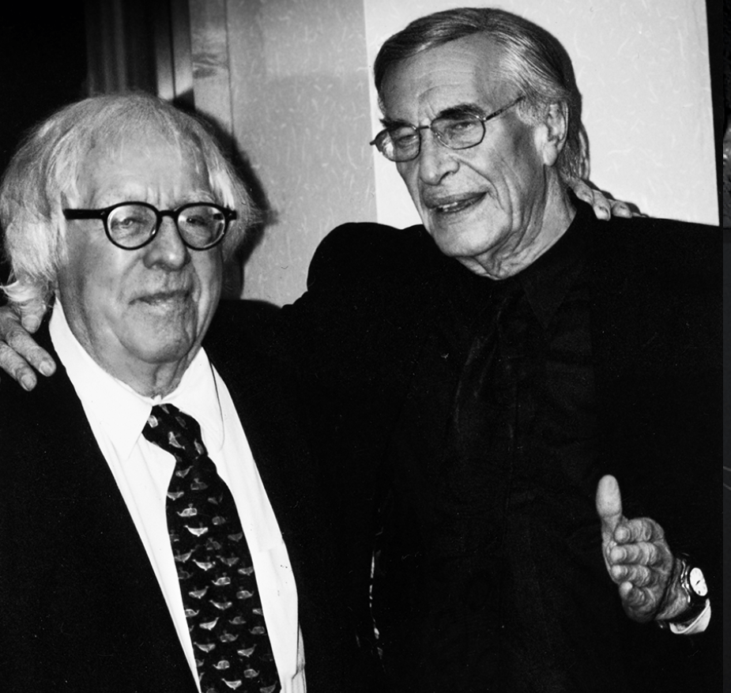

The Visitor, Ray Bradbury

The Visitor

Saul williams awoke to the still morning. He looked wearily out of his tent and thought about how far away Earth was. Millions of miles, he thought. But then what could you do about it? Your lungs were full of the “blood rust.” You coughed all the time.

Saul arose this particular morning at seven o’clock. He was a tall man, lean, thinned by his illness. It was a quiet morning on Mars, with the dead sea bottom-flat and silent—no wind on it. The sun was clear and cool in the empty sky. He washed his face and ate breakfast.

After that he wanted very much to be back on Earth. During the day he tried every way that it was possible to be in New York City. Sometimes, if he sat right and held his hands a certain way, he did it. He could almost smell New York. Most of the time, though, it was impossible.

Later in the morning Saul tried to die. He lay on the sand and told his heart to stop. It continued beating. He imagined himself leaping from a cliff or cutting his wrists, but laughed to himself—he knew he lacked the nerve for either act.

Maybe if I squeeze tight and think about it enough, I’ll just sleep and never wake, he thought. He tried it. An hour later he awoke with a mouth full of blood. He got up and spat it out and felt very sorry for himself.

This blood rust—it filled your mouth and your nose; it ran from your ears, your fingernails; and it took a year to kill you. The only cure was shoving you in a rocket and shooting you out to exile on Mars. There was no known cure on Earth, and remaining there would contaminate and kill others. So here he was, bleeding all the time, and lonely.

Saul’s eyes narrowed. In the distance, by an ancient city ruin, he saw another man lying on a filthy blanket.

When Saul walked up, the man on the blanket stirred weakly.

“Hello, Saul,” he said.

“Another morning,” said Saul. “Christ, I’m lonely!”

“It is an affliction of the rusted ones,” said the man on the blanket, not moving, very pale and as if he might vanish if you touched him.

“I wish to God,” said Saul, looking down at the man, “that you could at least talk. Why is it that intellectuals never get the blood rust and come up here?”

“It is a conspiracy against you, Saul,” said the man, shutting his eyes, too weary to keep them open. “Once I had the strength to be an intellectual. Now, it’s a job to think.”

“If only we could talk,” said Saul Williams.

The other man merely shrugged indifferently.

“Come tomorrow. Perhaps I’ll have enough strength to talk about Aristotle then. I’ll try. Really I will.” The man sank down under the worn tree. He opened one eye. “Remember, once we did talk on Aristotle, six months ago, on that good day I had.”

“I remember,” said Saul, not listening. He looked at the dead sea. “I wish I were as sick as you, then maybe I wouldn’t worry about being an intellectual. Then maybe I’d get some peace.”

“You’ll get just as bad as I am now in about six months,” said the dying man. “Then you won’t care about anything but sleep and more sleep.

Sleep will be like a woman to you. You’ll always go back to her, because she’s fresh and good and faithful and she always treats you kindly and the same. You only wake up so you can think about going back to sleep. It’s a nice thought.” The man’s voice was a bare whisper. Now it stopped and a light breathing took over.

Saul walked off.

Along the shores of the dead sea, like so many emptied bottles flung up by some long-gone wave, were the huddled bodies of sleeping men. Saul could see them all down the curve of the empty sea. One, two, three—all of them sleeping alone, most of them worse off than he, each with his little cache of food, each grown into himself, because social converse was weakening and sleep was good.

At first there had been a few nights around mutual campfires. And they had all talked about Earth. That was the only thing they talked about. Earth and the way the waters ran in town creeks and what homemade strawberry pie tasted like and how New York looked in the early morning coming over on the Jersey ferry in the salt wind.

I want Earth, thought Saul. I want it so bad it hurts. I want something I can never have again. And they all want it and it hurts them not to have it. More than food or a woman or anything, I just want Earth. This sickness puts women away forever; they’re not things to be wanted. But Earth, yes. That’s a thing for the mind and not the weak body.

The bright metal flashed on the sky.

Saul looked up.

The bright metal flashed again.

A minute later the rocket landed on the sea bottom. A valve opened, a man stepped out, carrying his luggage with him. Two other men, in protective germicide suits, accompanied him, bringing out vast cases of food, setting up a tent for him.

Another minute and the rocket returned to the sky. The exile stood alone.

Saul began to run. He hadn’t run in weeks, and it was very tiring, but he ran and yelled.

“Hello, hello!”

The young man looked Saul up and down when he arrived.

“Hello. So this is Mars. My name’s Leonard Mark.”

“I’m Saul Williams.”

They shook hands. Leonard Mark was very young—only eighteen; very blond, pink-faced, blue-eyed and fresh in spite of his illness.

“How are things in New York?” said Saul.

“Like this,” said Leonard Mark. And he looked at Saul.

New York grew up out of the desert, made of stone and filled with March winds. Neons exploded in electric color. Yellow taxis glided in a still night. Bridges rose and tugs chanted in the midnight harbors. Curtains rose on spangled musicals.

Saul put his hands to his head, violently.

“Hold on, hold on!” he cried. “What’s happening to me? What’s wrong with me? I’m going crazy!”

Leaves sprouted from trees in Central Park, green and new. On the pathway Saul strolled along, smelling the air.

“Stop it, stop it, you fool!” Saul shouted at himself. He pressed his forehead with his hands. “This can’t be!”

“It is,” said Leonard Mark.

The New York towers faded. Mars returned. Saul stood on the empty sea bottom, staring limply at the young newcomer.

“You,” he said, putting his hand out to Leonard Mark. “You did it. You did it with your mind.”

“Yes,” said Leonard Mark.

Silently they stood facing each other. Finally, trembling, Saul seized the other exile’s hand and wrung it again and again, saying, “Oh, but I’m glad you’re here. You can’t know how glad I am!”

They drank their rich brown coffee from the tin cups.

It was high noon. They had been talking all through the warm morning time.

“And this ability of yours?” said Saul over his cup, looking steadily at the young Leonard Mark.

“It’s just something I was born with,” said Mark, looking into his drink. “My mother was in the blowup of London back in ’57. I was born ten months later. I don’t know what you’d call my ability.

Telepathy and thought transference, I suppose. I used to have an act, I traveled all around the world. Leonard Mark, the mental marvel, they said on the billboards. I was pretty well off.

Most people thought I was a charlatan. You know what people think of theatrical folks. Only I knew I was really genuine, but I didn’t let anybody know. It was safer not to let it get around too much. Oh, a few of my close friends knew about my real ability. I had a lot of talents that will come in handy now that I’m here on Mars.”

“You sure scared the hell out of me,” said Saul, his cup rigid in his hand. “When New York came right up out of the ground that way, I thought I was insane.”

“It’s a form of hypnotism which affects all of the sensual organs at once—eyes, ears, nose, mouth, skin—all of them. What would you like to be doing now most of all?”

Saul put down his cup. He tried to hold his hands very steady. He wet his lips. “I’d like to be in a little creek I used to swim in in Mellin Town, Illinois, when I was a kid. I’d like to be stark-naked and swimming.”

“Well,” said Leonard Mark and moved his head ever so little.

Saul fell back on the sand, his eyes shut.

Leonard Mark sat watching him.

Saul lay on the sand. From time to time his hands moved, twitched excitedly. His mouth spasmed open; sounds issued from his tightening and relaxing throat.

Saul began to make slow movements of his arms, out and back, out and back, gasping with his head to one side, his arms going and coming slowly on the warm air, stirring the yellow sand under him, his body turning slowly over.

Leonard Mark quietly finished his coffee. While he drank he kept his eyes on the moving, whispering Saul lying there on the dead sea bottom.

“All right,” said Leonard Mark.

Saul sat up, rubbing his face.

After a moment he told Leonard Mark, “I saw the creek. I ran along the bank and I took off my clothes,” he said breathlessly, his smile incredulous. “And I dived in and swam around!”

“I’m pleased,” said Leonard Mark.

“Here!” Saul reached into his pocket and drew forth his last bar of chocolate. “This is for you.”

“What’s this?” Leonard Mark looked at the gift. “Chocolate? Nonsense, I’m not doing this for pay. I’m doing it because it makes you happy. Put that thing back in your pocket before I turn it into a rattlesnake and it bites you.”

“Thank you, thank you!” Saul put it away. “You don’t know how good that water was.” He fetched the coffeepot. “More?”

Pouring the coffee, Saul shut his eyes a moment.

I’ve got Socrates here, he thought; Socrates and Plato, and Nietzsche and Schopenhauer. This man, by his talk, is a genius. By his talent, he’s incredible! Think of the long, easy days and the cool nights of talk we’ll have. It won’t be a bad year at all. Not half.

He spilled the coffee.

“What’s wrong?”

“Nothing.” Saul himself was confused, startled.

We’ll be in Greece, he thought. In Athens. We’ll be in Rome, if we want, when we study the Roman writers. We’ll stand in the Parthenon and the Acropolis. It won’t be just talk, but it’ll be a place to be, besides. This man can do it. He has the power to do it. When we talk the plays of Racine, he can make a stage and players and all of it for me.

By Christ, this is better than life ever was! How much better to be sick and here than well on Earth without these abilities! How many people have ever seen a Greek drama played in a Greek amphitheater in the year 31 B.C.?

And if I ask, quietly and earnestly, will this man take on the aspect of Schopenhauer and Darwin and Bergson and all the other thoughtful men of the ages . . .? Yes, why not? To sit and talk with Nietzsche in person, with Plato himself . . .!

There was only one thing wrong. Saul felt himself swaying.

The other men. The other sick ones along the bottom of this dead sea.

In the distance men were moving, walking toward them. They had seen the rocket flash, land, dislodge a passenger. Now they were coming, slowly, painfully, to greet the new arrival.

Saul was cold. “Look,” he said. “Mark, I think we’d better head for the mountains.”

“Why?”

“See those men coming? Some of them are insane.”

“Really?”

“Yes.”

“Isolation and all make them that way?”

“Yes, that’s it. We’d better get going.”

“They don’t look very dangerous. They move slowly.”

“You’d be surprised.”

Mark looked at Saul. “You’re trembling. Why’s that?”

“There’s no time to talk,” said Saul, getting up swiftly. “Come on. Don’t you realize what’ll happen once they discover your talent? They’ll fight over you. They’ll kill each other—kill you—for the right to own you.”

“Oh, but I don’t belong to anybody,” said Leonard Mark. He looked at Saul. “No. Not even you.”

Saul jerked his head. “I didn’t even think of that.”

“Didn’t you now?” Mark laughed.

“We haven’t time to argue,” answered Saul, eyes blinking, cheeks blazing. “Come on!”

“I don’t want to. I’m going to sit right here until those men show up. You’re a little too possessive. My life’s my own.”

Saul felt an ugliness in himself. His face began to twist. “You heard what I said.”

“How very quickly you changed from a friend to an enemy,” observed Mark.

Saul hit at him. It was a neat quick blow, coming down.

Mark ducked aside, laughing. “No, you don’t!”

They were in the center of Times Square. Cars roared, hooting, upon them. Buildings plunged up, hot, into the blue air.

“It’s a lie!” cried Saul, staggering under the visual impact. “For God’s sake, don’t, Mark! The men are coming. You’ll be killed!”

Mark sat there on the pavement, laughing at his joke. “Let them come. I can fool them all!”

New York distracted Saul. It was meant to distract—meant to keep his attention with its unholy beauty, after so many months away from it. Instead of attacking Mark he could only stand, drinking in the alien but familiar scene.

He shut his eyes. “No.” And fell forward, dragging Mark with him. Horns screamed in his ears. Brakes hissed and caught violently. He smashed at Mark’s chin.

Silence.

Mark lay on the sea bottom.

Taking the unconscious man in his arms, Saul began to run, heavily.

New York was gone. There was only the wide soundlessness of the dead sea. The men were closing in around him. He headed for the hills with his precious cargo, with New York and green country and fresh springs and old friends held in his arms. He fell once and struggled up. He did not stop running.

Night filled the cave. The wind wandered in and out, tugging at the small fire, scattering ashes.

Mark opened his eyes. He was tied with ropes and leaning against the dry wall of the cave, facing the fire.

Saul put another stick on the fire, glancing now and again with a catlike nervousness at the cave entrance.

“You’re a fool.”

Saul started.

“Yes,” said Mark, “you’re a fool. They’ll find us. If they have to hunt for six months they’ll find us. They saw New York, at a distance, like a mirage. And us in the center of it. It’s too much to think they won’t be curious and follow our trail.”

“I’ll move on with you then,” said Saul, staring into the fire.

“And they’ll come after.”

“Shut up!”

Mark smiled. “Is that the way to speak to your wife?”

“You heard me!”

“Oh, a fine marriage this is—your greed and my mental ability. What do you want to see now? Shall I show you a few more of your childhood scenes?”

Saul felt the sweat coming out on his brow. He didn’t know if the man was joking or not. “Yes,” he said.

“All right,” said Mark, “watch!”

Flame gushed out of the rocks. Sulfur choked him. Pits of brimstone exploded, concussions rocked the cave. Heaving up, Saul coughed and blundered, burned, withered by hell!

Hell went away. The cave returned.

Mark was laughing.

Saul stood over him. “You,” he said coldly, bending down.

“What else do you expect?” cried Mark. “To be tied up, toted off, made the intellectual bride of a man insane with loneliness—do you think I enjoy this?”

“I’ll untie you if you promise not to run away.”

“I couldn’t promise that. I’m a free agent. I don’t belong to anybody.”

Saul got down on his knees. “But you’ve got to belong, do you hear? You’ve got to belong. I can’t let you go away!”

“My dear fellow, the more you say things like that, the more remote I am. If you’d had any sense and done things intelligently, we’d have been friends. I’d have been glad to do you these little hypnotic favors. After all, they’re no trouble for me to conjure up.

Fun, really. But you’ve botched it. You wanted me all to yourself. You were afraid the others would take me away from you. Oh, how mistaken you were. I have enough power to keep them all happy. You could have shared me, like a community kitchen. I’d have felt quite like a god among children, being kind, doing favors, in return for which you might bring me little gifts, special tidbits of food.”

“I’m sorry, I’m sorry!” Saul cried. “But I know those men too well.”

“Are you any different? Hardly! Go out and see if they’re coming. I thought I heard a noise.”

Saul ran. In the cave entrance he cupped his hands, peering down into the night-filled gully. Dim shapes stirred. Was it only the wind blowing the roving clumps of weeds? He began to tremble a fine, aching tremble.

“I don’t see anything.” He came back into an empty cave.

He stared at the fireplace. “Mark!”

Mark was gone.

There was nothing but the cave, filled with boulders, stones, pebbles, the lonely fire flickering, the wind sighing. And Saul standing there, incredulous and numb.

“Mark! Mark! Come back!”

The man had worked free of his bonds, slowly, carefully, and using the ruse of imagining he heard other men approaching, had gone—where?

The cave was deep, but ended in a blank wall. And Mark could not have slipped past him into the night. How then?

Saul stepped around the fire. He drew his knife and approached a large boulder that stood against the cave wall. Smiling, he pressed the knife against the boulder. Smiling, he tapped the knife there. Then he drew his knife back to plunge it into the boulder.

“Stop!” shouted Mark.

The boulder vanished. Mark was there.

Saul suspended his knife. The fire played on his cheeks. His eyes were quite insane.

“It didn’t work,” he whispered. He reached down and put his hands on Mark’s throat and closed his fingers. Mark said nothing, but moved uneasily in the grip, his eyes ironic, telling things to Saul that Saul knew.

If you kill me, the eyes said, where will all your dreams be? If you kill me, where will all the streams and brook trout be? Kill me, kill Plato, kill Aristotle, kill Einstein; yes, kill all of us! Go ahead, strangle me. I dare you.

Saul’s fingers released the throat.

Shadows moved into the cave mouth.

Both men turned their heads.

The other men were there. Five of them, haggard with travel, panting, waiting in the outer rim of light.

“Good evening,” called Mark, laughing. “Come in, come in, gentlemen!”

By dawn the arguments and ferocities still continued. Mark sat among the glaring men, rubbing his wrists, newly released from his bonds. He created a mahogany-paneled conference hall and a marble table at which they all sat, ridiculously bearded, evil-smelling, sweating and greedy men, eyes bent upon their treasure.

“The way to settle it,” said Mark at last, “is for each of you to have certain hours of certain days for appointments with me. I’ll treat you all equally. I’ll be city property, free to come and go. That’s fair enough.

As for Saul here, he’s on probation. When he’s proved he can be a civil person once more, I’ll give him a treatment or two. Until that time, I’ll have nothing more to do with him.”

The other exiles grinned at Saul.

“I’m sorry,” Saul said. “I didn’t know what I was doing. I’m all right now.”

“We’ll see,” said Mark. “Let’s give ourselves a month, shall we?”

The other men grinned at Saul.

Saul said nothing. He sat staring at the floor of the cave.

“Let’s see now,” said Mark. “On Mondays it’s your day, Smith.”

Smith nodded.

“On Tuesdays I’ll take Peter there, for an hour or so.”

Peter nodded.

“On Wednesdays I’ll finish up with Johnson, Holtzman, and Jim, here.”

The last three men looked at each other.

“The rest of the week I’m to be left strictly alone, do you hear?” Mark told them. “A little should be better than nothing. If you don’t obey, I won’t perform at all.”

“Maybe we’ll make you perform,” said Johnson. He caught the other men’s eye. “Look, we’re five against his one. We can make him do anything we want. If we cooperate, we’ve got a great thing here.”

“Don’t be idiots,” Mark warned the other men.

“Let me talk,” said Johnson. “He’s telling us what he’ll do. Why don’t we tell him! Are we bigger than him, or not? And him threatening not to perform! Well, just let me get a sliver of wood under his toenails and maybe burn his fingers a bit with a steel file, and we’ll see if he performs! Why shouldn’t we have performances, I want to know, every night in the week?”

“Don’t listen to him!” said Mark. “He’s crazy. He can’t be depended on. You know what he’ll do, don’t you? He’ll get you all off guard, one by one, and kill you; yes, kill all of you, so that when he’s done, he’ll be alone—just him and me! That’s his sort.”

The listening men blinked. First at Mark, then at Johnson.

“For that matter,” observed Mark, “none of you can trust the others. This is a fool’s conference. The minute your back is turned one of the other men will murder you. I dare say, at the week’s end, you’ll all be dead or dying.”

A cold wind blew into the mahogany room. It began to dissolve and became a cave once more. Mark was tired of his joke. The marble table splashed and rained and evaporated.

The men gazed suspiciously at each other with little bright animal eyes. What was spoken was true. They saw each other in the days to come, surprising one another, killing—until that last lucky one remained to enjoy the intellectual treasure that walked among them.

Saul watched them and felt alone and disquieted. Once you have made a mistake, how hard to admit your wrongness, to go back, start fresh. They were all wrong. They had been lost a long time. Now they were worse than lost.

“And to make matters very bad,” said Mark at last, “one of you has a gun. All the rest of you have only knives. But one of you, I know, has a gun.”

Everybody jumped up. “Search!” said Mark. “Find the one with the gun or you’re all dead!”

That did it. The men plunged wildly about, not knowing whom to search first. Their hands grappled, they cried out, and Mark watched them in contempt.

Johnson fell back, feeling in his jacket. “All right,” he said. “We might as well have it over now! Here, you, Smith.”

And he shot Smith through the chest. Smith fell. The other men yelled. They broke apart. Johnson aimed and fired twice more.

“Stop!” cried Mark.

New York soared up around them, out of rock and cave and sky. Sun glinted on high towers. The elevated thundered; tugs blew in the harbor. The green lady stared across the bay, a torch in her hand.

“Look, you fools!” said Mark. Central Park broke out constellations of spring blossoms. The wind blew fresh-cut lawn smells over them in a wave.

And in the center of New York, bewildered, the men stumbled. Johnson fired his gun three times more. Saul ran forward. He crashed against Johnson, bore him down, wrenched the gun away. It fired again.

The men stopped milling.

They stood. Saul lay across Johnson. They ceased struggling.

There was a terrible silence. The men stood watching. New York sank down into the sea. With a hissing, bubbling, sighing; with a cry of ruined metal and old time, the great structures leaned, warped, flowed, collapsed.

Mark stood among the buildings. Then, like a building, a neat red hole drilled into his chest, wordless, he fell.

Saul lay staring at the men, at the body.

He got up, the gun in his hand.

Johnson did not move—was afraid to move.

They all shut their eyes and opened them again, thinking that by so doing they might reanimate the man who lay before them.

The cave was cold.

Saul stood up and looked, remotely, at the gun in his hand. He took it and threw it far out over the valley and did not watch it fall.

They looked down at the body as if they could not believe it. Saul bent down and took hold of the limp hand. “Leonard!” he said softly. “Leonard?” He shook the hand. “Leonard!”

Leonard Mark did not move. His eyes were shut; his chest had ceased going up and down. He was getting cold.

Saul got up. “We’ve killed him,” he said, not looking at the men. His mouth was filling with a raw liquor now. “The only one we didn’t want to kill, we killed.” He put his shaking hand to his eyes. The other men stood waiting.

“Get a spade,” said Saul. “Bury him.” He turned away. “I’ll have nothing to do with you.”

Somebody walked off to find a spade.

Saul was so weak he couldn’t move. His legs were grown into the earth, with roots feeding deep of loneliness and fear and the cold of the night. The fire had almost died out and now there was only the double moonlight riding over the blue mountains.

There was the sound of someone digging in the earth with a spade.

“We don’t need him anyhow,” said somebody, much too loudly.

The sound of digging went on. Saul walked off slowly and let himself slide down the side of a dark tree until he reached and was sitting blankly on the sand, his hands blindly in his lap.

Sleep, he thought. We’ll all go to sleep now. We have that much, anyway. Go to sleep and try to dream of New York and all the rest.

He closed his eyes wearily, the blood gathering in his nose and his mouth and in his quivering eyes.

“How did he do it?” he asked in a tired voice. His head fell forward on his chest. “How did he bring New York up here and make us walk around in it? Let’s try. It shouldn’t be too hard. Think! Think of New York,” he whispered, falling down into sleep. “New York and Central Park and then Illinois in the spring, apple blossoms and green grass.”

It didn’t work. It wasn’t the same. New York was gone and nothing he could do would bring it back. He would rise every morning and walk on the dead sea looking for it, and walk forever around Mars, looking for it, and never find it. And finally lie, too tired to walk, trying to find New York in his head, but not finding it.

The last thing he heard before he slept was the spade rising and falling and digging a hole into which, with a tremendous crash of metal and golden mist and odor and color and sound, New York collapsed, fell, and was buried.

He cried all night in his sleep.

The End