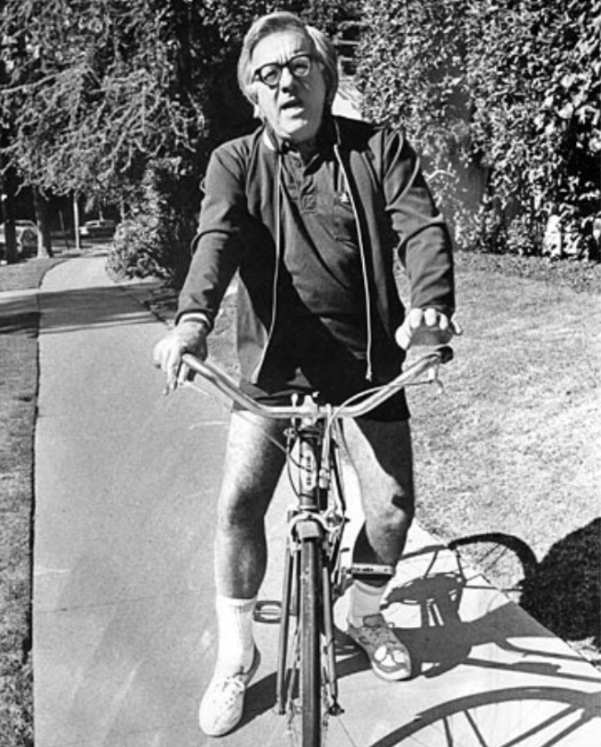

The Watchful Poker Chip of H. Matisse

When first we meet george garvey he is nothing at all. Later he’ll wear a white poker chip monocle, with a blue eye painted on it by Matisse himself. Later, a golden bird cage might trill within George Garvey’s false leg, and his good left hand might possibly be fashioned of shimmering copper and jade.

But at the beginning—gaze upon a terrifyingly ordinary man.

“Financial section, dear?”

The newspapers rattle in his evening apartment.

“Weatherman says ‘rain tomorrow.’”

The tiny black hairs in his nostrils breathe in, breathe out, softly, softly, hour after hour.

“Time for bed.”

By his look, quite obviously born of several 1907 wax window dummies. And with the trick, much admired by magicians, of sitting in a green velour chair and—vanishing! Turn your head and you forgot his face. Vanilla pudding.

Yet the merest accident made him the nucleus for the wildest avant-garde literary movement in history!

Garvey and his wife had lived enormously alone for twenty years. She was a lovely carnation, but the hazard of meeting him pretty well kept visitors off. Neither husband nor wife suspected Garvey’s talent for mummifying people instantaneously.

Both claimed they were satisfied sitting alone nights after a brisk day at the office. Both worked at anonymous jobs. And sometimes even they could not recall the name of the colorless company which used them like white paint on white paint.

Enter the avant-garde! Enter The Cellar Septet!

These odd souls had flourished in Parisian basements listening to a rather sluggish variety of jazz, preserved a highly volatile relationship six months or more, and, returning to the United States on the point of clamorous disintegration, stumbled into Mr. George Garvey.

“My God!” cried Alexander Pape, erstwhile potentate of the clique. “I met the most astounding bore. You simply must see him! At Bill Timmins’ apartment house last night, a note said he’d return in an hour.

In the hall this Garvey chap asked if I’d like to wait in his apartment. There we sat, Garvey, his wife, myself! Incredible! He’s a monstrous Ennui, produced by our materialistic society. He knows a billion ways to paralyze you! Absolutely rococo with the talent to induce stupor, deep slumber, or stoppage of the heart. What a case study. Let’s all go visit!”

They swarmed like vultures! Life flowed to Garvey’s door, life sat in his parlor. The Cellar Septet perched on his fringed sofa, eyeing their prey.

Garvey fidgeted.

“Anyone wants to smoke—” He smiled faintly. “Why—go right ahead—smoke.”

Silence.

The instructions were: “Mum’s the word. Put him on the spot. That’s the only way to see what a colossal norm he is. American culture at absolute zero!”

After three minutes of unblinking quiet, Mr. Garvey leaned forward. “Eh,” he said, “what’s your business. Mr. . . .?”

“Crabtree. The poet.”

Garvey mused over this.

“How’s,” he said, “business?”

Not a sound.

Here lay a typical Garvey silence. Here sat the largest manufacturer and deliverer of silences in the world; name one, he could provide it packaged and tied with throat-clearings and whispers. Embarrassed, pained, calm, serene, indifferent, blessed, golden, or nervous silences; Garvey was in there.

Well, The Cellar Septet simply wallowed in this particular evening’s silence. Later, in their cold-water flat, over a bottle of “adequate little red wine” (they were experiencing a phase which led them to contact real reality) they tore this silence to bits and worried it.

“Did you see how he fingered his collar! Ho!”

“By God, though, I must admit he’s almost ‘cool.’ Mention Muggsy Spanier and Bix Beiderbecke. Notice his expression. Very cool. I wish I could look so uncaring, so unemotional.”

Ready for bed, George Garvey, reflecting upon this extraordinary evening, realized that when situations got out of hand, when strange books or music were discussed, he panicked, he froze.

This hadn’t seemed to cause undue concern among his rather oblique guests. In fact, on the way out, they had shaken his hand vigorously, thanked him for a splendid time!

“What a really expert A-number-1 bore!” cried Alexander Pape, across town.

“Perhaps he’s secretly laughing at us,” said Smith, the minor poet, who never agreed with Pape if he was awake.

“Let’s fetch Minnie and Tom; they’d love Garvey. A rare night. We’ll talk of it for months!”

“Did you notice?” asked Smith, the minor poet, eyes closed smugly. “When you turn the taps in their bathroom?” He paused dramatically. “Hot water.”

Everyone stared irritably at Smith.

They hadn’t thought to try.

The clique, an incredible yeast, soon burst doors and windows, growing.

“You haven’t met the Garveys? My God! lie back down in your coffin! Garvey must rehearse. No one’s that boorish without Stanislavsky!” Here the speaker, Alexander Pape, who depressed the entire group because he did perfect imitations, now aped Garvey’s slow, self-conscious delivery:

“‘Ulysses? Wasn’t that the book about the Greek, the ship, and the one-eyed monster! Beg pardon?’” A pause. “‘Oh.’” Another pause. “‘I see.’” A sitting back. “‘Ulysses was written by James Joyce? Odd. I could swear I remember, years ago, in school . . .’”

In spite of everyone hating Alexander Pape for his brilliant imitations, they roared as he went on:

“‘Tennessee Williams? Is he the man who wrote that hillbilly “Waltz?”’”

“Quick! What’s Garvey’s home address?” everyone cried.

“My,” observed Mr. Garvey to his wife, “life is fun these days.”

“It’s you,” replied his wife. “Notice, they hang on your every word.”

“Their attention is rapt,” said Mr. Garvey, “to the point of hysteria. The least thing I say absolutely explodes them. Odd. My jokes at the office always met a stony wall. Tonight, for instance, I wasn’t trying to be funny at all.

I suppose it’s an unconscious little stream of wit that flows quietly under everything I do or say. Nice to know I have it in reserve. Ah, there’s the bell. Here we go!”

“He’s especially rare if you get him out of bed at four a.m.,” said Alexander Pape. “The combination of exhaustion and fin de siècle morality is a regular salad!”

Everyone was pretty miffed at Pape for being first to think of seeing Garvey at dawn. Nevertheless, interest ran high after midnight in late October.

Mr. Garvey’s subconscious told him in utmost secrecy that he was the opener of a theatrical season, his success dependent upon the staying power of the ennui he inspired in others.

Enjoying himself, he nevertheless guessed why these lemmings thronged to his private sea. Underneath, Garvey was a surprisingly brilliant man, but his unimaginative parents had crushed him in the Terribly Strange Bed of their environment.

From there he had been thrown to a larger lemon-squeezer: his Office, his Factory, his Wife. The result: a man whose potentialities were a time bomb in his own parlor. The Garveys’ repressed subconscious half recognized that the avant-gardists had never met anyone like him, or rather had met millions like him but had never considered studying one before.

So here he was, the first of autumn’s celebrities. Next month it might be some abstractionist from Allentown who worked on a twelve-foot ladder shooting house-paint, in two colors only, blue and cloud-gray, from cake-decorators and insecticide-sprayers on canvas covered with layers of mucilage and coffee grounds, who simply needed appreciation to grow! or a Chicago tin-cutter of mobiles, aged fifteen, already ancient with knowledge. Mr. Garvey’s shrewd subconscious grew even more suspicious when he made the terrible mistake of reading the avant-garde’s favorite magazine, Nucleus.

“This article on Dante, now,” said Garvey, “Fascinating. Especially where it discusses the spatial metaphors conveyed in the foothills of the Antipurgatorio and the Paradiso Terrestre on top of the Mountain. The bit about Cantos XV–XVIII, the so-called ‘doctrinal cantos’ is brilliant!”

How did the Cellar Septet react?

Stunned, all of them!

There was a noticeable chill.

They departed in short order when instead of being a delightfully mass-minded, keep-up-with-the-Joneses, machine-dominated chap leading a wishy-washy life of quiet desperation, Garvey enraged them with opinions on Does Existentialism Still Exist? or Is Krafft-Ebing?

They didn’t want opinions on alchemy and symbolism given in a piccolo voice, Garvey’s subconscious warned him. They only wanted Garvey’s good old-fashioned plain white bread and churned country butter, to be chewed on later at a dim bar, exclaiming how priceless! Garvey retreated.

Next night he was his old precious self. Dale Carnegie? Splendid religious leader! Hart Schaffner & Marx? Better than Bond Street! Member of the After-Shave Club? That was Garvey! Latest Book-of-the-Month? Here on the table! Had they ever tried Elinor Glyn?

The Cellar Septet was horrified, delighted. They let themselves be bludgeoned into watching Milton Berle. Garvey laughed at everything Berle said. It was arranged for neighbors to tape-record various daytime soap operas which Garvey replayed evenings with religious awe, while the Cellar Septet analyzed his face and his complete devotion to Ma Perkins and John’s Other Wife.

Oh, Garvey was getting sly. His inner self observed: You’re on top. Stay there! Please your public! Tomorrow, play the Two Black Crows records! Mind your step! Bonnie Baker, now . . . that’s it! They’ll shudder, incredulous that you really like her singing. What about Guy Lombardo? That’s the ticket!

The mob-mind, said his subconscious. You’re symbolic of the crowd. They came to study the dreadful vulgarity of this imaginary Mass Man they pretend to hate. But they’re fascinated with the snake-pit.

Guessing his thought, his wife objected. “They like you.”

“In a frightening sort of way,” he said. “I’ve lain awake figuring why they should come see me! Always hated and bored myself. Stupid, tattletale-gray man. Not an original thought in my mind. All I know now is: I love company. I’ve always wanted to be gregarious, never had the chance. It’s been a ball these last months! But their interest is dying. I want company forever! What shall I do?”

His subconscious provided shopping lists.

Beer. It’s unimaginative.

Pretzels. Delightfully “passé.”

Stop by Mother’s. Pick up Maxfield Parrish painting, the flyspecked, sunburned one. Lecture on same tonight.

By December Mr. Garvey was really frightened.

The Cellar Septet was now quite accustomed to Milton Berle and Guy Lombardo. In fact, they had rationalized themselves into a position where they acclaimed Berle as really too rare for the American public, and Lombardo was twenty years ahead of his time; the nastiest people liked him for the commonest reasons.

Garvey’s empire trembled.

Suddenly he was just another person, no longer diverting the tastes of friends, but frantically pursuing them as they seized at Nora Bayes, the 1917 Knickerbocker Quartette, Al Jolson singing “Where Did Robinson Crusoe Go With Friday on Saturday Night,” and Shep Fields and his Rippling Rhythm. Maxfield Parrish’s rediscovery left Mr. Garvey in the north pasture.

Overnight, everyone agreed, “Beer’s intellectual. What a shame so many idiots drink it.”

In short, his friends vanished. Alexander Pape, it was rumored, for a lark, was even considering hot water for his cold-water flat. This ugly canard was quashed, but not before Alexander Pape suffered a comedown among the cognoscenti.

Garvey sweated to anticipate the shifting taste! He increased the free food output, foresaw the swing back to the Roaring Twenties by wearing hairy knickers and displaying his wife in a tube dress and boyish bob long before anyone else.

But, the vultures came, ate, and ran. Now that this frightful Giant, TV, strode the world, they were busily re-embracing radio. Bootlegged 1935 transcriptions of Vic and Sade and Pepper Young’s Family were fought over at intellectual galas.

At long last, Garvey was forced to turn to a series of miraculous tours de force, conceived and carried out by his panic-stricken inner-self.

The first accident was a slammed car door.

Mr. Garvey’s little fingertip was neatly cut off!

In the resultant chaos, hopping about, Garvey stepped on, then kicked the fingertip into a street drain. By the time they fished it out, no doctor would bother sewing it back on.

A happy accident! Next day, strolling by an oriental shop, Garvey spied a beautiful objet d’art. His peppy old subconscious, considering his steadily declining box office and his poor audience-rating among the avant-garde, forced him into the shop and dragged out his wallet.

“Have you seen Garvey lately!” screamed Alexander Pape on the phone. “My God, go see!”

“What’s that?”

Everyone stared.

“Mandarin’s finger-guard.” Garvey waved his hand casually. “Oriental antique. Mandarins used them to protect the five-inch nails they cultivated.” He drank his beer, the gold-thimbled little finger cocked. “Everyone hates cripples, the sight of things missing. It was sad losing my finger. But I’m happier with this gold thing-amajig.”

“It’s a much nicer finger now that any of us can ever have.” His wife dished them all a little green salad. “And George has the right to use it.”

Garvey was shocked and charmed as his dwindling popularity returned. Ah, art! Ah, life! The pendulum swinging back and forth, from complex to simple, again to complex. From romantic to realistic, back to romantic.

The clever man could sense intellectual perihelions, and prepare for the violent new orbits. Garvey’s subconscious brilliance sat up, began to eat a bit, and some days dared to walk about, trying its unused limbs. It caught fire!

“How unimaginative the world is,” his long-neglected other self said, using his tongue. “If somehow my leg were severed accidentally I wouldn’t wear a wooden leg, no! I’d have a gold leg crusted with precious stones made, and part of the leg would be a golden cage in which a bluebird would sing as I walked or sat talking to friends.

And if my arm were cut off I’d have a new arm made of copper and jade, all hollow inside, a section for dry ice in it. And five other compartments, one for each finger. Drink, anyone? I’d cry. Sherry? Brandy? Dubonnet? Then I’d twist each finger calmly over the glasses. From five fingers, five cool streams, five liqueurs or wines. I’d tap the golden faucets shut. ‘Bottoms up!’ I’d cry.

“But, most of all, one almost wishes that one’s eye would offend one. Pluck it out, the Bible says. It was the Bible, wasn’t it? If that happened to me, I’d use no grisly glass eyes, by God. None of those black, pirate’s patches.

Know what I’d do? I’d mail a poker chip to your friend in France, what’s his name? Matisse! I’d say, ‘Enclosed find poker chip, and personal check. Please paint on this chip one beautiful blue human eye. Yrs., sincerely. G. Garvey!’”

Well, Garvey had always abhorred his body, found his eyes pale, weak, lacking character. So he was not surprised a month later (when his Gallup ran low again) to see his right eye water, fester, and then pull a complete blank!

Garvey was absolutely bombed!

But—equally—secretly pleased.

With the Cellar Septet smiling like a jury of gargoyles at his elbow, he airmailed the poker chip to France with a check for fifty dollars.

The check returned, uncashed, a week later.

In the next mail came the poker chip.

H. Matisse had painted a rare, beautiful blue eye on it, delicately lashed and browed. H. Matisse had tucked this chip in a green-plush jeweler’s box, quite obviously as delighted as was Garvey with the entire enterprise.

Harper’s Bazaar published a picture of Garvey, wearing the Matisse poker-chip eye, and yet another of Matisse, himself, painting the monocle after considerable experimentation with three dozen chips!

H. Matisse had had the uncommon good sense to summon a photographer to Leica the affair for posterity. He was quoted. “After I had thrown away twenty-seven eyes, I finally got the very one I wanted. It flies posthaste to Monsieur Garvey!”

Reproduced in six colors, the eye rested balefully in its green-plush box. Duplicates were struck off for sales by the Museum of Modern Art. The Friends of the Cellar Septet played poker, using red chips with blue eyes, white chips with red eyes, and blue chips with white eyes.

But there was only one man in New York who wore the original Matisse monocle and that was Mr. Garvey.

“I’m still a nerve-racking bore,” he told his wife, “but now they’ll never know what a dreadful ox I am underneath the monocle and the Mandarin’s finger. And if their interest should happen to dwindle again, one can always arrange to lose an arm or leg. No doubt of it. I’ve thrown up a wondrous facade; no one will ever find the ancient boor again.”

And as his wife put it only the other afternoon:“I hardly think of him as the old George Garvey anymore. He’s changed his name. Giulio, he wants to be called. Sometimes, at night, I look over at him and call, ‘George,’ but there’s no answer.

There he is, that mandarin’s thimble on his little finger, the white and blue Matisse Poker-Chip monocle in his eye. I wake up and look at him often. And do you know? Sometimes that incredible Matisse Poker Chip seems to give out with a monstrous wink.”

The End